Soundboks 2 Review - Powerful Portable Bluetooth Speaker

The Soundboks 2 portable bluetooth speaker is a massive speaker designed for someone that likes to entertain large crowds. It is in the high end range when it comes to indoors or outdoors speakers but it offers more than enough features and performance that you’ll enjoy. The important features of the speaker are below which we’ll discuss in this Soundboks 2 review.

Who is This Speaker For?

The Soundboks 2 speaker is designed for anyone possibly a DJ that throws huge parties often. It is also great for:

- large gatherings
- beach parties
- block parties
- Wedding receptions
- Company picnics
- Birthday parties
- Other outdoors events

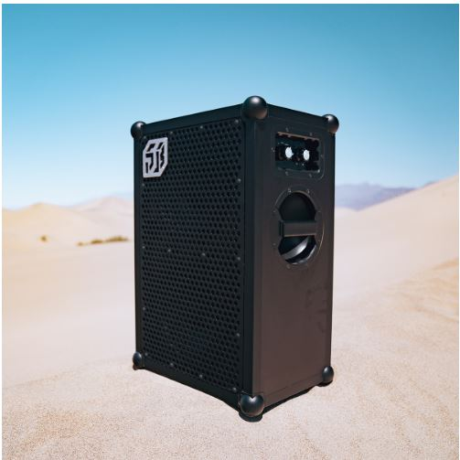

Buy From Amazon

Soundboks 2 Speaker Highlights

- Portable
- Bluetooth
- Battery powered
- High end price
- Built tough
- Great sound quality

Soundboks 2 Portability and Bluetooth Functions

The Soundboks or Sound Box 2 speaker is a popular choice for customers because it’s portable despite its massive size. It weighs 33 pounds, is 3 feet tall, 2 feet wide, is 1 feet deep, and can be transported for short distances by a single person or longer distances easily by 2 people, one on each side of the speaker. There is also a separate backpack attachment that can be purchased separately that allows an individual to carry the speaker on their back.

The bluetooth feature is an excellent component built into the speaker that allows users to sync their smartphone or mobile devices to the speaker. They can play whatever music or audio content they have downloaded on their phone or easily stream music directly to the speaker. There is a 100 ft range that the mobile device will need to be in for great reception, connectivity, and sound quality.

Soundboks 2 Battery Performance

For most users the battery component of the Soundboks 2 wireless speaker may be the biggest feature that they like. The speaker is not powered by a cord plugged into an outlet. It is a massive battery powered speaker. The battery simply needs recharging and that’s it.

The specs on the battery is it’s a LiFeP04 battery that is removable. It offers an impressive 40 hours of battery life and up to 100 total hours depending on how you use the volume controls. It you need the speaker to be pumped at full volume for an extended period of time they it on average can last up to 10 hours on one charge.

The typical time it takes for a battery to recharge is 3 to 4 hours. You can view the life of the battery by the LED indicators which shows how much power is left.

Soundboks Durability

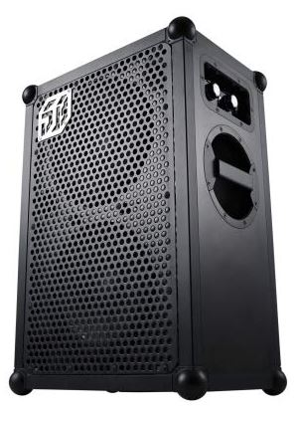

Buy From Amazon

Because the Soundboks 2 battery powered speaker is designed for either indoor or outdoor use when using outdoors it needs to be able to hold up against the elements. The speaker is weatherproof able to withstand rain, snow, extreme cold and hot temperatures. The casing of the speaker is made from Baltic birch plywood and wrapped in scratch proof powered aluminum.

The speaker is sturdy and also has ball corners to prevent it from damaging anything else during transportation. It also has metal piping along the edges and a metal grille in front to protect the speaker cones.

Sound Quality

If you’re looking for volume the Soundboks 2 outdoor speaker at its loudest reaches a volume of 122dBs. The volume goes up to 11 on the dial and music can be heard all around. To understand the power and sound of the speaker better you’ll want to know what individual speakers makeup the Soundboks speaker.

It is equipped with the following speakers:

- dual 2 x 96 dB custom 10 inch woofers
- 3 x 72 watt Merus Audio Eximo class D amplifiers with dynamic bass boosting technology
- 1 x 98 Neodymium silk dome tweeter

Because the speaker plays out of one side you will need to properly orient it to project the audio.
You can select between an indoor and outdoor mode depending on your preference. The outdoor mode offers a little more bass.

Easy Setup

Setting up the speaker is a quick and easy process especially with the bluetooth feature. If you are familiar with bluetooth technology then you can easily understand how to connect your phone or mobile device to the speaker.

- You will need to turn the power on via the power knob
- Select from the indoor or outdoor mode
- Wait for the bluetooth indicator light to blink
- Locate your Soundbok device serial number and connect to it

Price of Soundboks 2 Speaker

The Soundboks 2 price is on the high end side of things. It’s available on Amazon for $899. Some people may balk at the price while others aren’t bothered by the price probably because they have plans to use it more often. They also know they’re getting a speaker that will last for years and that’s durable.

On Amazon the speaker currently has over 150 customer reviews with 85% of customers that left a review rating the speaker 5 stars. It has a 4.5 out of 5 star rating - click to read reviews!!

What’s in the Box

After purchasing this speaker you can expect to receive at your doorstep a box weighing about 46 lbs. It will consist of the following:

Soundboks 2
Replaceable battery
Charger
Aux cable
A manual
25.6 inches high
17 inches wide
13 inches deep

