Atma-Stand’s Survival-Horror Quartet Challenge

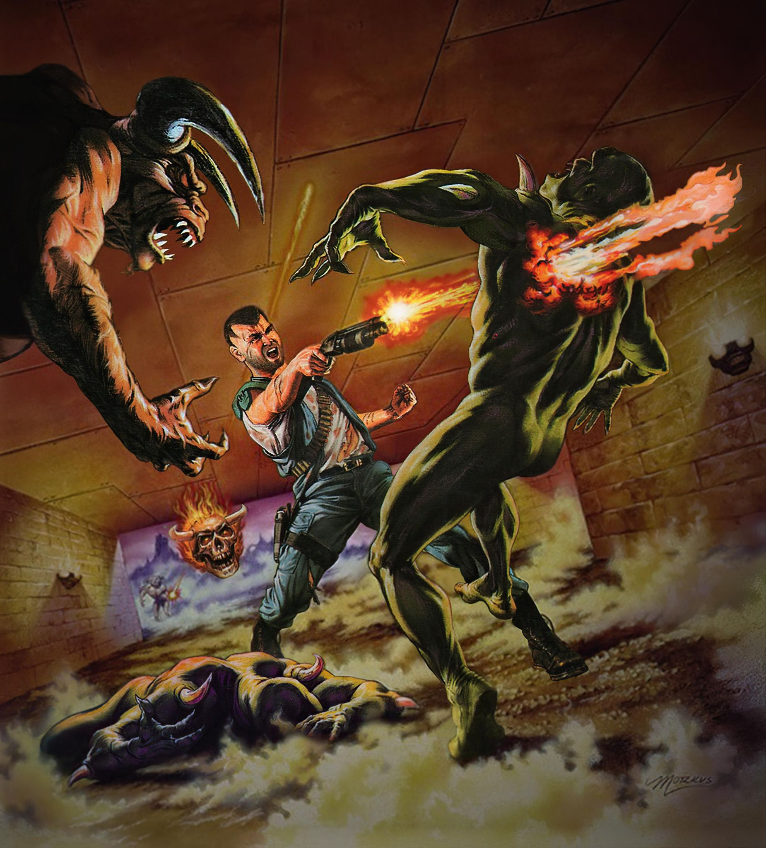

Foreword

It was a dark and stormy night, and you had just lost some precious progress in one of your favorite survival-horror games. That damn monster was just out of sight when it jumped you, and you were pretty tired after all. Turning your system off but not immediately going to bed, you check your usual websites for a minute or two and find an interesting post relating to Jumpchain. It reads as follows;

“Fear, something vital to all beings. It can cripple us in ways we cannot understand yet and also push us to achieve greater heights than we could have possibly dreamed of. As you might imagine, this is a relatively common theme in many Jumps. So, what if you, in your capacity of bearing meta-knowledge, were to have a direct involvement? Saving those who couldn’t be saved or killing those who wouldn’t be killed. These are all hypotheticals of course, but I would like to extend an open invitation for those would-be-Jumpers out there. Please select between one to four Jumps whose universes correspond to the concepts of Survival-Horror to begin a chain with and post your builds.”

You take a few moments to consider the challenge, feeling your heart quicken in pace as you do, and decide to go for it. Over the next few days, you slowly begin to consider the appropriate Jumps, how you would go about balancing one against another, and which you feel would be best, before finally submitting them to the post late one evening. You rub your eyes tiredly and get up to go to bed. As you open the door to your bedroom, the room you expect to see is not there. Rather, the bare walls and shelves of a warehouse welcome you. Its only occupant is a hauntingly beautiful woman with a predatory smile. Before you can react, the door slams shut behind you, forcing you fully into Your new warehouse.

Survival-Horror Quartet Rules

You try to make sense of the situation, maybe even argue against the sudden nature of your appearance. Your new Benefactor simply smiles and reiterates that you responded to the post with the spirit of the intent fully in mind. Whether you like it or not, you are now officially a Jumper. Before you can say anything else, your new Benefactor presents you with a complete list of rules for the Survival-Horror Quartet Challenge you signed up for, in the form of a very thin booklet depicting a hard-to-see figure battling several horrific monsters.

- You must Jump between One to Four Survival-Horror-themed worlds before taking any other Jump or Gauntlet.
- Each Jump taken will become the core of your Bodymod.
- You may use the basic version of the Warehouse Supplement to store Items and access Properties that you purchase during or after this challenge.

Survival-Horror Quartet Complications

Well, the rules seem pretty simple. This should be a cakewalk for you. Then, you flip the page and see something new. Considering the contents labelled under “Complications,” you soon begin to understand where the difficulty finally comes in.

- You may take one instance of either Generic First Jump or Generic First Virgin. However, you cannot take both and each level must relate to Survival-Horror.
- You may NOT take Generic Rebruary, or a Tutorial Jump during or after this challenge.
- You may only use Generic Jumps which directly involve Survival-Horror settings. Generic Jumps that do not include Survival-Horror settings as their primary focus cannot be used for this Challenge.
- You may not use the Universal Drawback Supplement during this challenge. However, you will be able to use it after you complete the Challenge. Additional Supplements or Crossovers cannot be used for this challenge unless the Base Jump has a drawback or option that links it to another related Jump, then they may be combined.
- For those Jumpers who take two or more Jumps during this challenge, you will soon begin to notice something apparent as you continue onward. Enemies you encountered during a previous Survival-Horror Jump will appear in some capacity during your successive Jumps. They will be considered Out-Of-Context problems for you and the denizens of the world you are currently in. They will act as anything from roving hordes of mindless horrors to determined pursuers, or world-threatening foes. Whether they recognize you or the threat you may represent is a matter of how much they interacted with you and how much of your appearance these enemies saw. After completing this challenge, these recurring enemies will no longer appear in future Jumps.

Survival-Horror Reward

After reviewing the various complications in this challenge, you come upon another page detailing information you have already been made aware of.

“For completing such a potentially harrowing challenge, I see no reason to restrict the strength you acquired during your time in this challenge. As such, and upon my authority as a Benefactor, any Perk, Power, and Item you acquired during this challenge, whether through purchases or scenario rewards, have now become the core of your Body-Mod. Go, and show the multiverse the will of a True Survivor!”

The Worst Enemy Lies Within

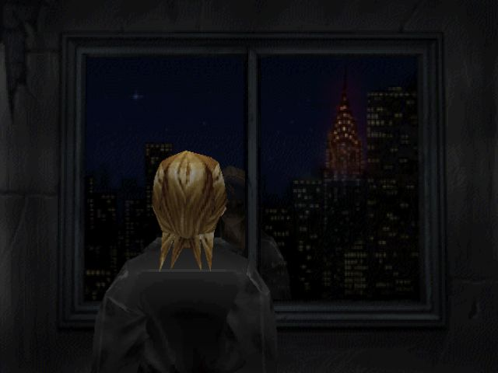

As you enter your warehouse after completing your last challenge Jump, you notice something that wasn’t there before. A large window overlooking a darkened city with a single building shining brightly. Something about it sends a chill down your spine. Your Benefactor notices your discovery, smiles, and explains that this cityscape and building represent a Special Challenge that can be considered a sort of… final exam. The goal is simple: ascend the building and defeat any horror you may come across. A car will be waiting outside of your warehouse to take you there.

- The Building consists of 11-41 floors, determined by how many Jumps you take for this challenge. Every floor in a set of ten, represents a year spent in that particular Jump.
- Each floor is filled to the brim with enemies you have encountered during a specific Survival-Horror Jump. At the end of each floor, there will be a boss-type enemy you have also encountered who guards the stairs to the next floor.
- The higher the floor, the more dangerous the foes, with the last floor containing the most dangerous enemies from that Jump.
- The level of threat resets when you clear 10 floors, at which point you will transition into another 10 floors dedicated to the next Jump in your Challenge-Chain.
- Regardless of how many Jumps you have taken, the final floor will contain… You!? No, rather this is a doppelganger that has formed from the horrors you’ve encountered. It shares your Perks and Items, but it wants more. It wants to become you, by any means necessary. Banish this nightmare and conquer the Building once and for all.

The Worst Enemy Lies Within Rewards

As the Doppelganger falls, you will find that it has dropped four cards, each with a symbol etched into them. While you may inspect each card carefully and handle them, you may only take one card with you out of this building.

- This Card depicts a figure joyfully swimming in a pile of what looks to be coins. Should you choose this Card, you will receive a permanent +100 to +400 Horror Points or HP. These points are determined by how many Survival-Horror Jumps you have taken for this challenge and can supplement your starting Character Points or Special Section Points with their own dedicated point pool. These Horror Points will reset at the beginning of each new Jump.
- This Card depicts several figures drawn closely together, and you cannot help but feel a deep and profound sense of camaraderie between them. Should you choose this Card, you will find that you can bring One to Four of your Companions into any future Jump/Gauntlet for FREE, depending on how many Survival-Horror Jumps you have completed.
- This Card depicts a figure surrounded by broken coins who draws something impossible to see into their body. Should you choose this Card, you will find that you can now Add Perks, Powers, or Items up to the value of 100 to 400 Points to your Body-Mod by spending double their Undiscounted Point value, depending on how many Survival-Horror Jumps you have completed.
- This Card depicts a demonic figure holding a bountiful basket. Upon choosing this Card, you will find that you will now Encounter Enemies from Previous Jumps in each successive Jump. Defeating these enemies will not only allow you to further hone your skills, but they will drop powerful Items or Supplies that you would not be able to readily find or even access without specific resources or locations.

Afterward

Regardless of your choices during this challenge, your Benefactor has found no small degree of entertainment in your actions and is delighted to see what you will do in the future. You may now fill out whichever document, in whichever genre you want to, and continue your journey.

Notes

- General
  - Most of the language in this Quartet Challenge I altered from the Isekai-Quartet Challenge I previously made. The main inspiration for this Challenge was a current replaying of Parasite Eve 2, and the idea of GOLEM No. 9 being a reoccurring Jump villain throughout a chain.
- Complications
  - I decided to allow the use of only one instance of GFJ or GFV due to some of the QoL Perks those Jumps have. Should you take either with a Jump after that, then choose your levels wisely, as those monsters you encounter within either GFJ or GFV will appear in a staggered manner. In your first year of the second Jump, you will monsters/enemies of your first GFJ/GFV level and so on, and so forth. This pattern will repeat until the challenge is completed.
- The Worst Enemy Challenge
  - While the original language did come from the Tower of Isekai from my Isekai-Quartet Challenge, I did make some changes.
    - The Doppelganger fight is inspired by surprise, surprise, The Purebred Eve fight from the original Parasite Eve, hence the shot of the PE1 Chrysler Building. However, it was also inspired by Davoth from Doom: Eternal, Darkness from Ridley Scott’s Legend, and the Stylado from Onimusha: Warlords.
    - The Fourth Reward was also something inspired by Parasite Eve, specifically Parasite Eve 2’s Bounty/Nightmare Modes.

Changelog

- Version .9 Created
- 7/16/2025 – Version 1.0
  - Minor Grammatical Changes have been made.
  - I’d like to thank everyone who offered their feedback on the document.

