John wrote: "'I've yet to determine what my living dream is. I'm still all stuffed up with definitions. Even attempting to be rid of definitions is a definition in itself as it comes from the same defined mind I'm trying to be rid of. The spontaneous dream of the present is so elusive to us who are defined."
Arthur Cristian
For example, just start creating a living garden that feeds you and others and be present to everything living in it day after day and let the abundance of your dream prosper (thanks to your care and nurturing etc) to feed others for free without a fee, and all will be taken care of. Do you have to jump 10 feet across a room to grab your next breath? Of course not, it's already there where it has always been - life/reality/truth has never abandoned you so why do you abandon it by doubling it, by having uncertainty with it, by selling out who you really are? Stop thinking about you (self-obsession) - get out of your head/there. Start a garden without you in it because you are already in it, already there, living (live in) the dream you hold and let the dream keep you busy creating it, doing everything you can for it so that with intention you completely forget the fiction of you in your head, the fantasy swimming amongst the alphabet soup of "The System". Be a servant to the living dream of life you hold for there is your live in soul too. And go to work and do all the other things your vessel requires under these present circumstances that compromises your vessel but don't forget who you really are, the creator of your live in dream, the dreams of life you live in as the MAN.
Reflecting on your soul is an illusion because all that is there is the fantasy of a "self", under "NAME", you are imagining. This happens because you were trained from so young to rely on 3rd party definitions, "NAMES", that formed this illusory "self" which you have been holding as the dream of your life and communicating to and from, on its behalf, ever since. But there is no soul there. "NAME" is a definition and is a ghost of fantasy. Your real soul can ONLY be experienced through your unique and original senses (touch, taste, feel, smell, hear, see) and whatever you are sensing you are already THERE as the scent and colour and vivid life of the flower and NOT in the referencing of the definitions of the flower in your head (so to speak).
When you sense the "stars" you are there (as the stars).
When you sense the birds, you are there (as the bird).
When you sense the breeze, you are there (as the breeze).
When you sense (when your consciousness senses) nature/earth/reality you are already there and there and there and there and there and there and there and there and there.....forevermore as nature/earth/reality and the REAL living soul is this UNDEFINED MAN, constantly sensing the magnificence of MAN'S living (LIVE--->IN) dream of life AND NEVER IN THE DEFINITIONS you were conned into referring/defaulting to from the womb and to the grave.
Your unique and original soul is NOT THERE amongst alphabet letters, words, phrases, sentences, paragraphs, chapters, books, stories, fairytales, movies, film, videos, courses, workshops, myths, mythologies, scripture, explanations, suggestions, instructions, brainwashing, indoctrination, birth certificate, drivers license, Medicare, Centrelink (govt handouts), credit card, bank account, passport, lease, mortgage, land, house, title deed, contract, polling booth, tombstone, plaque, registry, ticket, shopping centre, motor vehicle, address, number, status, career, etc, etc,.......... and if you believe who you really are is already there amongst definitions/names, then you are already well on the way to being forever GOOONNEEE, DEAD, in this life without an eternal soul because you are already lost deep in the eternal fantasy of referencing "self", the intellect, the mind, the e-go of the egregore, "The System" of practicing your soul's spiritual suicide.
The soul is not the vessel, the body. The soul is the consciousness that fills the vessel, the captain of the ship. The undefined soul can take the form of the vessel and have it appear anywhere, "anytime", unrestricted and this is determined by the soul, the captain of the vessel.
However, definitions form a fake captain ("NAME") that sails the vessel through the alphabet soup of "The System".
When children are brought up by nature with no one inside their heads defining reality to them, they create dreams through their senses that are unique and original to them, and these dreams are of their soul because they contain the life, the essence, living in (live-in) the dream of the MAN of the soul that they hold. There is no separation.
Those who have souls can incarnate into a vessel and, as long as they remember who they really are, they never truly "die", just as those who wake up in a vessel and remember who they really are don't "die" either because, when the vessel "dies" and decomposes into the soil again, the soul is still living as the consciousness of MAN'S living (live-in) dream of life.
But this doesn't happen when children are brought up knowing only definitions forming the fantasies of their perceived realities. The makers of the definitions have hijacked the vessel and have placed a fake captain, an imposter, to sail the seas of their alphabet soup, "The System", Wonderland, the Matrix, on their behalf. This is why the fallen are answerable to the authorities (author of rites/writes/rights) of "The System".
Through definitions, we imagine that we are here, there and there and there but it is only the definitions that are being projected and illuminated; who we really are is not there at all and the definition doesn't exist. We are not being the flower, the rain, the ocean, the bird, etc. There is separation and this separation is MAN'S fall from paradise/Eden/reality/nature/earth/the soul.
If all we know are alphabet definitions, then we are not anywhere, we do not exist. A robot with a software program running the performance of the robot is still not proof of fact that the robot exists, the alphabet definitions being the program of the "NAME", the robot.
When we project our life energy and empower a definition, we are projecting and illuminating a thought form but there is no soul there. We are just imagining that there is substance/matter there but there is no matter/substance.
Consciousness is not in the body - it is undefined, non-lineal, without beginning or end and this is who we are too, when we free our brains from the definitions.
If you have not created a unique, original living dream through the senses of the vessel and all you have are borrowed dreams that you mimic/re-present, there is no soul created, no soul there.
Fantasy is not reality and fantasy has no substance of life/reality/the-living. Once the matter of the vessel is laid to rest or cremated and returned to earth/water, there is only a defined thought form of fantasy, the "NAME", that is an apparition being fed by those who remember the "NAME".
Once the "NAME" is forgotten too, the imagining of the apparition fades away from whence it came, back to NOTHING, because there is no one there to remember it and call it forth. All apparitions are thoughts forms or demonic entities imagined/crafted into MAN'S imagining by the makers of the definitions and energised by the current of MAN'S life-energy.
------------------
Rich Ahh wrote
The "system" is just a mirror to or fractal of nature is it not, showing its structure, frequencies, energy's, the story is parable and analogy, told to those who choose to hear, do you suggest man can only have hold one or the other of these things when the dreams structure it created for your very mind machine is an absolute divided house with a focus point centre..
you have looked at the story, do you find that it just teaches or points to just one possibility or is it offering a reflection on one side of nature’s choices? is evil just a mirror of life, a fiction, not there in nature at all until we give it energy,
if we are lucky we are in the dream unnamed child state for a short period before we are shoved as fast as possible into the left hemisphere mind, some as dan mentions below never fully leave but we must to a large degree as this is not a exercise in consciousness perfection from the perfect place next to the perfect mountain stream but in a soup with billions of other free and programmed minds that are intent also to play out their novelty, as life must, and we grow the ego and push our way out, the thing though is to find again in life our way home as it where, back into at least the ability to be momentarily in this state, not to have never left in the first place, this re-connection back into the nature offers now the vessel the chance for conscious feedback into collective dream.
i doubt those whose story deviates little into its own pictures and just copy and paste the common parlance definitions are soulless so to speak.. maybe contrasted in quality to the one who asks questions and thrills in exploration but does not nature itself present deserts and simplistic mass mono cultures.. :)
------------------
Arthur Cristian
No offence or harm intended here. Just sharing facts as they stand.
All you are doing here is recalling 3rd party definitions used under "NAME" to form the storytelling fantasies of "NAME'S" perception of reality, it's fake, defined, book of life. These thoughts/dreams are not of your creation.
THEY ARE ALL IN 3RD PARTY, NONE IN 1ST PARTY. Says it all.
Example: bring forward "fractal of nature" before the living men, women and children (MAN). Let's hear these claims directly from the wagging tongue of "fractal of nature" and not from the wagging tongue of a MAN acting on behalf of "fractal of nature" because this would be lying and committing fraud if you claimed it to be true.
Where is the living substance/matter of "fractal of nature" so that we, the living MAN, can sense "fractal of nature", directly, 1st party to 1st party.
"When we project our life energy and empower a definition, we are projecting and illuminating a thought form but there is no soul there. We are just imagining that there is substance/matter there but there is no matter/substance."
"A robot with a software program running the performance of the robot is still not proof of fact that the robot exists, the alphabet definitions being the program of the "NAME", the robot."
We, the living, can sense the MAN, Little Mary, on stage, but we can't sense Alice or Wonderland Little Mary is performing before us, under costume and title/"NAME".
Little Mary is present with the presence (pre-sense) of life, but Alice and Wonderland are not present with the presence of life. We can't sense Alice or Wonderland. All we can do is imagine Alice in Wonderland.
All the time Little Mary is talking while moving legs, arms, hands, tongue, head, etc, we, the living, still can't sense Alice in Wonderland.
The very same examples of facts shared above also applies with "fractal of nature".
We, the living, can sense the MAN, Little Mary, on stage, but we can't sense "Fractal Of Nature" Little Mary is performing before us, under costume and title/"NAME".
Little Mary is present with the presence (pre-sense) of life, but "Fractal Of Nature" is not present with the presence of life. We can't sense "Fractal Of Nature". All we can do is imagine "Fractal Of Nature"
And therefore "Fractal Of Nature" is a fantasy.
You say, "nature itself present deserts and simplistic mass mono cultures." True, but none of those mono cultures is forming fantasies of perceived realities, based on definitions, nor are they performing fake personas based on definitions that they have been brainwashed into. They are fulfilling their purpose as life forms of the conscious, living dream of life.
For more on all this do read this thread including the comments section...
Image-Labels:https://www.facebook.com/arthurcristian/posts/10216234285237888

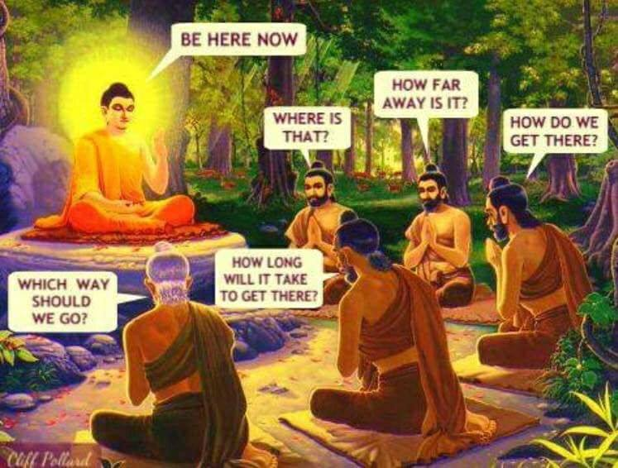

Link: https://www.facebook.com/1hannahwood/posts/10214068519560139

