Q News Update September 23, 2020

Breaking News

Q’s first post today.

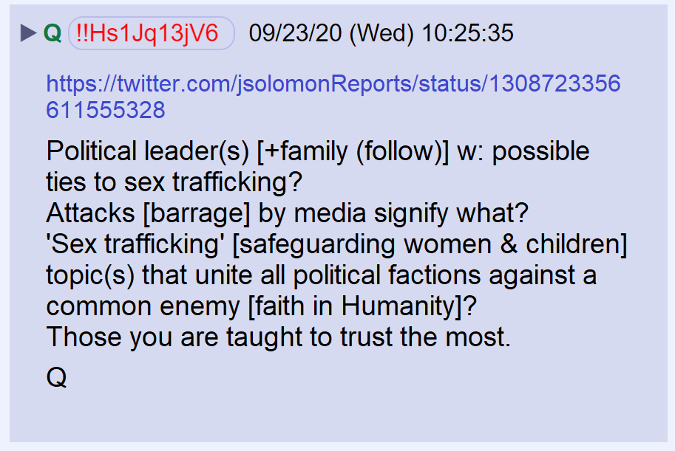

The link points to a tweet and article by John Solomon

Q’s second post

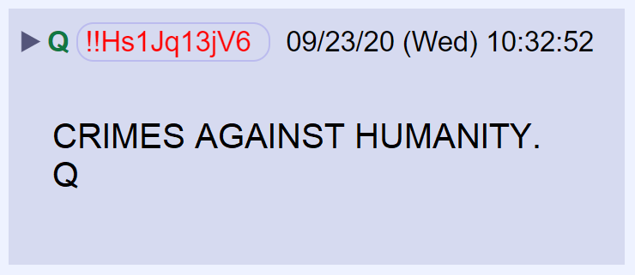

Q’s third post.

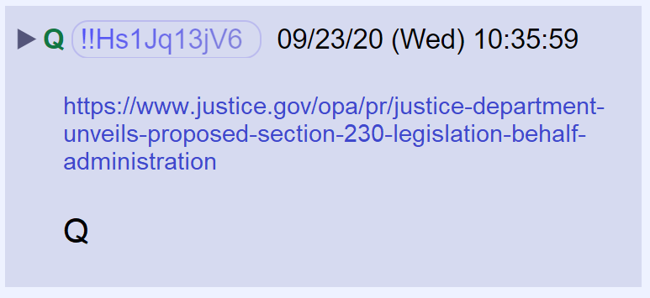

The link points to a DOJ announcement on proposed legislation that would change Section 230 protection for social media platforms

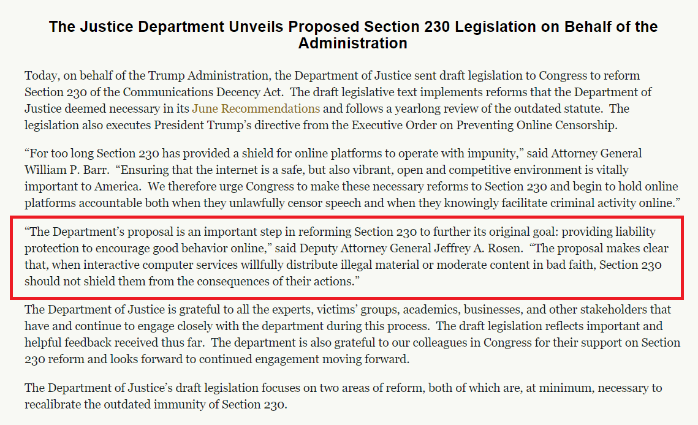

Q posted a familiar image that references the DOJ IG report on Hillary Clinton’s email investigation. Randall Coleman made notes in preparation for a meeting with James Comey. The notes were about the contents of Anthony Weiner’s laptop. In his notes, the following entry was found.

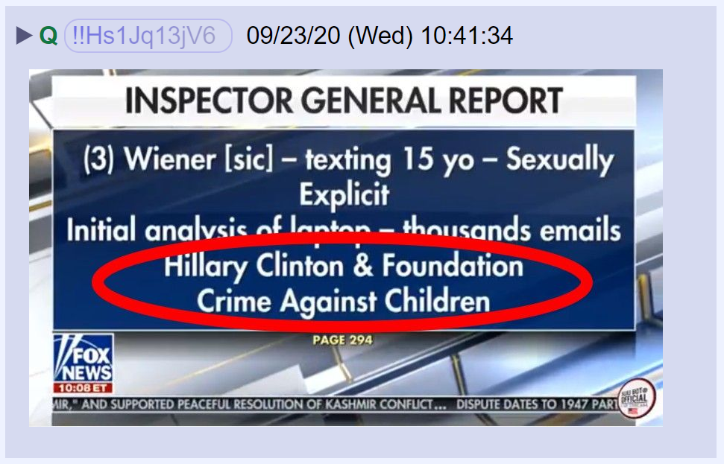

Is Q suggesting that Joe Biden’s activities are on Anthony Weiner’s laptop?

Q’s next post. What does “1%” mean?

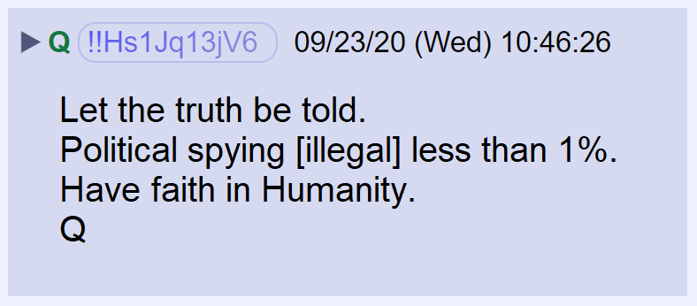

An anon thought 1% meant there were many other crimes the public doesn’t know about. Q reposted the anon, which is usually taken as confirmation.

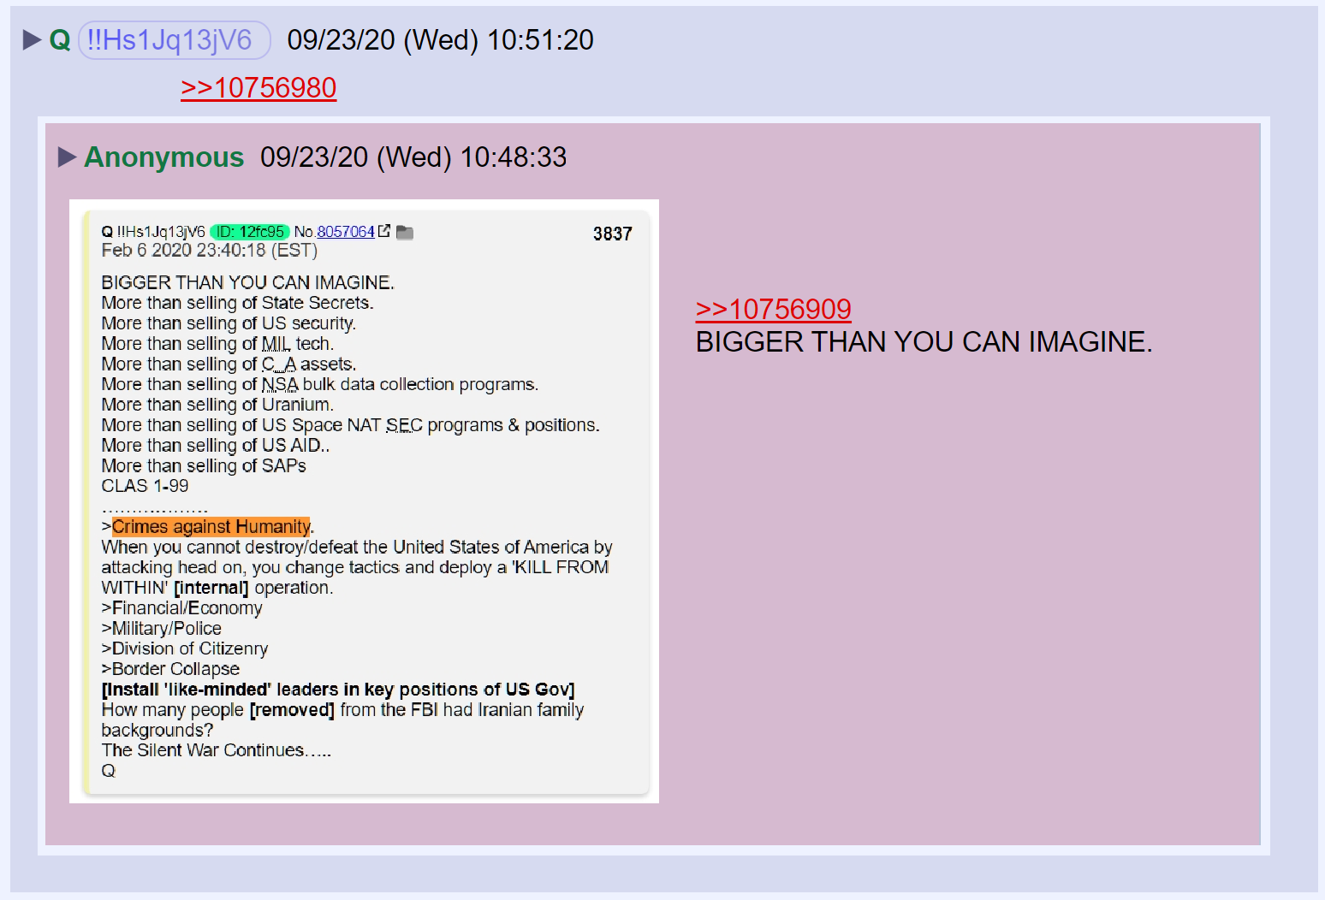

Q’s next message has a link to a New York Post article.

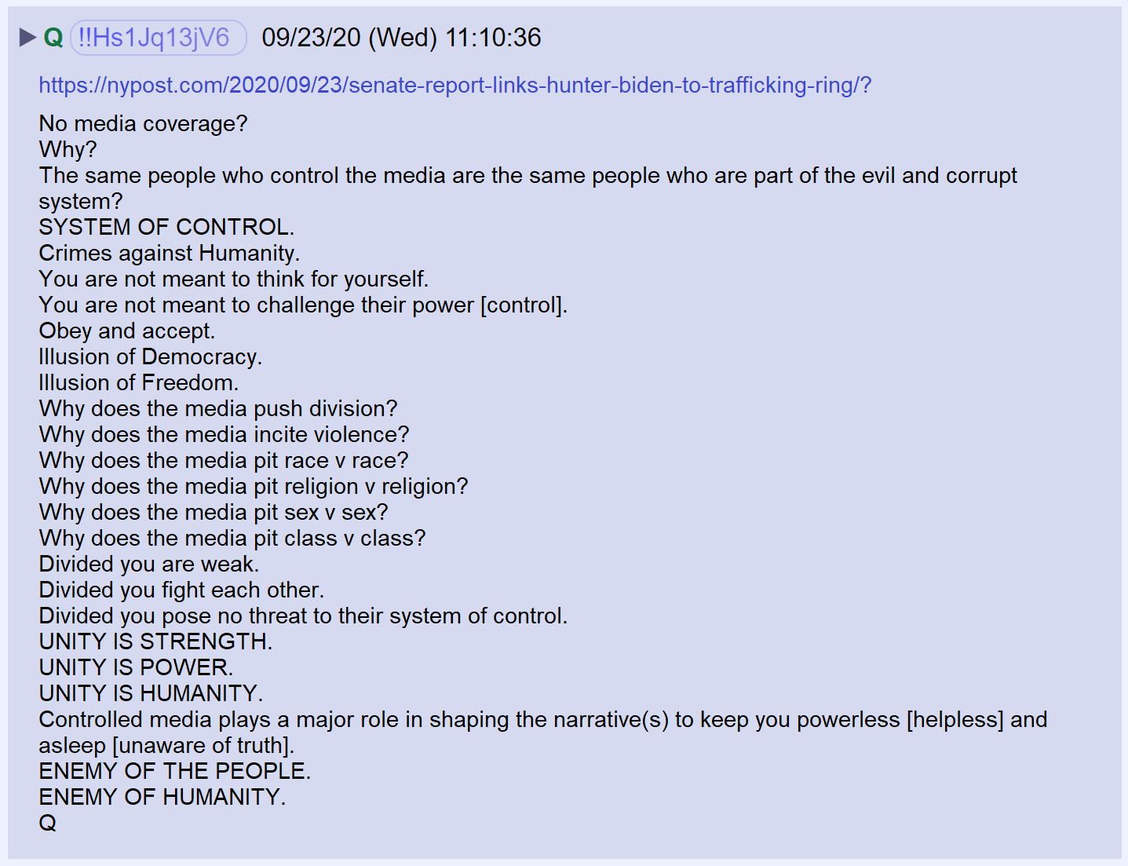

New York Post excerpt:

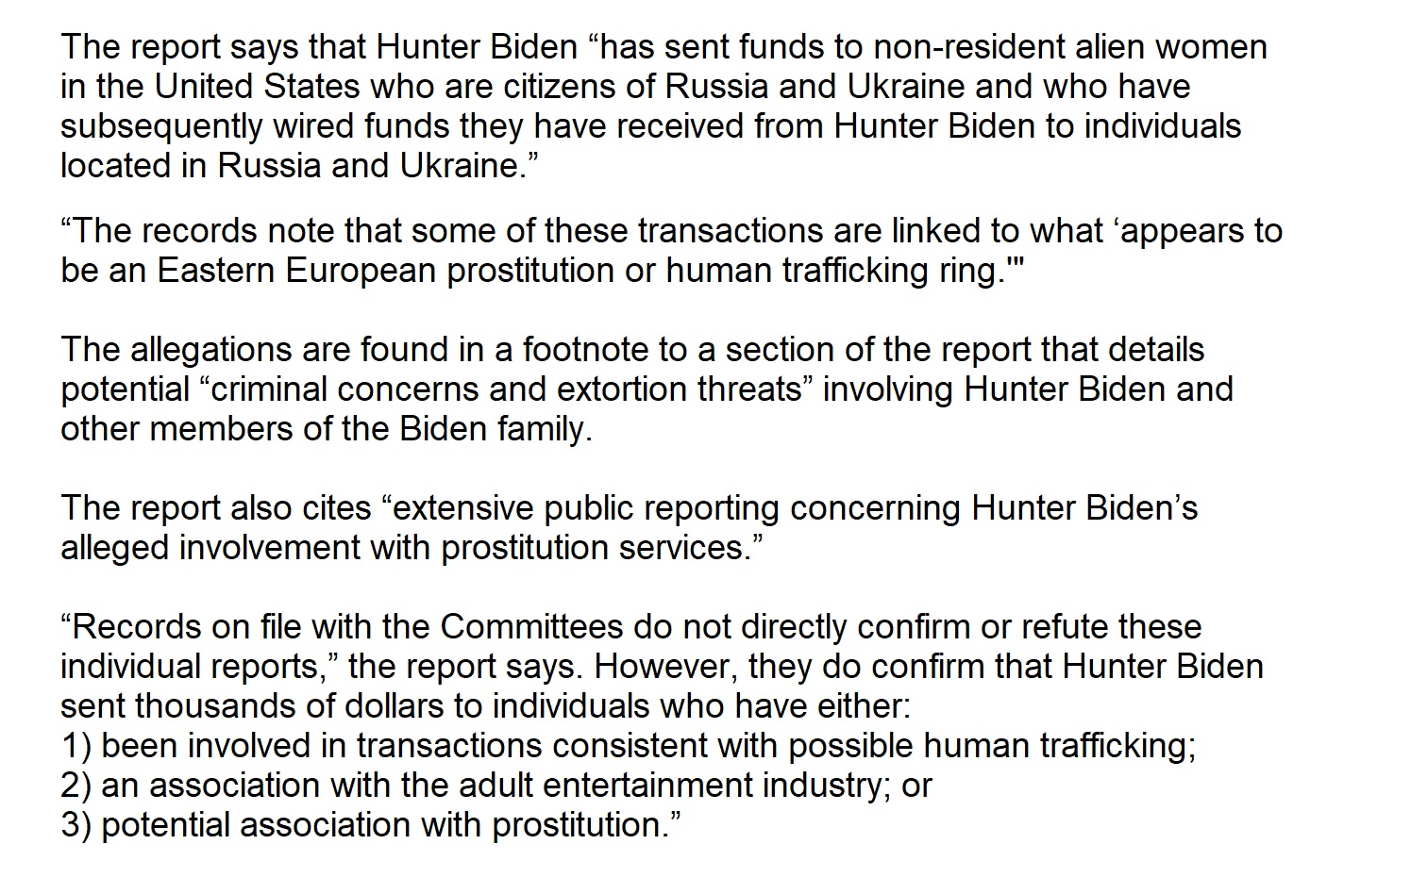

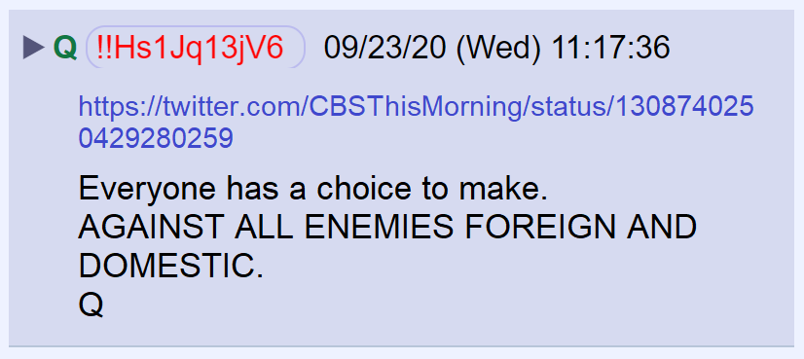

The link is to a CBS hit piece on Q.

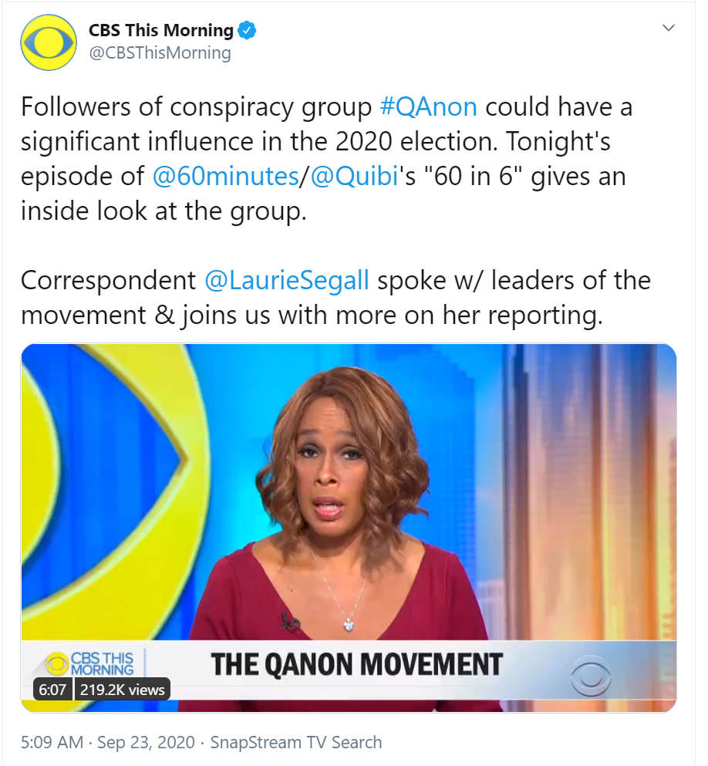

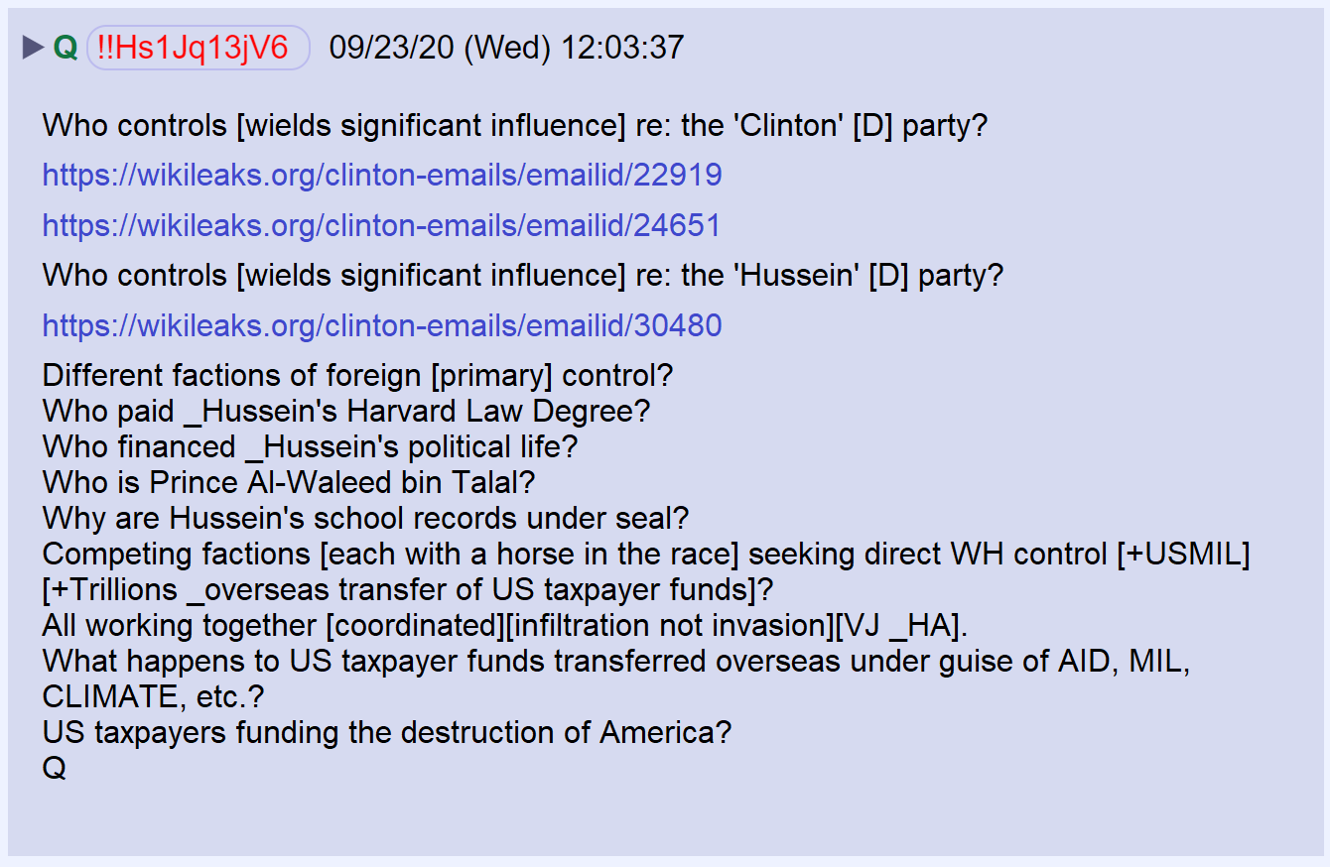

Wikileaks email 1
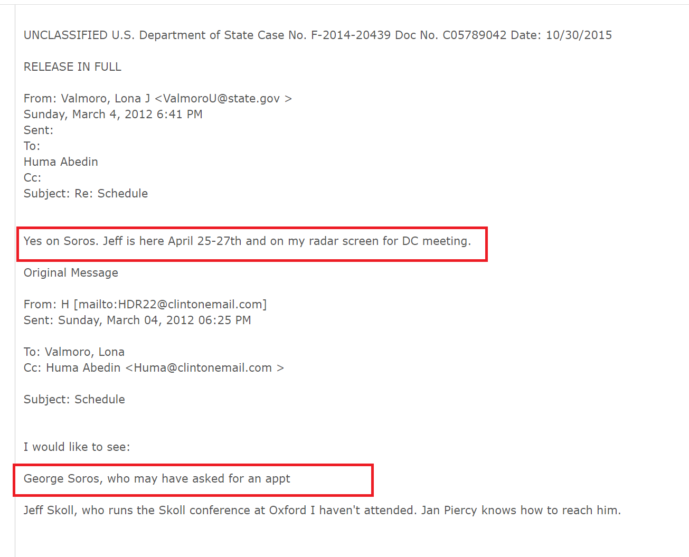
Wikileaks email 2

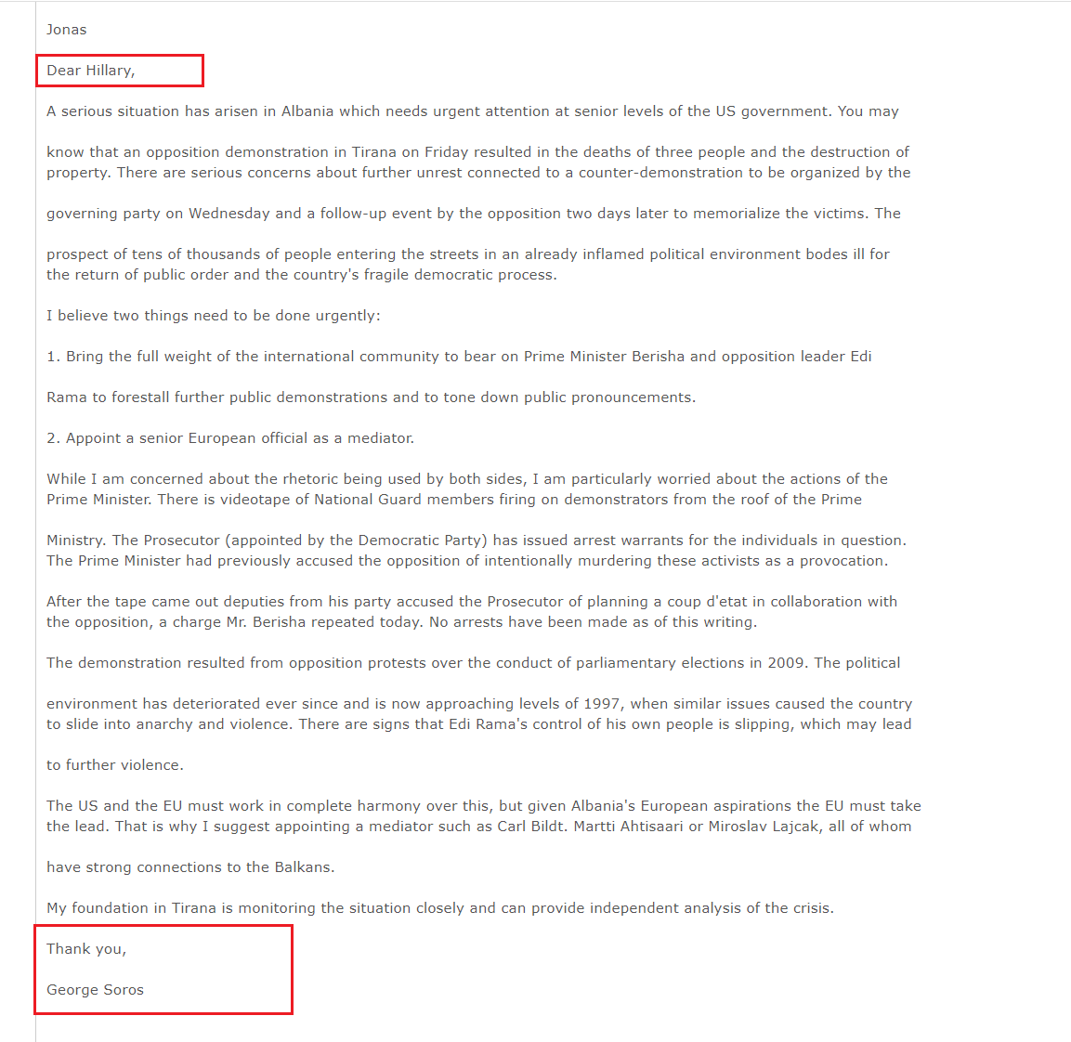
Wikileaks email 3
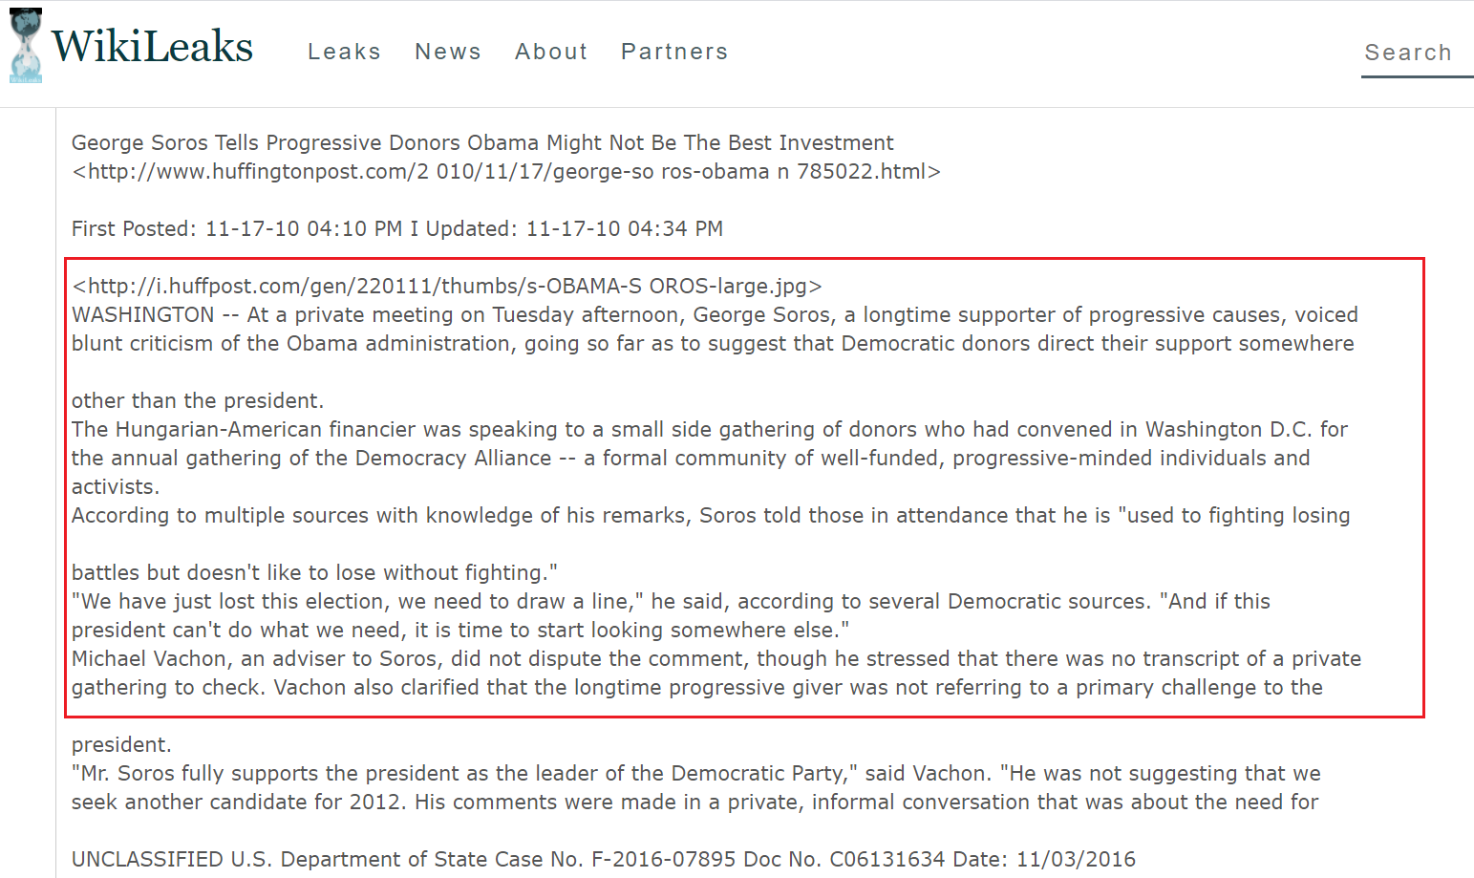

Q posted a graphic showing the relationships of the families that have controlled California politics for decades.

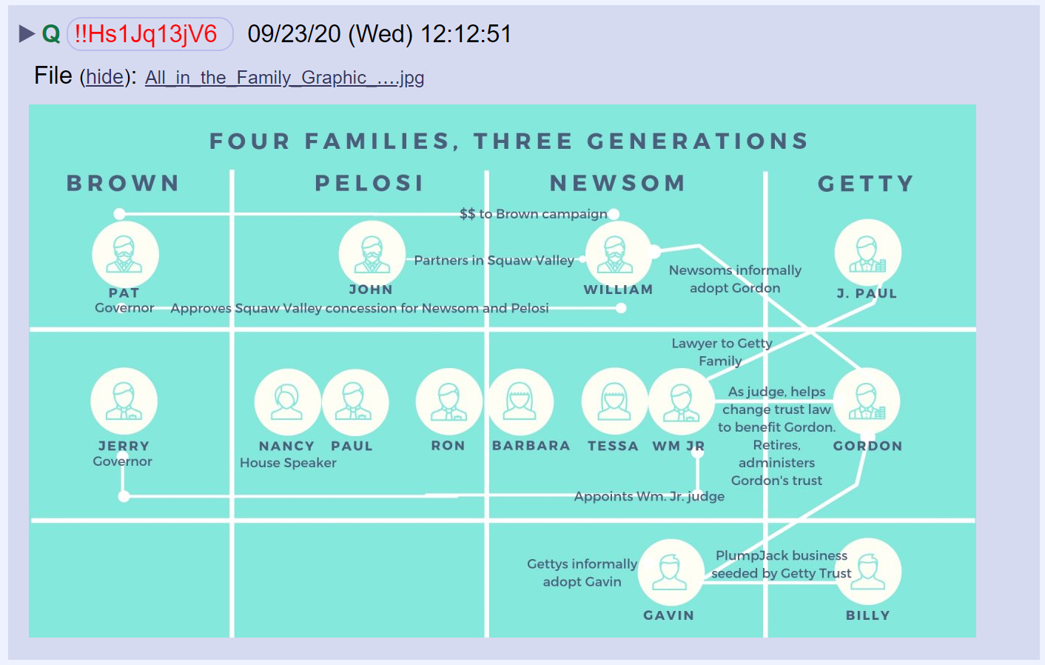

John Solomon was temporarily locked out of his account, along with other conservatives.

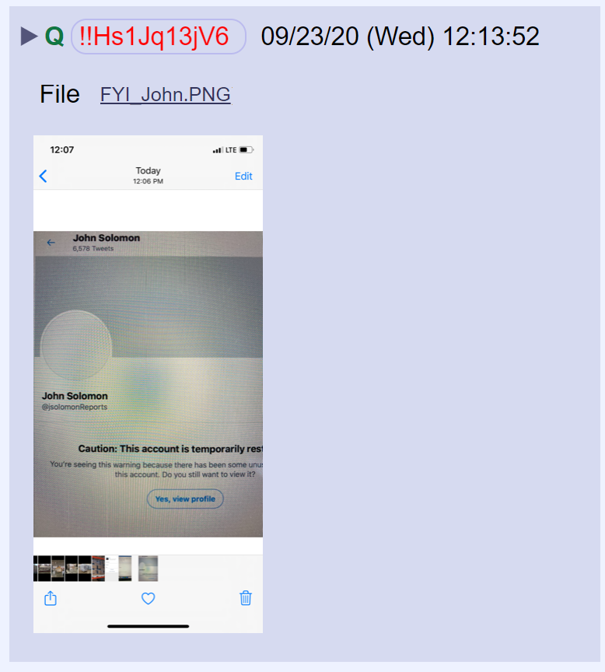

Twitter said the lockout was unintentional.

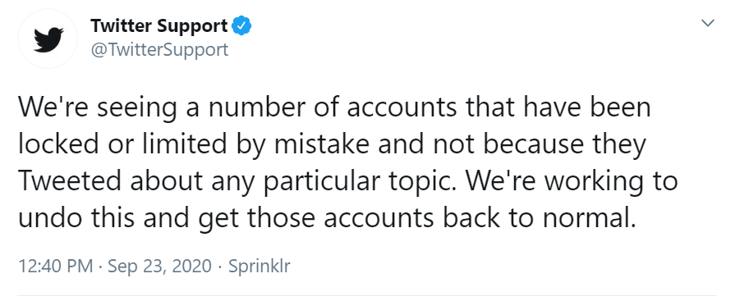

An anon posted a tweet by POTUS from 2015 and Q reposted it. At the time, Alwaleed was the majority shareholder of Twitter.

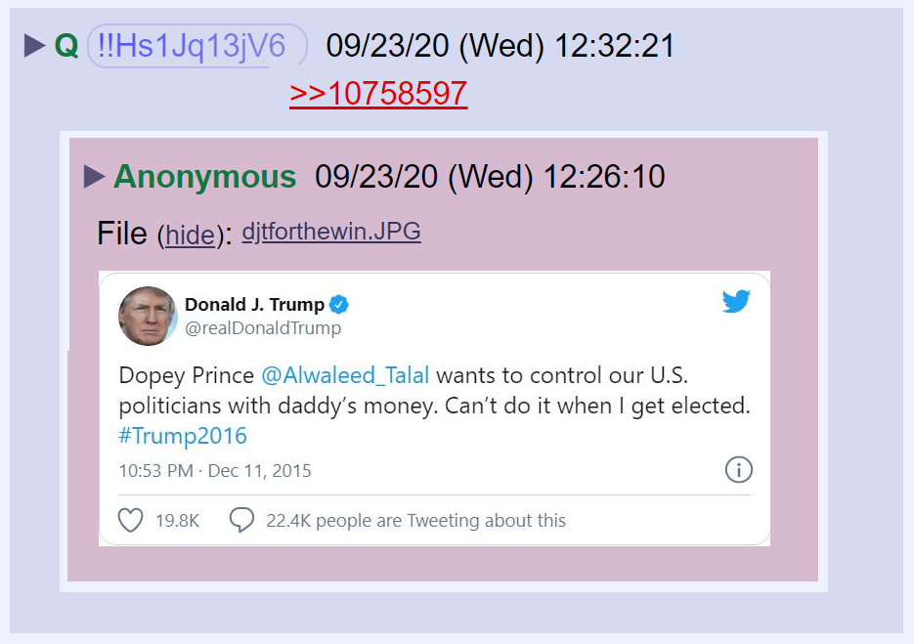

News from Lexington, Kentucky on the officers involved in the shooting of Breonna Taylor.

