Genocide in the Virtual Realm?

International Criminal Court Moot 2020

- Introduction
The International Criminal Court Moot Competition (“ICC Moot”) is the largest and most prestigious moot on international criminal law. This competition, held at The Hague in the Netherlands, simulates actual ICC proceedings by involving judges from international courts, tribunals and legal academics. Through the moot, participants acquire in-depth knowledge of international criminal law and the ICC itself, as well as familiarise themselves with other key institutions in this field. Beyond that, participants are able to network with professors, practitioners and other competition participants from all around the world.
Unfortunately, the International Rounds of the ICC Moot were cancelled this year due to the COVID-19 pandemic. Given the circumstances, Singapore Management University (“SMU”) took the initiative to organise the Asia-Pacific Friendly Rounds of the ICC Moot Competition 2020, held entirely online. This allowed participants to put their preparation into practice, learn from other teams from the region in a spirit of friendly competition, and deepen their interest in international criminal law. From 8th-10th June, 13 participating teams from Australia, Bangladesh, India, and Singapore came together to compete.
- The Moot Problem
- Summary
This year’s moot problem (found here) concerned the prosecution of Dr Cersei Bannister, the owner and CEO of Statusphere, a social networking platform akin to Facebook. The events surrounded two neighbouring States - Valaria and Solantis. Both States use the language Valarian, but differ in dialect. After centuries of discrimination by the Nothroki against the Stareks, the Stareks were expelled from Valaria in the 19th century. Today, the Valarian population has become entirely Nothroki, while the Stareks comprise 3% of the population of Solantis. This discrimination continues today.
In 2017, Dragos, a Nothroki extremist group committed to the ethnic purity of Solantis, was formed. Following its establishment, members of Dragos began criticizing Stareks on group e-bulletin boards hosted on Statusphere (a social media platform), and also began physically assaulting Stareks, leading to 23 Starek deaths in 2017.
The worst attacks occurred on 16th June 2019 and 7th November 2019. On the night of the former, dozens of people gathered outside the Starek worship center (which bore this address), locked the door from outside, and threw incendiary devices inside, killing 200 Stareks.
- Issues
Against this backdrop, participants grappled with three legal issues:
First, whether there were substantial grounds to believe that at least one of the statements made by Dragos members on Statusphere between January 2018 and January 2020 constituted direct and public incitement of genocide under Art 25(3)(e) of the Rome Statute. Participants locked horns over whether posts such as: “it is time for a widget roast. Tonight - 7:00 PM, 12 Liberty Blvd” led to the attacks on the 16th of June and 7th of November.
Second, whether Dr Bannister, as owner and CEO of Statusphere, in allowing users to post statements which may constitute incitement to genocide, and in failing to take action to immediately remove the statements advocating violence against the Stareks and to effectively prevent their reposting on Statusphere, could be held criminally responsible for inciting genocide and providing the means for incitement, pursuant to Arts 25(3)(e) and 25(3)(c) of the Rome Statute respectively. Participants argued over whether the failure to immediately remove the posts which allegedly led to the attacks of 16th June and 7th November rendered Dr Bannister criminally liable for incitement of genocide, despite the fact that the posts were initially believed by Statusphere’s content monitoring team to be innocuous (due to the language differences between Valaria and Solantis).
Third, whether the ICC had jurisdiction to prosecute Dr Bannister under Art 12 of the Rome Statute, since all actions related to the charges she faced occurred in Valaria, her State of nationality, which was not a party to the Rome Statute and, consequently, the ICC. Here, one of the primary controversies in interpreting Art 12(2)(a) of the Rome Statute was the existence and applicability of the “effects doctrine” in international criminal law. Under this doctrine, territoriality encompasses conduct which has substantial effect in the territory of a State Party to the Rome Statute. The Prosecution sought to apply this doctrine while the Defence sought to challenge its applicability and existence, arguing that allowing this doctrine would go against the Rome Statute’s drafters’ intention to respect rights such as state sovereignty and the principle of complementarity.
- Interesting Features about the ICC Moot:
  - Differences from typical moots
The first interesting feature of the ICC moot was the presence of three teams per round (with one team representing the Prosecution, the Defence and the Government of Valaria respectively) instead of two opposing sides usually found in other moots. This resulted in a different set of dynamics. As Nicholas Liu, the coach for the SMU team and a Lecturer of Law at SMU, noted, the presence of three teams per round resulted in increased pressure for all parties as they had to address two competing positions rather than one. Although the defence and government counsels were both ultimately seeking to get an acquittal of Dr Bannister, the principles with which they approached the case differed. Therefore, competing teams had to remain alert and adaptable to the vast arsenal of potential arguments from opponents. Thorough research clearly enabled participants to adopt the tripartite roles of the Defence, the Prosecution and the Government, and to adapt quickly to simultaneously keep track of two opposing counsels’ arguments.
Another interesting feature of the ICC Moot (compared to most international moots) was the rebuttal time - 10 minutes, as opposed to the standard 2-3 minutes. As one participant observed, the essential purpose of rebuttals remained unchanged– old arguments should not be rehashed, and new arguments are not allowed. Instead, the longer rebuttal time allows participants to better flesh out and elaborate on their points of rebuttal.
  - Virtual vs Physical
As the moot rounds were conducted virtually, the atmosphere obviously differed from a typical real-life moot. Reading a judge’s body language proved problematic. For instance, a participant mistook a judge simply moving his hand as an indication that he was raising a question. While conducting a virtual moot added a different kind of nuance to the art of persuasion, many mooters took this challenge in stride, performing well beyond expectations.
For instance, Choo Qian Ke from the NUS team noted that “virtual hearings can be conducted smoothly even when there are three parties making submissions and rebuttals with multiple judges asking questions, all from different locations across the world while not compromising the quality of advocacy and level of intellectual rigor!”
One of the judges, Dean of SMU Law, Professor Goh Yihan, felt that it was harder to strike up a personal connection with the speakers, compared to a real-life moot. However, he noted that it allowed judges across different countries and time zones to collaborate.
Indeed, the moot drew guest judges from various levels of seniority in the legal profession and from across continents. These ranged from fresh law school graduates and young associates, to the Deans of both NUS Law (Prof Simon Chesterman) and SMU Law (Prof Goh Yihan), and to members of senior members of the international law community (such as Justice Kang Jin Baik of the Extraordinary Chambers in the Courts of Cambodia, and Dr Fabricio Guariglia, Director of the ICC’s Prosecutions Division).
Judges generally had positive feedback. Many praised participants for their advocacy and adapting well to the online setting. Looking forward, the judges also highlighted areas of improvement for participants, including time management, listening attentively to questions and understanding judges’ concerns. For instance, guest judge Alexander Woon, from the Office of Transformation and Innovation (Judiciary) of the Supreme Court of Singapore, emphasised two key pieces of advice for mooters: a) the importance of structuring one’s argument in an easy to follow manner and b) answering the judges’ questions directly, with a “yes” or “no”, before explaining one’s answer.
- Results
After three intense days of mooting, SMU emerged as the team with the most rounds won (6 out of 6), whilst jointly attaining the highest average score for speakers (89.2 points out of 100) alongside NUS. In the individual category, Huang Wang Ting from NUS received the Best Oralist prize (92.2 points) while Andrew Chia, captain of the SMU team, was the runner-up (90.3 points). When asked about his thoughts, Andrew remarked that he was proud of his team members for their hard work and dedication despite the unusual circumstances.
- Conclusion
The ICC Moot 2020 invites those interested in international criminal law to ponder two things - (1) the underlying tension between ascribing individual criminal responsibility whilst remaining true to established legal principles, and (2) their consequential impacts on various notions of justice. These were tightly intertwined with use of technology in the scenario being considered. Legislators, especially those who drafted laws in the past, may not have considered the impact of not just social media, but technology in general.
On a closing note, we would like to share a tip from one of the judges, Ojaswee Bhattarai from Infinity & Partners. She told participants that while mooting can be nerve-racking, they should always relax, smile and enjoy themselves. Indeed, her advice applies both to mooting and to the outlook we should adopt in our daily lives, considering the difficulties we face today.
The ICCMCC 2020 Asia-Pacific Friendly Rounds has been a “bittersweet” conclusion to a 9 month-long journey consisting of countless hours spent on research, memorial drafting and practice rounds. Although the virtual friendly rounds cannot replace the full experience of competing at The Hague, especially the final round traditionally held at the ICC itself, we are confident that our participants would still look back fondly on their experience.

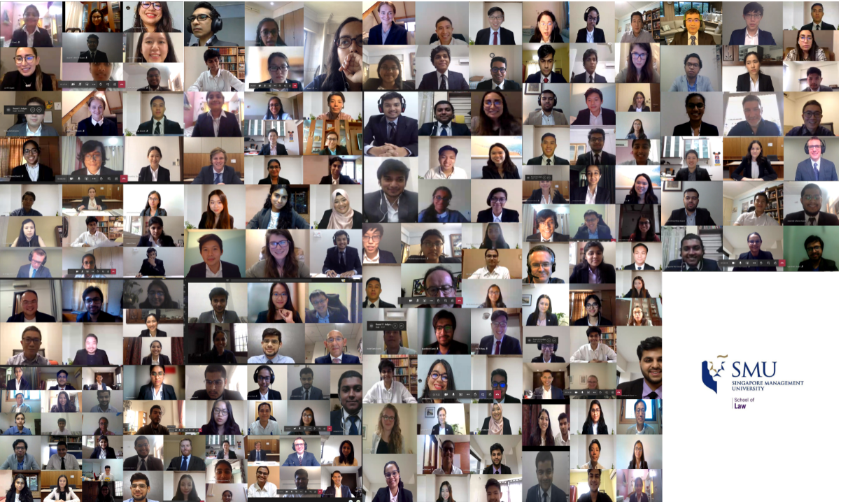

Written by Benedict Koh Yen Hin (Year 4 LL.B. Undergraduate), Tan Jing Yi, Rei (Year 2 LL.B. Undergraduate), Loke E-Qen, Julian (Year 2 LL.B. Undergraduate). The authors wish to express their thanks to Assoc. Prof. Chen Siyuan and Mr Nicholas Liu (Lecturer of Law, SMU School of Law) for their comments on earlier drafts of this article.
https://www.ibanet.org/ICC_ICL_Programme/ICC-Moot-Court-Competition.aspx.

