Praying Medic News – Tuesday November 2, 2020

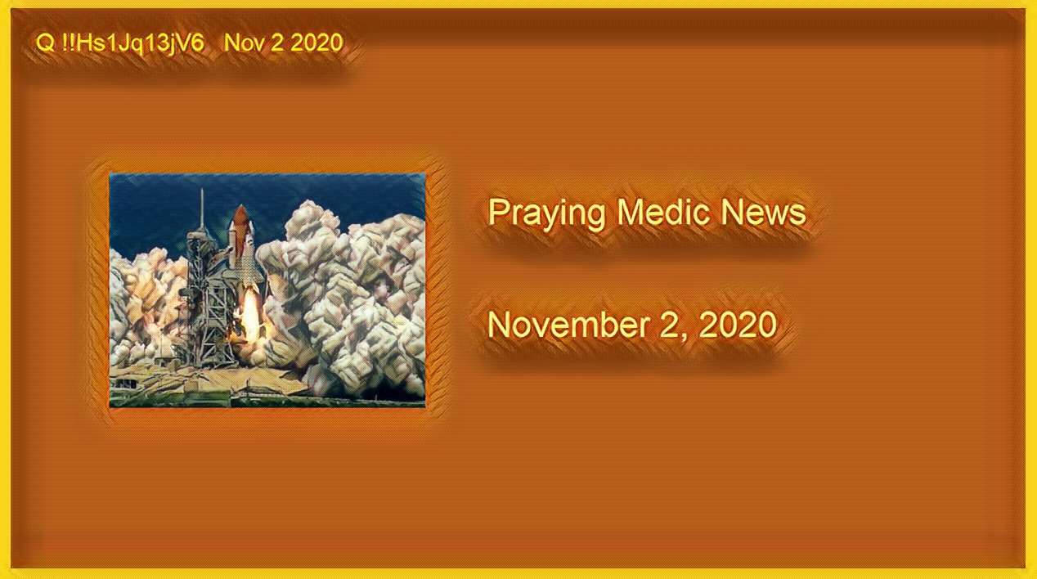

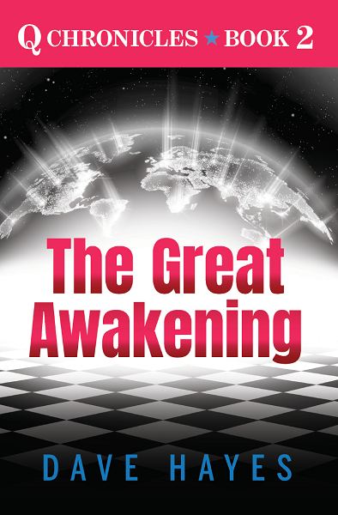

Link: https://www.amazon.com/dp/B08LF3NWLV

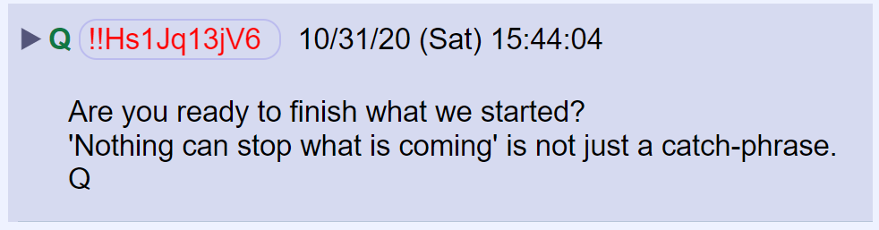

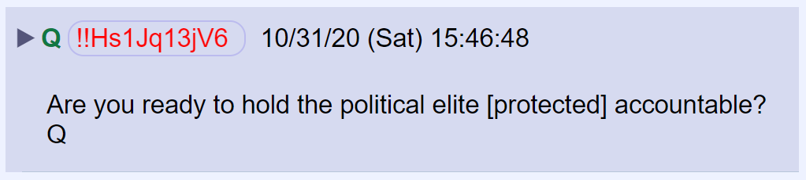

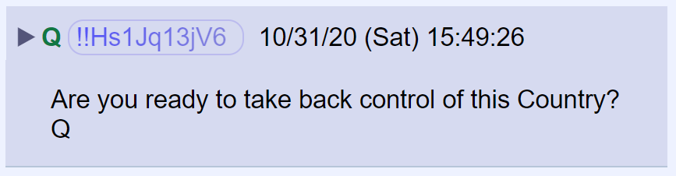

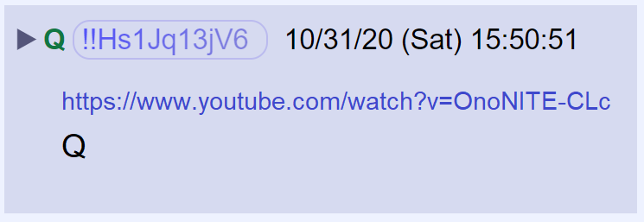

https://www.youtube.com/watch?v=OnoNITE-CLc

Q posted a link to a tweet by Tim Murtaugh.

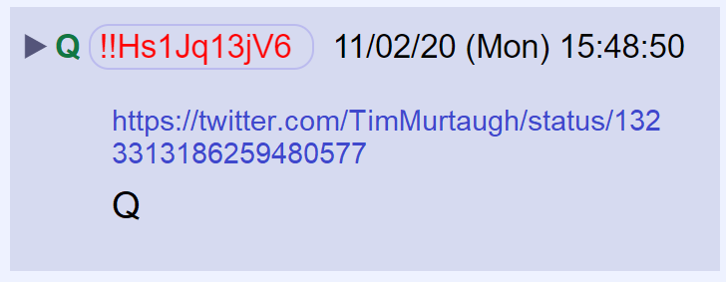

https://twitter.com/TimMurtaugh/status/1323313186259480577

Here’s the tweet.

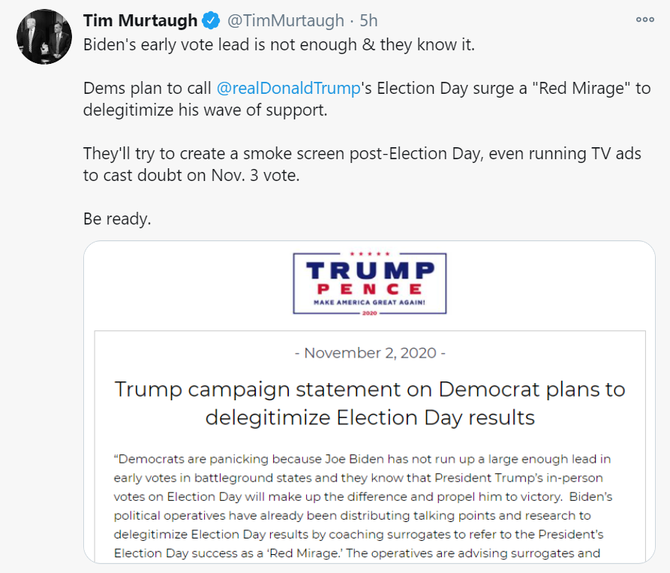

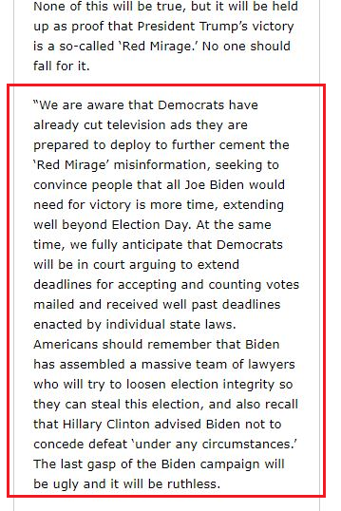

Full statement by Trump campaign.

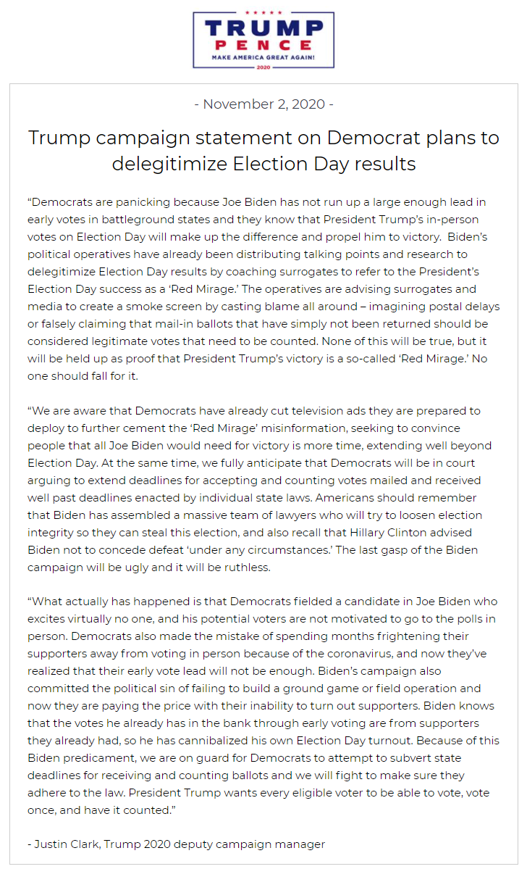

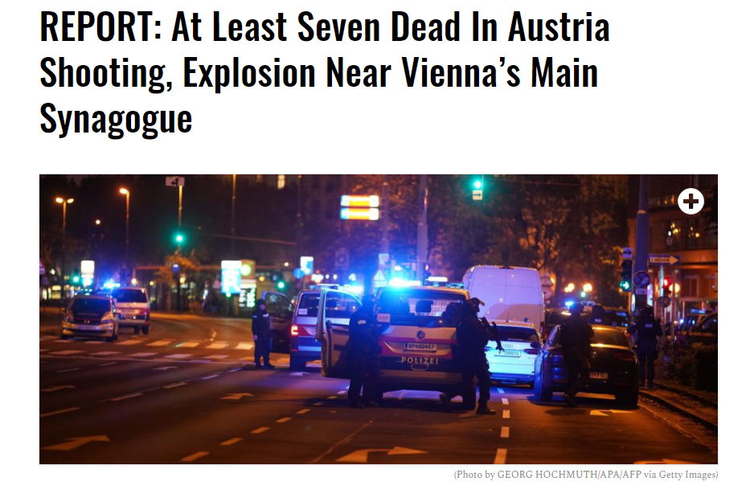
At least seven people have been killed in a shooting in Vienna, Austria.

Several gunmen opened fire near the city’s center. At least six shooting locations have been identified by police so far. Two of the dead are believed to be assailants including one who may have blown himself up.

Interior Minister Karl Nehammer called it an apparent terrorist attack.

The latest on the Hunter Biden laptop saga comes from the Daily Mail.

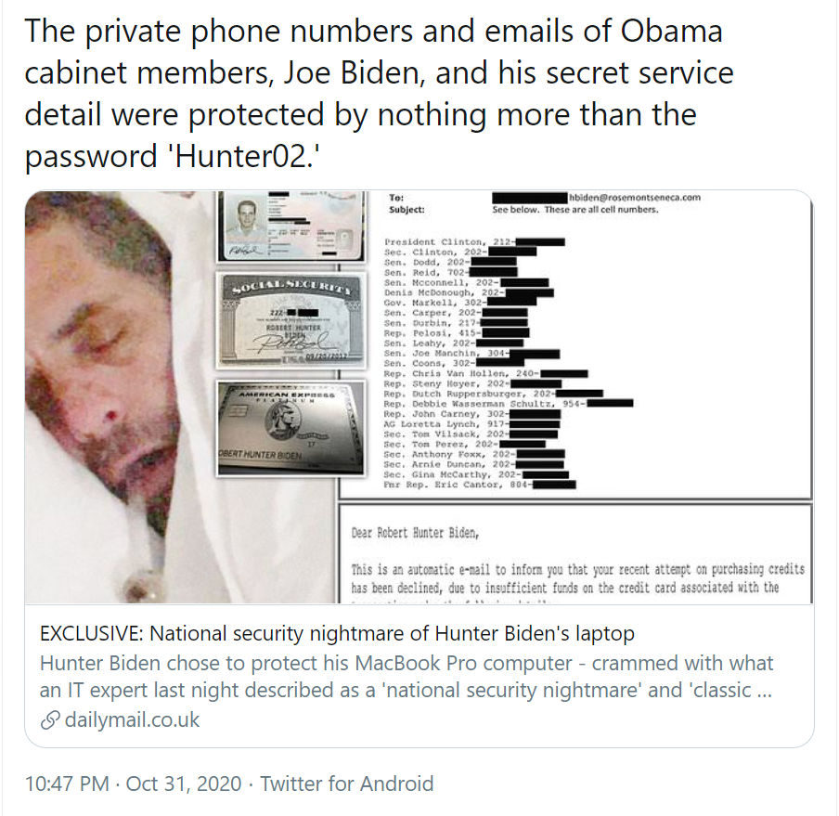
https://www.dailymail.co.uk/news/article-8901193/National-security-nightmare-Hunter-Bidens-laptop.html?

POTUS is holding 5 rallies a day.
58,000 people turned out for Saturday night’s rally in Butler Pennsylvania.

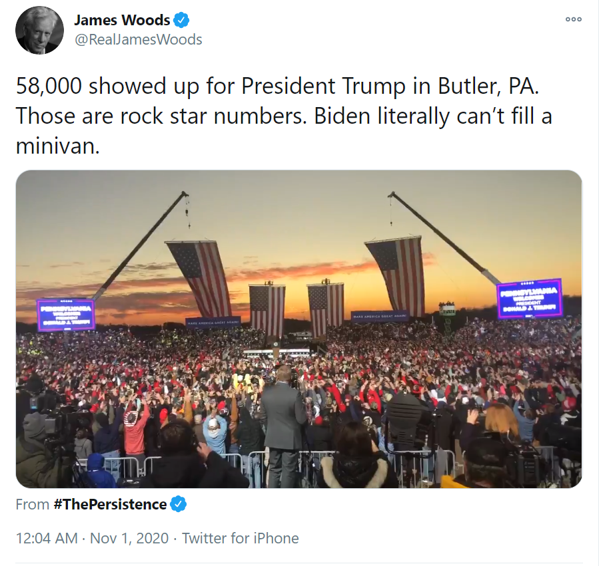

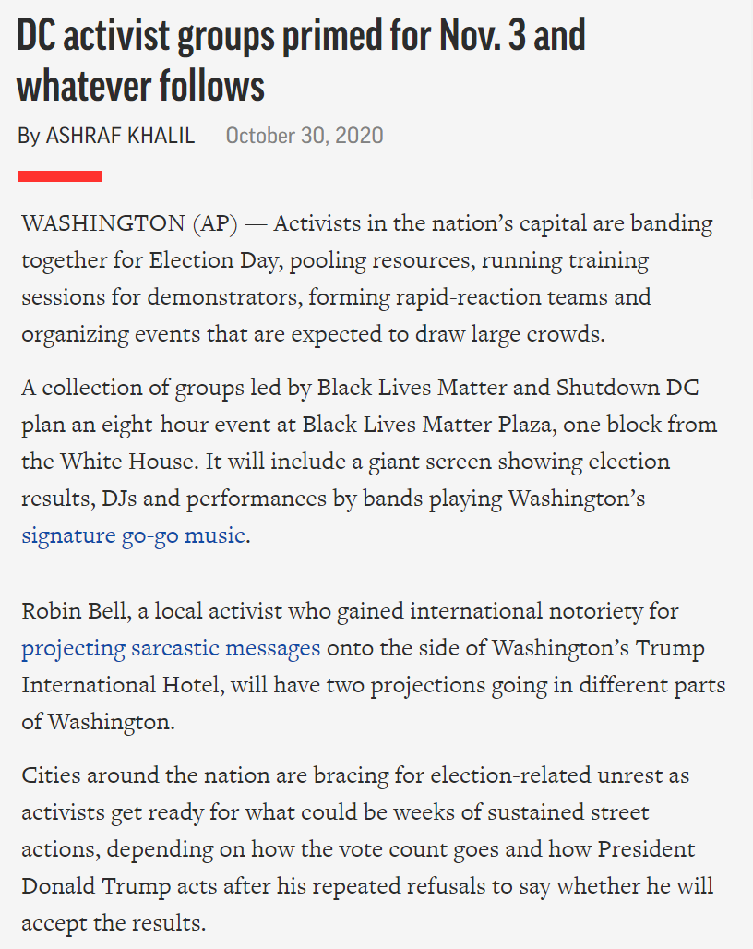

https://apnews.com/article/election-2020-race-and-ethnicity-elections-racial-injustice-bf4d4fc2b91b1ccdd833f373cb7bab3d

The White House is prepared for protests.

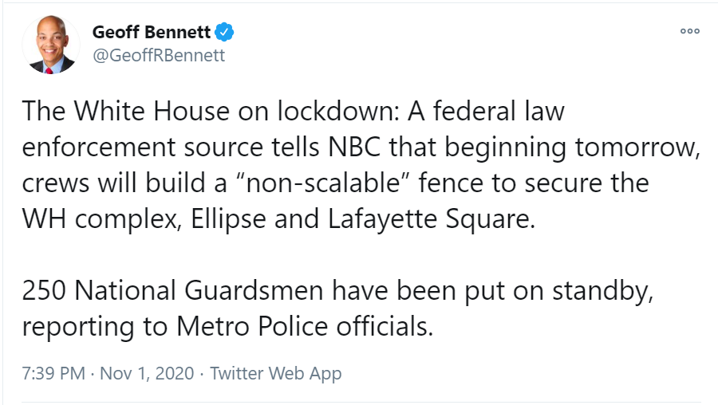

Podcast link: https://www.podbean.com/live/nevgT8wTwV?action=openLiveRoom&channel_id=nevgT8wTwV&live_task_id=X9EJOiaNu5K&lsid=X9EJOiaNu5K&utm_campaign=w_share_ls&utm_medium=dlink&utm_source=w_share

I never understood Trump’s push to make a vaccine available until today.

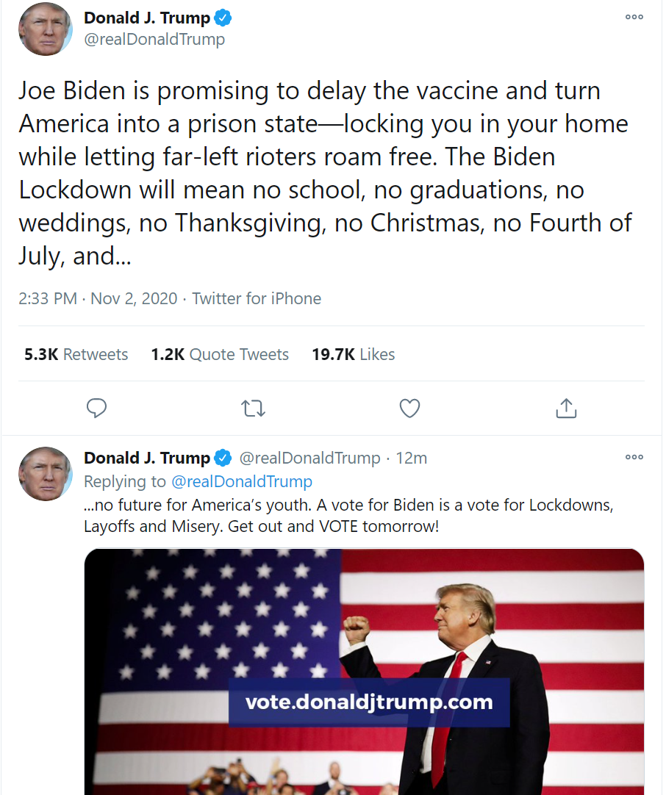

Trump's rush to make a vaccine available before the end of the year is his way of providing a medically defensible reason not to lock us down again.

Biden and the media's push to delay public access to a vaccine will be used to justify more lockdowns and institute the Great Reset—a plan to implement government healthcare, guaranteed minimum income, debt forgiveness, contact tracing, forced vaccinations, and permanent lockdown.

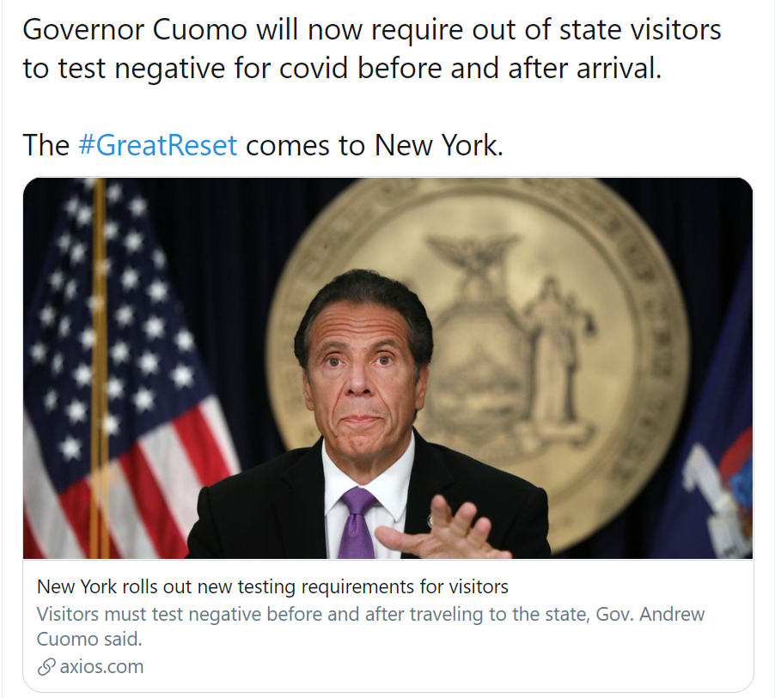
https://www.axios.com/new-york-new-testing-requirements-visitors-c347b842-592e-4159-ae52-ac64ff8a25f9.html

https://thefederalist.com/2020/11/01/michigan-governor-up-to-six-months-in-prison-if-businesses-dont-surveil-customers-for-contact-tracing/

Early voting in Arizona has already exceeded the total number of votes cast in 2016.

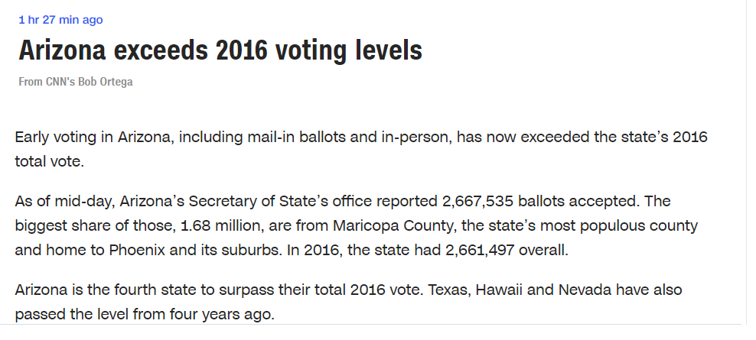

https://www.cnn.com/webview/politics/live-news/us-election-news-11-02-2020/h_09b1b6b7af418abe1bbbb4b94084a2a2

Swamp Draining update:
https://www.politico.com/news/2020/11/01/trump-second-term-cabinet-433739

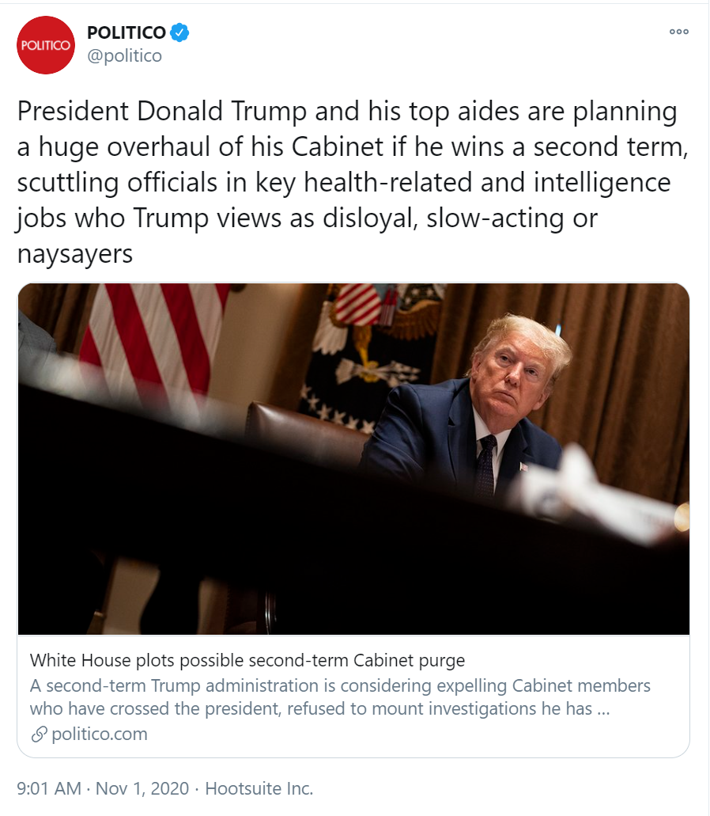

The DOW closed up 423 points today at 26,925.

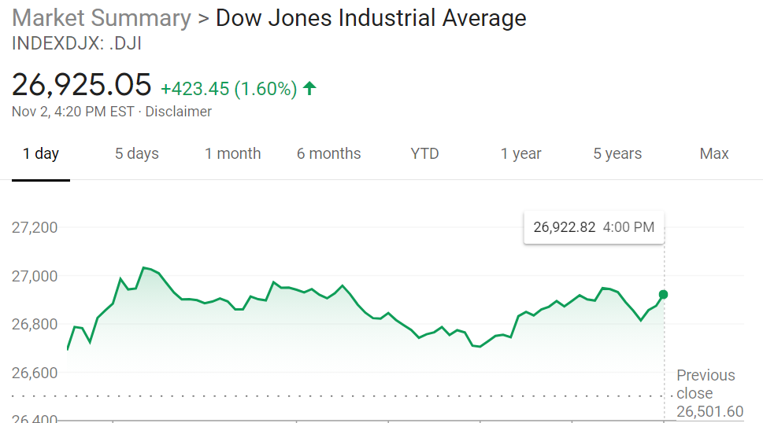

POTUS is wheels down in Traverse City, Michigan.

