Q News update October 1, 2020

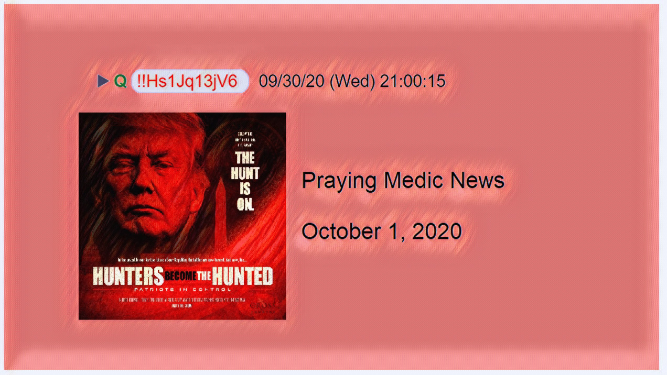

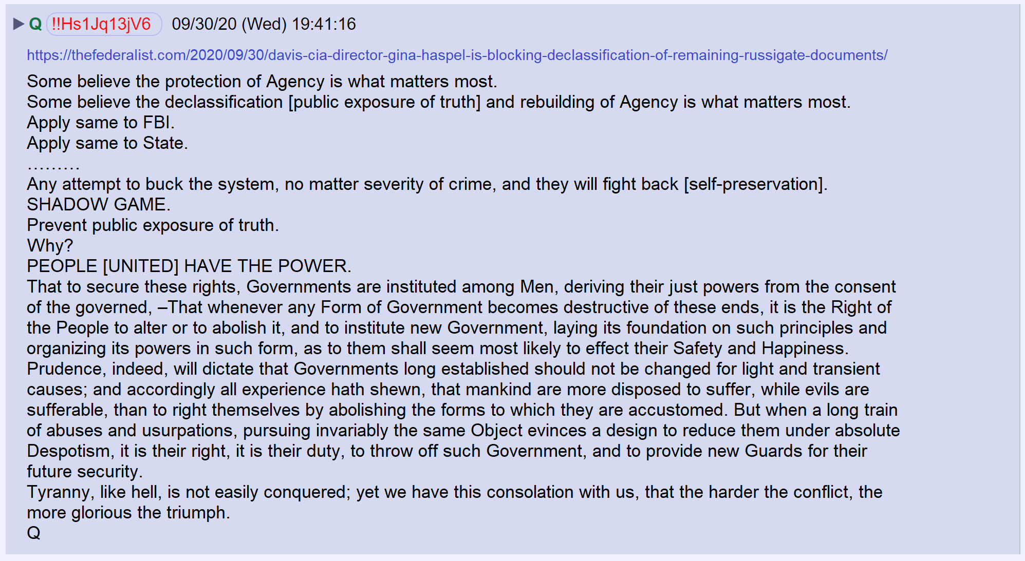

Linked article.

https://thefederalist.com/2020/09/30/davis-cia-director-gina-haspel-is-blocking-declassification-of-remaining-russigate-documents/

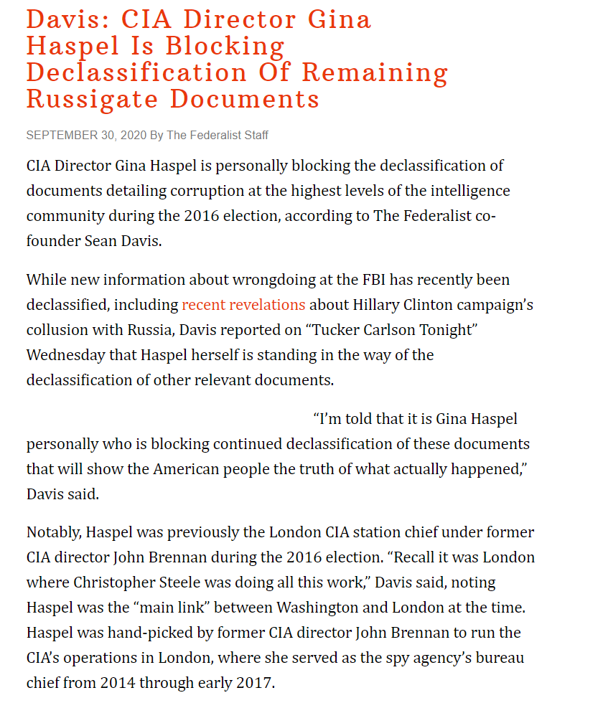

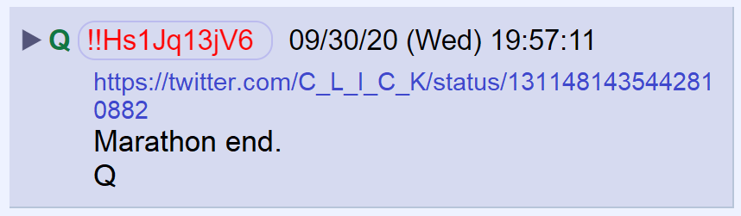

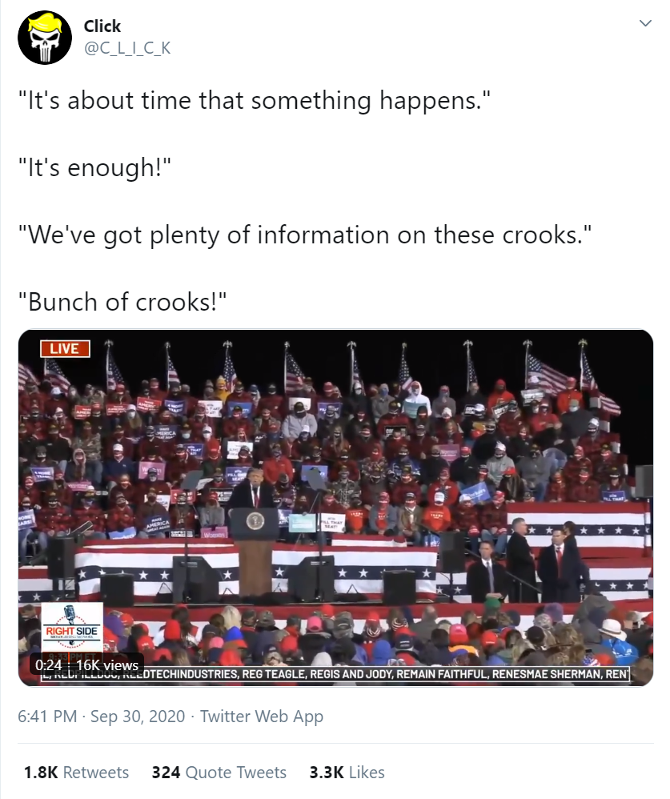

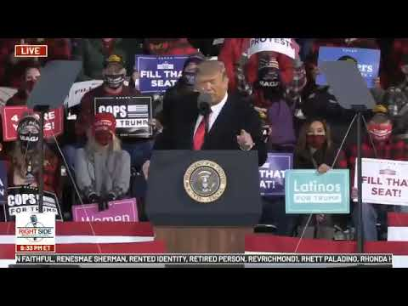

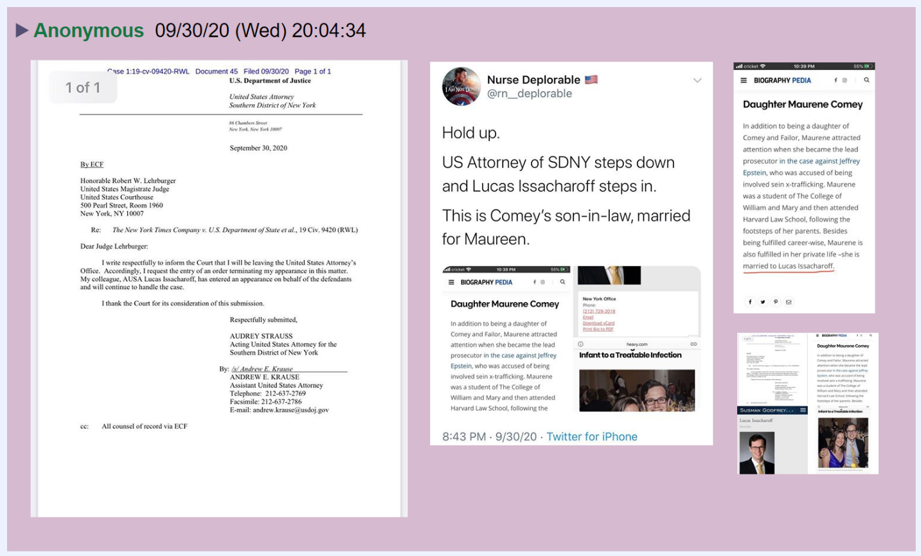

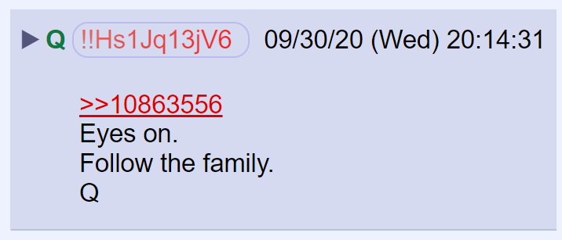

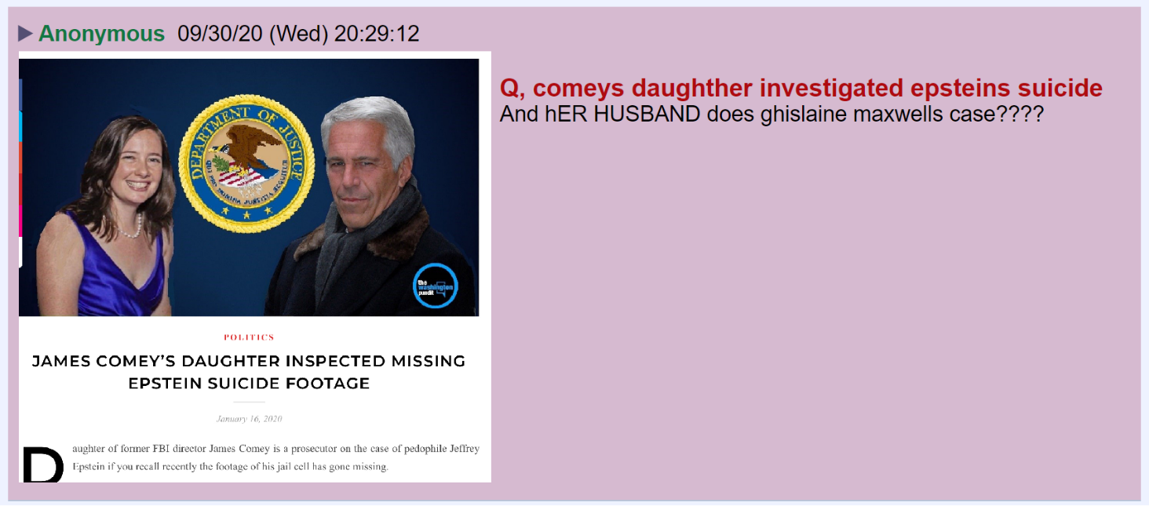

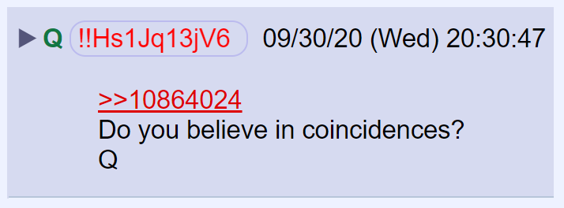

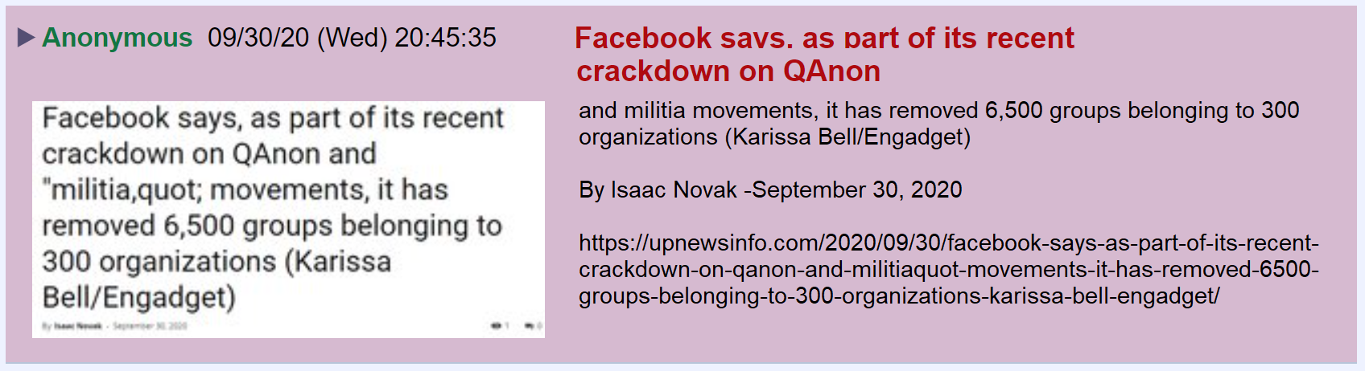

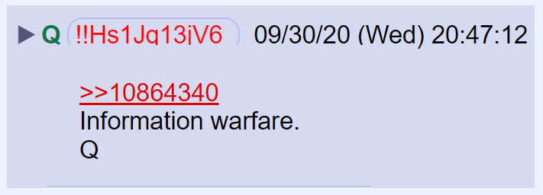

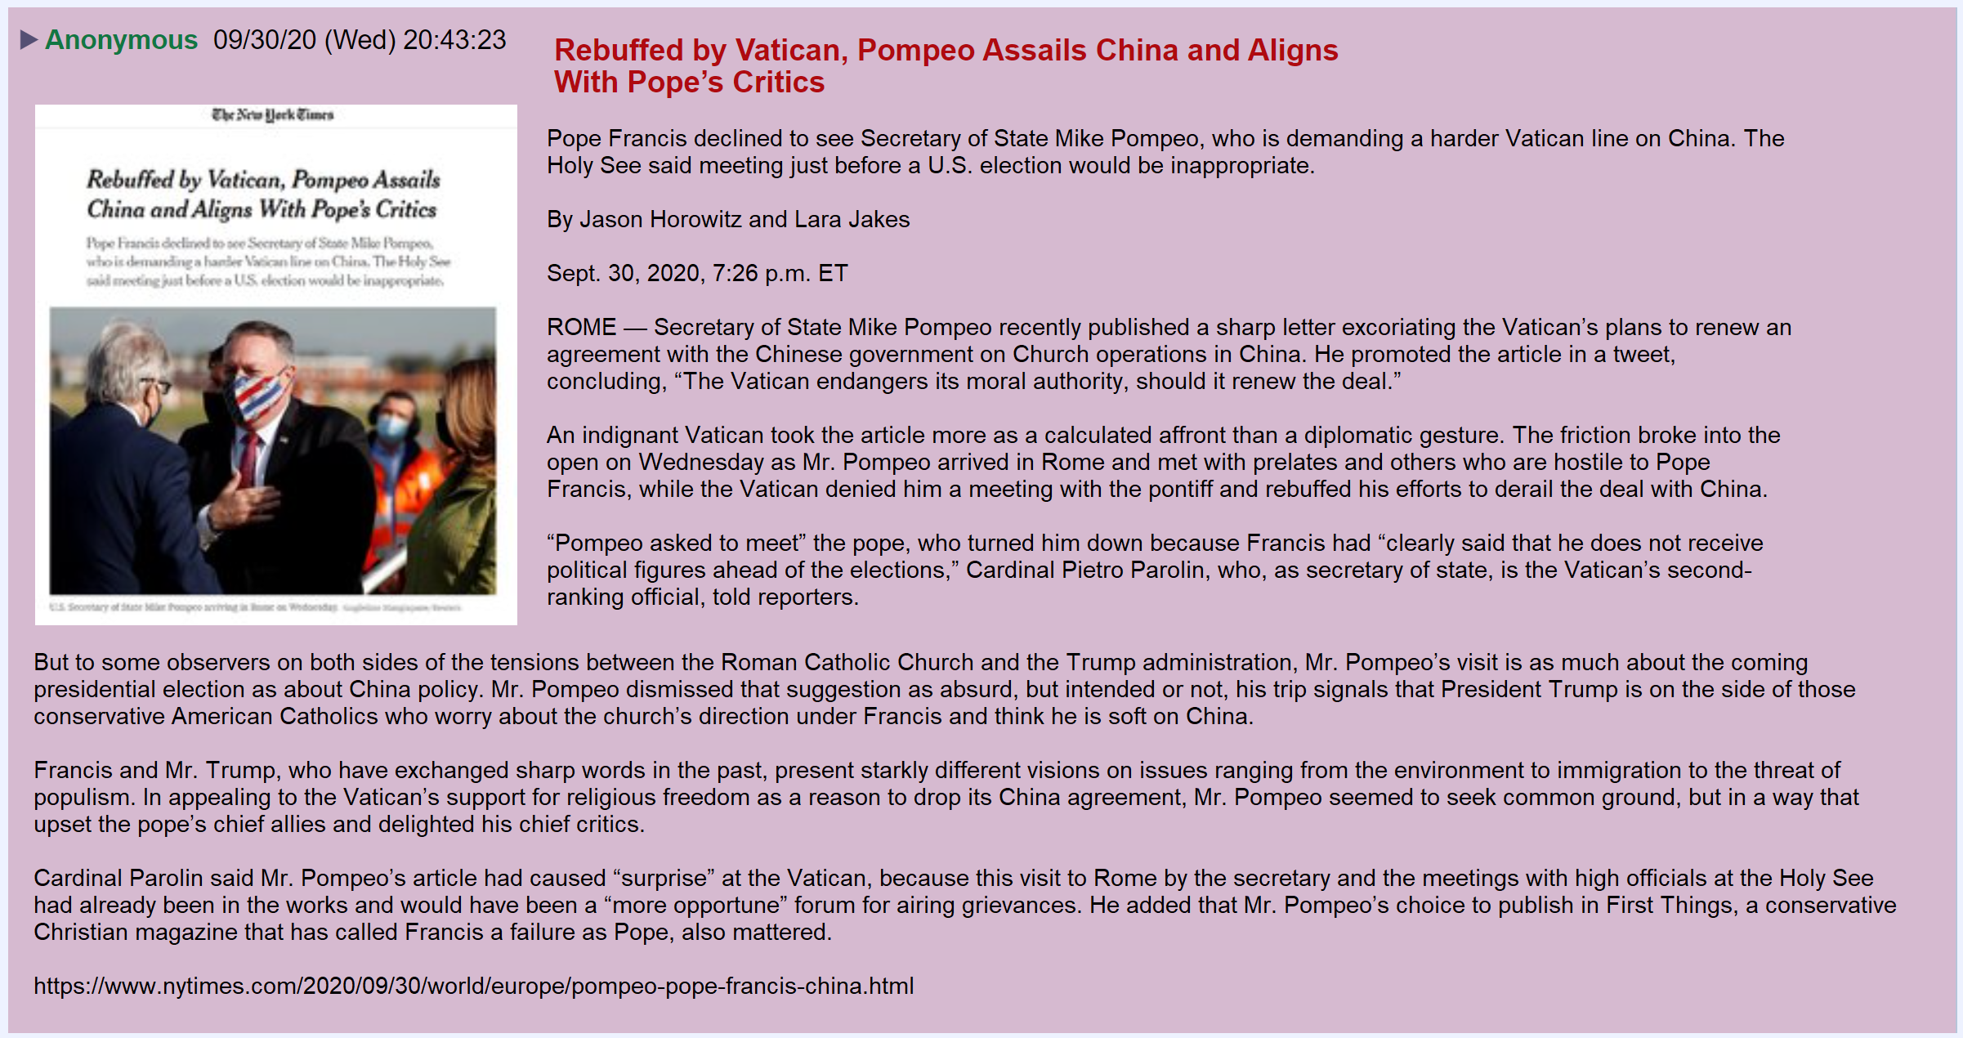

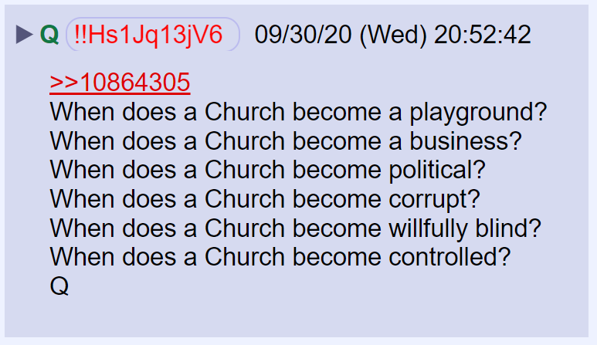

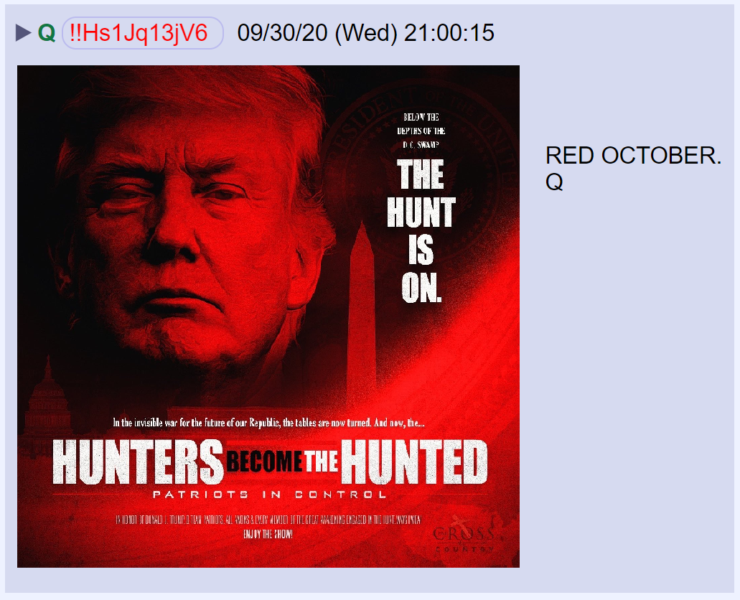

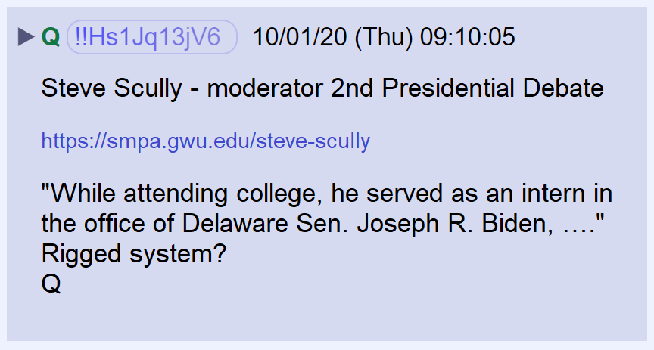

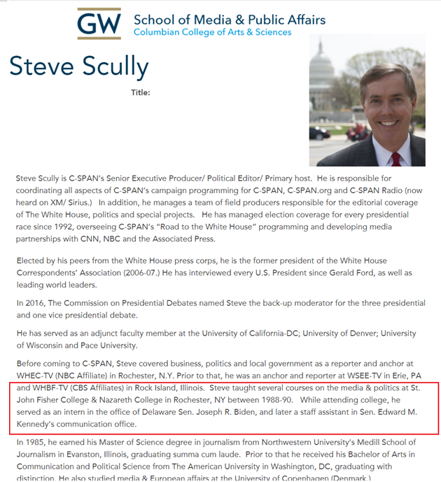

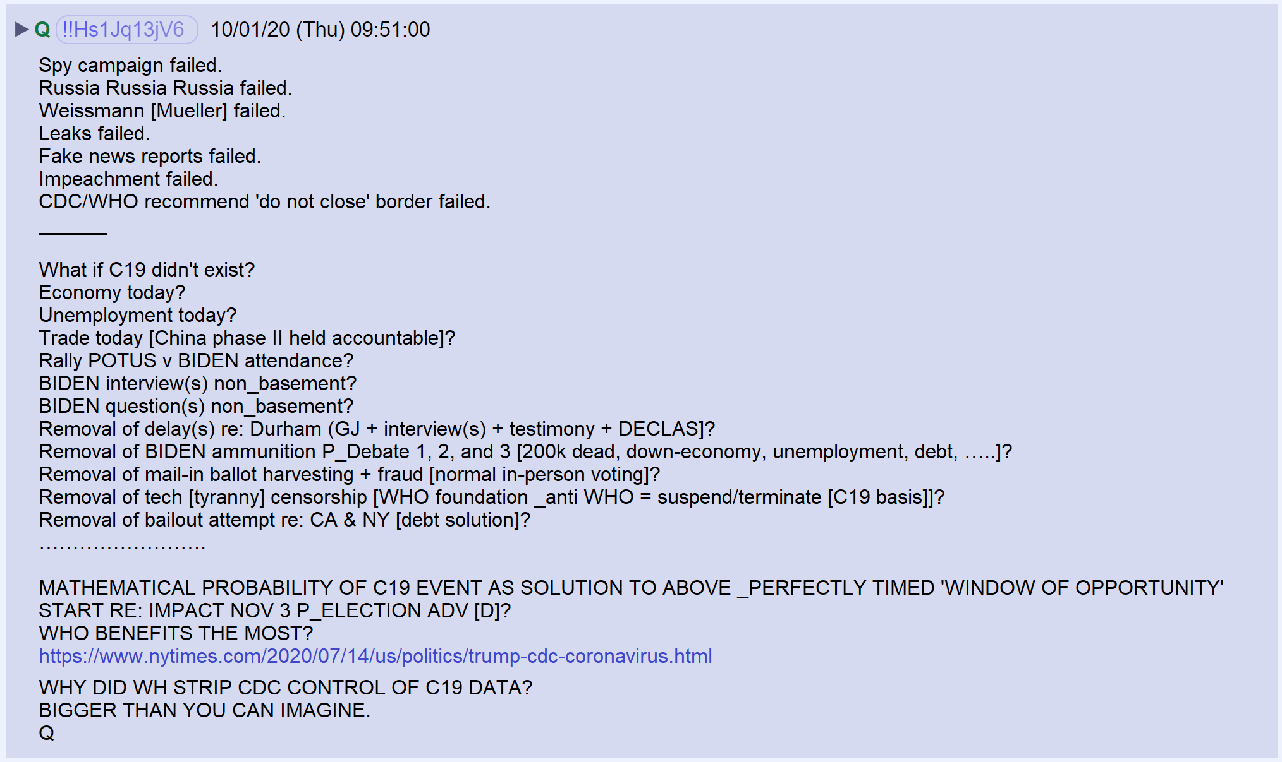

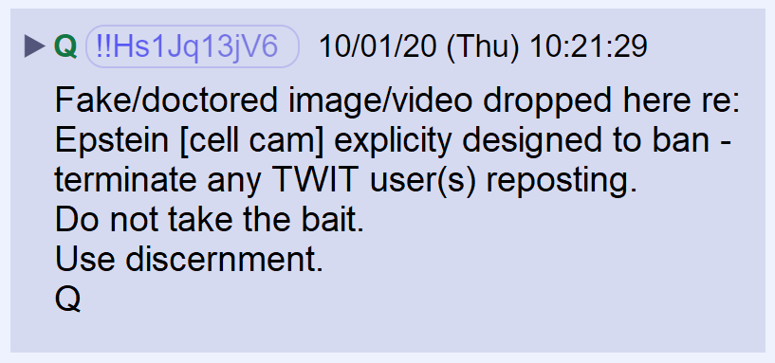

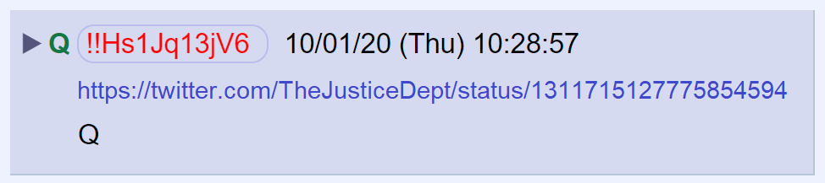

https://twitter.com/TheJusticeDept/status/1311715127775854594

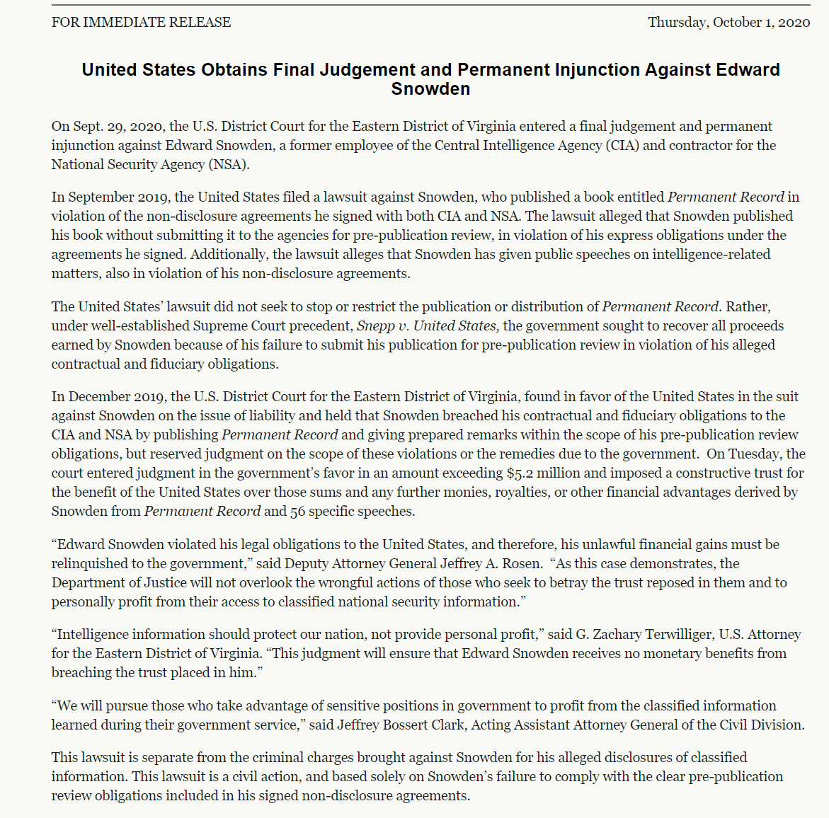

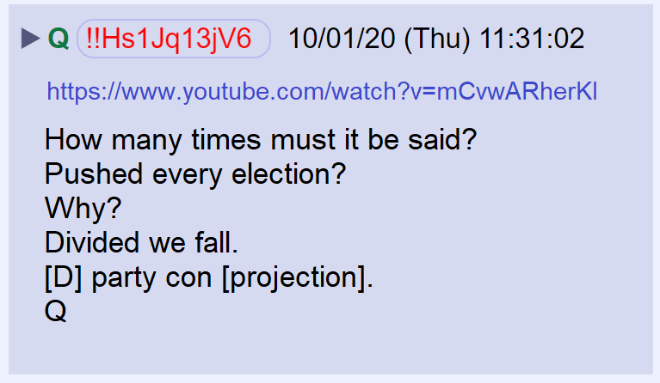

POTUS denounced white supremacy and racism

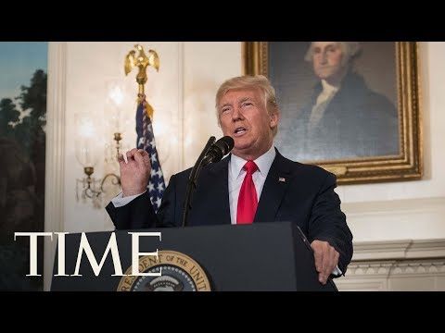

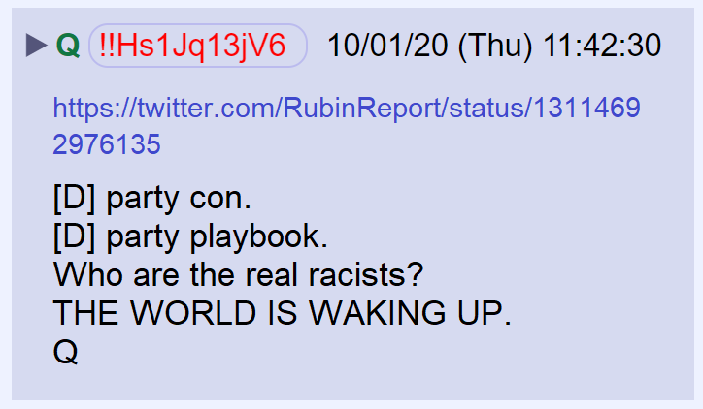

POTUS disavowed white supremacy in the 2016 debates.

https://www.theepochtimes.com/trump-declares-national-emergency-backing-domestic-mining-will-reduce-reliance-on-china-for-critical-minerals_3521562.html
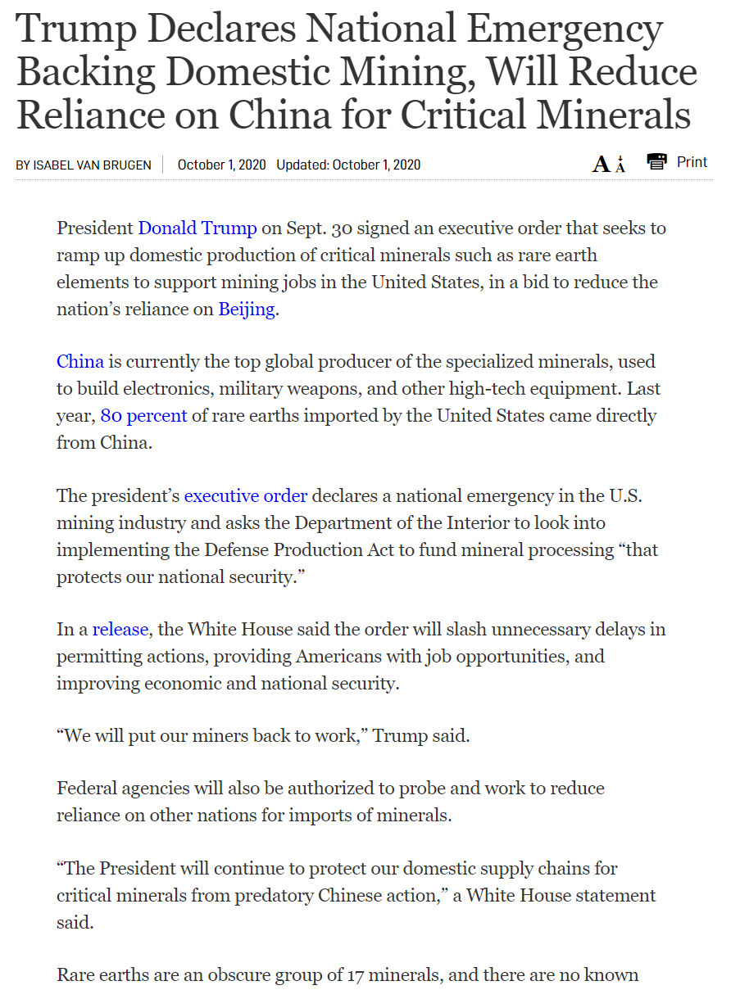

With the recent transfer of custody of four defendants, the United States has repatriated all Americans held by the Syrian Democratic Forces (SDF) who have criminal charges pending relating to their support for ISIS.

https://www.justice.gov/opa/pr/united-states-has-repatriated-27-americans-syria-and-iraq-including-ten-charged-terrorism

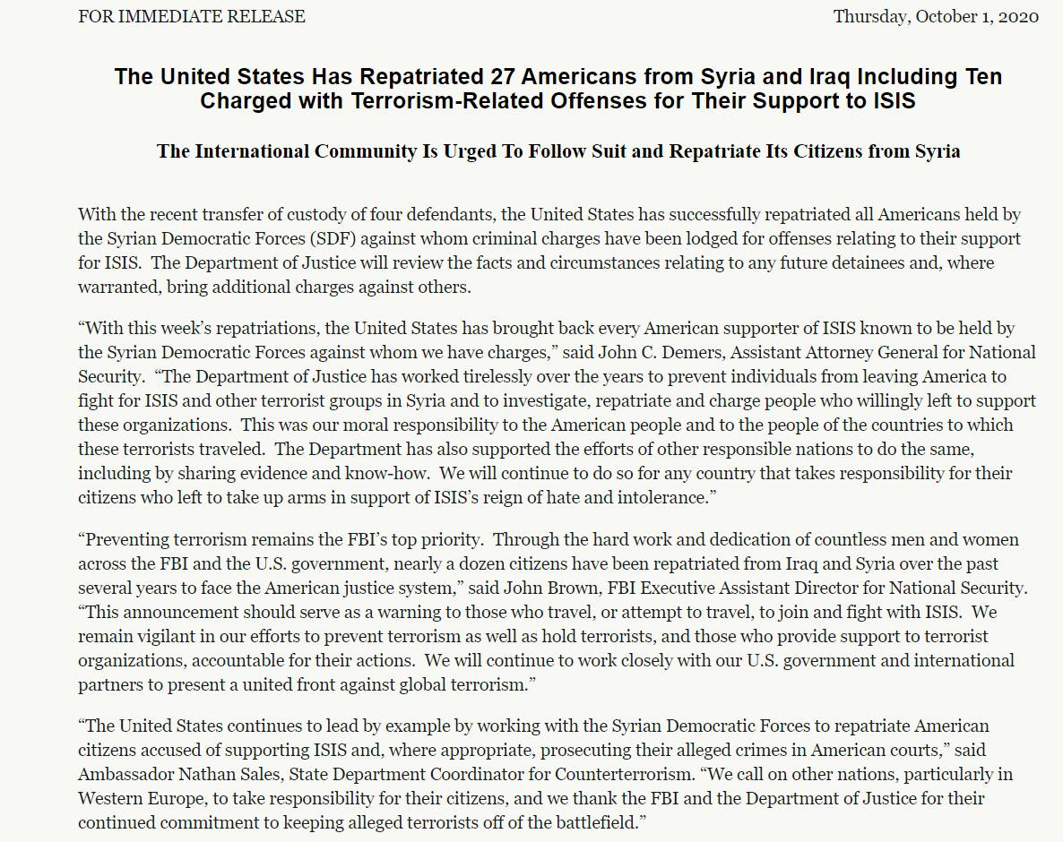

Just in from Reuter’s – the Treasury Department is waring companies that paying ransom to sanctioned hackers may be illegal.

https://www.reuters.com/article/us-treasury-cyber-idUSKBN26M77U?taid=5f7659a62e33a10001fe6238

