This is my Q thread for September 20, 2020

I’d like to start with a correction.

On the 16th, while talking about Antifa, Q closed with the phrase Anarchy-99 design.

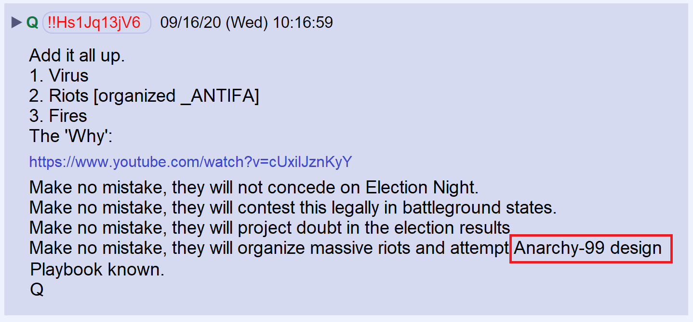

I thought it may have been a reference to the company 99 Designs, but friends pointed out it was probably a reference to the 2002 film XXX that starred Vin Diesel.
In the film, “Anarchy 99” was a Russian terrorist group.

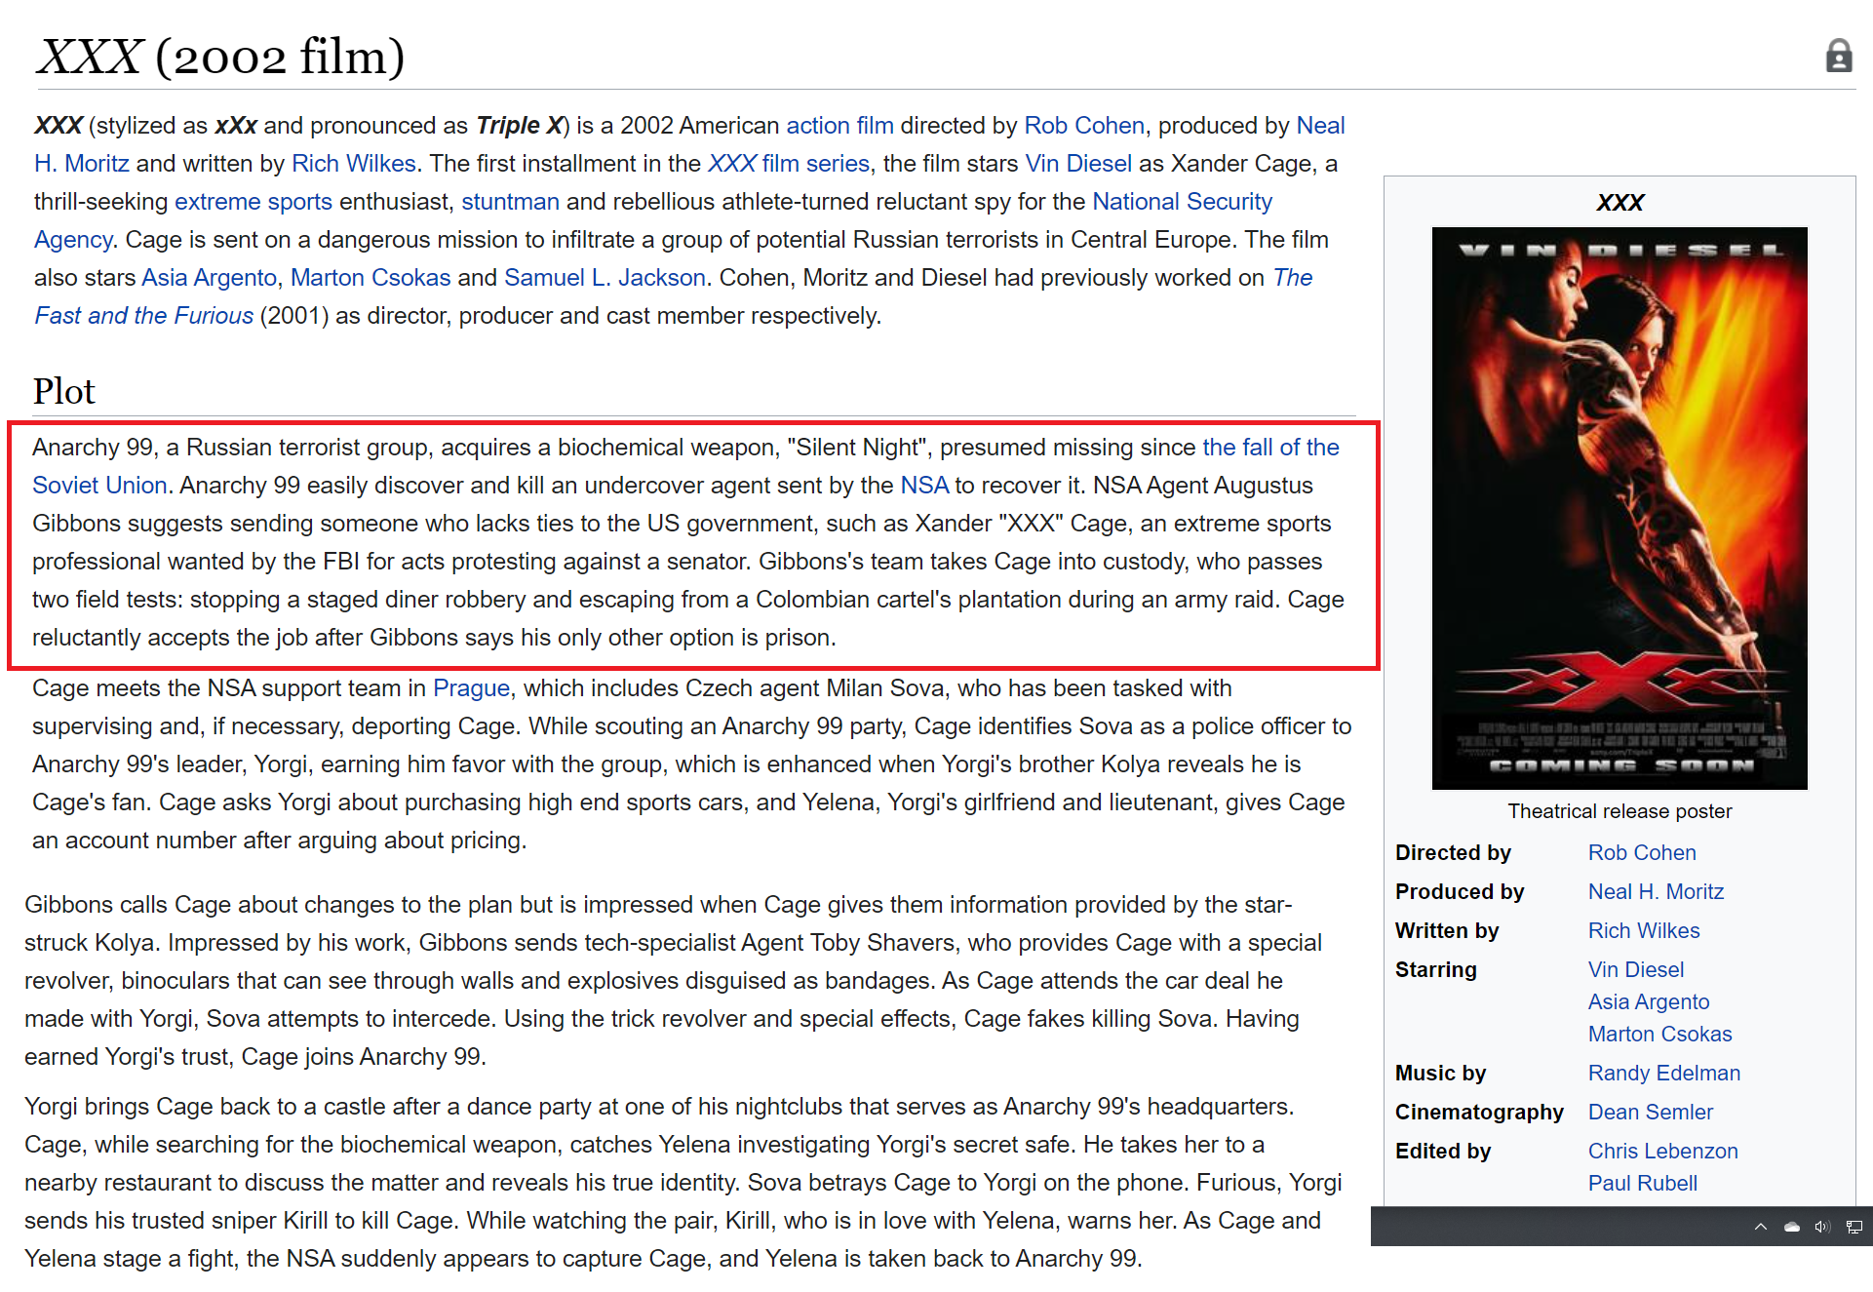

On September 17th, Q posted the message “Rig for Red.”
I assumed, based on past practice, that “Rig for Red” indicated that we would not hear from Q again for a while, since he’s gone silent after posting this message in the past.

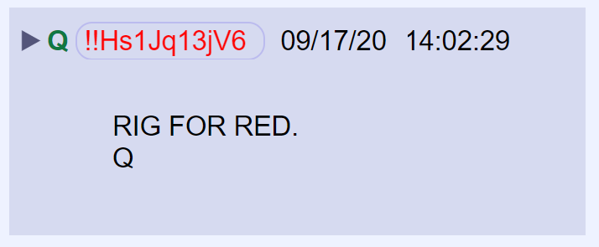

Apparently, it has a different meaning now. I suspect it’s a suggestion that a red wave is building as we approach the November election.

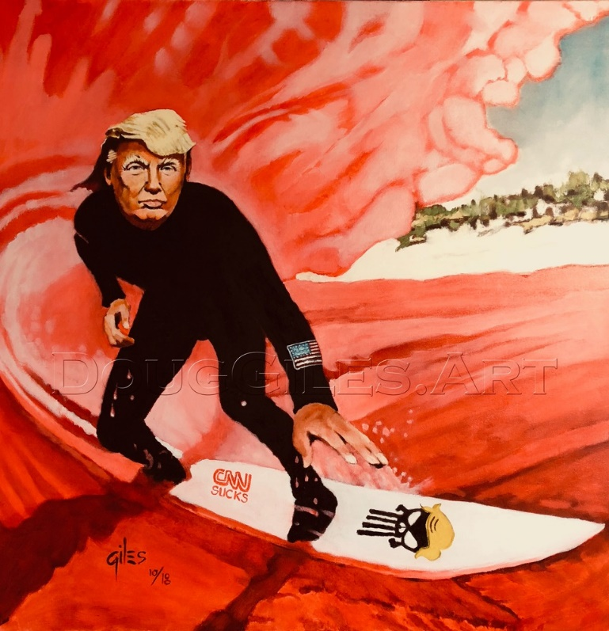

Last night, Q posted an image with a familiar phrase “Equal Justice Under the Law.”

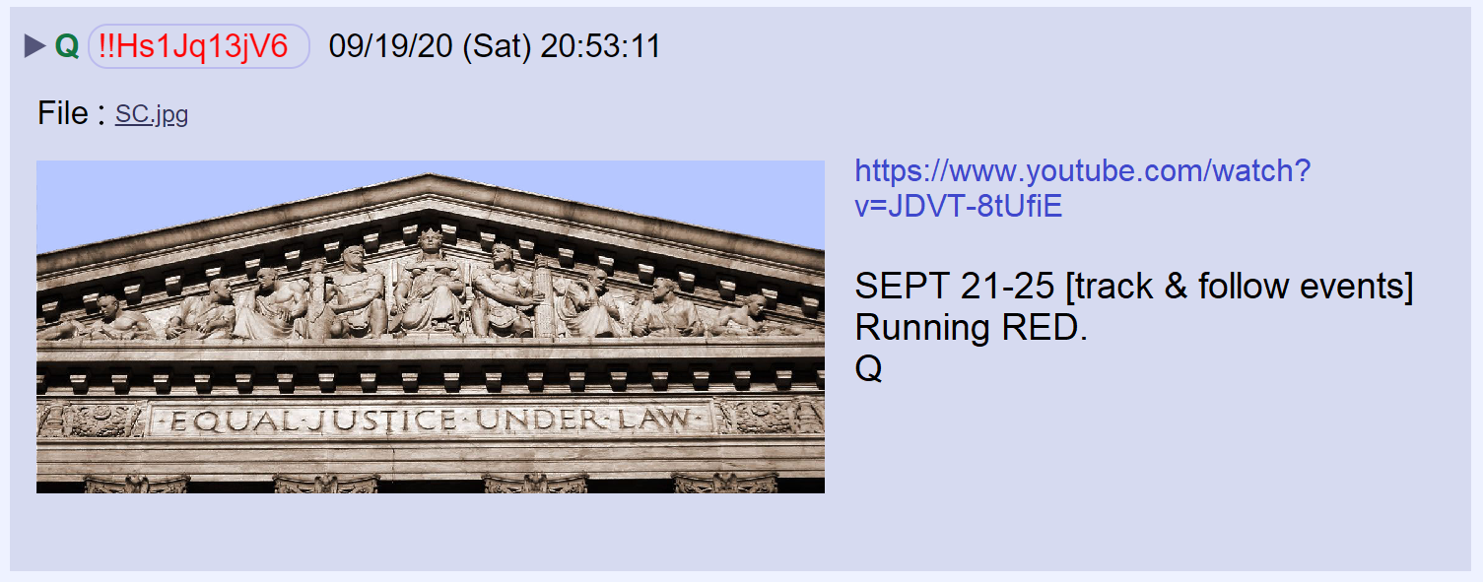

The image shows the roofline of the Supreme Court Building. The reference is to the coming Supreme Court Justice Appointment that POTUS is going to make following the death of Ruth Bader Ginsburg.
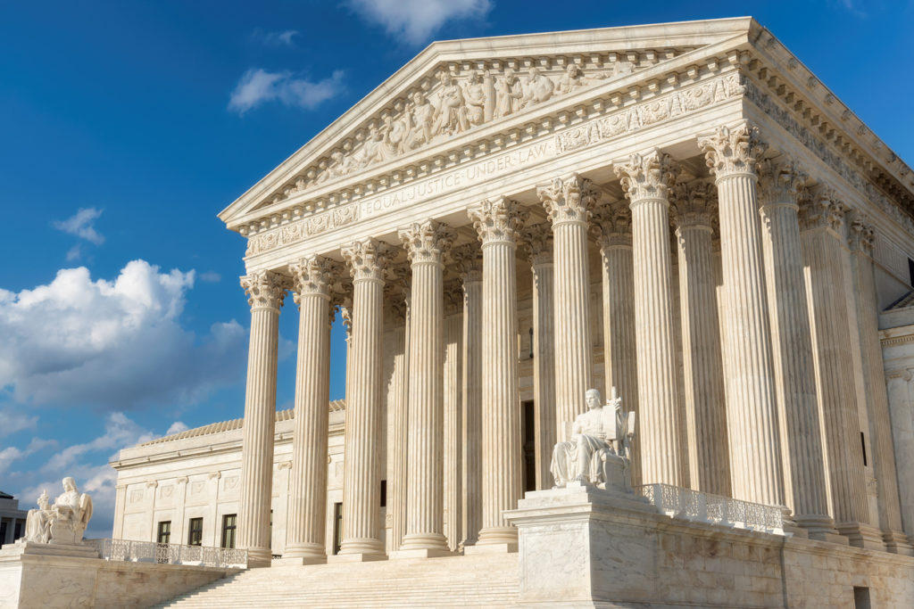

Q wrote: SEPT 21-25 [track & follow events]

Those were the same instructions given on the 13th.

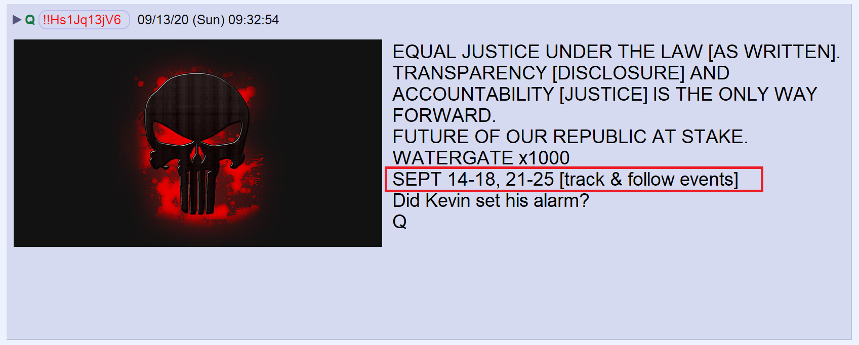

In an interview with George Stephanopoulos of ABC, Ted Cruz said he is isn’t 100 % sure, but he believes Republicans have the votes needed to approve a SCOTUS nomination.

Whoever the President’s nominates—they’ll be in for a battle. Nancy Pelosi has vowed to use “every arow in our quiver” to stop Trump’s nominee from being approved.
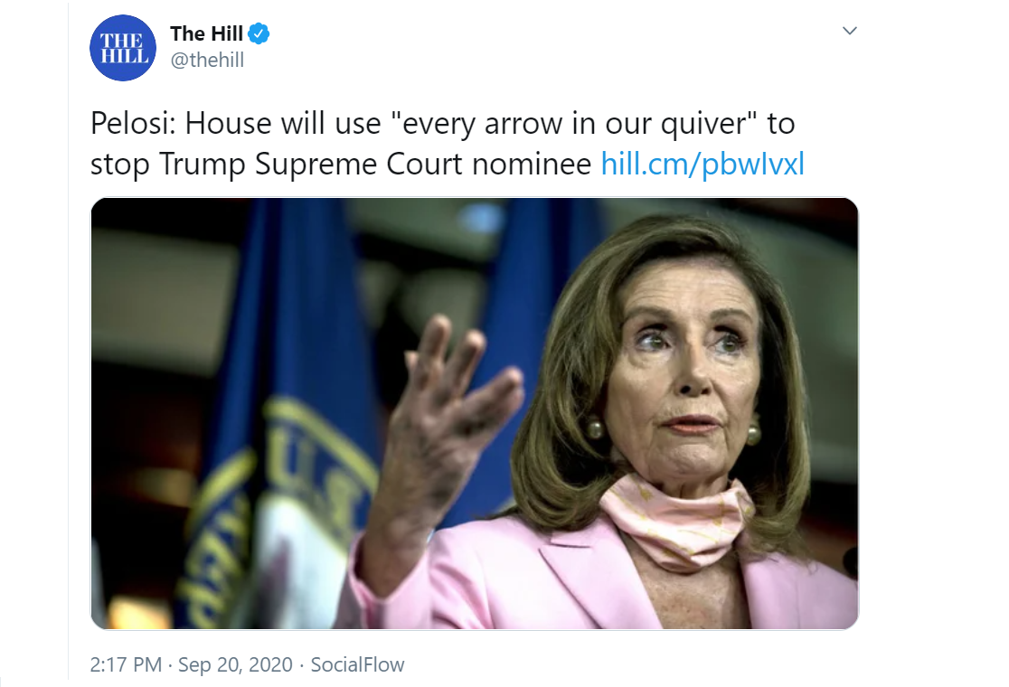

In the above drop, Q posted a link to a famous speech by Ronald Reagan about the war to defeat the tyranny of communism. One line that stood out to me was Reagan’s observation that some people would rather acquiesce to communism than fight it. “Better red than dead.”

In the above post, Q wrote “Running Red.”

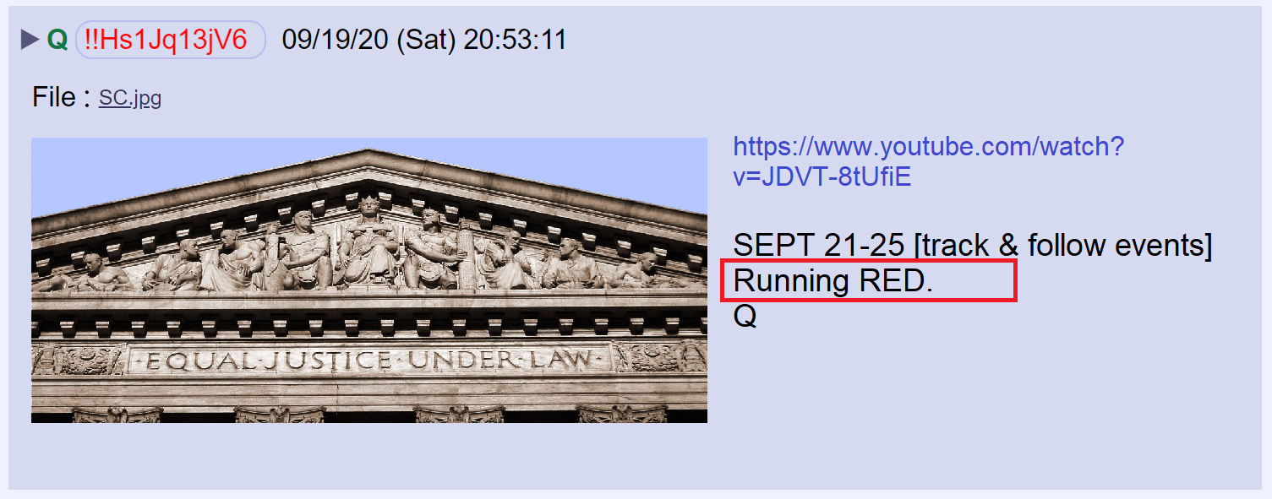

Running Red is a 1999 film about a Russian soldier forced to return to his former life to stop a plot to unleash a chemical weapon on innocent civilians.
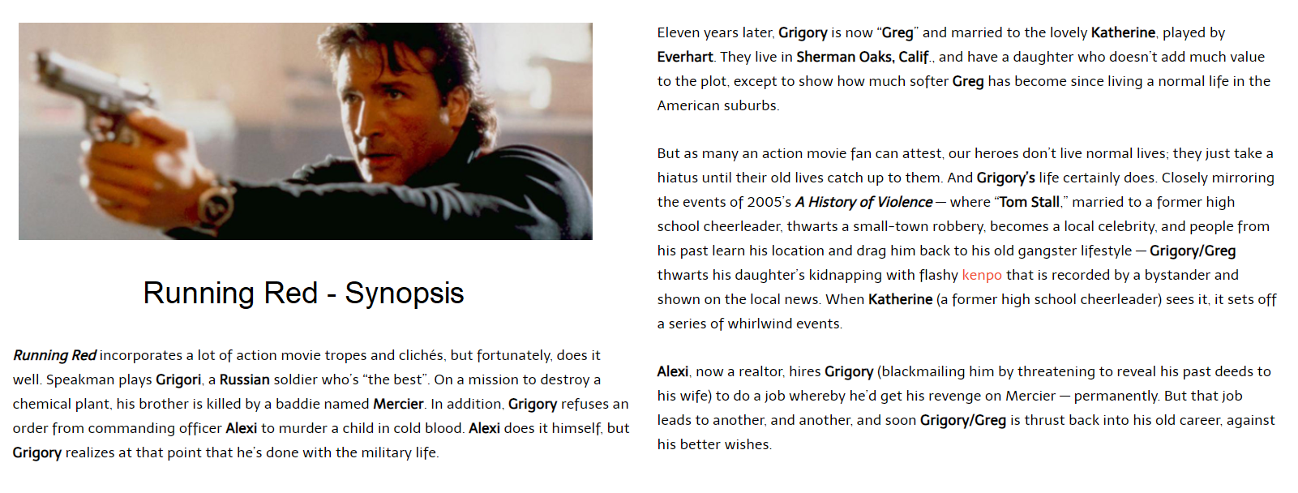

Is Q hinting at the possibility of a chemical weapon attack?

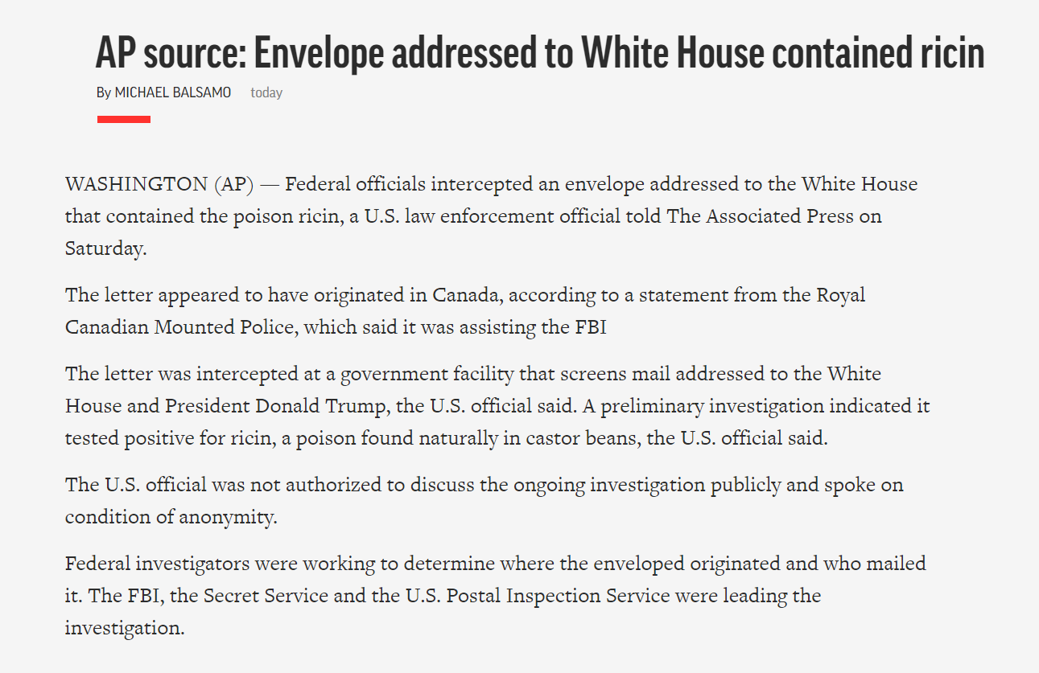

Breaking News

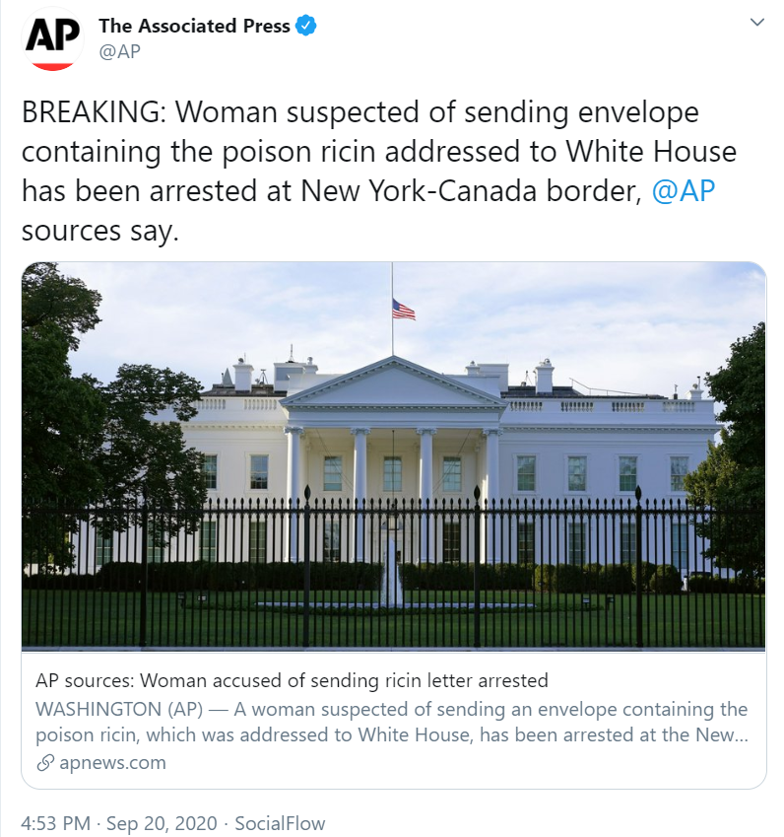

I don’t know if Q’s used the word “red” to refer to the threat of communism, or an anticipated Republican landslide in November. Maybe it hints at both.

This morning, Q highlighted the deceptive plan to steal the election through the public hysteria of a pandemic.

There is also a suggestion that military leaders will attempt a coup against the President after being bribed.
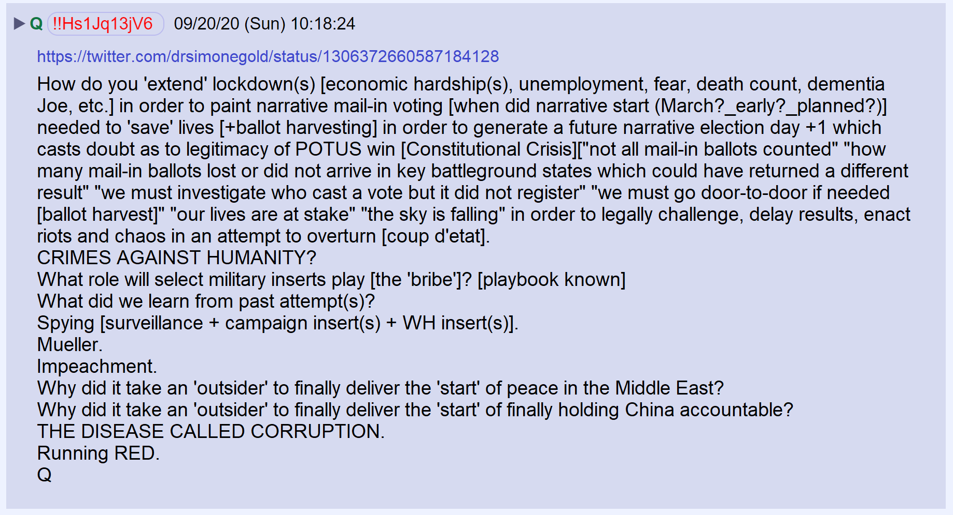

Q posted a link to a tweet by Simone Gold about Nevada’s decision to reverse its policy of blocking HCQ prescriptions.

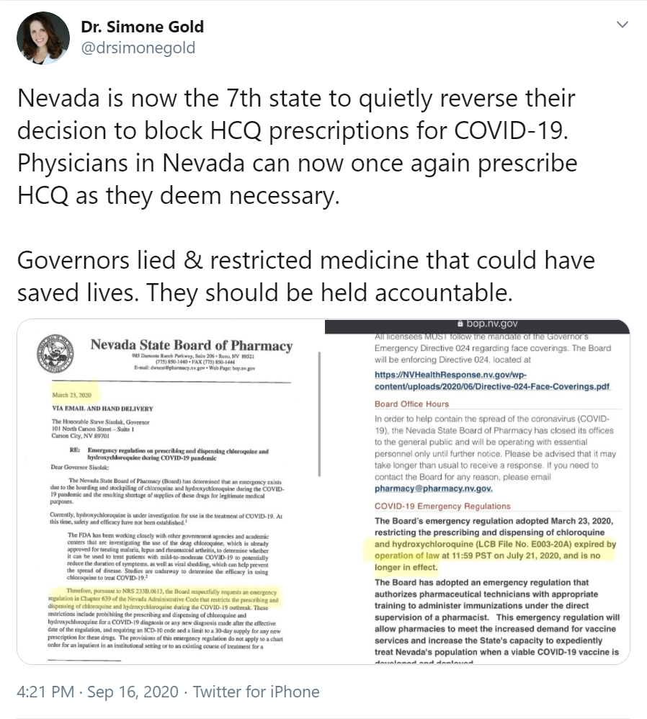

Q ended the post with the phrase “Running Red.”

“Running Red” could be a new signature. If it is, it will connect posts that discuss a common theme.

The last post from Q today is a prayer.

