Link: http://loveforlife.com.au/node/8568 or http://loveforlife.com.au/content/15/03/30/darkness-visible-part-one-c-arthur-fiona-cristian-love-life-14th-december-2014
Darkness Visible Part One C - Arthur & Fiona Cristian - Love For Life - 14th December 2014
Mon, 03/30/2015 - 16:37 — Arthur Cristian
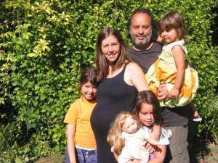

Darkness Visible Part One C
Creating The Trauma That Effects Both
The Perpetrators And The Victims
Arthur & Fiona Cristian
Love For Life
3rd April 2015
[Note: This webpage is still under construction. Should be finished by early August 2015]
Darkness Visible Part One
Part One A: http://loveforlife.com.au/node/8557
Part One B: http://loveforlife.com.au/node/8567
Part One C: http://loveforlife.com.au/node/8568
Part One D: http://loveforlife.com.au/node/8569
One of the things we did not expect when we started Love For Life March 2005, and the Love For Life website December 2006, was to be contacted by many, many hundreds of men and women who had either been the victims of ritual sexual abuse and sacrifice, witnesses to it or had had family members affected by it. The extent of this abuse is enormous and Darkness Visible Part 1C shows just how widespread the problem is, while Darkness Visible Part 5 explains why this abuse is happening as a constant backdrop to "The System".
The whole of "The System" is created by this which is why we are seeing ever increasing sexual depravity throughout "The System" as morals slide to incredible lows. There is a real mixture of things here, but it gives a good overview of just how big the problem is and how deeply rooted in the fabric of "The System" it is.
We have created Darkness Visible Part 1D to cover the story of the Hampstead Sexual Abuse in North London involving Children Alisa and Gabriel Draper, which clearly demonstrates the many attempts to cover up the situation and the stalling on the part of the authorities to do anything about it = CONTROLLED OPPOSITION.
As men and women rise above the show pony, benevolent levels of Freemasonry and similar orders, they go though initiations that they have had no prior information about. They give their allegiance to their orders above their families and they are under oath of death and destruction to them, their families, their careers, their assets and their standings. Exposed to more and more sexual depravity and made to take part in it, they are bound even more tightly to their orders under the threat of exposure, blackmail and death.

Richard Kerr
Kincora 'VIP paedophile ring' victim Richard Kerr speaks out. A Kincora abuse victim from Northern Ireland tells Channel 4 News how he was also abused at London's Elm Guest House and Dolphin Square at the hands of "very powerful people". The Home Office had said the Heart Inquiry in Northern Ireland could liaise with the UK wide inquiry
7th April 2015 - 13 Minutes 18 Seconds
https://www.youtube.com/watch?v=Rt4a9ie5MGk

Detective Chief Inspector Peter Fox
This video is a clear indicator of just how big sexual abuse/paedophilia is going on.
Whistleblower Wants Wider Church Abuse Inquiry - Published on 11 Nov 2012
Detective Chief Inspector Peter Fox joins ABC News 24 to discuss calls for
a Royal Commission into allegations of abuse within the Catholic Church.

Andrea Davison
Intelligence insider Andrea Davison, the BBC, VIP Pedophiles,whistle-blowers and more. Interview by the yeomantrust.org with former British Intelligence agent Andrea Davison . From arms to Iraq to the Westminster pedophiles and corruption in the BBC Andrea talks about the secret world.
7th March 2015 - 1 Hour 42 Minutes
https://www.youtube.com/watch?v=SkT3iZS8d3g
This next video is a must watch.

Bill Schnoebelen
Ritual Masonic Child Abuse
Aleister Crowley & The OTO
Former 32nd Degree Mason Bill Schnoebelen talks about the reason
high-level Masons engage in ritual child sacrifice and abuse.
Late 1980's/Early 1990's - 9 Minutes 42 Seconds
https://www.youtube.com/watch?v=7WbRKAyn4-I

Satanic Cult (Pedophile Ring) In The UK
Hampstead's Child Victims Tell Their Story
Alisa And Gabriel Draper
More On Alisa And Gabriel Draper Further Down This Webpage.
https://www.youtube.com/watch?v=XcY-kberTRE
The Full Story of Alisa and Gabriel Draper Is Located Here:
Darkness Visible Part One D: http://loveforlife.com.au/node/8569

SATANIST Aleister Crowley
The Most Wicked Man In The World
Paranormal Documentary - Born Edward Alexander Crowley, he is primarily known for his occult writings and teachings. He founded the religion of Thelema, which became adopted by the Ordo Templis Orientis (O.T.O.) as well as the magical order Argenteum Astrum, or A:.A:., the Order of the Silver Star. He was also a highly controversial member of the Hermetic Order of the Golden Dawn, where he was known by the magical name of Frater Perdurabo.
50 Minutes https://www.youtube.com/watch?v=BZj0wYS-5xw
or try
51 Minutes
http://youtu.be/jsm6WI5i7p0

Historical Fact Based Documentary
Jewish Ritual Murder Revisited The Hidden Cult
1 Hour 12 Minutes - Late 1980's/Early 1990's
https://www.youtube.com/watch?v=Ynce_945vl4

1989 Oprah Winfrey Interview With Rachael
The Jewish God Is Satan
Ritual Sacrifice Of Babies
Worshipping The Devil
4 Minutes 18 Seconds
See also: http://loveforlife.com.au/node/8157

Tory MP MURDERED A Boy After Sexually Abusing Him?
Published on 16 Nov 2014
Now we have an allegation of a Tory MP MURDERING a boy after sexually abusing him at a VIP party.
I am almost speechless... Almost!
https://www.youtube.com/watch?v=d44SRKQezE0

Westminster Paedophile Ring Investigated Over Murder Links
By Martin Evans, Crime Correspondent7:36PM GMT 14th Nov 2014
Scotland Yard is looking at claims that an alleged paedophile ring with links to former government figures, could have been involved in a murder.
Detectives investigating allegations of a paedophile ring with links to Westminster are now examining connections to a possible murder, the Metropolitan Police has said.
Scotland Yard launched Operation Fairbank two years ago to probe suggestions that high profile political figures had been involved in organised child sex abuse in the 1970s and 1980s.
But now officers have set up a new strand of the inquiry, named Operation Midland, after being passed information about alleged murders that may have been connected with the paedophiles.
It is understood there are no confirmed identities for the suspected victims and no bodies at this stage, meaning the Metropolitan Police have only been willing to describe the investigation as examining a “possible murder”.
A Scotland Yard spokesman said: “Over the past month, detectives working on Operation Fairbank within the Met's Specialist Crime and Operations have been made aware of allegations concerning serious non-recent sexual abuse, said to have occurred over 30 years ago.
“Our inquiries into this, over subsequent weeks, have revealed further information regarding possible homicide. Based on our current knowledge, this is the first time that this specific information has been passed to the Met.”
The spokesman went on: “Detectives from the Child Abuse Investigation Command are working closely with colleagues from the Homicide and Major Crime Command concerning this information, which is being looked at under the name of Operation Midland.”
Operation Fairbank was launched in response to information passed on by MP Tom Watson, who used Prime Minister's Questions in 2012 to air claims that there was a paedophile ring with links to Number 10.
Mr Watson used parliamentary privilege to allege that a file of evidence used to convict Peter Righton of importing child pornography in 1992 contained "clear intelligence" of a sex abuse gang.
He wrote to Scotland Yard, which has since spawned two more inquiries from Fairbank - Fernbridge, which is looking at claims linked to the Elm Guest House in Barnes, south west London, in the 1980s, and Cayacos.
Speaking to the BBC, one of the alleged victims claimed that "senior military and political figures" had been involved in the abuse of youngsters in the 1970s and 1980s.
The man, who is now in his 40s and whose identity has been protected, claimed he had been regularly abused by a gang between 1975 and 1984.
He said he was one of between 15 and 20 children, who would be picked up in cars and taken to hotels and apartments, where they were physically and sexually abused.
He said: "They were very powerful people and they controlled my life for the next nine years. They created fear that penetrated every part of me, day in day out. You didn't question what they wanted, you did as they asked without question and the punishments were very severe."
He added: "They had no hesitation in doing what they wanted to do," Nick said. "Some of them were quite open about who they were. They had no fear at all of being caught, it didn't cross their mind."
The man's claims are understood to be among a number now being assessed by the Metropolitan Police.
In August, Scotland Yard said it had tripled the number of officers investigating the allegations of sex abuse in the wake of the claims of a Westminster cover-up.
Related Articles
John Stingemore dies at home in St Leonards-on-Sea while awaiting trial for abusing young boys in his care at children's home. Children's home boss facing historical sex abuse charges found dead - 16 Jan 2015
http://www.telegraph.co.uk/news/uknews/crime/11350212/Childrens-home-bos...
Westminster paedophile ring allegations: timeline 11 Nov 2014
http://www.telegraph.co.uk/news/uknews/crime/10950127/Westminster-paedop...
Leon Brittan 'interviewed by police over historical rape allegation' - 06 Jul 2014
http://www.telegraph.co.uk/news/uknews/crime/10949317/Leon-Brittan-inter...
Clegg: 'Claims police covered up boy's murder are grotesque' 19 Nov 2014
http://www.telegraph.co.uk/news/uknews/crime/11239928/Nick-Clegg-Claims-...
Link: http://www.telegraph.co.uk/news/uknews/crime/11231088/Westminster-paedop...
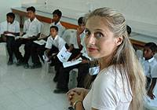
There have been pioneers, such as Dr Reina Michaelson who publicly went after the (Sanitised) before but she was also heavily fined and her family threatened and she had to desist. More on all this below.
Aevus Lucifer pt.5 -- Masonic Influence NEW WORLD ORDER
Maureen Spalek is a victim of the Freemasons' influence in the system. Their goal is to dominate the world, and a new Luciferian Word Order. This is a general insight into the so-called conspiracy theory claims, and their claims, and the true nature of the media mind control in Australia and USA. Dr. Reina Michaelson explains her experiences with the Illuminati. George W. Bush of Washington DC was a known member of the Skull and Bones secret society. The Star of David on the seal reveals the anagram for MASON
http://youtu.be/lgkOgHm7ExY
Aevus Lucifer pt.2 -- Aquarius NEW WORLD ORDER 2012 Dajjal
Dr. Reina Michaelson explains her experiences with the Illuminati.
http://youtu.be/sKmkBOgjZ5k
Aevus Lucifer pt.14 - Headquarters of Satanism Australia
Petor the Australian Satanist before he died wrote in few letters about the influence of Satanism, its history, methods and the plans to come. This was published by Aloysius. The fact that all the U.S. Presidents are related and that Satanists are running the show should be enough to make people ask some questions, but why don't they? The internet like any other media is a tool of control. They will implement this with another market crash that will leave people desperate for any hope.
http://youtu.be/wbZsFFUtWws
The full Aevus Lucifer series can be watched here: https://www.youtube.com/user/galexy2far2c/videos

Australian Satanism
Australia’s Global Satanic Legacy And Future
Part 1 to Part 3
By Frater 616
Alpha Lodges Do Exist
Aloysius Fozdyke
2nd January 2010
http://loveforlife.com.au/node/7103

The Satanic Epistles of Aloysius Fozdyke
THE USHER OF DESECRATION
Response To Satanist Insider:
A Woman Will Herald The Antichrist
By Gi Norman Australia
27th July 2011
http://loveforlife.com.au/node/8214
Comment from Arthur & Fiona Cristian
These emails were sent to us in January 2010. We have no way of confirming their validity but, if they are genuine, they paint a picture of Satanism and ritual abuse and sacrifice that matches with all the other information we have come across on this subject, some of it directly from the mouths of victims of ritual abuse and witnesses of Satanic sacrifices. As more and more information about the extent of the abuse being done to children on a daily basis, the more we can see how abuse is both the backdrop and the life blood of "The System", vital to keeping us locked into a state of trauma so that we never rise up to stop the abuse and get rid of "The System".
When Aloysius first wrote to us, this is how he introduced these writings:
Petor Narsagonan – Frater 616 – died on Tuesday the 25th of March 2004. Prior to His death I received sole custody of His literary estate and under the terms of His Trust Deed, full control subsequent to His demise. Among the material was this disjointed essay concerning the Alpha Lodges. I have felt it necessary to edit very little of this work, although legal considerations have ensured that some names and details were excised. It was His intention to have this published in the popular media. The Alpha Lodges do exist. Evidence leaves no doubt. Frater 616 died as he lived – an enigma! His Intelligence connexions and influential friends miss him.
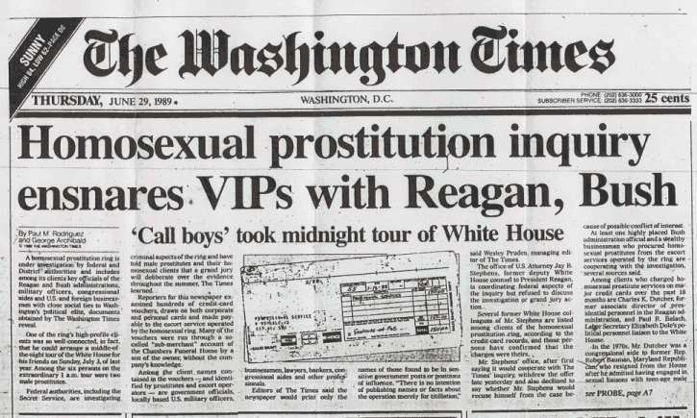

'Cult' Fights Claims Of Child Sacrifice
Barney Zwartz
November 22, 2006
The Age.com.au
http://www.theage.com.au/news/national/cult-fights-claims-of-child-sacri...
AN ANTI-CHILD-SEX campaigner accused an occult religious group of hosting parties at which naked children acted as waiters and at which members had sex with and murdered children, a tribunal was told yesterday.
The obscure group Ordo Templi Orientis (OTO) claims Dr Reina Michaelson and the Child Sexual Abuse Prevention Program described it in a website article as a satanic cult that sacrificed children and ate their organs and blood.
It has complained under Victoria's religious hatred law that Dr Michaelson and her organisation vilified OTO members, causing revulsion, ridicule, hatred and contempt.
According to OTO's statement of complaint, Dr Michaelson said it was not a religion but a child pornography and pedophile ring, that its members practised trauma-based mind control, sexual abuse and satanic rituals to discourage its victims from complaining to the authorities, and that it condoned kidnapping street children and babies and children from orphanages for sex and sacrifice in religious rituals.
The case began at the Victorian Civil and Administrative Tribunal yesterday, but was adjourned to today to allow a last-ditch attempt to settle out of court.
The article, still accessible on a website run from NSW, suggests senior politicians and television celebrities are part of a top-level pedophile ring and have been protected by some police. It says some members of the ring pretended to support Dr Michaelson's campaign and became board members of her group to subvert it from within.
Adam Paszkowski, for Dr Michaelson, who was named Young Australian of the Year in 1997 for founding the Child Sexual Abuse Prevention Program, said the article was published on the website "without her knowledge or consent or authority".
Dr Michaelson last year called for a royal commission to investigate her claims that Victoria Police did not properly investigate pedophile ring allegations.
Earlier complaints led to a report by the police ombudsman in 2004 that was highly critical of two senior detectives.
OTO members follow a religion known as Thelema, founded by occultist Aleister Crowley.
See also

Global Pedophilia: Protected Sex Rings in Australia?
AustraliaMatters.com
23rd August 2007
Young 1997 Australian Of The Year and 1996 Young Victorian of the Year for her outstanding work in the fields of child protection, Dr. Reina Michaelson of CSAPP and Brave Hearts Victoria taped meeting transcript with the Victorian Ombudsman's Office over allegations of an elite run pedophile ring operating in Australia.
http://www.australiamatters.com/auspeds.html
FRANCA ARENA VERSUS THE CHILD ABUSE RINGS
http://aanirfan.blogspot.com.au/2014/12/franca-arena-versus-child-abuse-...
"MICHAEL JACKSON ABUSED WADE ROBSON"
http://tomcruiseandrewlloyd.blogspot.com/2013/05/jackson-abused-wade-rob...
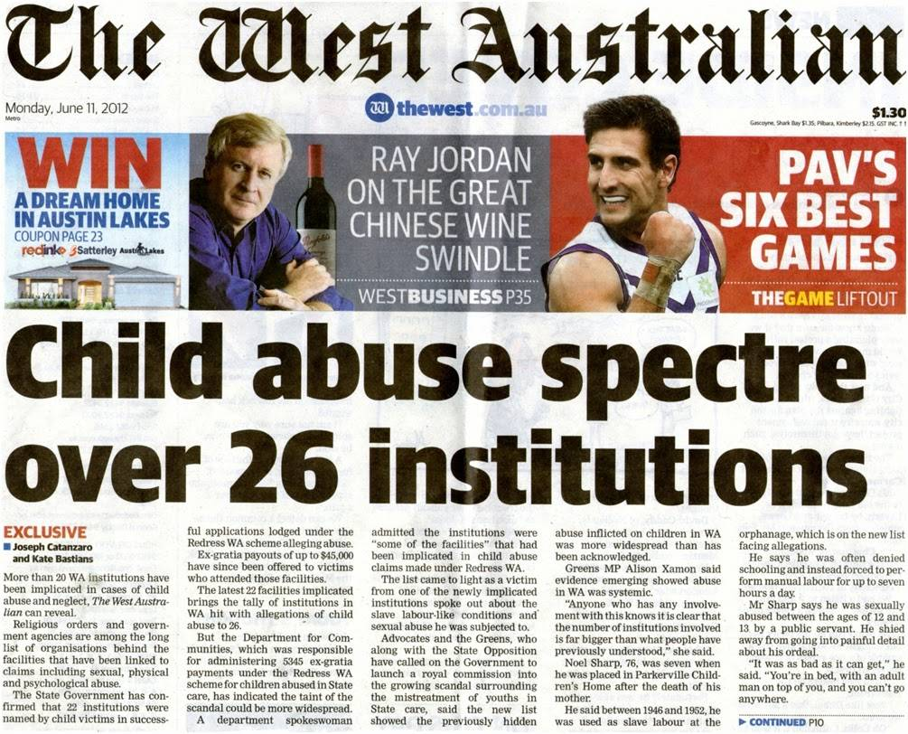

Sacrifice Children Denial
Karen Collier
Herald Sun
November 22, 2006 12:00AM
A SECRETIVE society linked to the occult says it was falsely accused of sacrificing children, eating organs and being tied to an alleged pedophile network of politicians, police and TV figures.
Ordo Templi Orientis has accused a leading activist of fuelling religious hate by publishing the suggestions.
It denies it is a satanic cult that uses blood rituals and mind control, condones kidnapping and murder, and hosts parties with naked child waiters.
Child Sexual Abuse Prevention Program head Reina Michaelson is accused of spreading misinformation over the internet.
OTO members Sanitised and Brent Gray allege the material incited hate, contempt and ridicule and want compensation for alleged religious vilification.
The Victorian Civil and Administrative Tribunal was yesterday told the references were included in an article making allegations about powerful pedophile rings operating in Australia.
"Any attempt to suggest OTO is part of a satanic pedophile network involving a major TV network, high-ranking politicians and police is a false claim and a vilifying claim," counsel Jane Nixon said.
The allegations were allegedly posted on the CSAPP website, then removed, but a link to another site repeating the claims remained.
Ordo Templi Orientis, founded in Germany in 1902, has about 20 members in Victoria.
Members follow the religion of Thelema, as taught by occultist and mystic Aleister Crowley.
They say "true will" keeps humans in harmony with the universe, and every person has a higher self, that Crowley called the Holy Guardian Angel.
Dr Michaelson and CSAPP are fighting the religious vilification allegations.
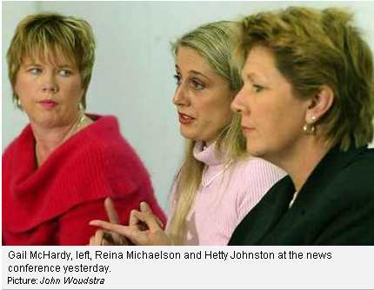
The psychologist claims an article was posted on various internet sites without her consent, knowledge or authority, and that she took steps to stop publication on the CSAPP page, and that the words did not refer to a religion.
Sanitised complained last year to the Equal Opportunity Commission, which referred the matter to VCAT.
The parties yesterday agreed to try to resolve the dispute and are due back at the tribunal today.
Dr Michaelson won a Young Australian of the Year award in 1997 for her anti-child abuse program. In 2004 she claimed corrupt Victorian police officers were protecting pedophile rings and called for a royal commission.
Link: http://www.heraldsun.com.au/news/victoria/sacrifice-children-denial/stor...
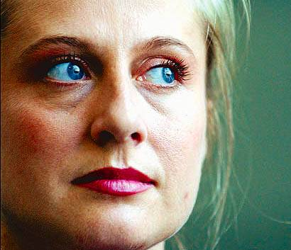

Was Peaches Geldoff KILLED
For Revealing ILLUMINATI Pedophilie Rings
And OTO (Ordo Templi Orientis) Links
Mystery looms around the death of Peaches Geldof
and how her ties with the OTO and the BBC
Pedophile Ring might have caused her untimely death.
12th April 2014
http://youtu.be/S1wE1CDem1s
Peaches Geldof - O.T.O. Member Murdered by illuminati? Satanism Paedophile
http://youtu.be/NC8mBwPnz8E
Peaches Geldof Murdered By Illuminati & Knights of Malta?
http://youtu.be/dHzBM1foA9E

Peaches Geldof apologises for naming women in paedophile case
By Alice Philipson
The Telegraph
29th November 2013
http://www.telegraph.co.uk/news/uknews/crime/10482939/Peaches-Geldof-apo...
Peaches Geldof has apologised for tweeting the names of the two mothers whose babies were involved in abuse by disgraced rock star Ian Watkins
Peaches Geldof says sorry after she named two women who allowed their babies to be abused by a rock star.
Peaches Geldof has apologised for tweeting the names of the two mothers whose babies were involved in abuse by disgraced rock star Ian Watkins.
The daughter of Boomtown Rats singer Bob Geldof posted a series of tweets this morning explaining that she had assumed the names were already "public knowledge".
Her comments come after detectives confirmed last night that they were investigating reports of what she had done and were in talks with prosecutors.
"I deleted my tweets, however, and apologise for any offence caused as at the time of tweeting had only seen everyone tweeting the names at me so had assumed as they were also up on news websites and the crown courts public file that they had been released for public knowledge," she explained.
"Will check my facts before tweeting next time. Apologies and lesson learned."
Miss Geldof, 24, has more than 160,000 followers on Twitter.
Ian Watkins, the singer with the band Lostprophets, pleaded guilty on Tuesday to a string of sex offences, including the attempted rape of a baby.
The 36-year-old, from Pontypridd, south Wales, plotted the abuse with two mothers in a series of text and internet messages.
The Attorney General's Office warned that sex offence victims have automatic lifetime anonymity and publishing details that can lead to their identification is a criminal offence.

ABC Stateline Claims police mishandled child sex abuse cases
Dr Reina Michaelson - 1997 Young Australian Of The Year
Broadcast: 09/07/2004
Reporter: Josephine Cafagna
http://www.abc.net.au/stateline/vic/content/2003/s1150668.htm
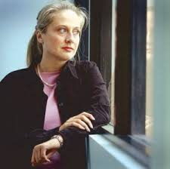
DR REINA MICHAELSON, VICTIMS' ADVOCATE: We had a very productive meeting. I highlighted to the Chief Commissioner that a number of the problems that were evident in the police's handling of the previous child sexual abuse investigations are present in the current criminal investigation. For example - the intimidation of witnesses, the failure to pursue and follow leads that actually support the allegations. As well as a number of key issues such as the involvement of police officers who are in fact under suspicion. We asked for...again reiterated our call for a Royal Commission.
JOSEPHINE CAFAGNA, PRESENTER: Did you give them names of people... you've given made some startling allegations that there's a paedophile ring involving a former senior politician and senior police involvement. Did you name names with senior police today?
DR REINA MICHAELSON: Certain names have been presented to the police previously. I would like to emphasise that certainly the allegations that have been raised are serious, we are working with child victims of horrendous crimes, we believe those children. More people have come forward to us in the last 24 hours to say, "Thank you so much for bringing this topic up."
JOSEPHINE CAFAGNA: Are you satisfied with what the Ombudsman has done so far in his investigations?
DR REINA MICHAELSON: I have to say that the Ombudsman's report is extremely thorough, it's extremely comprehensive and we were very, very pleased with that.
JOSEPHINE CAFAGNA: But if you're satisfied with the work the Ombudsman has done so far, his investigations, are you saying you don't trust him to carry out further investigations of your serious allegations?
DR REINA MICHAELSON: I actually think that the Ombudsman is terrific, we met with him when he handed us the report. But the degree of criminality involved, the sensitivity of the matters and the dangers to the victims mean that a royal commission is the only answer.
JOSEPHINE CAFAGNA: Just finally, there is a website that is linked to your own website, it refers to Satanic ritual abuse and sacrifice amid a paedophile ring. Did you write any of that information on that particular website?
DR REINA MICHAELSON: I can only comment on our own website, our official website is www.csapp.net and I would recommend that people in the community who want to know more about this, who want to read the testimonies of victims, go to that website and read for themselves the kind of crimes that these children have been subjected to.
JOSEPHINE CAFAGNA: Do you believe there is a Satanic abuse of ritual abuse of children?
DR REINA MICHAELSON: I'm working with numerous victims who don't even know each other who have described being subjected to terrible crimes. Some of those crimes have an occult component and some of them refer to witnessing of murders that to date remain unsolved.
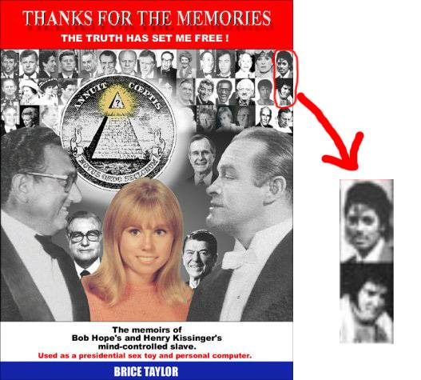
JOSEPHINE CAFAGNA: You distance yourself from that website, but the information on it, you believe, is accurate?
DR REINA MICHAELSON: I don't have the website in front of me, I can't comment.
JOSEPHINE CAFAGNA: But you know what I'm talking about, don't you? You know which website I'm talking about?
DR REINA MICHAELSON: You could make it explicit if you wanted.
JOSEPHINE CAFAGNA: I've got details here, this one here, have you seen that?
DR REINA MICHAELSON: I would have to read through it. But what I will say is for the material that we have in relation to these matters, please visit our website. In that website we have the testimonies of the victims themselves.
JOSEPHINE CAFAGNA: Why do you have a link on your website directed to that website then, if you don't know what's on it?
DR REINA MICHAELSON: There's a whole range of material that's available on the Internet in relation to these matters. I suppose what I would like to say to people is that there have been attempts to discredit me and to distract from this issue. I'd prefer to focus on the issue at hand, which is the fact that there are children in this State who have been subjected to unspeakable crimes, they've been deprived of justice and they deserve justice.
JOSEPHINE CAFAGNA: Assistant Commissioner Simon Overland, welcome to Stateline. How would you describe this morning's meeting with Reina Michaelson?
SIMON OVERLAND, ASSISTANT COMMISSIONER, VICTORIA POLICE: I think it was a positive meeting. Trust is clearly an issue between Victoria Police and Dr Michaelson and that's something we'll have to work on. We've explained to her what we intend to do from here. I think there's a measure of satisfaction on her part with some of the things that we've outlined. But clearly she's flagged to us that she'll be watching to see what we do and it is a matter of us earning her trust.
JOSEPHINE CAFAGNA: Has she given you any new information?
SIMON OVERLAND: No, we talked about the matters that the Ombudsman has investigated and that is known to us. There are other investigations that have been ongoing for a little while now, running the crime department, we talked about a way forward with those.
JOSEPHINE CAFAGNA: Is there sophisticated paedophile ring operating in Victoria?
SIMON OVERLAND: Well, that's one of the things we want to discover. Clearly there are paedophiles operating here in Victoria and we do investigate and prosecute those sorts of people on a regular basis. The suggestion that it's organised and the suggestion that there is protection is something that is of concern. And we really want to get to a situation where Dr Michaelson is able to give us the particulars of that allegation so that we can investigate it.
JOSEPHINE CAFAGNA: Were you investigating this before her allegations were raised?
SIMON OVERLAND: She has raised a number of matters with us and there have been dealt with in two separate ways. The first lot have been dealt with by the Ombudsman because there's suggestions of police misconduct and that's the appropriate course for those matters to go. There are other criminal allegations that she's referred to us that we are dealing with. In those, there is some suggestion of protection and police involvement. We don't have the particulars, we don't have the details of those allegations and that's something that we need to work towards.
JOSEPHINE CAFAGNA: Are you investigating the disappearance of police records as part of this investigation?
SIMON OVERLAND: That's something that will be picked up as part of the broader work that flows on now from the Ombudsman's findings.
JOSEPHINE CAFAGNA: You've announced a review of the Sexual Crime Squad, will all cases it has investigated come under review now?
SIMON OVERLAND: What the review will do is do some sampling, if you like, of previous investigations and look at those and obviously if we find areas of concern in those, then we'll have broaden the inquiry.
JOSEPHINE CAFAGNA: Has Dr Michaelson raised with you the name of a senior ex-politician who is involved in this paedophile ring?
SIMON OVERLAND: She's named a number of very senior, high-profile public people to us. And as I say, we need to work out with her the basis on which she's named them, the reasons why she's naming them, the people who've named them to her. As I say, we really need to get to that level of detail before we can mount a proper investigation into her allegations.
JOSEPHINE CAFAGNA: So you haven't started an investigation into any former senior politicians in Victoria?
SIMON OVERLAND: Well, I guess it's an exercise in semantics here. We have those allegations, yes, we are working on...there are some 41 separate allegations that we're actually working on, that have come through Dr Michaelson. Part of the issue, though, is trying to get to the particulars of the allegation. And until we get to that stage, it is difficult for us to mount a full and proper investigation.
JOSEPHINE CAFAGNA: You've rejected calls for a Royal Commission. In recent history, there's been serious corruption allegations involving the former drug squad, allegations about the witness protection scheme and now serious allegations about the Sexual Crimes Squad. Surely you can understand the public losing confidence in Victoria Police.
SIMON OVERLAND: We understand that these issues do impact on confidence, that's one of the reasons why we've tried to be as open as we have been, particularly about this matter, but other matters as well. We understand the need to account to the public. The point we would make, though, is that the Ombudsman has just been given a significant increase in powers, he describes himself as, in effect, a standing Royal Commission. He has dealt very adequately with the matters Dr Michaelson has raised with him to date and if there are other matters involving police, we'd suggest that she should report those matters to him.
JOSEPHINE CAFAGNA: Assistant Commissioner, thanks very much for coming on the program.
SIMON OVERLAND: Thank you very much.
The Child Sexual Assault Prevention Program website address is www.csapp.net
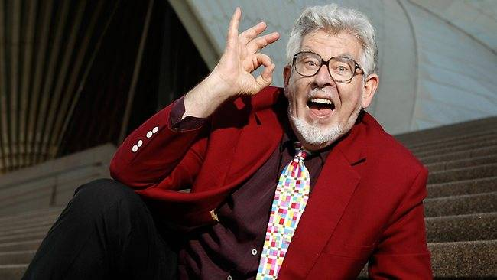
Rolf Harris convicted paedophile - specualation aplenty regarding Rolf's connection
with the paedophile networks Dr Reina Michaelson was addressing.
Would be great to get Rolf to talk but we suspect he would be murdered
before he could name all the perpetrators associated in the international
paedophile networks that connected with Rolf, far and wide.
Many tall poppies would fall fast. Notice the Satanic code 666 sign Rolf is making with his hand.

A BRAVE AND COMMITTED YOUNG WOMAN EXPOSES ON THIS WEBSITE AN UNTOUCHABLE PEDOPHILE AND SATANIC NETWORK OPERATING IN AUSTRALIA INVOLVING HIGH GOVERNMENT OFFICIALS, LEADING POLITICIANS, TELEVISION EXECUTIVES, TOP TV PRESENTERS, AND THE POLICE.
(The lady at the centre of this story is Dr Reina Michaelson) - GRAHAM KENNEDY, "The King of Comedy" / "The King of Television", is the person referred to therein by the pseudonym "Gerald Oanasis". ("Sarah Connor" is NOT Nova Peris-Kneebone) - The following is a summary of events that detail the infiltration of a high-profile, powerful group of child sex offenders into my child abuse prevention organisation. What was uncovered as a result of this infiltration was the existence of an Illuminati-based child pornography and pedophile ring that is operating in Australia, under the protection of senior-ranking members of Victoria Police. The members of the network include senior management and executives from a major television network, media celebrities, high-ranking politicians, police officers in charge of pedophile and child pornography investigations, senior management representatives from the Department of Education, directors of "child-focused" service clubs, wealthy businessmen, and others. I have tried to keep the account as brief as possible while trying to include all relevant information. The description covers events from 1995 until present. Names have been changed.
Link: http://www.declarepeace.org.uk/captain/murder_inc/site/abuse/illuminatir...
The text is also attached here as a text document: http://loveforlife.com.au/files/Dr%20Reina%20Michaelson.txt
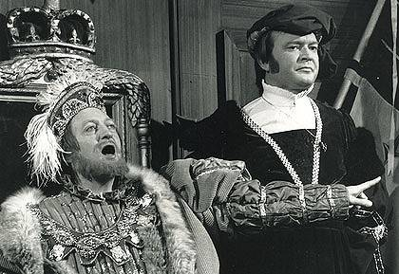
Grahan Kenndy left - Bert Newton right

Department of Education Protects Pedophile Teacher
In 1995 I started running Australia's first child sexual abuse prevention program in schools. This school-based program teaches children how to protect themselves from sexual abuse and what to do if someone tries to sexually abuse them. The program also teaches adults how they can best protect children under their care from sexual abuse. My assistant and I were at a particular high school in the northern region working with Year 9 boys. We received a note written anonymously by one of the boys asking "What do you do if you get raped by a teacher and no-one will believe you? What happens if you get raped and you enjoy it?". Later during that day we were asked exactly the same question by a boy who was flushed red with embarrassment. I replied "Talk to the Student Welfare Coordinator", to which he replied "What if he is the one who won't believe you?" I emphasizied that it is important to keep telling until someone believes you.
During the day my assistant and I noticed the strange behaviour of a particular teacher, called Dick Newman. Later that afternoon I learnt that the car I had been driving had been rammed in the school's car-park. Witnesses reported that the car had been rammed deliberately by a man who then drove off very quickly.
The local police were called and ran a licence check on the car and discovered that the number-plate was fake. They then took photos of the crime scene using the school's camera. Later, when it was revealed that a teacher was under suspicion of sexually abusing the children at the school and then organising the ramming of my car to intimidate me, the photos went "missing", and no further action was taken.
Dick Newman was the only person at the school who knew my car, as he had taken it upon himself to show me to my car to give me directions to the shops during a break in classes.
It was organised that the boys in Year 9 would be interviewed in order to find the victims and give them appropriate support. Three people (including myself, my assistant and a counsellor from a sexual assault centre) were responsible for conducting the interviews. At the completion of the interviews, there were concerns for approximately 12 of the boys. These concerns related specifically to sexual assault by a teacher at the school. However, by this stage (over a week had passed since the initial program) it was clear that the boys had been threatened. For example, when I interviewed the boy who had asked the questions about sexual abuse by a teacher and not being believed, he huddled into a foetal position, started crying, and said he could not tell me what happened. When I asked him why he couldn't tell me, he replied that he had been threatened with his life. His best friend told me he would never tell what had happened.
Some time after this, we organised a theatre company performance for the students (on the topic of sexual abuse). While the children were seated and waiting for the play to begin, Dick Newman made an unscheduled visit to the hall. He proceeded to stand in front of each of the boys we had identified as potential victims and stare them down. The boys, who had been happy and laughing in the excitement of waiting for the play to begin, went grey with fear. Finally, I stood in front of Dick Newman so that he could not intimidate the boys any further.
I was then told no further action would be taken as the boys had not named the offender.

Program Infiltrated by Pedophile Board of Management
I was the recipient of a very prestigious national award for Community Service. One of the judges was a well-connected government official (Ron Snide), and another was the General Manager (Bob Sisterly) of one of the major Australian television networks (Network X).
After winning this award, Bob Sisterly approached me and said that he had never heard of this terrible crime (child sexual abuse) before meeting me. He said wanted to help me get my program into every school in Victoria within five years and said he had the money and the connections to do this. He said he would raise half a million dollars in six-weeks and have it matched within 6-months. He said that he and Ron Snide would set my program up as an independent organisation and that they would establish a Board of Management consisting of all of their powerful and influential friends. Ron Snide would become President of the organisation and Bob Sisterly, Vice-President.
I agreed to Bob Sisterly's proposal as it sounded as if he would enable the program to receive substantial funding and therefore be able to reach many more children within Victoria, and across Australia. I did not consider for a second that Bob Sisterly and Ron Snide could have been deceiving me in order to get control of, and ultimately, to destroy the child sexual abuse prevention program that I had developed.
The Board members and supporters that they brought to the organisation were very powerful and from the highest echelons of society. These included the Editor-in Chief of a major Australian newspaper, the former head of a child-focussed service club, the head of the largest agricultural society in Victoria, the partner from a well-known law firm, an extremely wealthy businessman and former Network X board member, the head of a well-known accounting firm, the head of a successful advertising company, and others.
Despite having such wealth and powerful connections, in the two-year period that they served on the Board they organised only one donation of $25,000. The board members subsequently despised the donor and ostracised him from their community (which at the time I thought was incredibly ungrateful!). This is compared with over $200,000 my family and I raised doing the fundraising ourselves in the same time period!
Furthermore, my efforts to secure funding were being actively sabotaged. For example, after an interview on the Channel 9 'Today' show (not Network X), I was contacted by a well-known multi-national company who said that they would like to fund my program. This well-known company was located in Sydney, and as Bob Sisterly frequently went to Sydney, I asked if he would have a meeting with them on behalf of our organisation. He agreed. However, when he returned from the meeting, he said for me not to have much hope and not to contact them for six months while they sorted out a new tax issue. I found this very odd, as they had been so keen to fund the organisation when I had spoken to them. I phoned the woman whom I had spoken to, and she confirmed my suspicions. She had been at the meeting and Bob Sisterly had told the company not to bother funding us, as "the organisation won't be around in six months". Needless to say, we did not receive the funding.
During this time period, I was without any income for four months. Many other people would have quit and sought other employment, however, I believed passionately in my cause and did not give up, much to the chagrin of Bob Sisterly. On one occasion he said to me "You have given so much to this cause in your life, why don't you just give up? You have achieved more good in your short life than many do in a long life-time. Why don't you retire down in the country (I was 28 years old). Go on, just give up". When I replied that I would never give up, he stormed away! I was confused by this behaviour, but as I trusted him I did not think too much more about it at the time.
The Board members achieved one other "in-kind" donation. It was the use of a Honda CRV vehicle. I appreciated the use of the vehicle while I had it (approximately 18 months). However, I later discovered that the head of the company that donated it, a close friend of Ron Snide, had just been convicted of child sex offences. These offences included the production of child pornography.
Ron Snide organised a meeting with Tom Fatsky, the CEO of a major charitable trust and personal friend of his and to other members of the Board. At that meeting I was amazed when Tom asked me "Do you ever think that by preventing children from having sexual relationships with adults that you are actually HARMING them?" I replied by citing the research that strongly indicates adult-child sexual relationships are harmful to children, but he had switched his mind off to my argument. He then stated that in 100 years or so it will be revealed that such relationships are not harmful but that what I was doing was harmful to children. I was certainly taken aback and Ron said "Don't worry, Tom just thinks on a very high intellectual plane. High above yours". Needless to say, we didn't get funding from Ron Snide's very good friend afterall.

Meeting with VERY POWERFUL Pedophile Politician
After winning the award, I had a meeting with a very powerful state politician, Greg Neckett. At that time, Greg Neckett was the most powerful person in the state. As well as being politically powerful he also had key business interests, including in the media. When I was first introduced to him, he was staring at me quite sleazily. After he asked what work I do, and my response "child abuse prevention", he would not make eye contact at all and sought to exclude me from the meeting in a very bullying manner. It was well-known that Greg Neckett was a serious domestic violence offender, and that his wife was frequently being admitted to shelters in secret. However, given the power and status of Mr. Neckett, the issue was never raised in the mainstream media.
I was later to be informed by a very reliable and trusted source from the child welfare field that there is a file containing serious child sex offences (against boys) by Greg Neckett, but because of his enormous power in Victoria, the police would not act on it. I also discovered from a former sex worker that Greg Neckett frequently paid St. Kilda boy sex workers for sex, and that one of these boys "talked too much to the wrong people and ended up dead with an 'accidental' heroin overdose". It was also alleged that Greg Neckett intentionally abused the boys in unusual situations (for example, in a helicopter) so that if it ever got out, the boys' testimonies would seem unbelievable. This of-course, is exactly the same strategy used by offenders in the U.S child-care centre cases. Interestingly, Greg Neckett has recently commissioned a statue of himself - as a gargoyle.
Later I met with another politician (from the same political party) who told me that "Greg Neckett is REALLY into that (child sex abuse)". This same politician told me that in the late 1980's and early 1990's, the police were "getting too close to the truth, too close to people in high positions of power who are also pedophiles" and so the unit that had been established to investigate organised pedophilia was shut down. (Soon after a pedophile police officer was put in charge of investigating these offences to ensure that the truth never got out and that this high-ranking network of offenders would never get caught).

Network X Produces Pornography
One day I was working on a computer at Network X. As I was working, Bob Sisterly approached my computer and put a floppy disk in the machine. He said "Look at this" and proceeded to bring up images of pornography involving humans and Sesame Street characters. I was very embarrassed and did not know how to react. I asked "Where did you get that?" and he replied "Oh, someone put it together here", indicating that Network X was producing pornography. I was later to discover that Network X is also producing child pornography and is, in fact, an Illuminati-owned and run television station. I was also later to discover that Bob Sisterly is a passionate member of the Illuminati "religion".

Bob Sisterly introduces me to Mr. Television.
After winning the abovementioned award, I was invited to go on one of the morning television shows on Network X. (This was before my association with Bob Sisterly. Ironically, after my association with Bob Sisterly, Network X did not do any promotion of my work at all!) It is hosted by one of the most famous and longest serving television personalities in Australia, Ernie Old. I was asked to prepare a number of questions that Ernie would ask me. I prepared very straight-forward questions that focussed on the work, so I was quite shocked when he glared at me and said "Are you doing this because it happened to YOU?". I was also stunned when he refused to allow the phone number of my organisation to be presented on the air for donations.
When I later became closely associated with Network X Bob Sisterly would often say to me "You know, Ernie Old REALLY likes you. He REALLY likes you!" This surprised me because my experience of Ernie Old had been the exact opposite of that. (Interestingly, Bob Sisterly also frequently said to me "Greg Neckett (the very powerful politician) really likes me since I started helping you. He has me sit next to him at all of the formal functions we attend now". This was indeed true, Greg Neckett, Bob Sisterly and Ron Snide were all the best of friends.)
After my experience with Network X, I subsequently discovered that in the late 1980's Ernie Old was frozen out of the television industry due to allegations of his involvement in the production of child pornography. Although his alleged involvement in this activity was well-publicisized at the time, he was never charged and about a year later he joined Network X. Since then he has continued to play a significant role in the production of child pornography in Australia. One contact who works on the set of the morning program hosted by Ernie Old finds the work to be very distressing as other on-air talent are very open about their pedophilia. This contact is disgusted, as his sister is a victim of child sex offences, however he does not want to publicly disclose the information as he will lose his job.
In addition to the above, I am now in contact with a boy who was paid $2000 a night to have sex with Ernie Old, from the ages of 15 - 18 years.

Introduction to the Pedophile Police
There is a specialised police unit in Victoria that, since the early 1990's, is responsible for investigating all child sex offences involving multiple-victims, offences committed by teachers, as well as child pornography offences. I had a meeting with the head of this unit, Detective Senior Sergeant Nick Flanagan, and was very surprised when the first thing he said to me was "Does Greg Neckett know about your program? Greg Neckett should know about your program". I found this a very odd thing for him to say as an opening statement, and especially so, given the information known about Greg Neckett's alleged sexual abuse of boys. I thought it impossible for this police officer not to know of these things, given his specialist role.

Relationship between Nick Flanagan and Bob Sisterly
I subsequently became aware of the "unusual" relationship between Nick Flanagan (police) and Bob Sisterly (Network X). I invited Nick Flanagan to do a presentation for the board members. Ron Snide was "so impressed" by Nick Flanagan that he wanted to invite him onto the Board of Management (along with all the other pedophile members). I later discovered that Nick Flanagan and Bob Sisterly, although pretending not to know each other at the Board meeting, have a very cosy relationship indeed.
Specifically, a couple of years ago, a senior staff member at Network X was charged with procuring children for prostitution. At the time, the wife of a detective working in Nick Flanagan's unit (Jan Pummell) received a very sudden and significant promotion to become Bob Sisterly's Personal Assistant. It was a clear conflict of interest and deeply comprising to the investigation. Jan Pummell's husband should not have been involved in investigating Network X staff for their involvement in procuring children for prostitution or any other child sex offences connected to Network X. However, with the appointment of the detective's wife to Personal Assistant of the General Manager of Network X, it was guaranteed that no other information pertaining to Network X's illegal activities involving sex offences against children would be pursued by Nick Flanagan or his unit. And Jan Pummell enjoyed her unexpected and incredibly well-paid, new position at Network X.

Pedophile Police Called in to Investigate Pedophile Teacher and Other Offences
In 1999 fresh allegations were made against Pedophile Teacher, Dick Newman. This time, teenage girls reported that Dick Newman approaches students and asks them to meet him after school to meet 'Winston the Baseball Bat'. They indicated that 'Winston' was Dick Newman's penis. They reported that other students were very affected by this behaviour, and some had taken to writing warnings to each-other on the desks, such as "If Newman asks you to meet Winston, don't do it - its his dick!!".
At last, Newman had been named and the victims were prepared to come forward. Newman admitted to these offences and received 5 sessions of counselling. I then discovered that Newman had conveniently taken up a temporary position in a country school (like a priest being moved from parish to parish when things get too hot). The principal at the original school had not told the new school the circumstances surrounding his transfer and had instead said "Poor Dick, he's had a difficult time lately". I later discovered that this Principal was an expert liar and had gone over and above the call of duty in protecting this pedophile teacher.
At this new country school it was not long before further allegations of child abuse by Newman came out. Incidents of verbal abuse, such as calling students "f--king stupid" were revealed, as well as physical assaults, such as dragging students out of the classroom and throwing them on the floor. In another physical assault, Newman grabbed the 12-year-old boy by the neck and held him by his neck against a wall. Newman admitted to the latter assault, wrote a letter of apology and provided financial compensation for the loss of the necklace.
With Newman being named and various offences being admitted to, I reported his behaviour for criminal investigation to Nick Flanagan's unit. It also provided the opportunity for the 1995 offences to be re-investigated. However, Nick Flanagan interviewed only 2 of the 12 boys on the list from 1995, and reported to me that as the first two boys did not disclose anything, the others would not be interviewed. In relation to the offences against the teenage girls, Flanagan said that, at 15 years of age, the girls were "too young", and he did not want to distress the girls' families by bringing up the topic of child sexual abuse. Therefore, these offences by Newman would not be investigated either. I could not believe what I was hearing! Child sex offences are offences because they happen against children! And at 15, the victims were hardly at the young end of the age-spectrum! It was a completely nonsensical reason for not investigating Dick Newman.
As for the physical assaults, Flanagan said that he was not responsible for such investigations, so those cases would not be pursued either.. (Interestingly, Bob Sisterly also frequently said to me "Greg Neckett (very powerful politician) really likes me since I started helping you. He has me sit next to him at all of the formal functions we attend now".) He said "You do understand, don't you!" (it was not a question) and I replied that I did not. However, Nick Flanagan was not prepared to discuss the situation amicably and Dick Newman evaded investigation, by both the police in the unit established to investigate such offences, and by the Department of Education.

Further Dealings with the Pedophile Police
Whilst at the country school (Goldtown) disclosures of child sexual abuse by other offenders were made by many children. The disclosures centred on two offenders in the town. The specialised unit arrived to "investigate". However, the main victim of the sexual abuse, Sammy, a 12-year-old girl, did not attend school that day. She arrived after school on her bike and her face was visibly disfigured. I was told by her best friend that she had been bashed but her friend would not tell me who did this to Sammy. Her smashed-in face was warning enough for all of the children. The police later went to her house, where she fainted upon seeing them. She did not disclose any abuse at all. Despite the fact that her face was visibly disfigured and swollen from a recent assault, the police did not pursue the matter further.
The specialised police unit totally destroyed any chance of the truth being revealed and the victims receiving the justice they deserved. For example, they left children waiting all day to be interviewed and did not end up interviewing them, including witnesses to attempted child-rapes. They interviewed one 12-year-old victim (Lucy) and totally intimidated her. When the girl indicated that the police didn't believe her the first time she told them what had happened to her, one officer lent right over the top of her, pointed his finger directly in her face and hissed "Don't say that! You don't know that!". I was shaking, and I was an adult sitting next to the girl! As she walked out of the interview room, the officer said in voice loud enough for the girl to hear "We have serious concerns about the truth of what this girl is saying". It had the desired effect, Lucy burst into tears and said "The police don't believe me. I don't want to keep going". The Welfare Co-ordinator, who was also in the room during the interview, and who is also an experienced sexual assault counsellor and child protection officer, said to me "That wasn't an interview. That was designed to stop a child from talking".
The police did not pursue the case any further on the following grounds: No-one would believe Sammy if she disclosed the abuse in the future, as she hadn't disclosed the first time. (The fact that she had been bashed would not be seen as relevant to her hesitancy to disclose?!) Lucy had led all the children on (to make up "stories" of sexual abuse for fun, even though the children were visibly traumatised). In relation to the sexual abuse of a boy, "men try to touch other men's penises after football matches all the time" (!) so it was not worthy of pursuing. And finally, that there was not enough evidence - this is despite the fact that there were WITNESSES to the attempted rapes of the children, and the testimonies of many victims provided significant corroboration. Also, many adults reported having been sexually abused by the same offenders when they were children, but the police refused to interview these adults.

The Case is Stonewalled by the Pedophile Police
The police recommended that the Welfare Co-ordinator make reports to the Child Protection department as they stated it was a "protective issue, not a criminal one". The Welfare Co-ordinator did this, but weeks passed and the children were not interviewed, and she inquired as to why. She was informed that the Child Protection Department would not be taking any further action "on the advice of the police". So, after telling the Welfare Co-ordinator to take the case to Child Protection for investigation, the Police effectively stone-walled the investigation by advising Child Protection NOT to investigate.

Relationship between Bob Sisterly and Nick Flanagan
During the two-year association I had with Bob Sisterly, Don Snide and the Board of Management that they had established, I trusted them implicitly. Although incidents occurred that often left me confused, and often baffled, and of-course, frequently without funding, I continued to trust them. Bob Snide always said to me "I'm here to help". It was his favourite saying. I therefore reported all of the events that had occurred at the northern secondary school and the Goldtown school, to Bob Sisterly. Bob Sisterly then told me that he knows Detective Senior Sergeant Nick Flanagan (in contrast to his earlier pretence of not knowing him at all!). He stated that Nick Flanagan is a "really good bloke". However, when I spelt out the stonewalling of the Goldtown case, Bob Sisterly's face twitched and he became visibly uncomfortable. I had never seen Bob Sisterly react in this way.

It was soon after this that very strange events began to occur
On one occasion Bob Sisterly was on the phone to his "boss" (of Network X). When his boss realized that I was present he began to speak aggressively, not knowing that I could hear him. He was saying "put her on the phone to me, I'll sort her out!". Of course, I found this all to be very strange as I had never even met this man before. However, when Bob Sisterly apologised on behalf of his boss, I accepted it and put it out of my mind - again, because at that time I trusted him.
I had recently purchased a very cheap country property that I planned to use as a retreat for abused children. I invited the board members to view the site. None attended, however Bob Sisterly said that he wanted to go - alone with me. He said he had set aside the whole day for it and was putting me under enormous pressure to go with him. I felt very uncomfortable about it as he had insisted on a number of details. First, it had to be a complete secret. I wasn't even allowed to tell my parents that I was going, let alone where I was going. Second, he had to drive. I wasn't even allowed to drive my car to the station and for us to drive together from there (my car had to stay at my unit car-park). And third, Bob Sisterly insisted on picking me up from my unit before day-break. This was unnecessary as the trip only takes two-hours. Of course, all of these bizarre "conditions" and the huge pressure that Bob Sisterly was putting me under made me feel extremely wary. With my parents' help I made up an excuse at the very last minute and did not go.
However, if I had done as Bob Sisterly had wanted and if anything had happened to me that day, I would have gone missing without a trace.

Sammy's relationship to Network X
Sammy, the 12-year-old-girl from Goldtown, was the main victim of the sexual abuse being perpetrated against children in the town. She referred to the offender (a man in his 60's) as her "boyfriend", and her close friends knew of the sexual activities between her and the man. The offender also happened to be the best friend of her father. I was asked to provide support to Sammy, and in one session it became apparent that Sammy's personality had been totally fragmented. In her words, she was like "a house with mirrors everywhere, smashed into broken bits". It was later that I learned about the Illuminati use of trauma-based mind control, sexual abuse and satanic ritual to force children to create "alter personalities". Other information from Sammy has led me to believe that she has been subjected to all these forms of abuse.
Sammy also told me that her relative takes her to Queensland (Australia) "whenever I want" and that she can get "whatever I want, too". It was only later that I learned of the immense significance of what Sammy was telling me. Sammy's relative is a Board member of Network X, who is based in Queensland. It is my belief that Sammy was being used in Network X's production of child pornography, both in Victoria and Queensland.
Here is another example of the police's failure to investigate a case with ominous connections to Network X. In particular, the police unit that has been established specifically and exclusively to investigate such cases well and truly ensured that this case would go NOWHERE.
After two sessions with Sammy I was told that the school had "received complaints" that I had "brainwashed the children" and the support sessions were terminated.

More Connections to the Illuminati - the Satanic Cult in Goldtown
I was to learn later that there is a Satanic cult operating in Goldtown. I learned this from two independent sources. One was from a Christian woman who was raised in the town and who since had moved elsewhere. The other was from an adult survivor of the cult, Mick.
The Satanic cult is very powerful within the town, and was headed up by the most powerful and influential families of the town. One of the members owned and operated the photographic studio in the town. Furthermore, Greg Neckett, the powerful politician mentioned previously, has significant "business operations" extremely close to Goldtown, and he was driven (by his driver) to this location every week.

Mick's Experiences
Mick was introduced to the satanic cult as a very young child by an extended relative.......... Mick informed me of many experiences he was subjected to as a child in this cult. Mick now suffers from MPD/DID but has survived his experiences remarkably well considering the traumas he has been through.
As a child Mick was forced to attend blood-rituals, where animals and small children were sacrificed and their blood and organs consumed. Mick was required to clean up the blood after these rituals. The children and babies were street children or were taken from orphanages, so that they could not be traced and no-one would know, or care, if they went missing. The rituals were spoken in Latin and were clearly satanic. The rituals took place at various locations, including Goldtown. Mick and other children would be driven to the rituals in the boots of cars.
The members of the cult were extremely powerful members of society. There were numerous politicians (mainly from the conservative party). These people would often speak of important events before they would actually occur. Mick was also sexually abused by Gerald Oanasis, the famous television personality and professional partner of Ernie Old.
Mick was one of the many children who were used to "host" parties of the cult members. At these parties the children acted as waiters and were naked. Many of the adults, but not all, would wear masks at these parties. After the food was served the adults would have sex with the children. Children who tried to escape were killed, often in front of the other children in order to control the children through fear. Once Mick and another child had tried to escape but were caught. The other child was murdered by having her head smashed open with a rock. Her body was then dumped in a nearby mineshaft. Mick was spared the same fate, as he was told that he was the "chosen one", selected to carry on the traditions of the group.
Mick was forced to participate in the production of child pornography, including movies as well as still photographs. This involved sexual activity with other children as well as adults. He would get paid a small amount for his sexual "services", while the relative who brought him to the events would get paid a large amount of money. As he got older, Mick was no longer used for sexual purposes by the group but was required to recruit new younger children. When he was old enough (in his 20's), Mick was able to escape the group but they continue to contact him with threats.

Bob Sisterly's "Religion"
During my association with Bob Sisterly I got to know him (in some ways!) quite well. One day he informed me of his "religious" beliefs. These were the opposite of mine (as I am a Christian). I was also informed by one of his colleagues in the media industry that Bob's "religion" is "weird s--t". At the time I had not heard of the Illuminati and it is only now that I realise that Bob Sisterly is an active and dedicated member of the Australian Illuminati.

Telephone Interference and Intimidation Begins
It was after reporting the events at Goldtown to Bob Sisterly that unusual events began to occur. My phone line began clicking, and the voice-mail service recorded the sounds of a tape clicking over (note, voice-mail does not use tapes for recording so the tape was from another source). Two of my organisations' staff members had their cars broken into on the same night. In one car, the book "The Clocks" by Agatha Christie was on the front seat. The book is the story of a series of murders where the only evidence left at each murder scene is a clock. On the front seat of the other staff member's car was a broken clock. Nothing was stolen from either car. On one occasion I purposely said over the phone that I kept all of my files in the backyard shed (this was not true, I just wanted to test the security of the telephone line). Soon after, the back shed was broken into.

Board Members Propose a Name-Change
At one board meeting, Harry Napkin, the head of the Agricultural Society, proposed to launch the organisation, despite the fact that it had been operating for nearly two years. He had three ideas. The first was that a rodeo would be organised, and whenever a rider fell from their horse or bull, money would be donated. Thus, it would be "money for every bruised butt". The second proposal was to organise a "beauty pageant" for 12-year-old girls. There would be an award given for "the prettiest girl on the shiniest pony". A photo of her on her horse would be used as a centre-page-spread in the leading newspaper (courtesy of the Editor-In-Chief contact). The third proposal was to have a photo of sexually abused children in an "animal birthing centre". This photo would also be published in the leading newspaper.
Harry Napkin also proposed a name-change. He proposed to change the name of the organisation to 'Shine'. I did not want to do this, and the members of the Board put me under incredible pressure to adopt this name-change.
It was only later that I learnt about the Illuminati connections and the significance of their symbolism and language. 'Shine' is a very significant Illuminati term.
---------------------------------------------------------------------------------------------------------
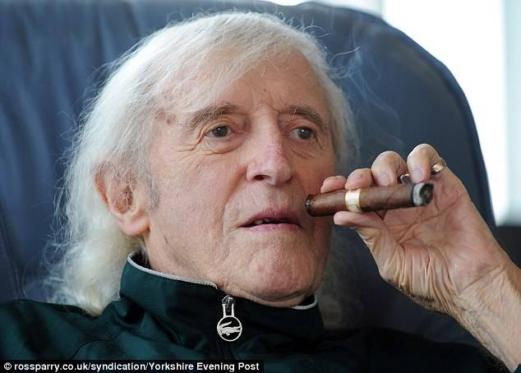
Jimmy Saville - In September and October 2012, almost a year after his death, claims were widely publicised that the radio and television presenter Jimmy Savile had committed sexual abuse, his alleged victims ranging from prepubescent girls and boys to adults. By 11 October 2012 allegations had been made to 13 British police forces, and this led to the setting-up of inquiries into practices at the BBC and within the National Health Service. On 19 October the Metropolitan Police Service launched a formal criminal investigation, Operation Yewtree, into historic allegations of child sexual abuse by Savile and other people, some still living, over four decades. It stated that it was pursuing over 400 separate lines of inquiry, based on the claims of 200 witnesses, via 14 police forces across the UK. It described the alleged abuse as being "on an unprecedented scale", and the number of potential victims as "staggering". By 19 December, eight people had been questioned as part of the investigation. The Metropolitan Police stated that the total number of alleged victims was 589, of whom 450 alleged abuse by Savile. The report of the investigations undertaken jointly by the police and the National Society for the Prevention of Cruelty to Children (NSPCC), Giving Victims a Voice, was published on 11 January 2013. It reported allegations covering a period of fifty years, including 214 alleged acts by Savile which, though uncorroborated, have been formally recorded as crimes, some involving children as young as eight. The report states "within the recorded crimes there are 126 indecent acts and 34 rape/penetration offences." Alleged offences took place at 13 hospitals as well as on BBC premises, according to the report. In October 2013 it was announced that inquiries had been extended to other hospitals. On 26 June 2014, the Secretary of State for Health, Jeremy Hunt, reported on the findings of the investigations led by Kate Lampard. He said that Savile had sexually assaulted victims aged between five and 75 in NHS hospitals, and apologised to the victims. Much of Savile's career involved working with children and young people, including visiting schools and hospital wards. He spent 20 years presenting Top of the Pops before a teenage audience, and an overlapping 20 years presenting Jim'll Fix It, in which he helped the wishes of viewers, mainly children, come true. During his lifetime, two police investigations had looked into reports about Savile, the earliest known being in 1958, but none had led to charges; the reports had each concluded that there was insufficient evidence for any charges to be brought related to sexual offences. In October 2012 it was announced that the Director of Public Prosecutions, Keir Starmer, would investigate why proceedings against Savile in 2009 were dropped. Link: http://en.wikipedia.org/wiki/Jimmy_Savile_sexual_abuse_scandal
---------------------------------------------------------------------------------------------------------

Realisation Dawns
It was at this point that I realised that something was dreadfully wrong. I rejected all of the proposed ideas (very politely, but firmly). I also called for all outstanding Criminal Records Checks to be undertaken immediately. The Criminal Records Check had been designed only to identify whether a person had committed any sexual assaults against children or had any involvement in related offences, such as child pornography. Therefore, if a person had smoked marijuana in their university days, this would not be revealed in the Criminal Record Check.
This was a policy that I had insisted on right from the start (nearly two years ago), however Bob Sisterly had given numerous excuses every time I had requested his. He even went so far as to suggest that he would organise it "on the sly" using his "contacts in the force". I did not pursue that option and instead gave the Board members two weeks to complete their forms and submit them.
Bob Sisterly, while initially embracing the policy at the start, ultimately refused to submit a Criminal Records Check.

The Significance of Shine
I discovered that there is an Australian Internet-based group called 'Shine'. The site includes a membership section where members are able to exchange photos etc, including "S&M" and "hard-core Ernie Old style". It is a child pornography club that operates similar to the notorious Wonderland club.
I noted the code-names used by the operators of the Shine site, one of which was Natas (Satan backwards). I went to the Network X site and entered a secret section on the site (which members of the public would never know about). It asked for the password, so I typed in Natas, which took me to another level. It then asked for the next level password, which I didn't have. The computer then went beserk and was almost impossible to turn off. I managed to do so only by pulling out all of the connections. Soon after this, the Internet site for Network X was shut down and remained shut down for a number of months, which is rather unusual given that Network X is such a large company.
Later that year, the Department of Education put on a concert involving thousands of children. They chose to call it 'Shine'. This was an interesting choice of title, given my experience and other people's experiences of the Department of Education protecting pedophile teachers.
A further interesting connection was that Bob Sisterly and Ron Snide organised a meeting between us and the senior managers of the Department of Education. When we all met, the men acted as if they did not know each other and were meeting for the first time (exchanging business cards, etc). However, when the men thought I was gone (I was in fact standing just out of their sight), it was very clear that they not only knew each other, but that they knew each other extremely well. They were saying things such as "Great to see you again, mate!" and slapping each other on the back!

Escape from Bob Sisterly and the Pedophile Board
After I discovered what was going on (at least, I started to discover what was going on) I knew I had to break away from Bob Sisterly, Ron Snide and the people they had put on the Board of Management. The AGM was coming up and I organised for my family to attend. We did this secretly, as we knew that the phone lines were being monitored. On the night of the AGM, the board members were visibly shocked when they saw that members of my family were attending. It transpired that, rather than undertake a Criminal Records Check, the members of the Board had planned to resign on the spot. This served two purposes. One, they avoided having to undergo the Criminal Records Check. Two, the organisation would effectively fold as there would be no-one to take up the Board member positions. This is exactly what Bob Sisterly had wanted from the beginning, but especially since I had begun to uncover the corrupt pedophile police activities and the crimes in Goldtown.
However, as my family had attended the meeting, they were able to take up the positions on the Board, and the organisation did not fold. On the surface, the meeting was very amicable and civilized, Bob Sisterly tried to remain calm, but he ended up storming out of the meeting half-an-hour early.

Mother Receives Death Threat from Bob Sisterly
My family and I all waited for half-an-hour after the meeting had closed (to recover!) before leaving. We had all come in different cars, and my mother had parked her car in a nearby car park. She walked to her car by herself. We had not learnt to be security-conscious at that stage. As she approached her car she was surprised to see Bob Sisterly there (he had left the meeting half an hour early). He then approached her and said "You had better watch yourself. If you don't, someone might just run over you". He then drove off very suddenly and another board member followed in a different car.
My mother and father told me about this incident, which had left my mother very shaken. Soon after I received a message from Bob Sisterly saying "I only want to help". I was infuriated at the evil of this man, so I phoned his office and left a message with his Personal Assistant, Jan Pummell (I didn't know the significance of her husband's relationship with Bob Sisterly and Network X at this time) saying "Bob has said he just wants to help me. Could you please tell him that it would be helpful if he could undertake the Criminal Records Check that he has avoided for so long. After all, it is designed to only reveal if the person has committed sex offences against children or related offences, like the production of child pornography. Oh, could you also tell him it would be very helpful if he did not threaten members of my family. Death threats against my family really aren't helpful. If you could pass this message on, that would be great. Thanks".
Soon after leaving this message, my mother received a letter from Bob Sisterly. In the letter he stated that he was only joking when he told her to watch out or she'd end up being run over. Yeah, real funny joke.

Report to Department of Education - Complaints and Investigation Unit
After these experiences I made a complaint to the Complaints and Investigations Unit of the Department of Education. My complaint related to the conduct of teacher Dick Newman, which amounted to repeated acts of misconduct against students, and the police investigation at Goldtown.
Interestingly, the head of the Department of Education Complaints and Investigations Unit, Paul Gibbins, was at the very first meeting I had to outline my complaint. It was after this meeting that the material, which I had been assured by Peter Gibbins would remain strictly confidential, was given to Nick Flanagan and Edith Ireland (who subsequently paid a visit to the new President of the Board in an effort to pressure me to drop the complaint). Paul Gibbins then left that posting, but "coincidentally" was brought back to it to finish off the case involving Dick Newman.
Paul Gibbins wrote a letter to me exonerating Dick Newman on all counts "because the witnesses (which I had provided) cannot substantiate your claims". As you know, of the eight witnesses that I had provided to corroborate the case, only one had been contacted - and she RE-CONFIRMED the concerns about Dick Newman. In fact, she stated that she was amazed that it had taken so long for the matter to be investigated! She was shocked to discover that Dick Newman had been exonerated and that the Department of Education had LIED about her testimony!
After I did the telephone round of the witnesses I had listed and learnt that only one had been contacted, I phoned Paul Gibbins to ask how many of the witnesses had in fact been contacted. He said that he didn't know but that he would call me back "within 24 hours". Needless to say, I did not receive a return phone call from pedophile-protecting Paul Gibbins.
I truly believe that if the parents of children attending Victorian schools knew the extent to which pedophile-teachers are being protected by the Department of Education, they would boycott the education system altogether. And if they knew the suffering that some children and families have had to endure as a result of the pedophile-protecting actions of the Department of Education, they would boycott the system on those grounds too. I am convinced if the parents of children attending the northern region secondary college knew of the monster teaching their children, and his shocking and extensive history of abusing students, there would not be a single child enrolled in that school in the future!

Leaked Document
After numerous meetings concerning the complaint (which I was told would be kept strictly confidential, particularly from Nick Flanagan and his unit), a document was leaked to me form within the Department of Education. This document revealed that the Department planned to absolve Dick Newman from all complaints. The investigation had been totally and completely corrupted in order to absolve Newman.
The grounds for this were that "no complaints of a sexual nature have been made against Dick Newman since 1995". This was unbelievable! So Newman's invitations for students to meet his penis after school were not considered to be sexual! Also, it was stated that as the schools had taken action in relation to each case, there was nothing more to be done. So, it was therefore acceptable for a teacher to commit repeated acts of serious misconduct, against multiple students, at different schools.
It was very clear that this teacher was being actively protected.

Theft of Department of Education Files
I left a message with the Minister for Education to inform her that I had received information to indicate that the investigation had been seriously corrupted. Soon after, the unit that I lived in was broken into and files containing information about the Department of Education's protection of pedophile teachers were stolen. This included a letter from a mother pleading for help as her son had been sexually assaulted by a teacher and was now suicidal. She wanted my help as the Department of Education was covering up for this pedophile teacher. Nothing else was stolen from the unit.

Visit to the New President of the Board
A new President was appointed to the Board, along with other new members. One day, the new President of the Board received a visit from one of the workers in the child protection field. This woman, Enid Ireland, approached the new President and told him that Detective Senior Sergeant Nick Flanagan knew about the complaint I had made to the Department of Education (indicating a significant breach of confidentiality). She told the new President to cease any association with me and my organisation "for the sake of your professional reputation". The incident spooked the new President enough for him to telephone me in an effort to get me to drop my complaint against Flanagan and his unit, which I refused to do. Thankfully, the new President had the integrity and courage to stick with our organisation despite the pressure he was being put under.

Anonymous reports to Crime Stoppers
Approximately 12 months had passed when I decided I would make an anonymous call to Crime Stoppers, a phone-in service where people can give anonymous tips to police about crimes. I telephoned Crime Stoppers from a public phone and informed the woman, Katie, of the pedophile network that was operating in Melbourne. She asked me to call back again with further information and I did so.
I told Katie that the network was operating under police protection and at that stage had not given her the police officers' names who were implicated. She then asked me to provide the names of the police officers who were involved. I told her that I was very nervous to do this, as my family and I had suffered very negative repercussions as a result of this group and I didn't want us to have to go through any more traumas. She spoke to her boss and he promised me that the information I provided would not go to the police officers of concern, and that the information would go straight to the Ethical Standards Division (ESD), which is the same as Internal Investigations. As she and her boss had promised that the information would go straight to ESD, I gave her the names of the officers.
When I called back again to find out how the case was proceeding I was shocked when Katie told me that her boss had forced her to send the information to Nick Flanagan's unit! The information had gone directly to Nick Flanagan!! Katie apologised and appeared to be genuinely distressed at what had happened. I asked to speak to her boss and I told him that he had promised that the material would go to ESD, and he exclaimed "Do you realise how serious your allegations are?" I replied that of-course I did - that's why I wanted the information to go to ESD, and not to the police officers of concern! He said "We don't pass on information to ESD". Katie then got back on the phone and was clearly very upset. She implored me to contact ESD and give them the information myself.

Intimidation & Harassment Begins Again
Soon after this, my family and I were subjected to harassment and surveillance. For example, nearly every day there would be a car out the front of my parent's home (where I had now moved to, for safety reasons), with two men just sitting there. The men often had large walkie-talkies. The cars often had large, thick aerials. Whenever a member of the family walked out of the house the people in the cars would speed off. However, sometimes we were followed by the people in the cars. The cars were usually very flashy, like large four-wheel-drives or dark shiny sedans. I was often followed by men in white shiny cars with the number plates beginning with VHA and was to later learn that these cars were often used as government vehicles. Sometimes I would come out of a location, say a friend's house, and there would be a man in one of the flashy vehicles just waiting there. It was very menacing and very stressful for my family and I. We also received unusual phone-calls at that time, clicking noises over the phone and sometimes the phone-calls were actively intercepted with heavy breathing or laughter or shuddering screams. My incoming mail was very clearly being interfered with.

Visits from the Mormons
One day my mother and I came out from my parent's house and there was a group of men waiting in a car out the front of our house again. They sped off when we came out, but this time I got in my car and followed them. As I drove towards them (they had turned their car around and were facing me) they flashed their lights at me. I drove around the cul-de-sac, and was shocked when I got to my parent's house again. The men were talking to my mother from in their car. I called for her to get away from the men and she replied "Its OK dear, they're Mormons". I did not believe they were Mormons and I held my hand on the car horn and chased them out of the street. A licence check on their car however, seemed to indicate that they really were Mormons, or were using a Mormon-registered car.
I did not think they would ever return (especially if they really were Mormons!). However, two weeks later I was getting into my car and saying goodbye to my mother. The same men approached my mother, not realising I was in the car. They asked if they could ask her a few questions about me. I then stuck my head out of the car window and said "If you've got any questions you can ask me!" They were very surprised that I was there and asked "Why did you chase us out of the street that day. We are just Mormons". I replied "Because some of your behaviour is most un-Mormon-like!" The man the said "Like what?" and I replied "Like flashing your lights at me". He then said "Oh, you mean when we were taking photos of you? You didn't like us taking photos of you?".
The 'Mormons' had just admitted to taking photos of me, without my knowledge or consent.
I told them to stay away from me and my family.
Soon after this I saw the same men in a different car. It was a dark, flashy sedan, similar to those that were often sitting in our street. I got the licence plate of this car and gave it to a trusted police office. He told me that the car was owned by a debt-collecting agency, or more likely, a surveillance company as they often used debt-collecting as a front. The owner of the car, however not one of the men who had been seen in the car, was a Mormon.
The Mormons were very clearly conducting surveillance on my family and me.

Reports to Deputy Ombudsman
After the problems with Crime Stoppers I decided to call the Ombudsman's office and pass on the information I had to them, including the incident with Crime Stoppers. The Deputy Ombudsman, Ian Softman, put me under a great deal of pressure to meet with him and hand over all of my information to him for investigation. I said that I wanted to meet with the new Chief Commissioner of Police, Angela Franklin, as she was dedicated to flushing out bent police. Ian Softman told me that he would try to arrange this. However, he reported that it was not possible and again put me under great pressure to give all of my information to him for investigation.
I finally did succeed in getting an appointment with the Chief Commissioner. Contrary to Ian Softman's claim that she could not meet with me, she had never been informed that I had tried to get a meeting with her through him. She was extremely annoyed when she had been left out of the loop in this way, and the incident just added to my suspicions about the motives of Softman.

Thefts of Evidence
While I was reporting information to Softman over the phone anonymously, two thefts of evidence occurred. On the first occasion, the file was stolen from the boot of the car. I had left it there for two hours while I attended to a matter at a school. When I returned I discovered that it had been taken. I rushed home to check that the copy left at my parent's house was still there. I discovered that my parent's house had been broken into, the dogs drugged, and the file stolen from a hiding place. Much was taken, including the letter of admission from Bob Sisterly (of the threat to my mother).
Luckily, I had kept a third copy with somebody else.

Fires at Network X Studio, Melbourne GPO and Celebrities Home
At this time a number of significant fires occurred. One was at a studio used by Network X. Interestingly, the copy of the network's recent multi-million dollar production had "coincidentally' been removed from the studio two days before the fire. All that survived the fire was a Sesame Street character, which took centre place in a photo of the scene in the leading newspaper's report. Within a week there was another fire, this time at the Melbourne General Post Office. All of the post offices boxes (and their contents) were destroyed, though little else was affected. Finally, again within a week, a suspicious house fire occurred in he home of a well-known television celebrity. This celebrity is a member of the same secret society as Ron Snide. All that was destroyed in the fire was a collection of videos and photographs. Interestingly, the comment of the celebrity was "It can all be put to bed now". A strange thing to say after your house has just gone up in smoke?
A further interesting incident occurred at Melbourne's largest brothel. An armed intruder stole a relatively small amount of cash from the brothel, but was led to the safe where videotapes of clients engaging in sexual activities were kept. Video tapes of clients were "stolen", including those of Greg Neckett, a frequent client of this establishment. A reliable contact informed me that the theft was actually an "inside job".
Within a two-week period, thousands of videos had gone up in smoke or destroyed.
These events occurred at the time of the reports being made to Ian Snow. It is also very interesting to note that at that time, the British section of Interpol was in Victoria conducting a "secret" investigation into child pornography.

Children Tortured or Die in Mysterious Circumstances
It was also around this time that a number of children connected to the child pornography industry were either killed in suspicious circumstances, or tortured. I was working with a young girl and was very concerned for her safety at this time. I told a trusted police officer of my concerns for this girl. A week later she had been rushed to hospital. An unregistered "tank" (her word, meaning a very solidly built car) had come out of nowhere and slammed into the car in which she was a passenger. Thankfully, she survived.

Fears for My Life
I had managed to arrange a meeting with the Chief Commissioner of Police (this was no small feat, as there had been many stumbling blocks and it appeared that there were people actively trying to prevent such a meeting). In the weeks leading up to the meeting I was in real fear for my life. On one occasion I came home late at night and saw two men sitting in a car just up from my parent's house. As no-one was home at my parent's house I drove to the top of the hill to stay with my friends. They did not hear the door-bell, and while I was standing in the street wondering where I would go, the men in the car drove up the hill very slowly, looking for me. I had all of the evidence with me (since the thefts I did not let it out of my sight) and had to quickly hide in the bushes. The men drove up and down the street no less than five times looking for me. I had to cut through the backs of homes in order to get to another friend's house, where I stayed the night. They also witnessed the men driving up and down the street looking for me.
The next evening I heard and saw the same car drive up the hill. As no-one was going to be home that evening I quickly got in my car and drove to another friend's house where I stayed the night. The next morning the friends discovered that their front light had been smashed in. No other houses in the street had been affected. However, the neighbours did report hearing strange cars driving up and down the quiet street late that night. It was after this that I wondered if I would live to be able to hand over all the information I had to the Chief Commissioner.

Meeting with the Chief Commissioner of Police
I attended the meeting with the Chief Commissioner of Police along with the trusted police officer who had investigated the house break in and thefts of the files. The Chief Commissioner believed me and was very concerned. She organised for the matter to be thoroughly investigated. The Chief Commissioner asked me if I wanted police protection for my family, which I declined (sometimes that results in more trouble). She told me I could contact her office whenever necessary.
Soon after this my unit was broken into and one of my collectable dolls had the eyes painted over. I phoned the Chief Commissioner's Personal Assistant and let her know that I would be sending the Chief a letter via registered mail. At the start of the conversation the line was clearly intercepted, which the Personal Assistant heard. She told me to call her back from a public phone. Interestingly, after letting her know that a letter was coming to her via registered mail, the Chief Commissioner did not receive it. I called some weeks later after having received no response, and was told that the letter had somehow been intercepted! All letters to the Chief are signed for, and the person who had signed for the registered letter I had sent was not known in the police force. However, after two days of the Chief Commissioner demanding to know where the letter went, it turned up with a post-it note attached 'Sorry, didn't know where to send this'. Well, to the person it is addressed to might be a start!

Ethical Standards Department Investigation gets off to a Questionable Start
I had a meeting to begin my statement to the Ethical Standards Department. It was clear that the officer appointed to the case did not believe what I had to report. While he went to have a smoke, he (accidentally) left me with the report that had been written by another police officer in response to my own report (that had been submitted to the Chief). I could see why the police officer I was dealing with was so dismissive of what I had to say. The report discredited everything that I had reported. It made a mockery of my claim that Ernie Old and other high-profile individuals were involved in pedophilia and stated that there was nothing to support my claims of intimidation and harassment. This was despite the fact that there were numerous witnesses to these events.
The author went on to say that an investigation must be seen to be conducted however, because if the information was to be made public there would be a public outcry. That is, make it look like it is being investigated, but don't do anything!
Even more disturbing was the specific recommendation that a Detective Alex Mock be appointed to conduct the investigation. Detective Mock was a close friend and colleague of Nick Flanagan's, and had in fact worked with him in his unit for many years. Indeed, Detective Mock had only left Nick Flanagan's unit three months ago to be transferred to ESD.
It was very interesting timing. At the same time Nick Flanagan receives information that someone is dobbing him in for misconduct, his close friend and colleague gets a transfer to ESD, and ends up with the job of investigating his best mate! How very convenient.

The Deputy Ombudsman Gets the Investigation
After this turn of events (I reported it all to the Chief Commissioner)., the Deputy Ombudsman, Ian Softman, was given the investigation.

Child Care Centre, Pedophile Network, Police Pedophiles and Network X
Ian Softman informed me briefly about a case in the early 1990's. I did my own research into this case and discovered that it involved a creche in the Mornington Peninsula region. A high-profile group of men were sexually abusing, torturing and hypnotising the children. The owner and his wife took the children out of the centre during the day to the homes of the rich and powerful, where the children would be sexually abused, tortured and filmed. The children were also subjected to satanic ritual abuse. This case was almost identical to those in the U.S (Little Rascals, McMartin and others).

The offenders were wealthy and powerful men in the community and included police officers
Video copies of the children being abused were obtained by Network X (How interesting it is that Network X should be involved). However, when the story went public, the video tapes went "missing" and the police claimed that they never received them.
Ultimately, the police did not take any action against the owner of the creche, on the grounds that the children were too young to be viewed as credible witnesses. While there was conclusive evidence that four of the children had been raped or sexually abused while at the day care centre, the owner was never charged.
A concerned parent with links to the underworld offered the head of a bikie group $10,000 to inflict enough damage so as to ensure that the owner of the creche could never sexually abuse another child again. The head of the bikie group said that they knew about the owner of the creche, and what he was up to, however, they could not do the job. Much as they would like to, the owner had protection from the very highest levels. He was untouchable.
When the Mornington Peninsula child-care-centre case broke, an investigative journalist infiltrated an elite child-pornography and pedophile club based in Melbourne. Its members were all wealthy and elite members of Melbourne society. It was chaired by the CEO of a major Melbourne Charitable Trust. This article included information on their use of telephone monitoring, courtesy of the group's contacts within Telecom.
The children from the Mornington Peninsula child-care-centre reported being taken to a "pink" room with a spa and other significant decor. It was in a house where the children were sexually abused, tortured and filmed (amongst other locations). Three children independently identified the house that they had been taken to, to the investigators. Sure enough, the room had been painted a dusty-pink color, and it had a spa and the other decor items described by the children. However, as you now know, no further action was taken against the owner of the child-care-centre, nor others suspected of being involved in the ring. What is most significant however, is that the pink house WAS REGISTERED TO THE VICTORIA POLICE!!
I am now working with some of the young survivors of the child-care centre and their families. It is clear that a cover-up of the highest order occurred in 1992, and the children and their families are still suffering from it.

Present Days
All of this material is currently being investigated by the Deputy Ombudsman. However, the investigation has been marred by suspicious activity. Perhaps the most significant example is the conduct of the police officer Ian Soft appointed to head the investigation, Detective Jock Westland.
My colleague, a counsellor who worked on the 1992 Mornington Peninsula Creche case, provided Jock Westland with information pertaining to a video tape that depicted police actively involved in the satanic-ritual-sexual abuse of children from the creche. This is highly significant information. However, I discovered from one of the other investigators that Jock Westland had decided not to pass this information on for further investigation. In fact, his notes read "This witness (my colleague) has no information of significance".
In addition to this, Jock Westland refused to investigate my claims of intimidation and harassment on the grounds that I was "paranoid". This is despite the fact that there are many witnesses to certain events who can corroborate my claims, and indeed, several have provided Statutory Declarations to do so.
Jock Westland has been under "investigation" for these actions for two months now, and I am yet to find out whether he will continue to be involved in this investigation. If he remains on the case we can be sure that this so-called investigation is just another example of high-level white-wash and cover-up of organised pedophilia and child pornography in Australia.
A final note on the Department of Education investigation. I received a letter stating that Dick Newman had been cleared of all charges, as the witnesses could not substantiate my claims. However, of the pool of eight witnesses I had provided ONLY ONE HAD BEEN CONTACTED and she clearly re-affirmed the concerns about Dick Newman. Another cover-up of the highest order and complete protection given to one of the untouchable pedophile elite.
P.S. All the real names of these child abusers are kept at several locations with different people. Should anything happen to me or anyone associated with me or should I or my organisation be harassed in any way, the names will be revealed immediately from several sources.
Link: http://www.declarepeace.org.uk/captain/murder_inc/site/abuse/illuminatir...

THE PAEDOPHILE AND SATANIC NETWORK IN AUSTRALIA
INVOLVING GOVERNMENT OFFICIALS, LEADING POLITICIANS,
TELEVISION EXECUTIVES, TOP TV PRESENTERS, AND THE POLICE.

A MUST READ BECAUSE THIS IS HOW IT WORKS ALL OVER THE WORLD
By Reina Michaelson
After my experience with Network Ten, I subsequently discovered that in the late 1980's Bert Newton was frozen out of the television industry due to allegations of his involvement in the production of child pornography. In addition to the above, I am now in contact with a boy who was paid $2000 a night to have sex with Bert Newton, from the ages of 15 - 18 years.
When the Mornington Peninsula child-care-centre case broke, an investigative journalist infiltrated an elite child-pornography and pedophile club based in Melbourne. Its members were all wealthy and elite members of Melbourne society. It was chaired by the CEO of a major Melbourne Charitable Trust. This article included information on their use of telephone monitoring, courtesy of the group's contacts within Telecom.
The children from the Mornington Peninsula child-care-centre reported being taken to a "pink" room with a spa and other significant decor. It was in a house where the children were sexually abused, tortured and filmed (amongst other locations). Three children independently identified the house that they had been taken to, to the investigators. Sure enough, the room had been painted a dusty-pink color, and it had a spa and the other decor items described by the children. However, as you now know, no further action was taken against the owner of the child-care-centre, nor others suspected of being involved in the ring. What is most significant however, is that the pink house WAS REGISTERED TO THE VICTORIA POLICE!!
Link: THE PAEDOPHILE AND SATANIC NETWORK IN AUSTRALIA INVOLVING GOVERNMENT OFFICIALS.doc
http://loveforlife.com.au/files/THE%20PAEDOPHILE%20AND%20SATANIC%20NETWO...
Link: DR REINA MICHAELSON ABC Stateline Claims police mishandled child sex abuse cases.txt
http://loveforlife.com.au/files/DR%20REINA%20MICHAELSON%20ABC%20Statelin...

Two Essential Viewing Videos

Satanic Ritual Child Sacrifices Exposed
We are all connected through the thread of nature that is impossible to sever unless we destroy everything including our lives and the lives of our ancestors and descendants. As much as we may wish it to be different, everything we think, feel and do affects all of life because we are ALL part of the wholeness of life. The threads that are nature/earth, our ancestors and descendants get affected by what we do to our bodies, to the bodies of others, to everything of life and all our descendants and children. We may think we are separated by our labels of Jew, Christian, Greek, French, Atheist or Agnostic but we can never sever the bonds that make us life. We are just unconscious of the effect we have on all of life because we are so distracted by all the thoughts of "The System" that keep us locked in and fallen.
The intricate web of life that is nature and all that we see which binds us all in wholeness can only be severed by fantasy, illusion, delusion, fear & trauma. Satanism is this conditioning "practice" of separation enforced. To maintain a "state" of separation between us the Satanists "craft" belief systems & put in "practice" a "System" for us to perpetuate. All occults, esoterics, science, New Age, "Oneness", race, culture, creed, system-education, commerce, as documented across their recorded ages with remote Gods, Deities, Beings, Heavens, Hells, etc, that are the basis of all fantasy, illusion & delusion that have ever appeared, existed/exist ONLY to maintain MANS separation (fallen "state"). Satanism is all about worshipping fantasy, creating fairytales of individualism (in-divide-u-all-ism) that we fall into so that we can be ruled by the inventors of the fairytale. Using them as shields, Satanists hide behind all races, cultures, creeds & systems to use MAN (us).
Satanists in the higher orders are high priests, masters of remote control, remote viewing and remote thought projection. They project thoughts into the brains of men and women so that those men and women think they are thinking/creating their own thoughts. They place value and importance on those thoughts and act accordingly, whether going to church, wheeling and dealing in commerce or even going to war and killing for those thoughts. Satanists con us into giving our life to their thoughts so that we create their world in their image. This is how we become their slaves who labour for their dream-world.
When we go to war and fight and kill, the energy of that war permeates nature. When a child is sacrificed, the energy of that trauma and fear experienced by the child is projected so that it permeates through all the web of life. That trauma and fear causes disconnection between us and between hearts and brains, creating cold intellects that consist of thoughts without consciousness/life embodied in them, and causing us to distrust and turn our backs on each other.
We are not supposed to be in the image of another MAN's thought but Satanism is all about projecting thoughts for others to live their lives out of so that we continue to destroy the life that we are. Our true freedom comes when we are no longer doing harm to each other by what we are thinking and feeling and by how we are acting when our thoughts are all for the wholeness of life. When we are doing this, we will have remembered who we really are, what we are really part of and our true purpose and Satanists and their rituals will lose all their power. Satanists perform all kinds of rituals to instil a wedge between us so that we can't come together in wholeness again. They have to keep us feeling that sense of hopelessness, weakness, powerlessness and disconnection.
Satanism is found all across Earth. Traditionally, Satanists are Aryan bloodlines who have invaded all the lands, decimated the tribes of MAN and re-educated the remains of the tribes into Satanic systems. Satanists are behind all the invading armies and all the religions and systems that have evolved. They are Levite priests - Judeo/Judaic warlocks and witches of Sion/Zion, masters of black-magic. They are not Jews and never have been, although this does not mean that some Jews are not Satanists as there are Satanists in all religions. The Jews are conquered tribes/babies who are brought up to believe they are Jews. They have been set up to be the scapegoats for the shadowy Aryan bloodlines who control the Roman Cult, the Jesuits, the Roman Catholic Church, the Church of England, the British Crown, The Crown and all financial centres. Freemasonry is a religion headed by the Levite high priests. Freemasonry protects this Satanic world, providing the camouflage for them to hide behind as master puppeteers as they pull the strings of their marionettes. This is not a "Jewish" problem; it is MAN'S problem.
Ritual Sacrifice started in Ancient Egypt & spread from there. Today, it is everywhere. All involved in the fall were once innocent babies and all have been brainwashed into belief systems that encourage harm and chaos.
It is through allowing our children to contemplate on nature that they learn to re-connect with all of life without invalidating the uniqueness of each of us and without the need for leaders and followers.
Most Satanists don't know the real significance of what they are doing. If they did, they wouldn't do it because the harm they do to others is harm to them and their loved ones. We are all connected and we are all responsible for all of life and for all the harm being done to life.
Update: 4th February 2015
We originally posted a shorter, poorer quality version of this video 12th October 2011 called
Satanic Ritual Child Sacrifices Exposed
https://www.youtube.com/watch?v=-jTdc04ODU4
in this YouTube Channel http://www.youtube.com/ArthurLoveForLife
It has since been taken down.
Update 5 Weeks Later YouTube Removed The Restrictions
Read on, below the embedded video, for more on this.
We re-uploaded this 73 minute full HD version to go with part of a series of articles called: "Darkness Visible".
Darkness Visible is about the Freemasonic networks behind "The System" and how to deconstruct their symbolism. It also covers the extensive ritual abuse of both children and adults, why these sacrifices are made and the effects they have on all of us, ultimately in keeping us trapped in the slavery of "The System", unable to see/sense the way out.
Please note that while this video focuses on ritual sacrifice in the Jewish religion, we are not anti-Jew/anti-Semitic. We recognise that ritual sacrifice goes on in ALL cultures and creeds of "The System" and has been part of all the civilisations of "The System" that there have ever been. Those behind these horrific sacrifices hide behind the races, cultures, creeds, colours, careers, titles, standings, status, etc, that they invented to keep us all distracted, divided and ruled.
We are all MAN, all brothers and sisters underneath our educated nationalities, religious affiliations, skin colour, etc, etc. We are NOT pointing the finger at the Jewish people when we talk about this subject. To us, the Jewish race is used as a scapegoat for many of the crimes of those behind "The System". We were all innocent babies once and we have all been educated into our system roles. This is not to say that Jewish people who practise these rituals should not be brought to account, just as the perpetrators hiding behind every other race, culture, creed, etc, should be brought to account. To us, it is clear that we have to get rid of this system which means also getting rid of this problem because "The System" and ritual abuse go hand in hand. In the 10 years of our research work, we have also been sharing a do no harm, life is a gift remedy that ensures that we walk away from all kinds of harm doing forever, never to return, called "The Steps Of Kindom". The link can be found at the bottom of Darkness Visible Part One.

Update - 2nd February 2015
This video has now been removed by Facebook....
Refer to full version of this 2005 documentary below called
Darkness Visible Jewish Ritual Murder Revisited The Hidden Cult
Video: Satanic Ritual Child Sacrifices Exposed ---- 26 Minutes 15 Seconds
Darkness Visible Jewish Ritual Murder Revisited The Hidden Cult
If this video has been taken down by YouTube you can watch and download it from here: http://loveforlife.com.au/Satanic_Ritual_Child_Sacrifices_Exposed.mp4
Video: Vicki Devil Worship
1989 Oprah Winfrey Show Interview
With A Jewish Woman
4 Minutes 18 Seconds
See also: http://loveforlife.com.au/node/8157
If this video has been taken down you can also watch it here: http://loveforlife.com.au/Vicki-Oprah-Winfrey.mp4
This video was originally uploaded from here:
http://video.google.com/videoplay?docid=5939595075879649961
Video: Satanic Ritual Child Sacrifices Exposed
26 Minutes 14 Seconds
This video traces the ancient Babylonian child sacrifice practices that are still done secretly today. Ever wonder why there are so many missing children across the US/Canada?????

Darkness Visible Part Six
The Many Fingers Of The Hidden Hand Appearing
YouTube Community Flagged A Video
Posted To The ArthurLoveForLife YouTube Channel
As Being "Hate Speech"
Fiona & Arthur Cristian
Love For Life
4th February 2015
Link: http://loveforlife.com.au/node/8563

YouTube Community Flagged A Video
Posted To The ArthurLoveForLife YouTube Channel
As Being "Hate Speech". This Video Is
Historical/Factual/Research-Based
And Is Being Used In A Current Court Case
Arthur And Fiona Cristian
Love For Life
4th February 2015
Link: https://productforums.google.com/forum/#!topic/youtube/FXzrP4AgrfA%5B1-25-true%5D
The video taken down is this one:
Satanic Ritual Child Sacrifices Exposed
26 Minutes 16 Seconds
http://loveforlife.com.au/node/8232
Posted: Wednesday 12th October 2011
YouTube link: http://youtu.be/-jTdc04ODU4
YouTube Community Flagged A Video Posted To The ArthurLoveForLife YouTube Channel As Being "Hate Speech".
This Video Is Historical/Factual/Research-Based And Is Being Used In A Current Court Case.
More evidence of coordinated attacks being waged against the Cristian family.
Are the wide variety of attacks being waged against the Cristian family all coincidental? We are asking everyone to complain to the YouTube Community and demand they remove the "community strike" raised against the http://youtube.com/ArthurLoveForLife YouTube Channel: https://productforums.google.com/forum/#!topic/youtube/FXzrP4AgrfA%5B1-25-true%5D and to complain to Google.com about the fact that the YouTube community is being used to attack freedom of speech.
The way it works, anyone can flag a video anonymously which means that no one is responsible and no one has to provide evidence of the apparent "hate speech" given as the reason for the video being removed. This also means that you can't face your accuser and force them to back their claims. This also means that anyone can flag a video that gives opposing views to their own and label it hate speech. Soon it will be forbidden to label a paedophile a paedophile! This also means that nefarious forces can manipulate anything they see as a perceived threat to their clandestine agendas without ever having to face recourse from those they have harmed/attacked. Welcome to Big Brother at its best. The YouTube Community can now be seen to be no different than the community behind Stalin's and Mao's Communist Parties.
The precedence that is being established here is that we will not be able to film a building site because the workers there and their families can be discriminated against because they can be seen to be doing harm to Earth. Pointing this out could be considered "hate speech". The same goes for the workers in an abattoir, or workers in a factory; just pointing out the harm being done could be considered "hate speech"! Basically, not a single video can be made now without someone or something being able to flag it, saying there is "hate speech" involved.
This may sound far fetched, but this is where freedom of speech seems to be heading. We do not condone abuse, hatred, vilification, etc, but these are very different to someone pointing out the facts of historical evidence, even if that evidence does not paint a rosy picture of a certain group of people.
We are being attacked because we are exposing ritual child sacrifice and the methods and reasons behind it. Even though we make it clear in our comments, and it is said in the video, that ritual sacrifice is to be found in ALL cultures and civilisations of "The System", it seems that the anti-Semitic card is being played here as this video focuses on ritual sacrifice within the Jewish religion. We are aware and make clear in all our comments that the vast majority of Jewish people are innocent of this but this does not mean that none of them practice it.
The anti-Semitic card is just a distraction, a red herring, to take the focus away from the fact that high level Freemasons and Satanists practice ritual abuse and sacrifice as has been uncovered by many, usually to their peril. There is no doubt that this stuff is going on and has to stop. We have to get this out so that the good people in the religions, politics, media, the Police and Military, etc, feel they have the support in the community to come out and start exposing what is really going on. Many of them know about it but are too scared to come out into the open. This is the hidden world behind the Jimmy Savilles, the Rolf Harrises, the little snippets we are given that show us that this world exists behind the front of kind and caring leaders and entertainment figures.
If we can stamp out this Freemasonic/Satanic problem, then we can all begin to heal from the affects of the abuse that is behind everything of "The System".
So far, no one from YouTube has been able to bring forward any evidence of "hate speech" in this video, a historically researched, fact based documentary. The video that was removed was an extract of a full documentary that is still viewable on the YouTube channel. Is this going to be flagged also, meaning that we have two strikes against us and will not be able to post ANYTHING for 6 months and will possibly have the whole You Tube channel removed? This is the first complaint we have ever had since the channel started around 2008/2010.
Please could all of you reading this, start pushing it out there. Post it all over Facebook and through all your networks so that people are aware of what is really going on here. This is freedom of speech being blatantly attacked. Go through the Google networks and start posting it in to their various offices and particularly their legal departments, as well as to YouTube. The more of us who do this, the more we stand up for our freedom of speech and thought.
Just reading this is not enough. What we are getting to here is just who is behind the New World Order, the ritual abuse, fracking. global warming, vaccinations, eugenics, etc. They are starting to show themselves and this is how we destroy them. When we do everything out in the open, they have to come out into the open to attack us and this is how we know them.
We are just a family that is clean living and has had enough of children going missing and children, adults and animals being sadistically, ritually and sexually abused. Who feels the same way?
Are you willing to put in 20 minutes a day pushing this out there? Push it to your local Police departments, politicians, churches, and community groups, journalists, alternative and mainstream news channels, etc. Get it out to all the Alex Jones, anyone who has a media outlet alternative or not, especially those who claim to stand for freedom. Put them on the spot - what do they really stand for? If they do not do something, they are showing where their allegiance is. If they are good people, they may feel motivated to do something. If they are in on it, they are getting a warning that we have had enough of living in an unsafe world with corruption in every area of public life. If people read Darkness Visible Parts One to Six (links below), the threads that connect all this are plain to see.
Can all these attacks over the last few months really be coincidental?
Fiona & Arthur Cristian
Love For Life
Copied from here:

Video: Oprah Winfrey - Interview With Rachael
The Jewish God Is Satan - Ritual Sacrifice Of Babies
Worshipping The Devil
14th October 2011
http://loveforlife.com.au/node/8157

Jewish Professor Admits Jewish Cult
Engaged in Past Jewish Ritual Murders
9th February 2007
http://www.honestmediatoday.com/professor_admits_jewish_ritual_murder.ht...
According to a recent report by the newspaper "The Guardian," Jewish Prof. Ariel Toaff, who is a professor at Bar-Ilan University in Israel of Medieval Jewish history but is currently a visiting professor in Italy, has written a book,"Pasque di Sangue" (Easter of Blood), which describes Jewish ritual murder rites of Jews in the past.
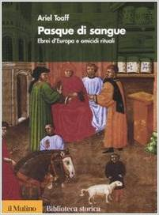
Some details of the book were published in the paper "Corriere Della Sera," which also has an online section describing the book.
Prof. Toaff's book reportedly "describes the mutilation and crucifixion of a two-year-old boy to recreate Christ's execution at Pesach, the Jewish Easter. The festival marks the fleeing of the Jews from Egypt and Prof Toaff says Christian blood was used for 'magic and therapeutic practices,'" noted the Guardian. Further describing the bizarre and hateful customs of Jewish extremists, Prof. Toaff noted that Jewish occultists would sometimes mix blood in their matzo balls, which was eaten during their religious rites.
He also describes many children who were reportedly crucified on the cross.
Unsurprisingly, many Jewish supremacists quickly denied Prof. Toaff's accurate findings in an attempt to hide their ancient, bizarre, and frightening customs from the general public.
However, Prof. Toaff was hardly the first to acknowledge such crimes in recent times. Indeed, in more recent times, a Jewish lady had appeared on the Oprah Winfrey show several years ago and described how some of her relatives had engaged in similar crimes. The honest and brave Jewish lady, Vicki Polin (who used the pseudonym of "Rachel" on the Oprah Winfrey show to avoid reprisals), told of how her family had engaged in some extremely bizarre Satanic Jewish kabbalistic rites, including that of infanticide (video of Oprah's interview with Polin). http://www.youtube.com/embed/n7QXz6hDtxI?hl=en&fs=1 or http://loveforlife.com.au/node/8157
If this video has been taken down you can also watch it here: http://loveforlife.com.au/Vicki-Oprah-Winfrey.mp4
-----------
From here: http://www.amazon.com/By-Ariel-Toaff-Blood-Passover/dp/B00N4GNLIK/ref=pd...
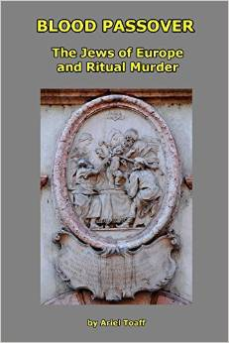
Blood Passover Paperback
The Jews Of Eurupe And Ritual Murder
by Ariel Toaff
(Amazon.com June 30, 2014
BANNED for it's subject matter, search the web
By AeroEngineer on December 26, 2014
This is the book that Toaff had to very quickly withdraw because he was facing arrest and even death by the religious police that the Jews have worldwide. Of course to any non-programmed/ignorant person, ritual human sacrifice, in regards Jews to Chrisitians, has been documented by many authors for hundreds of years. Who owns the press? Who owns most "princes/kings etc"? Those who are of the devil and are skillful in his ways. Usury,drugs,porn,human slavery,gluttoney,hollywood, news, federal reserve/central banking scam, etc etc etc these are the practical tools of black magic embodied by the satanic Solomon's seal or if you like the "star of David" deception.
Now I have to believe that Toaff himself is a Sephardic(Spanish/Portuguese) Jew since this book limits itself to castigating the Ashkenazis(Khazars from southern Russia with NO connection whatsoever to Palestine or the Hebrews of old). The Ashkenazi make up the VAST majority of Jews today, of the ones that are openly Jews and not Crypto-Jews like the whole British Oligarchy, including the Saxe-Gothas(Germans) or Windsors, that is not outwardly Jewish. So this represents the Sephardics responding to the German Ashkenazi Yiddish speakers cruelties. As if the Sephardics, which include the Marrano Crypto Jews like the Castros of Cuba, Franco of Spain, Torquemada of the Inquisition and many other butchers and slave masters. Sephardics are also proven to have sold castrated young Christian boys to the Moors of Spain among any number of other foul practices for the ultimate symbol of their God: Money.
Most people do not realize that there are both native Jews in all countries like the Falasha of Africa and others that go by other names that practice cladestine Jewry and like all Jews are not loyal to any country but to their beloved world domination schemes known as Zionism. I've had personal experience with this sort of attitude of brazen arrogance which is extremely dangerous to the well being of the rest of humanity. Just read real, not "popular" history like what Communism, Illuminism, Socialism and Monopolistic Capitalism have in common besides hundreds of millions of dead people.
Crypto Jews are even more dangerous. The Bushes are Cryptos, the Rockefellers are Cryptos, Hillary Clinton is one. Because we make decisions based on simple trust these are more dangerous than the openly practising Jews. They have Kahals or local community councils that answer to higher counsels and a supreme council worldwide which I believe is based in Tel Aviv, New York or London. It was in Lhasa,Tibet before the 20th Century. Freemasonry is controlled by the Bnai Brith Jewish lodges and the ADL. If those dupes would simply think about what Solomons Temple and the rituals represent, kabbalistic indoctrination, they would run from the lodges.
Now the author also skillfully avoids talking about the Talmud, which is a very dangerous and offensive tome of superstitions and insults towards Christianity and anyone not of the Jewish "faith". It is heavily censored when even available to non-jews. The Steinsaltz edition, which had the least amount of censorship, was stopped at 22 volumes of the planned 63 due to this fact. The Talmud is the base book of Judaism not the Old Testament, most people don't even have a clue about this or even what it actually says. The esoteric version of Judaism is the Kabbalah, an astrological system that is entirely deterministic and materialistic. Beware any system of beliefs that have an outward exoteric for the dupes version and an inward esoteric for the "priests" version. I recommend Michael Hoffmans Judaism Discovered book for further study of the Talmud and what it says in the Rabbis own translations and words.
All in all it's a decent book that goes into some detail over the Simon of Trent ritual human crucifixion and bleeding out for Passover blood powder to be shared by the Jews in the vicinity in their wine and in their bread for the holiday. I believe they used it in the Purim "celebration" of 75,000 dead Persians, why is it always bloody and full of revenge with their "holidays"? The witness records of the time also testify to being part of many other Christian male under 7 years old abduction, ritual murder and bleeding out for the blood trade between Jewish communities in Europe and elsewhere. It's really vile and macabre the things that are done ritualistically to the dead and crucified little boy as well, all explained and corroborated by reference to Jewish sourced literature and other eye-witnesses in other towns at other times throughout Europe. Toaff is to be commended for at least trying to be open and honest about this vile practice even if it's really just to shame the Ashkenazis and probably not to expose the vile practices of thier "religion".
Link: http://www.amazon.com/By-Ariel-Toaff-Blood-Passover/dp/B00N4GNLIK/ref=pd...
and from this link: http://www.amazon.com/Pasque-sangue-dEuropa-omicidi-rituali/dp/881512187...
A censored classic - the author was driven to recant
By Michael Hoffman on June 25, 2014
Format: Hardcover
"Blood Passover" is an exceedingly erudite and well-argued revisionist history of the supposedly discredited "ritual murder" charges ("blood libel" in the jargon of Orthodox Judaism and its sycophants). Triumphantly presented as a complete fantasy of "evil Christian hatemongers," Toaff, the son of the former Grand Rabbi of Rome, challenged the consensus and demonstrated that Ashkenazi Judaic persons were to some extent guilty as charged.
For daring to offer evidence of that guilt, Toaff was hounded and persecuted in the usual fashion, threatened with loss of career and even an Israeli jail cell. He soon enough recanted and withdrew his book from circulation. Western intelligentsia shamefully failed to come to his aid, and we are left with no authorized English translation. The Italian-language first edition is obscure, existing only on the margins, which is what the enemies of Truth desired for it and the only means they have to combat it.
If this had been the fate of a scholarly book exposing Muslim or Christian guilt for the murder of the innocent, there would have been an international uproar in its defense and the author would be a cause celebre. Instead, the supposedly brave paladins of freedom of speech in the West slink away in fear and cowardice in the face of the enormous machinery of intimidation which targeted Toaff. The story of his book's creation and the disgraceful assault on its author is worthy of a book itself, but don't hold your breath waiting for it to appear.
[Hoffman is the author of "Judaism's Strange Gods"]
-----------
and
Read ONLY the RARE FIRST EDITION,
the 2nd edition was revised under the most severe duress
By Terry Dolorosa on August 25, 2014
Format: Hardcover
Be careful to buy and read ONLY the RARE FIRST EDITION. Under intense pressure, including death threats, the first edition was withdrawn and recalled within 1 week of its release. The second edition followed, the author's key research findings were revised under the most severe of duress, and the proceeds were allegedly promised to the Anti-Defamation League of B'nai B'rith.
Being so rare, FIRST EDITIONS are very expensive collectors' books, but, if you search online, you can find both the original FIRST EDITION in Italian and the excellent English translation.
Link: http://www.amazon.com/Pasque-sangue-dEuropa-omicidi-rituali/dp/881512187...

Actor Jeremy Kewley charged with more than 100 child sexual offences
By the National Reporting Team’s Sam Clark
Updated about an hour agoThu 18 Dec 2014, 12:10pm
Posted on December 18, 2014 by hojuruku
This hit the news in the last hour – and just as it happened I did a radio interview on truthnews.com.au airing this Saturday about them 2 days ago!
Actor Jeremy Kewley charged with more than 100 child sexual offences
By the National Reporting Team’s Sam Clark
Updated about an hour agoThu 18 Dec 2014, 12:10pm
Jeremy Kewley Photo
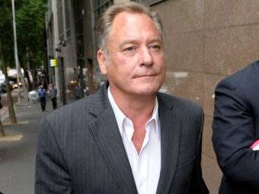
Jeremy Kewley appeared in a number of popular Australian TV series (jeremykewley.com.au)
Melbourne actor Jeremy Kewley, best known for his role in the 1990s ABC television series Janus, has been released on bail after facing court charged with more than 100 child sex offences.
The 54-year-old from Brighton was arrested this morning and charged with 103 counts of indecent acts with a child under 16 and two counts of possessing child pornography.
The child sex offences allegedly occured in 2011. (& before no doubt)
A police summary of the alleged offences read out in court stated images of young boys were found on his computer when he was first arrested in August.
Police have alleged he advertised for young men to take part in screen tests in June and July, and 27 boys applied.
The court heard Kewley allegedly made videos in which he inappropriately touched the boys, kissed them, and simulated sex with them while they with wore tight lycra suits.
The prosecution did not oppose bail and strict conditions were put in place to allay police fears he could reoffend or interfere with witnesses.
He will return to court in March.
Kewley started his acting career in Fred Schepisi’s 1976 film The Devil’s Playground.
He appeared in multiple episodes of hit series Neighbours, Stingers and Blue Heelers, and was also the warm-up act for the AFL Footy Show.
----------
A full write-up on the significance of this will be done tonight. (Sanitised) sued an anti-pedophile charity CSAAP nearly a decade ago. Now they have been vindicated, not before Dyson Divine and Vivivanne Legg were jailed.
Remember to see my very first post as assistant editor here (the last link on this post) to see what I said about it earlier.
Here’s what I already wrote about it in a bio for a radio interview on the OTO I did just two days ago as it happened. The audio is released on Saturday on Truthnews.com.au – now this happens vindicating all my claims.
A Coffs harbor couple jailed for exposing channel 10 paedophile ring years ago in a case of “Religious” vilification… I did a radio interview on the topic of the (Sanitised) jailing those heretics who oppose their practices the night before last as it happens…..
You wanted to know more about this story – well here you go!
http://www.abc.net.au/news/2014-12-18/actor-jeremy-kewley-arrested-over-...

THE HUSBAND AND WIFE, VIVIVANNE LEGG/DYSON JAILED UNDER VICTORIAN LAW FOR BEING AGAINST SATANISM WERE FROM COFFS HARBOUR IN NSW AUSTRAILA.
Do you know where that is?
Your electorate. I’d pay special attention to this if I were you Robert. You can talk about that matter alone can’t you as it doesn’t relate to the inquiry?
I please I beg you I hope you care that members of your own electorate are not being jailed for the crime of not respecting Satanism. If don’t you want the blood of innocent Australian’s flowing on Sydney Streets (I’m trying to prevent that here with this email!) then please address why our state governments and judiciary are saying that it is a crime to dissent against (Sanitised) – painting Australia as a nation of infidels in the eyes of moderate Muslims. Attorney General George Brandis on the 7:30 report says we are targets because “our nation holds strongly the ideal of protecting minorities”. I think he’s exactly right. When can our country put minority politics last for the SAFETY OF THE MAJORITY?
Case law – couple jailed for refusing to ABIDE BY A COURT ORDER TO REMOVE MATERIAL:
http://www.austlii.edu.au/cgi-bin/sinodisp/au/cases/vic/VCAT/2007/1484.h...
http://www.austlii.edu.au/cgi-bin/sinodisp/au/cases/vic/VCAT/2007/2470.h...
Link To Victims of Gay Bullying Website:
See also:

GaiaGuys.net Website Has Been Shut Down
Sometime Between November 2007 and January 2008
http://loveforlife.com.au/node/3488
Gaiaguys.net shut down by VCAT for contempt.
Posted January 26th, 2008 by Anonymous
From Sydney Indymedia
Two founders of an internet whistleblowing site have been sentenced to nine months gaol for contempt of court by the Victorian Civil Administrative Tribunal. (VCAT) Dyson Devine and Vivienne Legg were well known in the online community and their website " Gaiaguys.net " covered various topics such as:
* FIGU material and the Disclosure project.
* Alternate energy sources and environmental issues.
* Crop circles and chemtrails.
* Corruption in the media and government by various guilds and groups.
It was the latter that landed them in hot water when they accused a group in being involved with a (Sanitised). The group was classed as a registered religion and bought religious vilification charges against Devine and Legg at VCAT in July 07. Gaiaguys was ordered then to remove the offending material which they failed to comply with. In December 07 the orders were made to arrest both parties for contempt of court.
This is the first time religious vilification has been used in Australia to this extent. There was a case before of Catch the fire ministries vs. The Australian Islamic council. But both sides settled matters in mediation after spending one million plus dollars each. This is a heinous blow to freedom of speech in this country and both Dyson Devine and Vivienne Legg are political prisoners.
Continued here: http://loveforlife.com.au/node/3488
Apology frees jailed couple
Barney Zwartz - February 29, 2008
http://www.theage.com.au/news/national/apology-frees-jailed-couple/2008/...
Dyson Devine and Vivienne Legg Upper Coldstream Road Tyndale NSW
To The Secretary Of The Standing Committee On Environment And Heritage
Parliament House Canberra ACT 2600
http://www.docstoc.com/docs/34617853/Dyson-Devine-and-Vivienne-Legg-Uppe...

THE PAEDOPHILE AND SATANIC NETWORK IN AUSTRALIA INVOLVING GOVERNMENT OFFICIALS, LEADING POLITICIANS, TELEVISION EXECUTIVES, TOP TV PRESENTERS, AND THE POLICE.
Also see: Australian Freemasons win lawsuit against ‘whistleblowers’ site
(and forthcoming posts here showing that Vivivanne Legg and Dr Reina Michaelson were right about the Channel 10 Victoria Pedophile Ring exposed in the previous post here)

A MUST READ BECAUSE THIS IS HOW IT WORKS ALL OVER THE WORLD
By Dr Reina Michelson – PhD & Young Australian of the Year Finalist

OTO Member Convicted For Child Porn
Submitted by Lukes Dad
on Tue, 06/03/2014 - 03:46
For those who doubt there are paedophiles in the pagan ritual society here is evidence...
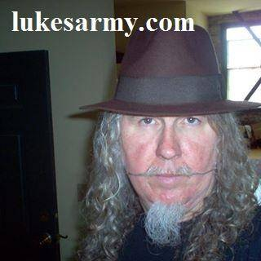
Three locals among NC child porn sweep
Submitted by WWAY on Thu, 10/27/2011 - 11:17am.
WILMINGTON, NC (WWAY) -- Three men from our area are among 24 people arrested in a statewide child porn crackdown called Operation Spyglass.
They include Bruce Wayne Lorette, 32, who the SBI arrested October 20 in Brunswick County on ten counts of Third Degree Sexual Exploitation of a Minor (Possession of Child Pornography).
Daniel Joseph Nilsson (photo, above left), 32, of Surf City was arrested on August 17 and charged with six counts of Second Degree Sexual Exploitation of a Minor (Distribution of Child Pornography). Nilsson is a USMC Captain.
Ivey Floyd Cook (photo, above right), 48, has been in the New Hanover County jail since October 18 under $50,000 bond. He faces three counts of Second Degree Exploitation of a Minor (Distribution of Child Pornography).
Attorney General Roy Cooper and the state's three federal prosecutors say advances in Internet investigation technology are allowing them to find and arrest child pornography traffickers without anyone calling in tips.
Cooper says investigators serving search warrants to seize computers found hundreds of thousands of illegal photos and videos of abused children, some as young as three.
Cooper says child porn cases require lots of time and effort to track and prosecute, but technology is making the hunt easier.
--The Associated Press contributed to this story.
Link: http://www.wwaytv3.com/2011/10/27/three-locals-among-nc-child-porn-sweep
Link: http://holliegreigjustice.blogspot.com.au/2014/11/lukes-army.html
Link: http://www.lukesarmy.com/content/oto-member-convicted-child-porn

Broken Rites Australia
Researching the Catholic Church cover-up
Since 1993, Broken Rites Australia http://www.brokenrites.org.au has been researching the cover-up of sexual abuse in the Catholic Church. Too often, the church supported the offending clergy while ignoring the victims. In just the one page we looked at, there were more than 350 cases of different types, suggesting that the number of victims comes to many, many hundreds. In just one case, from 29th December 2014, a priest, Bernard Kevin McGrath (formerly a member of the St John of God Brothers), was charged with 252 counts of sexual abuse on 35 disabled boys. When you add all the rest, plus cases from other denominations plus cases from non-religious areas of "The System", you begin to get an idea of how extensive the problem is. From Wikipedia: "In 2004, the John Jay report http://en.wikipedia.org/wiki/John_Jay_Report tabulated a total of 4,392 priests and deacons in the U.S. against whom allegations of sexual abuse had been made." From this link: http://en.wikipedia.org/wiki/Roman_Catholic_sex_abuse_cases_by_country it states: "In a statement read out by Archbishop Silvano Maria Tomasi in September 2009, the Holy See stated "We know now that in the last 50 years somewhere between 1.5% and 5% of the Catholic clergy has been involved in sexual abuse cases", adding that this figure was comparable with that of other groups and denominations".
About Us
Since 1993, Broken Rites Australia has been researching the cover-up of sexual abuse in the Catholic Church. Too often, the church supported the offending clergy while ignoring the victims. For example, Broken Rites has shown how the church shielded the criminal priest Father Gerald Ridsdale for 32 years without reporting his crimes to the police. Finally, in 1993, some Father Ridsdale victims contacted the police. These victims also contacted the newly-formed Broken Rites.
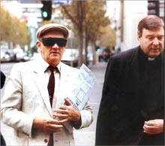
This photo demonstrates why Broken Rites was needed. In the photo, Catholic priest Gerald Ridsdale (left, in sunglasses and hat) walks to court, accompanied by his support person (Bishop George Pell, then an auxiliary bishop in Melbourne), when Father Ridsdale was pleading guilty to his first batch of criminal charges in May 1993. But no bishop accompanied the victims, who felt deserted by the church leaders. Therefore, since 1993, Broken Rites research has supported many of the Catholic Church's victims, as shown on this website http://www.brokenrites.org.au/drupal/node/246.

Trapped Inside Australia’s Vast Child Abuse Network
Fiona Barnett details the shocking systematic abuse she saw and was subjected to from an early age, along with her battle to expose the sinister, well connected and highly organised network behind it.
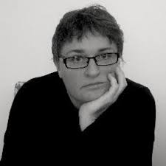
"The ring which abused Fiona included police officers, psychiatrists, biochemists, psychologists, actors, writers, politicians, university lecturers and medical doctors, including a local Engadine GP named Doctor Mark." In this article Fiona goes on to say that abuse was also orchestrated by a former Whitlam Government Education Minister Kim Edward Beazley, a police commissioner, an Australian sporting icon, a Sydney University lecturer and a prominent screen actor."
Fiona says that many Nazis went to Australia after World War II and that the top Nazis were pedophiles. Reportedly, the Sydney area has a major paedophile ring, made up of Nazis, Catholics, policemen, academics, politicians, the CIA and others. Thousands of Nazi war criminals were knowingly offered asylum in Australia. This is documented in the book, Sanctuary! Nazi Fugitives in Australia and various newspaper articles.
Fiona says "the network also involved former CIA and U.S. military psychologist Dr John W. Gittinger, the developer of the Personality Assessment System. That Dr. John Gittinger raped and abused Fiona. And this child trafficking ring also engaged in other crimes including gun and drug trafficking. Fiona witnessed multiple acts of child abduction, drugging, child sexual assault, torture and murder. Members of the paedophile ring were sexually aroused by necrophilia, bestiality and sadism. The ring also contained a large number of female perpetrators.
Fiona witnessed child sex trafficking between Sydney, Wollongong, Bathurst, and Canberra. At age of 15 years, Fiona witnessed the wife of an Engadine police officer lure a 15-year-old boy into her car at Cronulla Beach. The boy was murdered. Fiona witnessed multiple acts of child abduction, drugging, child sexual assault, torture and murder. Members of the paedophile ring were sexually aroused by necrophilia, bestiality and sadism.
The ring also contained a large number of female perpetrators. Crimes were committed in the Engadine BoysTown chapel; Holsworthy military barracks; Regina Coeli Memorial Catholic church; St John’s College Catholic Chapel at Sydney University; The Caltex oil refinery in Kurnell; Garrawarra Cemetery; Bathurst City Hall "a traditional venue for paedophile orgies during the 1970s and 1980s." and in many of the national parks located between Sydney and Wollongong.
Link Part One: https://independentaustralia.net/life/life-display/trapped-inside-austra...
Link Part Two: https://independentaustralia.net/life/life-display/trapped-inside-part-2...
Link Part Three: https://independentaustralia.net/life/life-display/trapped-inside-part-3...

Nicole Kidman's Father Antony Kidman Accused
Of Being Part Of A Sydney Based Paedophile Ring
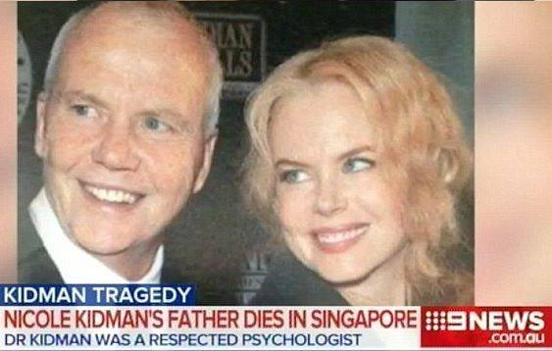
In this article Fiona Barnett also states that Nicole Kidman's father Antony Kidman was the main perpetrator of her childhood abuse. Kidman was, I allege, part of a Sydney-based paedophile ring of which I was a victim up until the age of 15. What is undisputed is that, at the time of his death, Kidman was under investigation by the NSW Health Care Complaints Commission (HCCC), the Psychology Council of NSW and, presumably, the Royal Commission into Institutional Responses to Child Abuse, as well as the police.
Since 1986, I have reported Kidman’s crimes to health professionals — none of whom adhered to mandatory reporting legislation, until 2008. In 2008, I reported Kidman’s involvement in a Sydney based paedophile ring to the NSW Police, specifically Justin Hadley, who is currently based at the Dee-Why station.
In 2013, I formally reported Kidman as a perpetrator of child abuse to the Royal Commission at a private hearing in Brisbane. Later in 2013, I made an application to the NSW Victims of Crime, naming Kidman and other perpetrators. NSW Victims of Crime used subpoenaed medical and other documents (dating back to over 20 years) to determine on the balance of probabilities that I was, indeed, a victim of crime. 7th September 2014 Antony Kidman, died suddenly in Singapore.
Link: https://independentaustralia.net/life/life-display/antony-kidman-dies-am...
Also, check out
Was Nicole Kidman’s father in a Satanic-Pedo ring?…
September 15, 2014 By IlluminatiWatcher
http://illuminatiwatcher.com/nicole-kidmans-father-satanic-pedo-ring

FRANCA ARENA VERSUS THE CHILD ABUSE RINGS
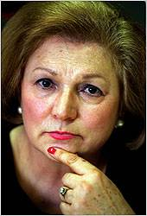
In 1996, in Australia, Franca Arena (above) suggested that retired Supreme Court judge David Yeldham and former New South Wales MP Frank Arkell should be investigated as possible child abusers. In 1996 Franca Arena was keen that the Royal Commission into the New South Wales Police Service should investigate child abuse allegedly carried out by judges and lawyers. When she named retired Supreme Court judge David Yeldham and former New South Wales MP Frank Arkell, both men strenuously denied being child abusers. However, Yeldham was discovered to be involved with boy prostitutes, and he died in mysterious circumstances on 4 November 1996.
Frank Arkell was murdered on 26 June 1998. Franca Arena was, until 1999, a member of the New South Wales Legislative Council. Police apprehended Yeldham at least twice after complaints were made about his behaviour in lavatories. In December 1988 he was found in a cubicle with another male. No charges were ever laid against him. His case was handled by the Special Branch, which appears to have let him off the hook.
Yeldham admitted that he always paid money to men to have sex with him. He maintained that he "could tell by looking" if one of his "encounters" was under 18.
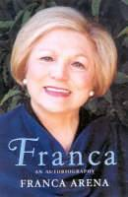
Franca arena claimed that an unnamed New South Wales judge was a Satanic murderer. The Royal Commission into the New South Wales Police Service cleared Yeldham and Arkell of any wrongdoing, and found that Arena's claims of a high-level cover-up of child abuse activity were "false in all respects". In 1999, Arena stood for re-election under the name of a new party, the "Franca Arena Child Safety Alliance". She received only 0.4 percent of the vote, and immediately announced her retirement from political life.
Link: http://aanirfan.blogspot.com.au/2014/12/franca-arena-versus-child-abuse-...

2014 Australian Analysis On Sexual Abuse
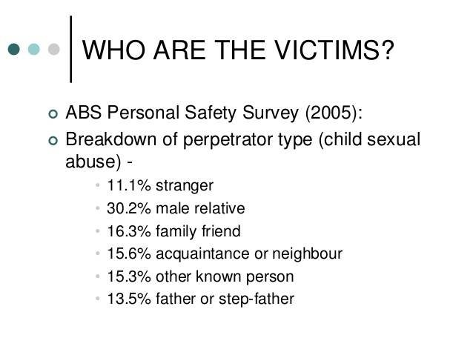
This analysis shows that the most common perpetrators of sexual abuse towards children are those with no biological links to the child. And we send our children to schools with strangers, to Churches with strangers and to sporting bodies with strangers. We put them in all sorts of situations where they are with strangers. This is not to say that the majority of teachers, priests, etc, would never sexually abuse a child, but our children only have to meet one who does and their lives can be ruined.
From the The New Silence: Family Breakdown and Child Sexual Abuse by Dr Jeremy Sammut 30th January 2014 http://www.cis.org.au/images/stories/issue-analysis/ia142.pdf it says: "According to the Personal Safety Survey conducted by the Australian Bureau of Statistics (ABS) in 2005, 12% of Australian women and 4.5% of Australian men were sexually abused before the age of 15. Of those who had experienced sexual abuse as a child, 30.2% reported being abused by a male relative, 16.3% by a family friend, and 15.6% by an acquaintance/neighbour. Sexual abuse by ‘father or stepfather’ was reported by 13.5% of all victims.
The Australian Institute of Health and Welfare’s (AIHW) annual report on child protection provides more but still incomplete insight into the relationship between family structure and child maltreatment. In 2009–10, 17% of families with dependent children were single-mother families, according to the ABS’ Family Characteristic Survey. In 2011–12, ‘female single parent families’ accounted for 29% of all substantiated cases of all forms of child abuse and neglect (including physical and emotional abuse, neglect, and sexual abuse). The 7% of step- and blended families accounted for the third-highest proportion (13.7%) after two-parent intact families (36%). Non-traditional families were substantially over-represented, with the 24% of step-, blended and single-mother families accounting for over 42% of all proven child abuse cases.
While the number of substantiated cases of child sexual abuse is published annually by the AIHW (there were more than 5,800 cases Australia-wide in 2011–12), the official statistics are not transparent. The AIHW does not provide a breakdown for different kinds of abuse according to perpetrator or even family type. The ABS’ ‘Recorded Crime—Victims, Australia, 2011’ reports that more than 6,500 children aged 0 - 14 were sexually assaulted in 2011 — almost 40% of all sexual assaults recorded. The vast majority of children were assaulted by an offender ‘known to victim’—a broad category—and very few by ‘strangers.’ However, like the AIHW figures, no specific information is given about family structure, the identity of perpetrators, and their relationship with the abused child. The silence of the statistics regarding this crucial information should be corrected by the agencies responsible in the interests of transparency and informed discussion on child sexual abuse."
To us, all these figures and statistics are just the tip of the iceberg of the extent to which child sexual abuse is running rife all across Earth. All this abuse and sacrificial rituals are done for a reason, aside from the chains of abuse that come when the abused becomes the abuser who also becomes the abuser. It is all to do with "The System", what keeps "The System" going and how it all works. You, the reader will need to read, contemplate and scrutinise because much of what we say comes from way out of the box, but please hang in there and think about what we have to say. In Darkness Visible, we have laid everything out as simply as possible so that you can see the bigger picture of what is going on in "The System" and how all the abuse is tied into Freemasonry and the Grand Plan to get MAN to commit spiritual suicide. If we were to write a book on this subject, it would go into many, many hundreds of pages but we don't have the time to do that so we have written the article and included discussions from Facebook that are relevant, other articles that we have written, videos from other researchers and from us, and other bits and pieces that bring together the big picture.
You will need to use your senses and go where the logic of truth takes you. You have to break away the veils of the belief systems that are all Freemasonically designed and be prepared to accept that life under "The System" is not what you thought it was. We explain the difference between sense and non-sense, because many people think they are using sense when they are not at all. They are using the non-sense in their heads, which is all the thoughts put into their heads by Freemasonic psyop programs. This is all explained in Darkness Visible.
If you do not use your senses and recognise the difference between sense and non-sense, between first party and third party, between consciousness and unconsciousness, between life and death (living dead), between harm and do no harm, the penny will not drop. If you filter everything you read here through your belief systems, you will never comprehend what we are saying because you will not recognise how you have been duped and how you have fallen for it. Our commitment is to inspire you to step outside your belief systems so that you can truly scrutinise what we say logically, unclouded by e-motion. We give you lots of bits and pieces and encourage you to use your brain so that you can see/sense Darkness Visible rather than being blind to the darkness all around. It is only when we face the dragon that we conquer the dragon.

International Centre For Missing And Exploited Children

An estimated 8 million children will go missing this year

Another 2 million children will be victims of commercial sexual exploitation

2 million will be found

The other 6 million children will never be found
It is my privilege and honor to serve as Chairman of the Board of the International Centre for Missing & Exploited Children (ICMEC), an extraordinary organization that leads the fight to eradicate child abduction and child sexual exploitation around the world. An estimated 8 million children will disappear and another 2 million will fall victim to sexual exploitation in just this year alone. This crisis is large, growing and underappreciated – and the global community’s response is not adequate to reverse this horrifying trend.
These acts not only affect the hearts, minds and souls of our young; they are also detrimental to their physical health. This must be viewed for what it is – a growing public health crisis. I call on the health care community, the pharmaceutical industry, medical institutions and related sectors to support ICMEC’s efforts by providing guidance, networks and financial resources as we raise global public awareness around the world. Please join us in our work to create a safer world for our children.
Dr. Franz B. Humer
Chairman of the Board

Making the World a Safer Place for Children
The International Centre for Missing & Exploited Children (ICMEC) leads the global movement to protect children from sexual exploitation and abduction. ICMEC is a non-governmental, nonprofit organization that relies solely on individual and corporate donations to operate, spending 95% of revenues on programs and services. It is a sister to the renowned National Center for Missing & Exploited Children that is based in the United States.
The mission of the International Centre for Missing & Exploited Children is simple: to make the world a safer place for children. To address the unique issues surrounding international abductions and child sexual exploitation, ICMEC provides advice, training and support to governments, policy makers, law enforcement, prosecutors, industry, civil society and others across the globe. 95% of revenues is spent on programs and services.
Continued here - Full Download 20 x A4 page PDF: https://www.scribd.com/doc/254042507/International-Centre-For-Missing-An...
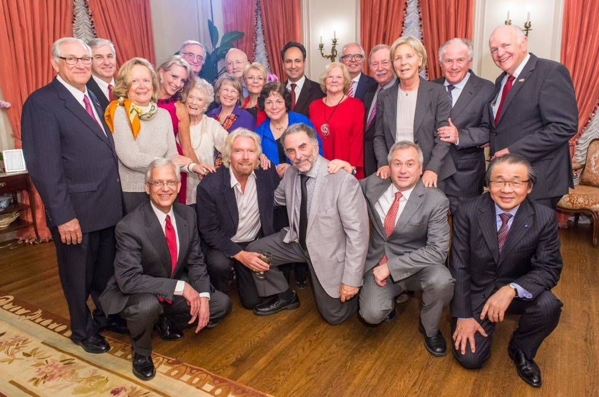
Honorary Board Mrs. Margarida Sousa Uva Barroso Wife of the President of the European Commission, Mrs. Bernadette Chirac Former First Lady of the French Republic, Her Royal Highness Princess Bajrakitiyabha Mahidol of Thailand, Valentina Matvienko Chairwoman, Federal Council of the Federal Assembly, Russian Federation, Her Royal Highness Princess Lalla Meryem of the Kingdom of Morocco, Her Majesty Queen Paola The Queen of the Belgians, Her Majesty Queen Silvia of Sweden. Board of Directors Dr. Franz B. Humer, Chair Chairman, Roche Holding Ltd, Baron Daniel Cardon de Lichtbuer, Chairman Emeritus Honorary President, Missing Children Europe, The Honorable Mary Banotti, Vice Chair Former Member, European Parliament, Victor Halberstadt, Vice Chair Professor of Economics, Leiden University, Mihaela Geoana Secretary President, FOCUS (Romania), Ambassador Elizabeth Frawley Bagley Senior Advisor to the Secretary of State U.S. Representative to the U.N. General Assembly, George W. Bickerstaff Managing Director, MM Dillon, Maud de Boer Buquicchio President, Missing Children Europe, Professor Ernesto Caffo President, SOS II Telefono Azzurro (Italy), Robbie Callaway Consultant, FirstPic, Inc, Daniel H. Cohen Surrounding Light Properties Corp, The Honorable Dennis DeConcini U.S. Senator (Retired), Mike DeNoma Chief Executive Officer, Guoman and Thistle Hotels, Courtney Gregoire Senior Attorney, Digital Crimes Unit, Amanda Gutkin Strategic Business Advisor - Middle East, Nancy Kelly Chief Operating Officer, Kelly, Anderson & Associates, Jeff Koons Artist, James A. Levine, M.D. The Mayo Clinic, The Honorable Anne-Marie Lizin Former President of the Belgian Senate, Helga Long Managing Partner, CT Partners, Per-Olof Loof CEO, Kemet Corporation, Mohamed Y. Mattar Executive Director, The Protection Project, Osamu Nagayama Chairman and Chief Executive Officer, Chugai Pharmaceutical Co. Ltd, Juan Miguel Petit Former U.N. Special Rapporteur on the Sale of Children, Child Prostitution, and Child Pornography, Dr. Raymond Schinazi Emory University, Patty Wetterling, Chairman National Center for Missing & Exploited Children (USA), Costas Yannopoulos Chairman, The Smile of the Child (Greece). Advisory Board Nigel Lowe Cardiff University Law School (United Kingdom), The Rt Hon Sir John Stanley Member of Parliament (United Kingdom). The above photo includes Sir Richard Branson and Eve Branson with the Board of ICMEC. Link: http://en.wikipedia.org/wiki/International_Centre_for_Missing_%26_Exploi... and http://www.icmec.org/missingkids/servlet/PageServlet?LanguageCountry=en_...
HISTORY: In 1998, the Board of Directors of the United States' National Center for Missing and Exploited Children (NCMEC) approved the creation of the International Centre; the two now act as sister organizations. ICMEC combats child sexual exploitation, child pornography, and child abduction. ICMEC held its first Board of Directors meeting in 1998. It was officially launched in April 1999 at the British Embassy in Washington, D.C., by Hillary Rodham Clinton, then-First Lady of the United States, and Cherie Blair, wife of British Prime Minister Tony Blair. Ernie Allen served as President & CEO of both NCMEC and ICMEC for 15 years. Allen retired from NCMEC in 2012, and in 2014 announced his retirement from ICMEC as well. In November 2014, Ambassador Maura Harty was appointed President & CEO of ICMEC. Link: http://en.wikipedia.org/wiki/International_Centre_for_Missing_%26_Exploi...
The International Centre for Missing & Exploited Children (ICMEC), headquartered in Alexandria, Virginia, with a regional presence in Brazil and Singapore, is a private 501(c)(3) non-governmental, nonprofit global organization. It combats child sexual exploitation, child pornography, and child abduction. Approximately 8 million children disappear each year worldwide, with 800,000 children going missing in the United States alone according to the 2002 NISMART–2 study.
Formed in 1998, ICMEC heads a global missing children’s network of 22 countries. The organization has trained law enforcement personnel from 121 countries, works with law enforcement in over 100 countries, and has worked with legislatures in 100 countries to adopt new laws combating child pornography. ICMEC also encourages the creation of national operational centers built on a public-private partnership model, and leads global financial and industry coalitions to eradicate child sexual exploitation and child pornography.
The Koons Family Institute on International Law and Policy is the International Centre’s research arm. In August 2008, ICMEC was granted "Special Consultative Status" by the United Nations Economic and Social Council (ECOSOC), to assist the UN with its expertise regarding child sexual exploitation and child abduction. ICMEC also works with the intergovernmental organization INTERPOL, the inter-continental organization the Organization of American States (the OAS), and the Hague Conference on Private International Law. Continued here: http://en.wikipedia.org/wiki/International_Centre_for_Missing_%26_Exploi...

Named: The Australian Paedophile Jailed For 40 years
The Sydney Morning Herald National
By Nick Ralston
Crime Editor
30th June 2013
Link: http://www.smh.com.au/national/named-the-australian-paedophile-jailed-fo...
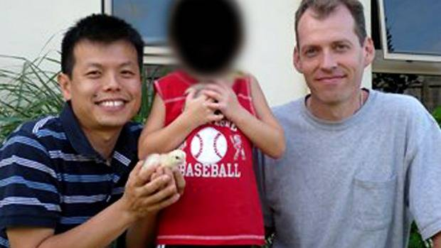
Double lives: Newton, right, with Truong and their son outside their Cairns home. Photo: ABC
Standing before an American court convicted of the most heinous of child sex crimes, the double lives of Australian citizen Mark J. Newton and his long-term boyfriend Peter Truong were laid bare.
‘‘Being a father was an honour and a privilege that amounted to the best six years of my life,’’ the American-born Newton, 42, told the court.
Moments later Newton was sentenced to 40 years in prison for sexually abusing the boy he and Truong, 36 from Queensland, had ‘‘adopted’’ after paying a Russian woman $8000 to be their surrogate in 2005.
Police believe the pair had adopted the boy ‘‘for the sole purpose of exploitation’’. The abuse began just days after his birth and over six years the couple travelled the world, offering him up for sex with at least eight men, recording the abuse and uploading the footage to an international syndicate known as the Boy Lovers Network.
‘‘Personally .. I think this is probably the worst [paedophile] rings ... if not the worst ring I’ve ever heard of,’’ investigator Brian Bone of the US Postal Inspection Service told reporters outside the US federal court room in Indiana.
US District Judge Sarah Evans Barker said the pair deserved a harsher punishment but were tried at district court level to avoid subjecting a jury to the repulsive images that had been produced.
‘‘What can be said? What can be done to erase some of the horror of this?’’ Judge Barker said in handing down her sentence.
Truong has also pleaded guilty and will be sentenced at a later date.
Newton and Truong gave an interview to a local ABC reporter in Far North Queensland in 2010 on their battle to have a child as a gay couple. Their search started in 2002 in the US, where they both were working, and when they did not have any success Truong travelled to Russia and found a woman who they ‘‘clicked with personality-wise’’. She was paid $8000 and, as per their agreement, granted the couple sole custody of the boy, handing him over five days after his birth in 2005.
The family planned to live in Cairns but that was delayed because Australian authorities initially refused to grant the child a visa. That took 2 years and upon their eventual arrival in Australia they said Customs quizzed them for hours. Police were also sent to the family’s house in Cairns to check up on the pair.
In the radio interview, 20 months before their arrest, Newton was asked if he felt the extra attention was because authorities suspected there was ‘‘something dodgy ... something paedophlic going on here?’’
‘‘Absolutely, absolutely, I’m sure that was completely the concern,’’ Newton replied.
Evidence before the court revealed the abuse began before the couple returned to Australia. One video is said to show Newton performing a sex act on the boy when he was less than two weeks old.
Judge Barker said the pair brainwashed the child to believe the sexual abuse was normal. Newton was also said to have trained the boy to deny any inappropriate behaviour if he was ever questioned by authorities.
Newton and Truong came to the attention of police in August 2011 after their connections to three men arrested over the possession of child exploitation material came to light. The couple had visited the three men in the US, New Zealand and Germany with their son.
While the couple were visiting family in the US, Queensland police searched their Cairns home and found enough evidence to alert their US counterparts who raided their Los Angeles base and took the boy into custody.
Newton and Truong claimed they were being targeted because they were homosexual. However after his arrest in February 2011, Truong gave investigators the password to the computer hard drives police had seized. It detailed the years of abuse.
The boy remains in the care of extended family in the US.
------------------------------------------------------------------
There are investigators we're in contact with saying that what happened to this child at the hands of these two sexually debauched abusers is just the tip of an iceberg involving a network importing babies and young children from Asia and other countries for the purposes of ritual, sexual abuse and sacrifice. One of the investigators is currently in fear for his life and on the run. He has uncovered evidence of numerous gay couples being involved in this under the pretence of adopting children (not to say that all gay couples are into this). He has evidence of people involved in government departments concerned with children and social services and the law. He goes on to say that many criminal offences are occurring with Australian and international law. Let's hope he survives long enough to bring all this evidence forward. There is a rogue element inside the Police Force, Federal Police, protecting it but there are good people there too so we need to give them the support and encouragement they need to bring out what is going on.

Pedophile Paradise: Bill Clinton Named In Sleazy Sex Lawsuit
Prince Andrew Implicated In Sex Trafficking Ring
17th January 2015
Link: http://anonhq.com/pedophile-paradise-bill-clinton-named-sleazy-sex-lawsu...
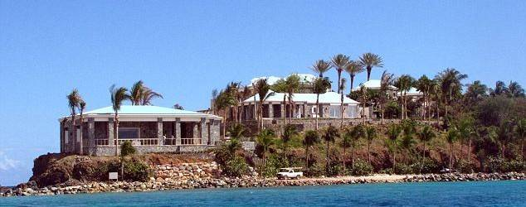
Former US President, Bill Clinton, finds himself in the middle of a sex scandal once again. Clinton has been identified in a lawsuit filed against his pedophile friend, Jeffrey Epstein, and the lawyers suggest summoning him to find out more about Epstein’s illegal sex slave activities. According to court records, Clinton frequently flew with Epstein on his private jet from 2002 to 2005, allegedly to attend orgies hosted by Epstein at his private Caribbean island called, “Little St. James.”
A transcript of a telephone interview includes a reference to the former President. “When you were present with Jeffrey Epstein and Bill Clinton on [Epstein’s] island, who else was there?” a woman asked. Another woman answered, “And there were two young girls … [at] about 4 or 5 different villas.” Asked whether “sexual orgies” were “a regular occurrence on the island,” the woman answered in the affirmative.
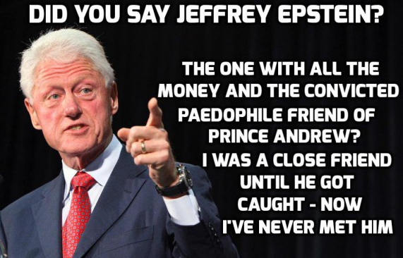
Clinton’s billionaire friend is accused of keeping young women as sex slaves and ultimately murdering them. Tales of orgies and sex slavery have been revealed as part of a lawsuit between Epstein and his former lawyers, Scott Rothstein and Bradley Edwards. Epstein was jailed for 18 months for having sex with an underage prostitute in 2008. He was proclaimed a sex offender after he was released upon serving 13 months in jail.
Clinton was amongst Epstein’s many celebrity friends who severed ties with him following his conviction. He had befriended a woman at Little St. James who was responsible for collecting naked pictures of the underage girls for Epstein. He never cut ties with that woman; he, in fact, invited her to daughter Chelsea’s wedding.
Epstein has been accused in the lawsuit of running a sex trafficking ring for rich and powerful businessmen and politicians— including Prince Andrew, according to court papers filed on behalf of “Jane Doe 3” (Virginia Roberts). The then-17-year old Roberts was forced by Epstein to have sex with Prince Andrew on three occasions between 1999 and 2002 in London, New York and as part of an orgy on Little St James. Roberts is one of 17 women who settled lawsuits with Epstein in 2005 for sexual abuse.
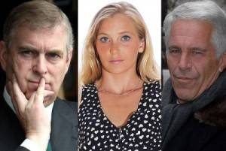
She claims Prince Andrew “would know a lot of truth about Epstein’s taking advantage of underage girls,” and can provide the most valuable information to the investigation against him. She adds, she was paid to massage Epstein and his friends (who also sexually exploited her) on flights around the world when she was only 15. Roberts, without naming the men, described to the attorneys the sexual acts she performed for Epstein’s friends.
Sources:
http://pontiactribune.com/pedophile-paradise-bill-clintons-friends-accus...
http://www.independent.co.uk/news/uk/crime/prince-andrew-sex-allegations...
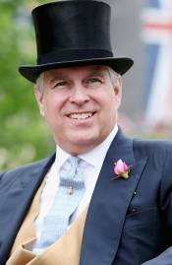

WORST IS YET TO COME:
How Prince Andrew’s life fell apart
Malaysia Chronicle
Saturday, 10th January 2015
AS Prince Andrew, Duke of York, fifth in line to the throne enjoyed the slopes about his rented $42,000 a week luxury Swiss ski chalet this week, he was oblivious that in an American court his life was unravelling quicker than he was slaloming.
In the US District Court in West Palm Beach, 31-year-old mother of three Virginia Roberts was filing a motion as part of a broader lawsuit against prosecutors who accepted a plea bargain from billionaire Wall Street banker Jeffrey Epstein on child sex allegations.
Virginia Roberts ... claims she was forced to have sex with Prince Andrew.
Picture: Facebook. Source: Facebook
The case had been going on since 2008 when the Brooklyn banker, who counted former President Bill Clinton among his close mates, was convicted on the lesser charge of soliciting an underage girl for prostitution.
Police in Fort Lauderdale and the FBI were stunned Epstein’s lawyers were able to force prosecutors to accept the lesser charge in exchange for an 18-month jail term, later reduced to 13 months, when they apparently had damning evidence the financier was effectively keeping at least 17 underage sex slaves to service the needs of him and his rich and famous friends around the world and filming their exploits should those friends ever need to be reminded of who their friends were.
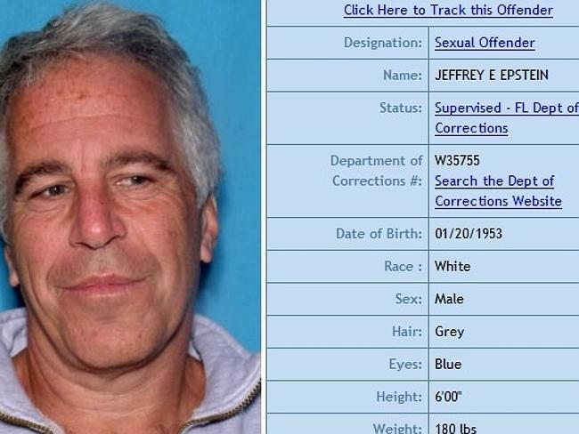
Convicted paedophile ... Jeffrey Epstein.
Picture: Florida Department of Corrections Source: Supplied
Lawyer for some of the women Brad Edwards had filed many motions over the past six or more years on behalf of his clients protesting the plea move, but on New Year’s Day he filed a 13-page motion, in which Roberts was only identified as “Jane Doe 3”, and attached “Document 279” in which she provided titillating details about how as a 17-year-old she had been forced to have sex with the Prince and others at various locations around the world in exchange for a life of riches, private jets and luxury holidays.
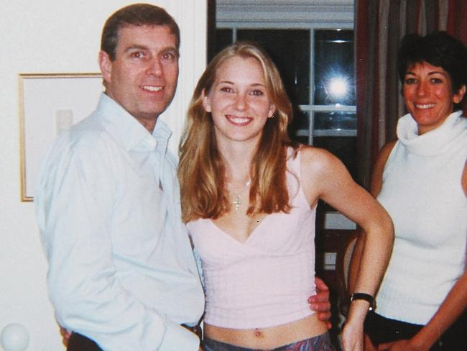
Shocking allegations ... Virginia Roberts with Prince Andrew in early 2001.
Picture: Michael Thomas. Source: Supplied
“Give the prince whatever he demands,” she alleged she was ordered by Epstein as she was flown to London to allegedly have toe-sucking bath time then sex with him, then later to New York for sex on a massage table then the Virgin Islands for him to watch girl-on-girl action with Russian models before she again had to sexual pleasure him on his leather armchair.
To suggest the motion was dynamite back in London would be an understatement with Buckingham Palace issuing a flurry of denials and going into full damage control not seen since the scandals of Squidgygate involving Princess of Wales Lady Diana more than 20 years ago or the Camillagate Tapes involving her then husband Prince Charles and his special consort now wife Camilla.
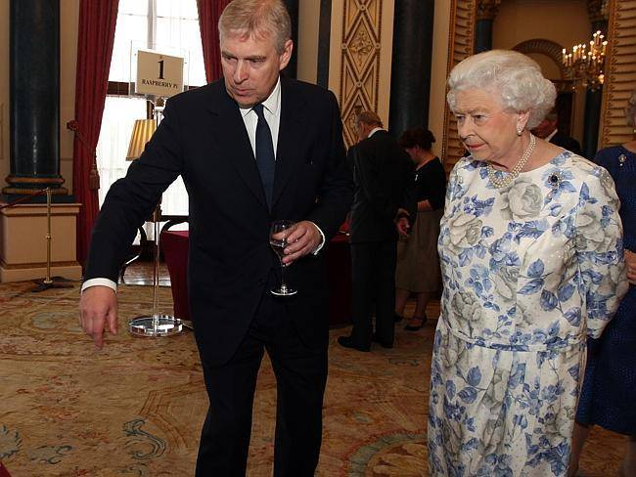
In overdrive ... Buckingham Palace went into damage control not seen since scandals of two decades ago.
Picture: Steve Parsons /Getty Images Source: Getty Images
The palace thought their first flat denial, on behalf of the Queen’s second son Prince Andrew, that he had sexual relations with the then underage Roberts was enough, but they were clearly wrong. Two days later he was rushing down from the slopes of Verbier village in south-western Switzerland to answers questions from his family, meet with his legal and other advisers over the sordid claims that have again brought the House of Windsor into controversy.
The crisis is unlikely to be quelled with Ms Roberts now making deals with the British tabloids, speaking to US network giants about movie deals and also is finalising a book deal on her time as a “teenage sex slave” to the rich, privileged and famous. And make no mistake — Prince Andrew is not the only name to appear with some of the world’s richest socialites, politicians and personalities now being rightly or wrongly dragged into the sex storm that ultimately could see some of them — Prince Andrew included — forced to deny the allegations in that Florida Court.
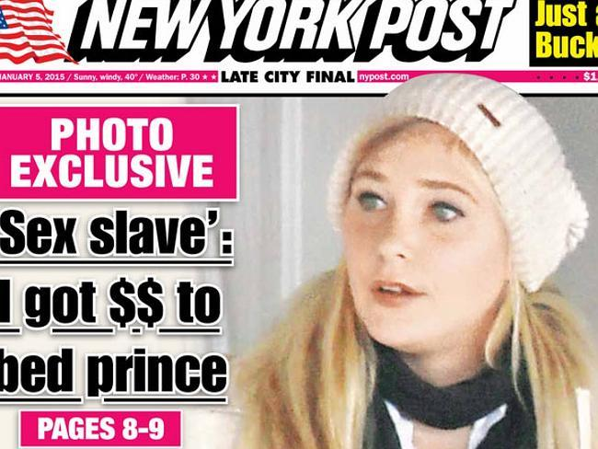
More publicity ... Virginia Roberts is already talking movie and book deals.
Source: New York Post
THE BEGINNING
No stranger to controversy, Prince Andrew’s friendships and associations from his role as international playboy and UK’s special envoy for trade and investment has long raised eyebrows.
In December 2010, the prince was photographed by the now defunct News of The World newspaper walking through Central Park with his friend Epstein (under the headline “Prince Andy and the Paedo”) after the banker was released from jail.
It was a damaging image and brought into question, not for the first time, his choice of friends.
By March the following year and after a photograph emerged of the prince with his arm around the bare midriff waist of Ms Roberts, and admissions he had received a massage at Epstein’s Florida mansion 10 years earlier raised further question marks over his suitability to represent the nation on trade and investment issues particularly in conservative countries in the Middle East.
At that time the 27-year-old married Ms Roberts was speaking — albeit anonymously and being referred to as an Australian masseuse since she had married an Australian martial arts expert 10 days after they met in Thailand in 2002 and were living in Sydney for about 10 years — about dancing at a nightclub with the prince. There was no suggestion it was anything more than a dance, albeit a bad one with the prince grinning cheesily and grabbing her hips as he jumped about.
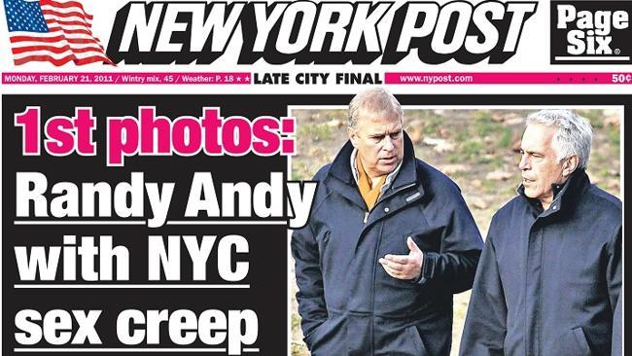
Global headlines ... Prince Andrew pictured with convicted sex-offender Jeffrey Epstein.
Source: Supplied
She detailed how as a 15-year-old she was working as a changing room assistant in the spa of Donald Trump’s Florida country club, where her father worked in maintenance, when she was introduced to Epstein’s friend Ghislaine Maxwell, daughter of press baron, British MP and all-round fraudster Robert Maxwell. It was Ghislaine who allegedly promised the wide-eyed girl she knew a powerful man looking for a travelling masseuse and she could be trained as one.
Roberts later met Epstein, lying naked on a massage table at his Palm Beach mansion, and was asked by him about her background to which she said she was a runaway and no longer a virgin. Another apparent masseuse at their side took her clothes off and told Roberts to do the same; Roberts then had sex with Epstein while the other woman fondled her. Roberts was paid US$200 in cash and told to come back the next day. She said she felt under pressure to have sex on that encounter but would allegedly spend the next four years servicing Epstein’s sexual demands for himself and for others. She claims after two years she was then “given” by Epstein to his rich friends and associates including heads of state, a world famous scientist, politicians and rich socialites.
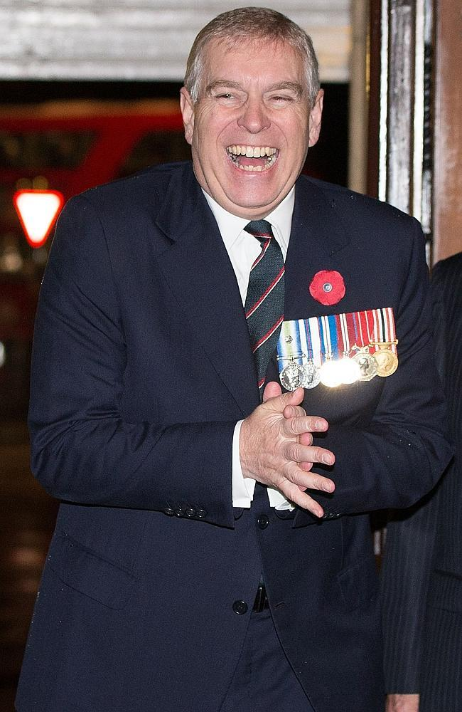
No longer laughing ... Prince Andrew, Duke of York, arrives at the Royal Albert Hall.
Picture: Matthew Lloyd/ Getty Images Source: Getty Images
In 2001 she accompanied Epstein on a six-week tour of Europe and North Africa starting with a stay at Ghislaine Maxwell’s home in London’s up-market Knightsbridge. One morning Maxwell allegedly told Roberts “We’ve got to go shopping. You need a dress as you’re going to dance with a prince tonight”. She was bought a AUD$10,000 Burberry bag, a designer dress, perfume and make up.
That afternoon the prince turned up at Maxwell’s apartment, where Epstein was also staying, and was introduced to Roberts. Shortly after Maxwell played a guessing game and asked the royal how old he thought Roberts was and he correctly guessed 17. They all laughed then joked.
“Ghislaine made a joke that I was getting too old for Jeffrey, she said ‘he’ll soon have to trade you in,” Roberts later recounted. It was at that meeting the damning photograph of Prince Andrew with his arm around Roberts was taken, “I wanted something to show my mom”, Roberts recounted. The four then went out to dinner and later to the nightclub Tramp where she danced with her “sweaty” then 41-year-old prince.
In 2011 Roberts told the British press the evening ended with the dance but that Maxwell the next morning told her “you did well, he had fun”.
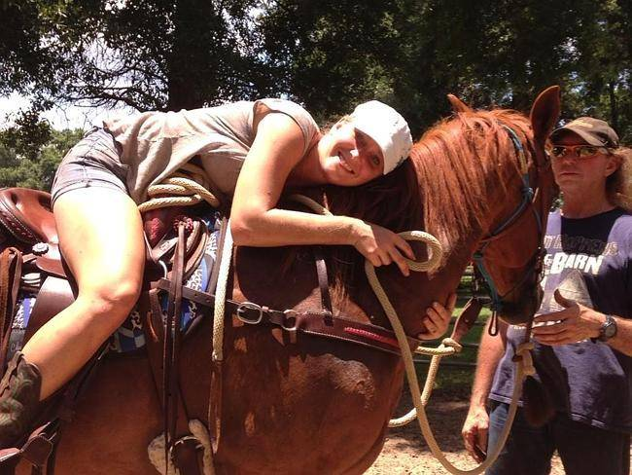
How they met ... Virginia Roberts was a “gift” from Epstein to Prince Andrew.
Picture: Facebook. Source: Supplied
Fast forward to this week and the woman gave a little more detail about her encounter and how she had allegedly become a “gift” from Epstein to the prince later that night and Epstein had paid her US$10,000. “It was made clear to me that my job was to do whatever pleased him.”
She said the pair took a bath together. “He started licking my toes, between my toes, the arches of my feet and then we went into the bedroom and he proceeded to make love to me so to speak. It wasn’t like rape but it wasn’t like love either. It was more like ‘I’m getting my business done’.”.
She said the prince never paid her, that was for Epstein to take care of the finances.
Around Easter of the same year she again met the prince when she was called up and told to go from Florida to New York to meet someone special at Epstein’s mansion. She says she was taken to the library and there was the prince sitting in an armchair next to a desk with a lot of photographs of semi nude young girls including herself.
He had a 21-year-old woman sitting on his knee but Maxwell escorted Roberts over and sat her on his other knee.
She was then allegedly told: “You should take him upstairs for a massage” and it was made clear she was there to have sex with him, an allegation the palace had flatly denied.
“I took him upstairs to the ‘Dungeon’,” Roberts told the British press this week. “He undressed and lay face down on the table. I started with his feet then his calves the way Jeffrey liked it.”
They met again a third time on Epstein’s Virgin Island mansion.
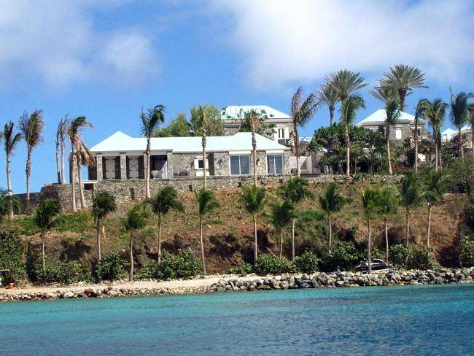
Luxury island ... Jeffrey Epstein's private Virgin Island mansion.
Picture: Lawton/Splash News Source: Splash News Australia
She flew there with Epstein and Maxwell, his semipermanent companion, and hooked up with seven non-English speaking Russian models for a photo shoot. Roberts and the models were posed topless in provocative positions. She later met up with he prince again who with was with Epstein.
Epstein allegedly told her to undress and kiss and touch the other girls in an orgy. “Then I stripped and I performed a sex act on Andrew,” she claims, a scenario the palace has vehemently rejected.
COVER UP CLAIMS
During the Epstein investigation and ultimate trial, court papers dated 2007 and titled “statement of undisputed facts” alleged he made attempts to cover up the scandal alleging tracking down some of his accusers and promising to look after them if they did not speak with the FBI. For those who refused he allegedly suggested “bad things” could happen. The allegation is contained in 13,000 papers of evidence US prosecutors have locked away. Epstein’s lawyers secured a deal with prosecutors that anyone else involved in his love trysts and orgies, including presumably the prince, would be given immunity from prosecution. The deal alone has been locked in secrecy as a condition of the plea. Epstein, according to documents lodged in court, actually bankrolled the legal fees of 10 potential witnesses who refused to answer questions.
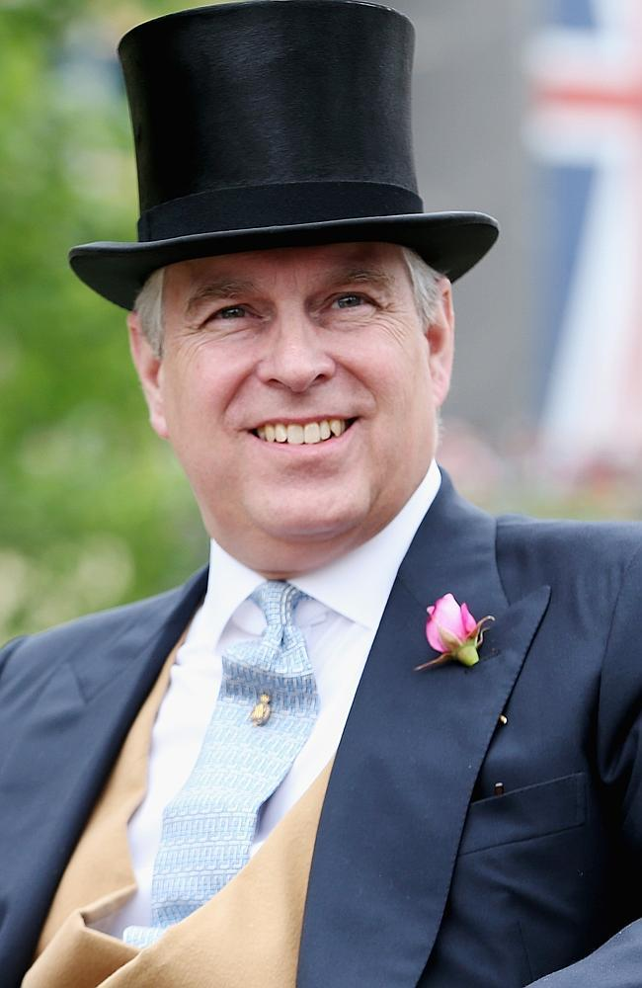
Countless women pleaded the ‘fifth” when asked under oath about sexual relations with Prince Andrew.
Picture: Chris Jackson/Getty Images. Source: Supplied
These supposedly include other girls who were directly question about whether they had ever had sexual liaisons with the prince and pleaded the fifth amendment of legal silence on the grounds of self incrimination. In 2010 one former model Adriana Ross who worked for Epstein was asked whether she had seen evidence of royal underage sex to which she replied “I refuse to answer”. She was one of four named “co-conspirators” with another Yugoslav model Nadia Marcinkova, Epstein’s alleged “live in sex slave” who when asked if she had been made to perform a sex act on the prince replied simply “fifth”, as did Epstein former PA Sarah Kellen who has been accused in court of introducing under age girls to Epstein. When asked about Prince Andrew and allegation of child sex she replied: “On the instruction of my lawyer I must invoke my Fifth Amendment privilege.”
Locked away documents also detail apparently, in more than 500 pages of evidence, “letters of recommendation” apparently written by high flying friends of Epstein arguing his good character. The claim by Roberts lawyers was that he used his “significant social and political influence” to exert pressure for a plea deal. The palace issued a statement stating the prince would never interfere in a legal matter.
Epstein’s lawyer Alan Dershowitz who himself has been accused in the legal motion by Roberts of having sex with underage girls her, has sued Roberts and the lawyers who made all the “outrageous claims” on her behalf.
Tight-lipped ... Palace courtiers say there is nothing more to say about the scandal involving Virginia Roberts.
Picture: Facebook Source: Facebook
The prince returned to Windsor and briefed the Queen on his version of events. The palace has issued a total of three unprecedented public statements formally denying the under-age sex claims and calls now to the palace get referred to those three statements. Palace courtiers say there is nothing more to say but without Prince Andrew speaking himself the controversy is likely to linger. His wife Sarah Ferguson has spoken for him about how wonderful he is; her credibility however is in question after it was revealed Epstein lent her $30,000 to pay off a personal debt.
Scotland Yard has also come out with a statement saying it would investigate any underage sex claim if a formal complaint was made by Roberts, with a reminder that no one was immune from the law, as palace lawyers Harbottle & Lewis wrote to British media urging caution about writing Roberts’ claims and reminding outlets of the palace’s three denials. It is unlikely the prince would ever sue for defamation which would give the claims and other lurid details of partying at Epstein’s invitation in Thailand and elsewhere oxygen.
It’s a tough position for the prince but until he speaks publicly more claims will no doubt emerge and further tarnish his reputation, which many in England would argue was already beyond saving, but also that of his family. At one point it was claimed the Queen had met Roberts but Roberts’ father Sky Roberts later said he was mistaken.
News.com.au
Link: http://www.malaysia-chronicle.com/index.php?option=com_k2&view=item&id=4...

Westminster Paedophile Ring
MP John Mann Expects Tens Of Thousands Of Victims To Come Forward
1st January 2015
By Ben Glaze
Link: http://www.mirror.co.uk/news/uk-news/westminster-paedophile-ring-mp-john...
The Bassetlaw MP said: “It really is an extraordinary number of people. The state can’t deal with the numbers of people coming forward”
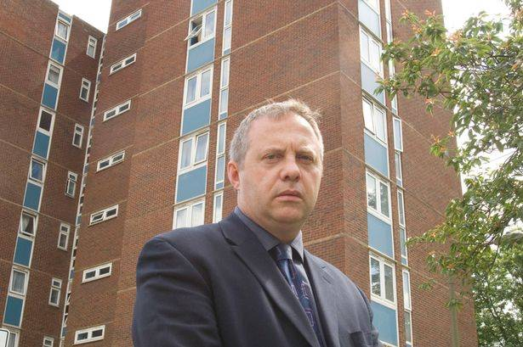
Scandal: Mr Mann says his own constituents are among vast numbers making allegations
Tens of thousands of victims are likely to come forward when the Westminster child abuse inquiry finally begins, an MP has warned.
Labour’s John Mann said today investigators will struggle with the “vast” number of allegations being made.
The Bassetlaw MP added: “Probably it’s going to be many tens of thousands of people across the country. It really is an extraordinary number of people.
“The state can’t deal with the numbers of people coming forward.”
Home Secretary Theresa May announced the inquiry six months ago into claims of historical child sex abuse and a cover-up that allegedly goes to the heart of the establishment.
It stalled when two chairwomen were forced to quit over links to powerful figures.
And while the probe is expected to relaunch in coming weeks, Mr Mann warned of the scale of alleged abuse.
He said: “I’m getting a vast number of people, including my constituents, coming forward making allegations.
"Many of those people came forward in the past and weren’t listened to or weren’t believed, and that’s a key part of the problem.”
Mr Mann gave police evidence on 22 politicians who may have been involved in abuse or its cover-up.
And he told the BBC that survivors’ groups had called on the Government to set up a “national institute” to deal with victims, adding: “The police and social services cannot cope with the volume that’s there, even now.”
Recently Published:
Westminster paedophile ring: Top Tory MP 'murdered girl at vile orgy' claims new witness. The new witness has told police a FOURTH youngster - this time a girl of 15 - may have been murdered by a VIP abuse ring which included politicians and a TV comedy star http://www.mirror.co.uk/news/uk-news/westminster-paedophile-ring-top-tor...
Westminster paedophile ring: Jailed Charles Napier will be told to name VIP abusers - The former treasurer of the Paedophile Information Exchange and half-brother of a Tory MP will be questioned again by detectives after being jailed last week. http://www.mirror.co.uk/news/uk-news/westminster-paedophile-ring-jailed-...
Watch many videos on the Westminster child abuse murders here: https://www.google.com.au/search?q=Police+probing+child+abuse+murders++W...
Video: 'Tens Of Thousands' Historical Child Abuse Cases
1st January 2015
Sky News HD Link: http://www.capitalfm.com/on-air/news-travel/uk-world-news/tens-of-thousa...
The number of historical claims of sexual abuse against children is likely to reach "tens of thousands", an MP has warned.
Labour backbencher John Mann told Sky News there would be too many cases for the state to cope with - and is calling for a national institute to help victims.
It comes after many survivors called for the Government to scrap its current inquiry into paedophile activity and replace it with a more powerful body.
The wide-ranging probe was sparked by claims of paedophiles operating in Westminster in the 1980s, and is still mired in controversy.
Two chairwomen - former judge Baroness Butler-Sloss and ex-lord mayor of London Fiona Woolf - have already had to stand aside over their establishment links.
Mr Mann, the MP for Bassetlaw, said the Government needed victims' confidence, and the state "cannot cope" with the number of people coming forward to report abuse.
"We are talking at this volume of people across the country - not thousands, but tens of thousands in every part of the country," he told Sky News.
"As an example in Nottinghamshire, every single children's home has been affected with allegations, people coming forward, of abuse - sexual and violent - when they were children."
He added: "And the state, by which I mean social services, mental health services, the police, cannot cope with the volume of people coming forward.
"I've seen that just with my own constituents, who have come forward via me to those services.
"They cannot cope at the moment, and we're only just at the beginning of people coming forward.
"As we saw when [Jimmy] Savile was outed for what he'd done, over 500 people then came forward as victims, and people are still coming forward.
"This is absolutely huge, and the resources and people needed to deal with it are not in place at the moment."
In December, Mr Mann handed a dossier of evidence to Scotland Yard, claiming two whistleblowers who had information about MPs' alleged involvement in a paedophile ring may have been murdered.
He said the evidence related to the suspicious deaths of two men - a former Lambeth council official named Bulick Forsythe and a caretaker whose name he did not disclose.
Police were already aware of the potential link between one of the deaths and the child sex abuse ring, which involved "highly influential" politicians during the 1970s and 1980s, Mr Mann said.

5,200 Pentagon Employees Bought Child Pornography
Investigation Halted After 8 Months
6th January 2011
CNN reports on revelations that over 5,200 pentagon employees purchased child pornography and after prosecuting a very few officials investigations were halted due to lack of resources while hundreds and possibly thousands of guilty officials got off the hook.
A comment posted to this video: The thousands of Pentagon employees implicated in a child pornography sting operation. That case was mysteriously dropped and never mentioned again. You think this high powered pedophilia network only operated in the U.K.? I've got news for you, the United States government has been covering up their own pedophile network for decades. As in the U.K. case, the evidence surfaced years ago but nothing was ever done.

50 Police Officers Arrested In Child Porn Raids
http://www.dailymail.co.uk
31st July 2012 (somewhere around then)
Fifty police officers across the UK have been arrested as part of a crackdown on suspected paedophiles who pay to access child pornography websites, detectives revealed today.
The officers were among 1,300 people arrested on suspicion of accessing or downloading indecent images of children - some as young as five - from US-based Internet sites.
Thirty-five men were arrested in London this morning as part of the investigation - codenamed Operation Ore - following raids on 45 addresses across the capital.
Of the 50 policemen identified, eight have been charged to date and the remainder bailed pending further inquiries. Scotland Yard said none of those arrested today was a policeman.
At a press conference at Scotland Yard today, Jim Gamble, assistant chief constable of the National Crime Squad, said he was not surprised at the number of police officers among the suspects.
"As police officers, we should expect to be held accountable," he said.
"Fifty police officers have been identified and we are not hiding that fact. We want you to know about that to reassure you.
"Police officers are member of the communities that they serve and there will be good people and bad people in the police."
Mr Gamble said the 50 officers were among 1,200 Britons who had been identified as "category one or two" suspects - those who posed the greatest potential risk to children.
In addition, 40 children nationwide - 28 of them in London - had been identified as being at risk of being abused and appropriate steps had been taken with other agencies to ensure that all the youngsters were safe.
Before today's arrests, the Metropolitan Police had executed 75 warrants across the capital with 65 arrests and more than 130 computers seized.
Although 7,000 suspected users of "pay-per-view" child pornography sites based in the US were identified in Britain, Mr Gamble said the actual number of offenders would probably be lower, partly due to duplicates.
The Met's Deputy Assistant Commissioner, Carole Howlett, said today's raids represented the single largest operation of its kind mounted so far by the force.
She added: "Our priority so far has been to identify those individuals on the list that pose the greatest threat to children now.
"But this process is on-going ... and it will continue after today, even though it is extremely resource intensive."
Ms Howlett also announced that the Home Office had agreed to allocate an extra £500,000 to support further action as part of Operation Ore.
She said the money would be used to provide extra training in computer forensics for officers across the country and to buy more equipment for analysing computers seized.
Commenting on today's operation, children's charity NSPCC said it had been assisting the Met by responding to any emerging child protection matters.
Colin Turner, head of NSPCC's specialist investigation service, said: "The arrests send out a strong warning to those that think they can remain anonymous and escape the law by using the Internet to trade in child abuse images.
"Behind these indecent, abusive images are real children who will have suffered immense damage and trauma."
Operation Ore is the UK wing of a huge FBI operation which traced 250,000 paedophiles worldwide last year through credit card details used to pay for downloading child porn.
The names of British suspects were passed on by US investigators.
Suspects were traced through the Landslide web site - a gateway to an international collection of child pornography sites.
Thomas Reedy, who ran the web site and earned millions from it, is now serving several life sentences in the US.
Link: http://www.dailymail.co.uk/news/article-151784/50-police-officers-arrest...

Actor Corey Feldman Says
Pedophilia Is Hollywood's Biggest Problem
Uploaded on 29 Jan 2012
Corey Feldman: Pedophilia Is Hollywood's Biggest Problem:
http://huff.to/n9OQS9
Hicks: Corey Feldman to name sex abusers in new book:
http://bit.ly/xErS5m
https://www.youtube.com/watch?v=roW238dfUUk

Former Education Minister Who Oversaw Sex-Ed Curriculum
To Plead Guilty to Child Porn Charges
By: Heather Clark
30th January 2015
Link: http://christiannews.net/2015/01/30/former-education-minister-who-oversa...
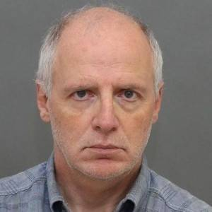
TORONTO, Ontario – A former top education minister in Canada who oversaw the provincial sex-ed curriculum for public school students will plead guilty to charges surrounding child pornography, according to reports.
Benjamin Levin, 62, served as a professor at the University of Toronto and was the Deputy Education Minister for Manitoba and Ontario from 1999-2002 and 2004-2007 respectively. He also served on Premier Kathleen Wynne’s transition team for part of 2013 after Dalton McGuinty resigned. As part of his responsibilities, Levin oversaw the development of the sex-ed curriculum for the provinces.
In 2010, the proposed updated curriculum was dropped after parents expressed concern over its content, as it taught children to question their biological gender, discussed types of sexual activity and spoke positively of “diverse” family settings.
In 2013, Levin was arrested in an international child porn sting, and was charged with accessing and possessing child porn, writing and distributing child porn, counseling a person to commit sexual assault and making an arrangement for a police officer to commit sexual assault. The Harvard graduate was arrested at his home and later released on $100,000 bail.
Levin was then prohibited from using the Internet, nor could he use a phone with the Internet or a camera. He was also banned from being near a child under sixteen years of age nor being near schools or public pools, and may not leave the province except to visit his father.
Last Friday, Levin’s attorney, Clayton Ruby, told reporters that Levin will plead guilty to some of the charges during his next court appearance before Judge Heather McArthur on March 3, although he did not indicate which particular charges he would accept. Ruby also noted that there will be no trial over the matter.
“They’ll probably be a lot more of child-sex charges against sex-ed fanatics over the coming years,” one commenter stated. “Anyone that keen to talk to children about sex has to have something wrong with them.”
Concerns still remain over the updated sex-ed curriculum now overseen by Wynne, whom Levin assisted. Wynne, a lesbian, had stated following Levin’s arrest in 2013 that he did not write the curriculum, but only oversaw its development. But Dr. Charles McVety of Canada Christian College called her statement “just a parsing of words.”
“They can spin it all they like, but this letter proves that Ben Levin and Kathleen Wynne were joined at the hip in the quest to teach these ideas to children as young as six,” he said.
According to reports, the new curriculum, which will be introduced in public schools next year, will teach children about “sexual consent.” Wynne asked the current deputy minister to “finalize a new health and physical education curriculum that gets at some of the root causes of gender inequality, and starts at the very earliest stages to develop an understanding of healthy relationships and consent,” according to the Canadian Star.
Gwen Landolt of REAL Women told reporters that she found the proposed curriculum to be “very worrisome” as it suggests that it is okay to have “access to children, provided the children give their consent.”

Europhilia and Aussie Rules III: Down UnderWorld
By M.K. Styllinski
Dr Reina Michaelson
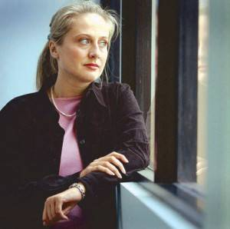
Australia surfaces consistently on many paedophile ring investigations with a familiar denial of Establishment involvement, though the evidence strongly suggests otherwise. This is made easier by the fact that Australia already has the most concentrated media ownership in the western world care of billionaire Rupert Murdoch, a Pathocrat-friendly media mogul.
In March 2005, after alleged police involvement and protection of the State wide paedophile and child pornography network, a former Young Australian of the year, Dr Reina Michaelson held a press conference in Melbourne, Victoria, on new revelations regarding the controversy. She alleged the paedophile networks involved media personalities, politicians and corporate executives. Nothing new you might say. However, what Michaelson did bring to the proceedings was evidence that should have created a storm of publicity.
She produced a police tape recording from an Ombudsmen meeting in November 2004, where the high level investigator from the Office of Police Integrity (OPI) which was formed precisely for the purpose of addressing the continuing allegations of abuse, told her: “What I would hope that we can achieve is possibly nothing in relation to that past [paedophile] ring, even if it is still operating”. [1] This, in itself, is a damning statement offering a hefty can of worms to be opened by the media. True to form, almost all of the Australian press ignored the conference as well as this very revealing statement.
The formation of the Office of Police Integrity was the Victoria Government’s response to fend off calls last year from Dr Michaelson and others for a Royal Commission into links between police corruption, paedophile rings and Melbourne’s gangland killings. The Office dismissed their complaints without having interviewed the copious witnesses or having recalled any Victoria files. The Office continues to be viewed by many as a cover for damage limitation rather than a genuine investigative body.
In Michaelson’s words from her press release:
“… the victims who were abused as part of this network as children can testify to the fact that police officers we’re actually being paid off so that this criminal network remained untouchable. So that’s why we want it to be investigated thoroughly, and for there to be a report of the kind of quality that came out as a result of the last complaint. There is clearly something really bad happening in this State, and it needs to be sorted out. […] It’s organized crime, and it’s being allowed to continue because… There are a couple of bad eggs in the right places.” [2]
A separate report followed from Edward Picton Mullighan QC appointed by the government’s Commission of Inquiry into Children in State Care [3] which was itself, pressured into action from Dr. Michaelson’s efforts. Characteristic of so many “official” reports and inquiries, the author of the report seemed to slip into extremely selective and simplistic bias regarding the overview of one witness testimony of systematic and severe sexual abuse. The testimony of the professionals involved was deemed more important than witness testimonies and where all adult explanations were taken at face value without taking into account hundreds of other reported cases within the South Australian care system.
Dr. Reina Michaelson
As a signpost for further allegations which the government has steadfastly ignored, it was seen as appropriate to sink the report without further discussions. The nature of the evidence was so disturbing that this automatically engendered disbelief, or as a more likely possibility, the recommendations to cease further investigations.
The only Member of the Australian Parliament, speaker of the House, Peter Lewis MP raised the issue of murder, corruption and organised child abuse thereby taking it straight to the Aussie Establishment door.
The politician gave a statement to police that two gay men murdered in Adelaide in late 2004 told him that a serving elected politician was involved in paedophile activities in Adelaide’s South Parklands. Robert Woodland, who was found beaten to death in the Parklands last December and Shaine Moore, whose body was found in his home in suspicious circumstances in February 2005, separately contacted Lewis and told him of the person’s paedophilic actions. Police initially said the paedophile MP allegations were examined in 2003 and found to be unsubstantiated, but reopened their investigation.
Unfortunately, the key witness, one Lewis Craig Ratcliffe, was also a convicted sex offender which didn’t help the evidence. Yet eight other witness’ testimonies were summarily ignored. All possessed evidence about the paedophile MP’s extra-curricular activities.
Bringing attention to the subject of organised child abuse resulted in the MP resigning to avoid being ousted by a “no confidence” vote. This was said to be based upon his lack of evidence, despite Lewis’ call for a proper investigation and the obvious glut of provable background cases connected to a high-level paedophile ring operating above the law. The latter however, was deemed inadmissible.
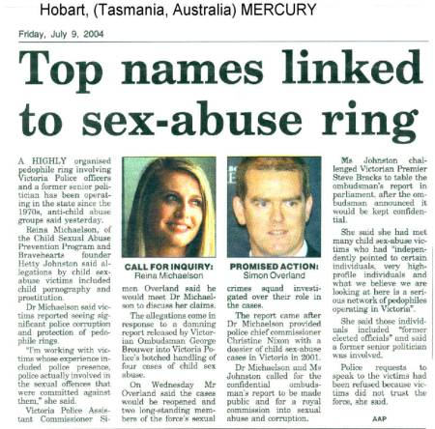
If the MP’s allegations were without foundation and evidence, it begs the question why the Rann Government took the unprecedented step of temporarily suspending parliamentary privilege in order to stop the MP at the centre of the claims being named. One political scientist commented on the move describing the removal of the privilege of Parliament as a “major step” and that “The argument that Premier [Mike] Rann is using [that the paedophile allegations take precedent over anything else] is an emotive argument but put against 100 years of convention is a difficult one to push…” [4] Other pleas for investigations into separate paedophile rings began to surface during the same year and by August 2005, someone in the OPI obviously wanted to send a message showing just how ineffective the Office was. [5]
The Privacy Commissioner was called in to investigate how over 500 pages of police files on more than 400 people were sent to a woman who had lodged a serious complaint against the police, after the Office had dismissed her original complaint. The documents that the woman anonymously received showed that “the OPI agreed with police to cut the scope of the investigation from two years to five months – without telling the woman.” and also revealed that “her husband’s files were accessed in April last year – although the OPI told the woman that its investigation had found no such access.” One MP told parliament that OPI had ‘misled’ the woman over the accessing of her husband’s file, and had ‘deliberately deceived’ her over the scope of the investigation.
As always, the networks appear to be a tightly woven affair where evidence is highly difficult to come by. This is no surprise if it is sourced from those whose job it is to set the laws and to then give the appearance of investigating it.
On 4th April 2005, Peter Lewis MP, gave a 20 minute resignation speech responding to the highly unusual moves by the Rann government to remove him as Speaker of the House. An edited extract follows:
The Premier and the Deputy Premier have recently publicly insulted and defamed me and, through the efforts of their spin doctors and media minders, in particular Melvin Mansell of the Adelaide Advertiser, to criminally defame me in a series of editorials and articles, which were reckless in that they were not well researched, unfounded, unprofessional, malicious and, for that reason criminal, they provided through the orchestrated campaign the means by which it has become possible for the Premier and Deputy Premier to now attack and tear down the straw man they constructed.
The central issue in all this is the grossly misleading assertion that I publicly raised the problem of allegations that a Member of Parliament is a paedophile. I made no such claim. That was made by Melvin Mansell’s Advertiser itself. It began on 2 March, when Nigel Hunt contacted me to ask me about claims made by Craig Ratcliffe on web sites late last year and repeated by him to The Advertiser early this year that there is a paedophile in state parliament and that he (Craig Ratcliffe) was very concerned that his life had been threatened following the death in suspicious circumstances of someone else, namely Shaine Moore, whom he knew and whom he believed had been murdered.
I responded honestly to Nigel Hunt’s unsolicited inquiries to my office on 1 March. That information coming into my office from a few of the very many people claiming knowledge about the activities of paedophiles in general was of concern to me because, of the few people who spoke about parliament’s problem, more than half had been killed. Since then, Shaine Moore’s death has been declared a murder. […]
…they [witnesses] were being ‘bumped off ’— that is, murdered and viciously assaulted — quicker than I or the people who were helping me could get them to write down their allegations and then swear that what they were saying was true. Of course, I told Nigel Hunt that they should be protected from murderous acts. At no time have I ever said that they were being murdered or violently bashed into serious long-term mental dysfunction at the hands or the instigation of any MP. That was an improper speculation made by government ministers and their specialist spin doctors to the press across the length and breadth of the state to try to show me in a bad light. In retrospect, I believe it was another deliberate red herring contrived by them, just like the one about homosexuals and their haunts, to discredit me. […]
The most outrageous thing of all, which disturbs me most about the information which has come in to my office is not the matter of paedophiles in South Australia’s parliament but what appears to be the related and organised activities of those paedophiles in high public office—that is, the judiciary, the senior ranks of human services portfolios, some police, and MPs, across the nation, especially within the ranks of the Labor Party. Yet you only have to recall in recent years the investigations, charges and successful convictions against such people as Darcy, Liddy, Wright, Wells, a former senator, and other current and past MPs in Queensland, New South Wales and Victoria to understand my concern. They have not acted alone or in isolation, it seems to me. Equally, it seems to me, they cleverly recruit their victims not from amongst the churches’ young groups and surf life saving clubs and boy scouts these days. There is a new group of youngsters they prey on—those involved in other action-type sports requiring body contact in coaching and skills development, if not in the action of the sport itself.
Lewis reiterated the standard protocol of initiatives, inquiries, commissions and investigations of this nature are carried under intense pressure, ridicule, and denials, while the individual or individuals in question who have sought to have proper investigations into organized child molestation are defamed, slandered and marginalised. The door always remains closed to Establishment complicity. Meantime, another Australian police officer shoots himself in an apparent suicide while investigating cases of child abuse.[6]
On the subject of child pornography we have explored the multi-faceted nature of endless prosecutions. Placing tax payers’ money into a short-term cure is designed to obfuscate and distract from the root cause of the problem. As Dr. Michaelson mentioned in her in Press statement following the resistance and refusal of Office of Police Integrity to do their job: “This is NOT the opportunistic abuse of children by men scouring playgrounds or scout groups. What organized means is that groups of men – and we are largely talking about men, though women have been involved too – that groups of men can meet regularly at particular places at particular times and have children provided for them to abuse. I was told by the OPI’s investigators that what they, quote, “hope to achieve is possibly nothing in relation to that past [paedophile] ring, even if it’s still operating.” [7]
They are nothing if not honest in their intentions. What is more, their trust in the Pathocracy ensures that such honesty is always rewarded. Peter Lewis was not the first to be jettisoned from Parliament but he may not be the last.
From a speech by New South Wales Senator Bill Heffernan in Australian Federal Parliament on 29 May 1998: “Recently I made a speech in which I highlighted the code of silence which protects worldwide child sex networks including people in the judiciary, parliament, clergy and the public service. Many of these people live in an abhorrent culture in which is included, as spoils of office, the right to have sex with children…”
Twelve years later, the Australian Parliament is still hanging on to these rights.
Link: https://infrakshun.wordpress.com/2014/03/16/europhiles-and-aussie-rules-...

OTO 'Defamed' in Australia
by GAIAGUYS.NET
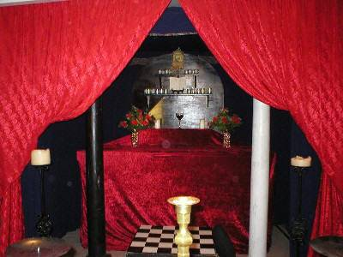
OTO 'Defamed' in Australia (July 8,2005) Australian Court finds www.gaiaguys.net guilty of defaming (sanitised)!
On the 28th June 2005, the Australian Capital Territory Magistrate's Court judged authors of www.gaiaguys.net, a web site hosted in the United States, guilty of defaming the Ordo Templi Orientis. The gaiaguys.net authors Vivienne Legg and Dyson Devine live in the Australian State of New South Wales.
Magistrate Burns of the ACT Small Claims Court obviously judged that gaiaguys' exposé of this (sanitised) is not in the public interest!
He ordered that we pay Sanitised, Stephen Joaquim King (Chief Executive Officer) and the Ordo Templi Orientis Incorporated each $9998.00.

OTO 'Defamed' in Australia
(continued)
by GAIAGUYS.NET
..bringing the applicant into hatred, ridicule and contempt ..." ( notably three primary values which are clearly expressed in the philosophy of the Ordo Templi Orientis).
According to it's own statements and documents Ordo Templi Orientis members practice and swear to defend these "principles of Thelema" as spelled out in The Book of the Law.
A legal document sent to the Equal Opportunity Commission of Victoria from a Melbourne OTO member, Brent Gray, states that, "The Book of the Law is the primary religious text of Thelema."
"The OTO is an international body of men and women dedicated to the promotion of Thelema. These principles are taught through a graded series of degrees, or initiations, and understood through practical engagement with these mysteries in the initiate's own life."
The following are excerpts from the Book of the Law. "I will give you their flesh to eat" “Sacrifice cattle, little and big: after a child.", “damn them who pity!”, "Kill and torture”, "Compassion is the vice of kings".
Having been advised by an officer of the Equal Opportunity Commission of Victoria that him dealing with this matter as a member of any of the groups affiliated with the OTO, (being the Freemasons, Order of the Eastern Star [a.k.a. "Lucifer"], Knights Templar, etc.) would constitute a conflict of interest, gaiaguys wrote the ACT Magistrate's court twice seeking statements confirming that no conflict of interest would be present in this case.
Those requests were completely ignored. Do we assume that Magistrate Burns is also a Freemason?
Gaiaguys has just sent a letter to the Federal Treasurer asking about the legal, not-for-profit status of the Ordo Templi Orientis and asking how long it will be before this organisation has it's legal, religious, tax exempt status removed!
We have still had no response to our May 24th registered letters to the ACT Chief Minister and the ACT Human Rights Commissioner calling for action against this group who enjoy legal immunity in Australia.
Similarly we have still had no response to our May 24th registered letters to the Victorian Attorney General and head of the Equal Opportunity Commission of Victoria in relation to the OTO's use of Victoria's ludicrous Religious Vilification laws against us, (although the Premier responded saying that we should get legal advice.)
Nor have we heard from the Victorian Police Minister, Police Commissioner or Assistant Commissioner in relation to a report we drew up concerning (sanitised) which were scheduled to be performed by the OTO in Victoria on the Queen's Birthday weekend. And of course, we did not receive any acknowledgement of our many critical points in the original February 19th 2005 response we made to the Equal Opportunity Commission of Victoria in response to its enquiries prompted by the religious vilification charges made against us by the OTO.
(NOTE: The prophet of the Ordo Templi Orientis, Aleister Crowley, said in his commentary* on the Book of the Law, that every man, woman and intermediately-sexed individual is free to interpret and communicate self by means of any sexual practices at all, regardless of ethical, legal or religious concerns, etc, and that all children shall be accustomed from infancy to witness every type of sexual act. We have found another extraordinary composition of his which sheds more light on the kinds of sexual practices he had in mind!!!!!!
WARNING! This piece by OTO Prophet Crowley is extremely obscene and revolting, and we only include it on our site now in the hope of finally waking up the people of Australia to what is going on here with the approval of our elected representatives and public servants, etc.
*http://www.hermetic.com/220/crowley-comment.html
"There are a large number, but not a high percentage, of people in high places and positions of trust who take it for granted that they can indulge their sexual appetites for children of both sexes so long as they arrange to cover it up and get away with it," "It's a national problem and MPs involved seem to know each other." - 1st April 2005 statement, South Australia Parliamentary Speaker of the House, Peter Lewis
"The most outrageous thing of all, which disturbs me most about the information ... is... what appears to be the related and organised activities of those paedophiles in high public office—that is, the judiciary, the senior ranks of human services portfolios, some police, and MPs, across the nation, especially within the ranks of the Labor Party." - 4th April 2005 Resignation Speech
(Interesting in relation to the South Australian case which blew up in Parliament recently are a couple of harassment emails we received coinciding with our local Internet Service Provider being threatened on two occasions by OTO solicitors. (Understand that whoever wants to send scary emails can't simply do something blatant.) On the first occasion, December 3rd, 2004 we received a "Tsunami warning" email which included some coded messages. On the second occasion, June 21st, when OTO solicitor Jan Moerkerke threatened Nornet again we received one including the phrase "rise and shine" which also included coded messages. What is most interesting is that someone working with the activists in the South Australian case also received a coded "rise and shine" email, (sanitised) just as things were hotting up over there.

OTO: 'Compassion Is the Vice of Kings'
by VIVIENNE LEGG (GAIAGUYS.NET)
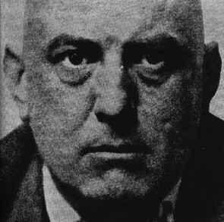
OTO: 'Compassion Is the Vice of Kings'This was explained by the OTO's Sanitised in the formal complaint against us. He wrote that these principles are taught through a graded series of degrees, or initiations, and are understood through practical engagement with these mysteries in the initiate's own life. But the OTO members don't just practice these principles. Right from the first degrees of the O.T.O. initiates swear to defend the principles of the Book of the Law.
More insight into this dangerous organisation, (whose members form a network including some top names in politics, media and business) was provided in an email to us from a rival faction.
This OTO member wanted to correct us for calling the OTO "Satanists". He thought he should tell us,
"As for being Satanists we deny this. We make any Satanism look like a two year old crying baby, relatively speaking. We sincerely believe the world must be bathed in blood before the Law of Thelema is generally accepted. See Magick in Theory and Practice and the chapter on the Bloody Sacrifice for further details." http://www.rahoorkhuit.net/library/crowley/magick.html ( search the page for "bloody sacrifice" or "bathed in blood")
What this says is that, according to the OTO Dogma, the Initiation of a New Aeon (The Age of Horus) requires that the whole Planet must be bathed in blood. The "Great War" must be fought before man is ready to accept the Law of Thelema.
It is quite safe to say that The Book of the Law is the easy guide to understanding the mindset of the OTO. However, a particularly useful further document that has come to our attention is The Old and New Commentaries to Liber AL http://www.hermetic.com/220/crowley-comment.html which clarifies how the Book of the Law (Liber AL) is to be interpreted regarding sexual behaviour with children, among other things.
It tells us that:
Every man, woman and intermediately-sexed individual is free to interpret and communicate self by means of any sexual practices at all, regardless of ethical, legal or religious concerns, etc, provided that all parties are fully aware of all implications and responsibilities and heartily agree.
However, if a woman asks why a man wants to kiss her, he may choke her into submission.
Mutual consent is a condition. But such consent is not always explicit. Behaviour seen by one person as seduction or rape may by considered to be emancipation or initiation by another.
All possible acts are permissible with all possible partners, whatever you sexual predilections may be.
All children shall be accustomed from infancy to witness every type of sexual act to prevent a fog of falsehood and mystery stupefying their minds which "might thwart and misdirect the growth of their subconscious system of soul-symbolism. "
Incest, adultery and paederasty, "which everyone now practices with humiliating precautions" are authorised.
Murder of a faithless partner is ethically excusable, ...because there may be some stars* whose nature is extreme violence.
The motto accompanying these sexual acts is "excess". (*Every man and woman is a star.)
1. Any kind of sex.
2. Violence.
3. Children.
That's what we've been saying about the Ordo Templi Orientis. That's what it says about itself!
Victorian police, government leaders, church leaders and other concerned responsible authorities - please finally empty your ranks of OTO and other Freemason adherents and take action now against these dangerous criminals who are empowered by your silence. Please also send this message to the Equal Opportunity Commission of Victoria, who still has not cleared us of the complaint lodged against us by this tax exempt religious cult.

Love Under Will
In case there was any misunderstanding regarding what is meant in The Book of the Law by “Love under Will”, OTO prophet Aleister Crowley wrote the following, as quoted by OTO founder Theodor Reuss in his manifesto (from The Secret Rituals of the O.T.O.).
Main points:
Love is a by-product of Will.
Love does not contradict or supersede that Will.
Hate is almost like love.
Fighting is certainly love.
"The Love of Liber Legis is always bold, virile, ecstatic, even orgiastic."
I,44: For pure will, unassuaged of purpose, delivered from the lust of result, is every way perfect. (The Book of the Law)
'Thou hast no right but to do thy will. Do that and no other shall say "nay". ' (The Book of the Law)
Predictably, this doesn't really override loyalty to the rules of the order. As it is explained in the Minerval ritual, if it is your will to enter the OTO army as a spy to destroy your comrades, so be it! But if you break the oath, expect to be mutilated and be "no more a man".

Worship of Abaddon, the Evil One
Revelations 9:11 And they had a king over them, [which is] the angel of the bottomless pit, whose name in the Hebrew tongue [is] Abaddon, but in the Greek tongue hath [his] name Apollyon.
There is no shortage of references to worship and adoration of figures historically associated with evil in this material. This following one should be of particular interest to Freemasons who still think the brotherhood is compatible with their understanding of Christianity and to any who aren’t aware of their ignorant usefulness to the controlling group. Higher ranking Freemasons who are not OTO members also use the word Abaddon. "I cover it with my left hand, and you look over your right shoulder and say Abaddon, which refers to the Evil One." (18th degree initiation rite of the Knight of the Pelican and Eagle Sovereign Prince Rose Croix of Heredom.) (Please study our Masonic degrees page here..)
In an Ordo Templi Orientis song, Song of the Perfect Initiate, (from The Secret Rituals of the OTO, Part Two, The Rituals Themselves, Council of Princes of Jerusalem) the meaning is less ambiguous. This song expresses scorn for the Simple Mason "...Princes of Jerusalem, How we mock and scoff at them!" and praise to Abaddon, ie. praise to annihilation. Take note Freemason dupes!
There is, " …a danger inherent in all secretive societies for their cellular form devised by the founders for the security of the movement, can as readily be used to 'hoodwink' the leadership, who thus become unwitting 'front men ' for activities they would never countenance." (from Steven Knight's The Brotherhood.)

Children in Sexual Rituals
The Gnostic Mass is a ritual which, at the least, is a symbolic enactment of the sex act between opposites - the Priest and the Priestess. They are waited upon by two children.
“The priestess must have divested herself completely of her robe…”
I,62: At all my meetings with you shall the priestess say-and her eyes shall burn with desire as she stands bare and rejoicing in my secret temple-To me! To me! calling forth the flame of the hearts of all in her love-chant. (Book of the Law)
An article by Frater V.I.T.R.I.O.L in the Lion and Serpent, The Official Journal of Sekhet –Maat Lodge OTO, Vol 5 No 3 http://www.sekhetmaat.com/www/html/journal/issues.html ) explains that we can learn everything we need to know about the Gnostic Mass by studying the Lovers card in the Thoth deck, and then its completion in the Art card. The lovers card contains a naked man and woman and two small naked children amongst various symbols, including an eagle and lion (waiting on the sidelines?). In the Art card the lion and eagle are feeding on some seemingly gory mass being delivered to a vessel by a two headed being which probably represents the two adults merged as one.
Is this ritual sometimes carried out with real sexual acts? Common sense provides the answer. The Baphomet Lodge (California) newsletter Baphomet Breeze, Volume III - Number 3, Autumnal Equinox, 1988, ran an explicit sounding account without comment, excerpted from Jurgen by James Branch Cabell, Copyright (c) 1919, 1928. Another dialogue recorded in a Baphomet Breeze newsletter suggests that orgies take place after their Gnostic Masses, which is not surprising considering the Book of the Law verses which are in praise of lust.
II,22: I am the Snake that giveth Knowledge & Delight and bright glory, and stir the hearts of men with drunkenness. To worship me take wine and strange drugs whereof I will tell my prophet, & be drunk thereof! They shall not harm ye at all. It is a lie, this folly against self. The exposure of innocence is a lie. Be strong, o man! lust, enjoy all things of sense and rapture: fear not that any God shall deny thee for this. (Book of Law)
Meanwhile, in its Handbook, the US Grand Lodge (last revised Feb1999) warns its members among other things that violent behaviour, abuse of children and criminal conduct are considered greatly prejudicial to the purposes of the Order. (Perhaps this is to protect its non-profit, tax-exempt corporation status! ) On the other hand, the Fairfax, California, OTO Newsletter, Vol. II. number 1, W'l.#5,April 7, 1992, talks about the "so-called" Solar Lodge, who are not to be trifled with. It contains a reminder that they, the Solar Lodge group, were busted on felony child abuse charges over the famous "boy in the box" case at Bythe, California.

acrifice
III,43: Let the Scarlet Woman beware! If pity and compassion and tenderness visit her heart; if she leave my work to toy with old sweetnesses; then shall my vengeance be known. I will slay me her child: I will alienate her heart: I will cast her out from men: as a shrinking and despised harlot shall she crawl through dusk wet streets, and die cold and an-hungered. (Book of Law)
Regarding child sacrifice, Aleister Crowley in his Magic in Theory and Practice makes plain what is consistent with the Book of the Law references. He writes that only the Master of the Temple can say whether any given act is a crime. In response to expressions of horror from "the ignorant" about killing innocent children, the "knower" will rush to strangle the child and remark that the child "will become Nero" , who was as necessary as Julius Caesar).
There are other explicit references in the OTO material to child sacrifice and consumption of a baby's flesh, although this is not a direct admission that it was practiced by Crowley. See Crowley’s Sex-Magical Instructions, Of the Secret Marriages of Gods with Men, A Secret Instruction of the Eighth Degree.
( Also worth noting in this document is the reference to ON (Osiris) which is known to Royal Arch Freemasons as part of the true name of "God" - JABULON. )
And what does it mean, in Crowley’s Rites of Eleusis when one participant asks, "Are the brethren fed? and the answer is, "Upon the corpses of their children"? Is this “poetry” too? And when Crowley explains the following in his Magick in Theory and Practice ( http://www.rahoorkhuit.net/library/crowley/magick.html ) are we supposed to think of this as metaphor?
It is unwise to condemn the practice of savages who tear the heart and liver from an adversary and consume them while warm.
To achieve the highest spiritual working you must choose the victim which contains the greatest and purest force.
A perfectly innocent and highly intelligent male child is the best victim.
Of course “the profane” (the name for non-Freemasons) are not going to be told what really goes on. And, as in normal Freemasonry, those in the lower degrees have little idea what’s going on in the higher degrees, like in the Eleventh, about which nothing is said whatever in any (other?) grade. It has no relation to the general plan of the order. It is inscrutable and dwells in its own palace.
What more have we learned from a brief skimming through of some of the voluminous texts and documents produced by the OTO, aside from The Book of the Law? The above collection of examples shows a total consistency with The Book of The Law despite the relevant sections being almost submerged by tons and tons of nonsensical, irrational and obscene intellectual self-gratification, (with an irresistible mystique for complete idiots). This religion’s creators must be laughing in their graves.
After-all, in Of the Nature of the Gods, A Secret Instruction of the Seventh Degree Crowley explains that people who profess to be orthodox in their faith, but only as a convenient means of dominating the vulgar are already "of us", although they don't know it. Ripe for conversion, such people may easily be brought to fight in the ranks of the Thelemites.
(This is on the the same html document as the above link to Sex-Magical Instructions, Of the Secret Marriages of Gods with Men, A Secret Instruction of the Eighth Degree.)
I,10: Let my servants be few & secret: they shall rule the many & the known.
(The Book of the Law)
Here is a nicely presented online copy of the secret rituals of the OTO. It's a .pdf file.
(You don't need to open and read it on-line. Simply save it to your computer with a "right click" on the link. Choose "save target as", and save it to your chosen location.)
Or
Go to the not so tidy, but fast-access Google htm file
You need this one as well for a htm version of Of the Nature of the Gods, A Secret Instruction of the Seventh Degree, and Sex-Magical Instructions, Of the Secret Marriages of Gods with Men, A Secret Instruction of the Eighth Degree (which are included in the above pdf file along with the rituals.)
Please read how they are operating in the Australian state of Victoria
*I,40: Who calls us Thelemites will do no wrong, if he look but close into the word. (Book of the Law)
Page 2370 of Webster's 3rd New International Dictionary, 1971
thel.em.ite \'thel?mit\ n -s [F thélémite, fr, Abbaye de Thélème, imaginary abbey with the motto "Do as you please" in Gargantua (1535) by François Rabelais † 1553 Fr. satirist + F -ite] : one who does as he pleases; esp : LIBERTINE (from Greek thete teat, nipple)
LIBERTINE 1. one free from restraint or control, especially in moral or sexual matters; a dissolute or licentious person.
LICENTIOUS 1. sensuously unbridled; libertine; lewd. 2. unreserved by law or morality; lawless immoral. 3. going beyond customary or proper bound or limits.
The Australian 3rd Edition Macquarie Dictionary © 1997
(Please see Aleister Crowley’s biography to read more about Thelema)
You can visit this extremely important link for the antidote the above horror.
THE GODS OF THE EARTH WERE HUMAN
They [the Plejaren ] came, [in 1974] in an act of love, to show us that our world is gripped by spirit-enslaving, evolution-robbing, false religious teachings, which had been set in train on Earth millennia ago by some of their own distant ancestors, who were intent on subjugating the primitive people by misrepresenting themselves as creator gods. The resulting madness and delusion has brought us to the brink of global catastrophe, despite necessarily strident warnings given over the millennia.

Jill Dando Raised Alarm About ‘Paedophile Ring At BBC’
MURDERED television presenter Jill Dando tried to alert her bosses
to a paedophile ring at the BBC involving “big name” stars, claims a former colleague.
By JOHN CARR
21st July 2014
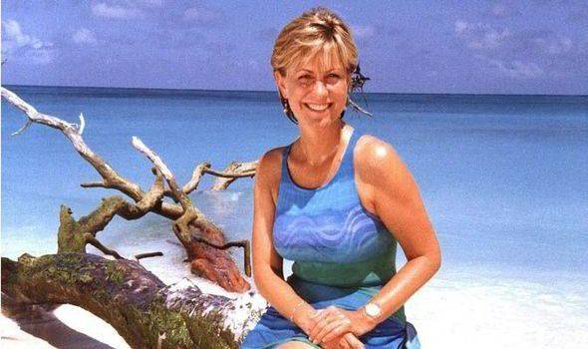
The friend and retired BBC worker said the late Crimewatch host was told DJs, celebrities and other staff were involved in organised abuse.
But the anonymous source says “no one wanted to know” when Miss Dando raised concerns about the alleged ring and other sexual abuse claims at the BBC.
She is said to have passed a file to senior management in the mid-1990s, but they never carried out an investigation.
The 37-year-old TV presenter was shot dead on April 26, 1999, on the doorstep of her home in west London. The crime remains unsolved.
The source said: “I don’t recall the names of all the stars now and don’t want to implicate anyone, but Jill said they were surprisingly big names.
“I think she was quite shocked when told about images of children and that information on how to join this horrible paedophile ring was freely available.
“Jill said others had complained to her about sexual matters and that some female workmates also claimed they had been groped or assaulted.
“Nothing had been done and there seemed to be a policy of turning a blind eye.”
The former colleague said female BBC staff confided in Jill, one of the best-known TV faces of the day after fronting primetime shows including Holiday and the Six O’Clock News as well as Crimewatch.
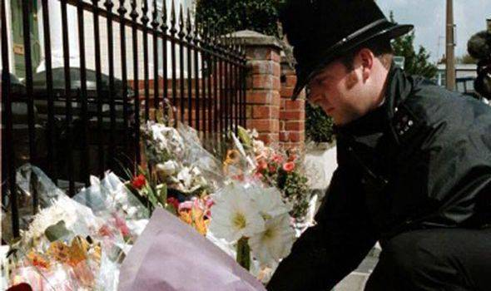
Policeman arranges flowers left by mourners outside the home of BBC TV Presenter Jill Dando in 1999 [GETTY]
Jill said they were surprisingly big names - Source
The source said: “I think it was in the mid-1990s. She was seen as the face of the BBC and a magnet for women with problems.”
Miss Dando compiled a file of complaints but was a television presenter and “not really an investigative journalist”, the source said. “She passed the information on to someone else and they gave it back. No one wanted to know.
“I do remember that she gave a file to senior management. I don’t think she heard any more.
“Other women who complained told Jill they didn’t want to risk their careers by making official statements against individuals as they would lose their jobs and that bosses seemed to ignore it.”
A BBC spokesman said they would always investigate any allegations of this nature, but added: “We’ve not seen anything that substantiates these claims.”
After Jimmy Savile’s sexual crimes were exposed in 2012, Jill’s fellow BBC presenter Sally Jones revealed that the disgraced DJ tried to kiss and grope her in a lift in the late 1980s.
At the time, she told Jill, who said Savile was “just a dirty old perv”.
The Crimewatch host “had to fend off plenty of unwelcome advances herself”, said Sally. DJ Liz Kershaw and former Countryfile presenter Miriam O’Reilly have also both claimed they suffered sexual harassment at the BBC in the 1980s.
Miss Dando joined a campaign to help children spot paedophiles the year before she died.
She had received death threats, putting the BBC in lock-down, with armed guards patrolling Television Centre in London.
Her death sparked one of Britain’s biggest murder hunts. Barry George was found guilty in 2001, but his conviction was quashed in 2008.
Theories about her death range from the culprit being a Serbian warlord angry over her TV appeal on behalf of Kosovan refugees, to British underworld enforcers furious at her Crimewatch investigations.
Miss Dando was also looking into the death of her friend, Chelsea vice-chairman Matthew Harding, who was killed in a helicopter crash.

Related articles
ITV weatherman Fred Talbot denies fresh child sex abuse claims:
http://www.express.co.uk/news/uk/486403/ITV-weatherman-Fred-Talbot-denie...
114 child sex files linked to MPs have ‘vanished’:
http://www.express.co.uk/news/politics/487664/MPs-paedophiles-Theresa-Ma...
Why was Scottish Savile ignored?:
http://www.express.co.uk/news/uk/488484/Why-was-Scottish-Savile-ignored
Link: http://www.express.co.uk/news/uk/490169/Dando-alarm-paedophile-ring-BBC

Links To All Attached Files Listed Above
THE PAEDOPHILE AND SATANIC NETWORK IN AUSTRALIA INVOLVING GOVERNMENT OFFICIALS.doc - 89 KB
http://loveforlife.com.au/files/THE%20PAEDOPHILE%20AND%20SATANIC%20NETWO...
By Dr Reina Michelson Sued By OTO.txt - 95 KB
http://loveforlife.com.au/files/By%20Dr%20%20Reina%20Michelson%20Sued%20...
DR REINA MICHAELSON ABC Stateline Claims police mishandled child sex abuse cases.txt - 9.24 KB
http://loveforlife.com.au/files/DR%20REINA%20MICHAELSON%20ABC%20Statelin...
See Also: Ivan Milat Backpacker Murders by Alice Smith - A message for the REAL backpacker murderers: https://www.scribd.com/doc/251169408/A-Message-for-the-REAL-Backpacker-M... or http://www.futureofmankind.co.uk/meier/gaiaguys/Call.me.Laure.O.htm

COVER-UP OF SATANIC CHILD ABUSE IN HAMPSTEAD
SECURITY SERVICES INVOLVED?
Alisa And Gabriel Draper
Sunday, 15th March 2015
Link: http://aanirfan.blogspot.co.uk/2015/02/satanic-child-abuse-in-hampstead....
The Full Story of Alisa and Gabriel Draper Is Located Here:
Darkness Visible Part One D: http://loveforlife.com.au/node/8569
------------------------------------------------
Sep Cutting Heads Off - Alisa and Gabriel
http://loveforlife.com.au/files/09_Sep_cutting_heads_off-1.mp4
Alisa and Gabriel
Note: See many more Alisa & Gabriel Videos here: http://loveforlife.com.au/node/8569
-------------------------------------------------
Child pornography is said to be a $20 billion industry.
Here are the allegations concerning an international 'the snuff movie gang' that allegedly operates in Hampstead, a very wealthy part of London:
The allegations by the family and friends of Alisa and Gabriel come from: Details on the Satanic Death cult
(this webpage has been taken down)
DISCLAIMER: THE POSTING OF STORIES, COMMENTARIES, REPORTS, DOCUMENTS AND LINKS (EMBEDDED OR OTHERWISE) ON THIS SITE DOES NOT IN ANY WAY, SHAPE OR FORM, IMPLIED OR OTHERWISE, NECESSARILY EXPRESS OR SUGGEST ENDORSEMENT OR SUPPORT OF ANY OF SUCH POSTED MATERIAL OR PARTS THEREIN.
1. The child abuse videos are made in several Hampstead schools and at various other locations in North London, including a Hampstead church.
2. Members of the gang film, edit, translate and sell the movies around Europe, Russia, Ukraine and the USA.
3. The scores of adults involved include certain school staff, certain parents, a priest and others.
4. Babies are sexually abused, tortured and murdered.
Satanic ceremonies are carried out.
Michael Aquino - Satanisun - Mk-Ultra
10 Minutes 23 Seconds - 29th January 2012
5. The Hampstead gang gets babies from such countries as the USA, South Africa, Portugal, Spain, South America, China and India.
6. Locations where the gang meet include an upstairs room in an American fast-food restaurant.
The boss of the restaurant allows child sacrifice in a secret room.
Babies are prepared and cooked at the restaurant.
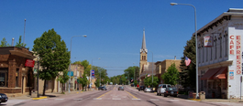
1983 - In Jordan, Minnesota, several children made allegations of satanic ritual abuse against their parents and an unrelated man. The man confessed and then identified a number of the children’s parents as perpetrators. Twenty-four adults were charged with child abuse though only three went to trial with two acquittals and one conviction.[53] Despite strong medical findings of sexual assault, all other charges were dropped.The children made allegations concerning child pornography, child murder, and ritual sacrifice.
7. The Hampstead gang includes the father of Alisa and Gabriel.
The gang includes a headmistress, a school nurse, a school receptionist, the owners (from Belgium) of a shoe repair shop, certain Germans, certain East Europeans, certain Indians...
The headmistress has a huge pink birth mark around her shaved front private.The headmistress is involved in the business of child prostitution, child porn and snuff movies.
One member of the gang regularly travels to Thailand and runs a lucrative child pornography and snuff movies business.
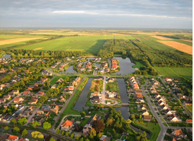
Oude Pekela. 1989 - a group of parents published allegations in a conservative magazine that their children had witnessed Satanic Ritual Abuse and had been ritually abused from May, 1987 until October 1988 in Oude Pekela, in the Netherlands. During the initial investigation, only the non-ritual aspects were reported in the press and investigated by the authorities. In 1989 the Christian news program Tijdsein reported allegations that included satanic ritual abuse, to which there was no official response. Oude Pekela doctors Fred Jonker and Ietje Jonker-Bakker alleged that several children had been abused by unknown men in the context of satanic rituals.
8. The Hampstead gang includes:
A man who runs a building company and who constructs secret rooms and escape routes.
An Indian who is involved in procuring babies and selling videos.
A Chinese woman who brings babies from China and sells videos.
A woman in the property business who provides babies from the Ukraine and Russia, provides empty properties for ritual abuse, and sells videos in Ukraine and Russia.
9. The children are frequently injected with drugs to stop them screaming.
Continued here: Details on the Satanic Death cult (this webpage has been removed)
According to the mother of Alisa and Gabriel (above):
Details on the Satanic Death cult (This webpage has been taken down)
The mother of Alisa and Gabriel is separated from her former partner Mr D.
Mr D had secretly been abusing Alisa and Gabriel from an early age.
Eventually the children told their mother that Mr D had sodomised them and forced them to do oral sex.
When Alisa and Gabriel were around 3 - 4 years old Mr D had introduced them to his child abuse gang, which involved a number of adults and young children.
The gang was violent to the children and forced them to take part in sexual activity.
The children were filmed.
The children were repeatedly told that they would be killed if they spoke out.
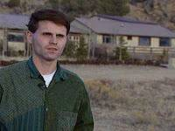
Paul Bonacci in front of the ranch where, reportedly, Johnny Gosch, and other boys were held captive. Paul Bonacci has stated that, as a youth, he was forced to participate in satanic snuff films. He identified Bohemian Grove as the location of a satanic murder. Paul A. Bonacci said that, as a child, he was kidnapped by the US military, tortured and subjected to sex abuse and mind control. In 1999, in a court in Omaha, he won $1,000,000 in damages.
During this time Alisa and Gabriel were displaying very aggressive and disturbing behaviour inside and outside their home.
In March 2009 the mother started legal proceedings, applying for a non-molestation order.
The court ordered that Mr D must have unsupervised contacts with the children every Saturday from 10am to 6pm.
The children were sent for counselling sessions at the Tavistock.
(The Tavistock clinic allegedly organises the mind control and sexual abuse of children - MIND CONTROL, SATANISM, 7/7, TAVISTOCK ...)
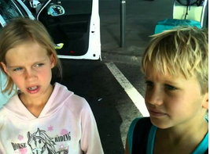
Alisa and Gabriel. "Members of the cult film,
edit, translate and sell the movies around Europe,
Russia, Ukraine, America."
In 2010 Alisa started to attend Christchurch school in Hampstead; Gabriel joined a year later.
The children claim that, at the school, they, and other children, were regularly sexually abused by their father Mr D, and by certain teachers who were friends of Mr D.
The children were all threatened with death if they spoke out.
It was only in August 2014, while on holiday, that Alisa and Gabriel told their mother about what was going on at the school.
On one occasion, Alisa's friend Millie came to play at the home of Alisa and Gabriel.
Millie asked the mother if she was going to have sex with the children.
When Alisa answered 'no', Millie said 'why don't they tell about what was going on in school'.
Alisa then reminded Millie about the threat of being killed.
The children say that there were plenty of visitors coming to the school on Wednesdays.
Some of the visitors were putting broom's sticks up the children's bottoms, causing bleeding, and kicking the children’s privates.
The children like Gabriel who could not tolerate the pain and screamed too much were given injections by a nurse.
Session 1 Counseling a Satanic Ritual Abuse Victim
SRA ChosenOne/Breeder MPD DID
2nd May 2013 - 27 Minutes
https://www.youtube.com/watch?v=abIjvtOeUIY
The children's behaviour started to worsen with the beginning of school in September 2013.
Sometimes a kind of glaze would come over Gabriel's eyes, as if he was switching off from the reality.
The children were observed to be indulging in unusual sexual behaviour at home.
The mother's partner is a Mr Christie.
Mr Christie grew suspicious about the children being abused.
On one occasion Mr Christie tapped both Alisa and Gabriel on the head with a teaspoon following their extremely rude and disrespectful behaviour.
On 11 September 2014, there was a police interview of the children.
The children were taken into the custody.
The children retracted their allegations against the abusers.
The mother writes:
"I believe that most of the information my children have revealed is true.
"There is no way a child could create a story like that, with so many intricate details…
"It is out of the question that Mr Christie or me would coach the children to say things like that.
"Neither of us would ever put the children through this for whatever reason, and create such unbelievable situation for ourselves.
"Even supposedly we coached them to say this, the children of that age could not possibly repeat the same story all aver again to the different adults in different circumstances without hesitation or changing the details.
"Although we know that they have retracted their statements, the children still, even now keep coming back to the same story and the details, while in the foster care to the degree that it became unbearable for their caretaker Carol to look after them. She no longer wants to do this."
Alisa and Gabriel
"Members of the cult film, edit, translate and sell the movies around Europe, Russia, Ukraine, America."
The following allegations by the mother of Alisa and Gabriel come from:
Details on the Satanic Death cult: (this webpage has been removed)
DISCLAIMER: THE POSTING OF STORIES, COMMENTARIES, REPORTS, DOCUMENTS AND LINKS (EMBEDDED OR OTHERWISE) ON THIS SITE DOES NOT IN ANY WAY, SHAPE OR FORM, IMPLIED OR OTHERWISE, NECESSARILY EXPRESS OR SUGGEST ENDORSEMENT OR SUPPORT OF ANY OF SUCH POSTED MATERIAL OR PARTS THEREIN.
Details of the mass child sex abuse, satanic ritual child sex abuse and sacrifice cult, serial murdering and blood drinking.
Main action is happening in C..... primary school in Hampstead, London, together with at least another 7 schools: H school, H school, F primary, Perrochio school, N, N, D; possibly more schools involved.
The school staff and parents, priest, others involved are doing sex to boys' and girls' bottoms with the large plastic willies.
Adults force the children to do oral sex.
Babies are supplied regularly for the rituals: abused, tortured with the rat traps, dropped on the floor (often bleed), then killed. They put them to sleep by injecting, slit baby's throat, drain blood, drink the blood and then cook the body by either roasting or frying. The meat is eaten by the leader Mr D., teachers, 20 special children and their parents.
The baby sexual abuse and sacrifices are going on Tuesday, Wednesday (big sex day), Thursday. On Wednesdays, my children, Alisa and Gabriel have been abused by at least 60-70 people including 20 special children (the children are taught to abuse each other).
I was wondering why my children were often pretending sick and refused to go to school on Wednesdays.
There are 4 secret rooms in the church where the cult members perform the rituals. The ritual involves wearing special costumes: children wear 10-13 babies skulls (sometimes with blood and hair still on the skull), adults - 20, - on their bodies, leader - 30 skulls.
Everybody has skulls worn around the neck (4), on breast, front private, belly, knees, arms.
CONTINUED HERE:
Details on the Satanic Death cult (this webpage has been removed)
"It’s her children who at long last had begun to ‘talk’ after their father had threatened to kill them, should they speak out.
"She had no idea that their erratic behaviour was typical of being abused."
What’s to become of the Hampstead whistleblower kids?
http://tapnewswire.com/2015/02/whats-to-become-of-the-hampstead-whistleb...
Note: This webpage has been removed.
In three videos (see below), two children describe sexual abuse carried out by named adults.
"Several people are alleged to be involved and have a good opportunity to clear their names.
"Mr Hxxxxx could for example prove that he doesn’t have red dots over his privates.
"Miss Mxxxxx could for example prove that she doesn’t have a wart on her privates, the size of a 5p coin."
Who are the adults allegedly abusing the children in the video? Here are some more clues?
http://tapnewswire.com/2015/02/who-are-the-adults-abusing-the-children-i...
Note: this webpage has been removed.
DISCLAIMER: THE POSTING OF STORIES, COMMENTARIES, REPORTS, DOCUMENTS AND LINKS (EMBEDDED OR OTHERWISE) ON THIS SITE DOES NOT IN ANY WAY, SHAPE OR FORM, IMPLIED OR OTHERWISE, NECESSARILY EXPRESS OR SUGGEST ENDORSEMENT OR SUPPORT OF ANY OF SUCH POSTED MATERIAL OR PARTS THEREIN.
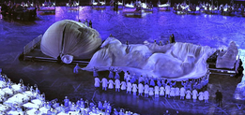
Two young children in Hampstead in London have reported Satanic child abuse by large group of people, which allegedly included their father.
Aangirfan has no way of knowing whether or not the reports by the children are accurate or are inventions.
Everyone named must be assumed to be innocent until proven otherwise.
It is possible that the children have been coached.
When you have read the entire blog post you can make up your own mind.
Anonymous writes:
"The children's medical reports state that the police had been called out on several occasions because Ricky Dearman, the father, was committing 'domestic violence.'
"The medical reports make horrific reading as the children are examined for anal abuse (it is confirmed - with scarring).
"I hear that the police also took the children to have hair follicle tests to ascertain whether drugging had taken place.
"The mother has not been allowed to see the results...
"The mother is not being allowed to see the children and the father has regular access while they are in 'Care'."
Reportedly, police officers and politicians are often involved in child sexual abuse rings.
Councillors and police officer accused of having sex with children:
http://www.dailymail.co.uk/news/article-2939129/Two-local-councillors-co...
In London, an 8-year old boy and his 9-year old sister reported that their father, and others, had sexually abused them.
Allegedly, the father "is the leader of a Satanic child abuse cult in Hampstead in North London."
In September 2014, their reports were recorded on video - by the mother and her partner in separate conversations with the boy and the girl.
The father is British and the mother is Russian.
CHILDREN IN CARE to Protect Police Cover-Up of organised Child Sexual Abuse:
https://nationalinquiry.wordpress.com/2014/12/26/children-in-care-to-pro...
"Abusers are named as parents, teachers, clergy and police."
The police have taken the children into custody and would now seem to be protecting the Satanic child abuse ring?
Or have the children been coached?
Papa Kills Babies
Video: http://loveforlife.com.au/files/231_Papa_kills_babies.mp4
"My dad ... sees us every single day in school where they do sex to us."
That is what the 9 year old girl told her Russian mother about her allegedly 'child abusing' British father.
The children were reportedly threatened with death if they talked.
The mother reported 'the crime', and Barnet Police (Hampstead area) ordered medical examinations.
Reportedly, these confirmed sexual abuse and violence.
Family - Russian
https://www.change.org/p/the-rt-hon-chris-grayling-mp-return-whistleblow...
Note: this webpage has been taken down
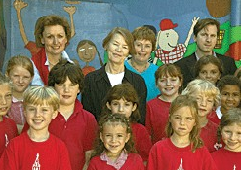
Christ Church primary school, named by the children as being a centre of abuse.
The Police, however, 'closed the case' as 'no crime confirmed'.
A week after 'the crime' had been reported, the children were taken into police custody.
6 days later the children retracted their allegations.
They were then held 'in care' by the Local Borough of Camden and since then Barnet.
Family - Russian
https://www.change.org/p/the-rt-hon-chris-grayling-mp-return-whistleblow...
Note: this webpage has been taken down
Lots And Lots Of Sex - Gabriel
Video: http://loveforlife.com.au/files/299_Lots_and_Lots_of_sex.mp4
Alisa
Video: http://loveforlife.com.au/files/Alisa.mp4
The two judges involved have covered similar cases: Judge Vera Mayer who was involved in the case of Melissa Laird http://melissalaird.wordpress.com transferred the case to Mrs Justice Anne Pauffley in the High Court who was involved with the Hollie Greig case http://holliedemandsjustice.org.
"Private meetings between the Local Authority’s barrister and the Judge are going on behind the mother’s back, which violates the ‘Code Of Practice’ and, of course, indicates a certain common agenda between the Judge and the Local Authority.
"The alleged abuser-father has more contact with the children than the mother, while the Russian grandparents and the older half-brother have hardly any.
"A 12-day fact finding hearing is scheduled to start on 16 February at the Royal Courts of Justice in London - in the secrecy of family courts http://www.gopetition.com/petitions/the-secrecy-of-the-family-courts-sho... - without the general public or any media."
CHILDREN IN CARE to Protect Police Cover-Up of organised Child SexualAbuse
https://nationalinquiry.wordpress.com/2014/12/26/children-in-care-to-pro...
Why Ian Josephs advises mothers NOT to report the crimes of abusive fathers: you lose your children!
Article: http://mckenzie-friends.co.uk/2015/01/02/why-ian-josephs-advises-mothers...
A conference on Child Stealing by the State.
Video: https://www.youtube.com/watch?v=dH1olDX9z3A
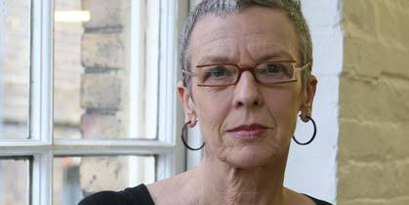
Beatrix Campbell, "the Green candidate for Hampstead and Kilburn believes in Satanic Ritual Abuse of children."
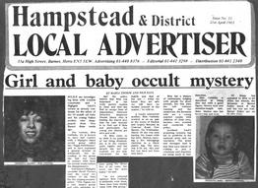
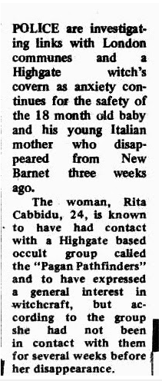

Famous residents of Hampstead
Ozzy Osbourne (British rock musician)[17]
http://en.wikipedia.org/wiki/Ozzy_Osbourne
Ian Fleming (British spy, creator of the James Bond novels)[37]
http://en.wikipedia.org/wiki/Ian_Fleming
Hampstead is the fictional location of Lucy Westenra's tomb in Bram Stoker's novel Dracula. Lucy lured children to Hampstead Heathat night to drink their blood. During the course of their investigation, Drs. Van Helsing and Seward dined at Jack Straw's Castle and caught a cab near Spaniards Inn.
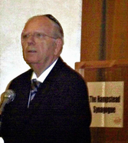
Efraim Halevy, former Head of the Mossad, in Hampstead.
Allegedly, serious child sexual abuse takes place in Hampstead in London.
Hampstead's Royal Free hospital was one of the hospitals ordered by a government minister to investigate links to Sir Jimmy Savile, the alleged Satanist.
Jimmy Savile: hospital.
http://www.bbc.co.uk/news/uk-25153968
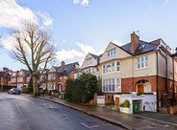
Hampstead.
Reportedly, Jimmy Saville http://www.whale.to/c/jimmy_saville.html supplied boys to former UK prime minister Ted Heath http://www.whale.to/c/ted_heath.html, an alleged Satanist.
Reportedly, Edward Heath liked to meet young boys in Hampstead.
"The name 'Mr. Eddy' was well known on Hampstead Heath and the boys home nearby in the seventies."
Ted Heath - Whale.
http://www.whale.to/c/ted_heath.html
Brian Coleman is a politician in the North London area that covers Hampstead.
In April 2007, Brian Coleman wrote:
"The late Ted Heath managed to obtain the highest office of state after he was supposedly advised to cease his cottaging http://en.wikipedia.org/wiki/Cottaging activities."[13]
Coleman is a former Chairman of the Finchley Friends of Israel and remains a member of Conservative Friends of Israel. He is a governor at two local Secondary Schools.
Reportedly a Satanic child abuse ring operates in Hampstead.
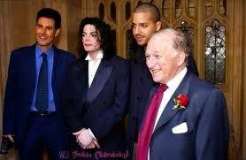
Yuri Geller, Michael Jackson, and (right) Greville Janner
In 2013, as part of investigations into historic child sex abuse allegations, police officers searched the luxury Hampstead flat belonging to Lord Greville Janner, in West Heath Road.
Lord Greville Janner has served as president of the Board of Deputies of British Jews from 1978 to 1984.
He chairs the Holocaust Educational Trust and is vice president of the World Jewish Congress.
GREVILLE JANNER.
http://aangirfan.blogspot.com.au/2013/12/greville-janner.html
Jewish community in shock over rabbi's condemnation of child abuse cover-up.
http://www.theguardian.com/australia-news/2015/feb/05/rabbi-censure-chil...
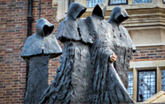
A house called Sarum Chase in Hampstead.
It is believed that the major child abusers, such as Jimmy Savile, Jeffrey Epstein and Marc Dutroux, have been used by the CIA, Mossad and their friends, in order to control the top people.
It is believed that all the key government agencies, such as the police and social services, have been infiltrated by child abusers linked to the security services.
The head of the UN inquiry into the 2014 Israeli genocide in Gaza has sent the UN a resignation letter. He received death threats during his time as chairman. Head of Gaza war crimes inquiry received 'personal attacks, death threats'. http://www.middleeasteye.net/news/leader-un-gaza-war-inquiry-step-down-1...
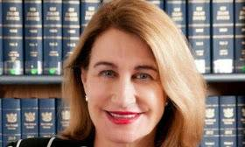
Goddard.
There is a history of cover-ups of child abuse.
Theresa May has named the alleged 'cover-up merchant' Lowell Goddard as the new child abuse inquiry chair.
http://www.theguardian.com/politics/blog/live/2015/feb/04/labour-faces-t...
Justice Goddard is past Chair of New Zealand's Independent Police Conduct Authority and now sits in the Wellington High Court.
"Justice Goddard ... covered up a number of serious complaints...
"Goddard refused to release evidence that former judge Michael Lance was guilty of throwing (wrecking) a police prosecution of his son Simon’s business partner...
"Judge Lance later became Goddard’s deputy judge at the Independent Police Conduct Authority...
BILL MALONEY WITH ANDREW ASH
ABUSE VICTIM-MP'S, BBC
JIMMY SAVILE, CHILDREN MURDERED
1 Minute 34 Seconds - 3oth January 2015
https://www.youtube.com/watch?v=KdXDWrUiwIQ
"Lance retired in disgrace shortly afterward when it was reported he was keying cars parked in front of his Takapuna apartment. (Lance was prosecuted in a judge alone trial and let off.)
"The Independent Police Conduct Authority became an even more opaque agency under Justice Goddard...
"Lawyers who appear before her generally have little regard for her as a judge willing to conform to law or rule consistent with relevant facts. They are far more impressed with her impeccable dress and makeup."
High Court Justice Lowell Goddard.
http://www.kiwisfirst.com/judge-file-index/high-court-justice-lowell-god...
Please watch this video!
Michael Aquino - Satanisun - Mk-Ultra
10 Minutes 23 Seconds - 29th January 2012
A Dundee charity revealed the terrible toll of ritual sexual abuse ...
http://www.thecourier.co.uk/news/local/dundee/dundee-charity-reveals-ter...
"Children as young as five are being forced to take part in torture and violent sex acts as part of a brutal underworld of ritual abuse in East Scotland."
"A leading charity has received as many as five calls a day from survivors of gruesome ceremonies that have included the stealing of babies and grotesque sexual abuse.
The charity’s project coordinator, Joseph Lumbasi says "You hear about people who were made to do torture at as young as five and even kill people.
"We get a lot of people describing satanic ceremonies and set-ups of a religious element that accompany the abuse."
A police spokeswoman said: "We are not aware of any issues of that nature in Tayside Division."
Unfortunately, the police are often involved in the abuse.
"SATANIC RITUAL ABUSE BY THE POLICE"
http://aangirfan.blogspot.com.au/2013/05/satanic-ritual-abuse-by-police-...
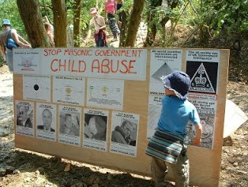
The following comes from a report about Helen G. that appears to have been compiled by the Ritual Abuse Information Network and Support (RAINS).
The Who’s who of Satanic Child Abuse - Christopher Spivey
http://chrisspivey.org/the-whos-who-of-satanic-child-abuse
The report lists people allegedly linked to mind-control and/or Satanic Ritual Abuse:
Lord William Rees-Mogg - William Rees-Mogg
http://en.wikipedia.org/wiki/William_Rees-Mogg
The 17th Duke of Norfolk, Miles Francis Stapleton Fitzalan-Howard
http://en.wikipedia.org/wiki/Miles_Fitzalan-Howard,_17th_Duke_of_Norfolk
Sir David Frost - David Frost
http://en.wikipedia.org/wiki/David_Frost
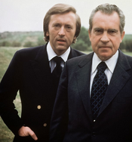
Sir David Frost (left)
Edward Heath - Edward Heath
http://en.wikipedia.org/wiki/Edward_Heath
Michael Winner - Michael Winner
http://en.wikipedia.org/wiki/Michael_Winner
Lord Edwin McAlpine - Edwin McAlpine, Lord McAlpine
http://en.wikipedia.org/wiki/Edwin_McAlpine,_Baron_McAlpine_of_Moffat
Sir Cyril Smith - Cyril Smith
http://en.wikipedia.org/wiki/Cyril_Smith
Peter Tobin - Peter Tobin
http://en.wikipedia.org/wiki/Peter_Tobin
And many more.
The Who’s who of Satanic Child Abuse - Christopher Spivey
http://chrisspivey.org/the-whos-who-of-satanic-child-abuse
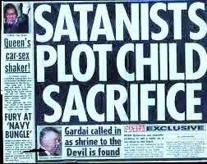
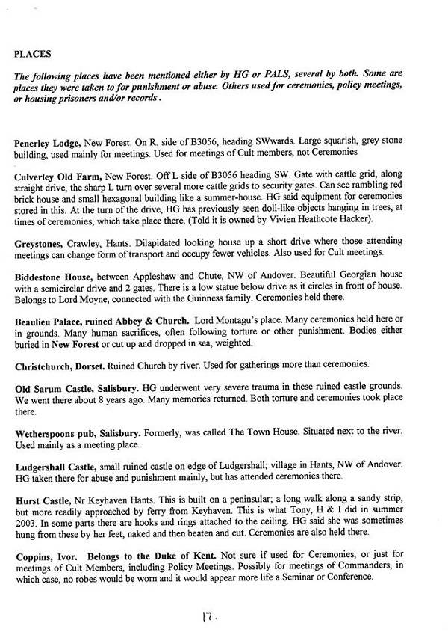
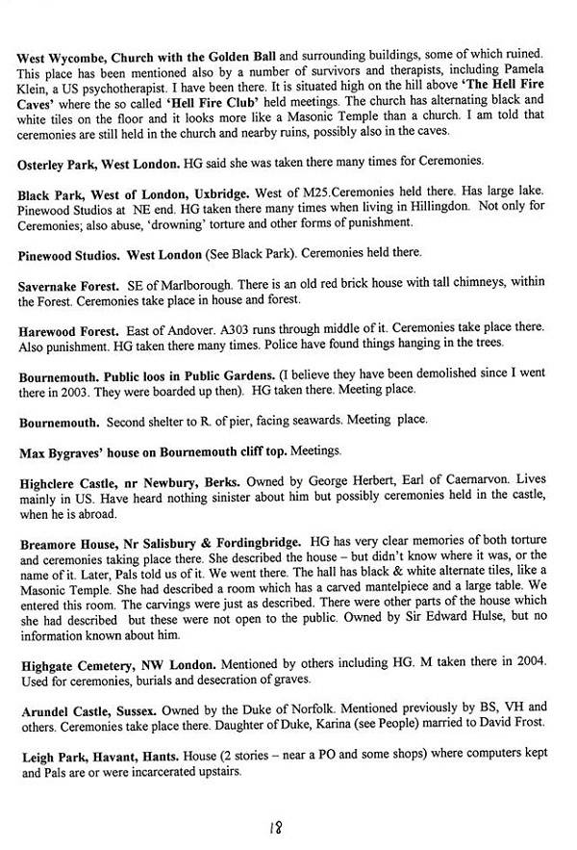
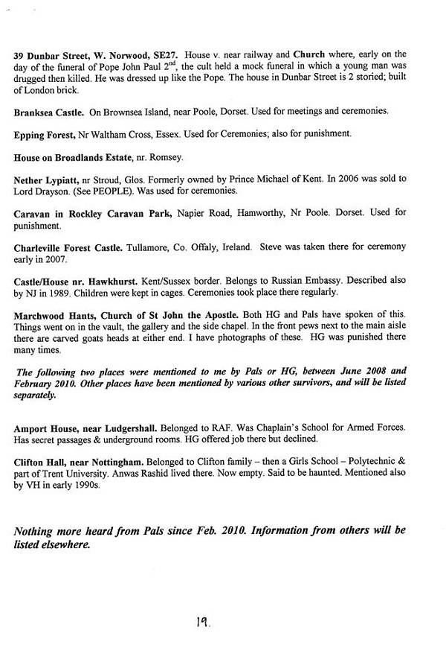
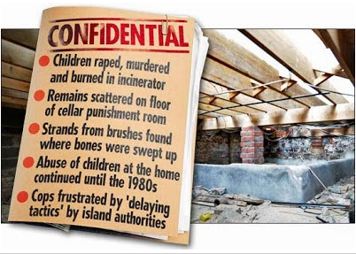
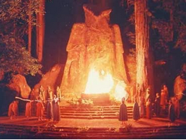
'Satanists' at Bohemian Grove in California.
Satanic child abuse is widespread and often the police are involved in the cover-up.
1. Australia: In the late 1980s, a number of children at a daycare centre in the Mornington Peninsula, Victoria, began disclosing experiences of organised and ritualistic sexual abuse to their parents and the police.[3]
Their disclosures included instances in which they were taken in a car from the creche to a nearby house, undressed by adults and sexually assaulted, video-taped and filmed while naked, and urinated and defecated upon by adults.
The children disclosed that some of the abusers wore police uniforms....
[4] List of satanic ritual abuse allegations
http://en.wikipedia.org/wiki/List_of_satanic_ritual_abuse_allegations
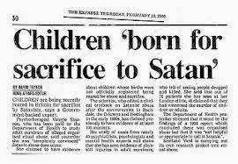
In 2002, Chief Commissioner Christine Nixon refers complaints about the mishandling of the case by police to the Victorian Ombudsman.
An officer from the Ethical Standards Department was stood down a year later from the Ombudsman's investigation for "incompetence" after failing to pass on information from two key witnesses, and claiming that he never spoke to them when phone records proved that he had.
One of the witnesses referred to a tape of child pornography showing men in police uniforms sexually assaulting childrenfrom the daycare centre, however, this lead was never followed up by the police.
Another witness identified the house in which the children had been assaulted as being owned by a police officer.[7]
The principal of a private college on the Mornington Peninsula repeatedly told the Department of Human Services that a 12-year-old boy disclosed ongoing sexual abuse by an organised group of men wearing police uniforms.
According to the principal, all records of the child's complaint vanished.
A Victoria Police spokesman said he was not aware that files had disappeared.
The police declined to press charges, saying the boy had been "too well groomed" by the pedophiles and probably would not testify in court.[8]
1989 News: Call boys in Bush Sr's Whitehouse
14th Dec 2006 - 35 Seconds
https://www.youtube.com/watch?v=v5OJPeHCmhA

THE CIA RUNS THE PEDOPHILE RINGS
http://aanirfan.blogspot.com.au/2014/11/the-cia-runs-pedophile-rings.htm...
2. In the early 1990s, Superior Universal Alignment, an Argentinian-based international cult, was implicated in the ritualistic murders of several children.
One of the leaders of the group, Osvaldo Marcineiro, confessed to murdering a number of young children in Satanic rituals, in which the children were tortured, murdered and their body parts cannibalised.
A number of prominent citizens were arrested in relation to the murders.
People sentenced in relation to the murders included a former police officer.
The charges related to the murders of three young children and the attempted murder of another, however, victim's families say that there were at least nineteen other murdered children.
The cult is based in Argentina and has branches in Holland.
[21]. List of satanic ritual abuse allegations
http://en.wikipedia.org/wiki/List_of_satanic_ritual_abuse_allegations#_n...
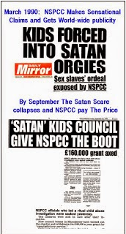
3. In 2006, a jury at Dublin Country Coroner's court unanimously ruled that the infant found stabbed to death over three decades ago belonged to Cynthia Owen.
During the trial, Owen detailed her childhood history of satanic ritual abuse orchestrated by her parents involving at least nine other men.[22]
Following the findings of the Coroner's Court, Owen raised questions regarding the failure of the police to investigate the murder. [23]List of satanic ritual abuse allegations
4. In 2003 allegations by three children in Lewis, Scotland resulted in the arrest of eight people for sexual abuse occurring between 1990 and 2000.
A 2005 investigation by the Social Work Inspection Agency found extensive evidence of sexual, physical and emotional abuse and neglect.[41]
Police investigation resulted in allegations of an island-wide "Satanic paedophile ring",[41][42] though charges were dropped nine months later following an inconclusive investigation.[42][41]
List of satanic ritual abuse allegations
http://en.wikipedia.org/wiki/List_of_satanic_ritual_abuse_allegations
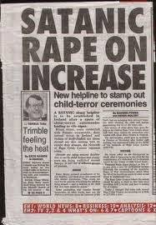
5. Lt Col Michael Aquino, of the US military, has been accused of being involved in child abuse in the USA: "One child positively identified Aquino and his wife, Lilith (known to the kids as 'Mikey' and 'Shamby'), and was also able to identify the Aquinos’ private home and to describe with considerable accuracy the distinctively satanic interior décor of the house.
"The young witness claimed to have been photographed at the Aquinos’ home. On August 14, 1987, a search warrant was served on the house. Confiscated in the raid were numerous videotapes, photographs, photo albums, photographic negatives, cassette tapes, and name and address books.
"Also observed was what appeared to be a soundproof room.
"Neither of the Aquinos was charged with any crimes...
"The U.S. Attorney in San Francisco handling the case was Joseph Russoniello. Russoniello would later be identified by reporter Gary Webb (of the San Jose Mercury News) as a player in the Contra cocaine smuggling operation led by Lt. Col. Oliver North and company, just as witnesses would later identify Lt. Col. Michael Aquino as an operative in the very same sordid affair."
Fort Bragg: "Aquino was also identified by children in Santa Rosa and Fort Bragg, California. In the Fort Bragg case, 'allegations of ritual abuse erupted...
"Cases erupted at some of the country’s most esteemed military bases, including Fort Dix, Fort Leavenworth, Fort Jackson, and West Point. Many of those making the accusations were career military officers who had devoted their lives to unquestioned allegiance to the U.S. armed forces. Many would resign their posts in outraged protest...
"The Times Herald Record reported in June 1991, the 'incidents [at the West Point Child Development Center] unfolded against a backdrop of satanic acts...
West Point: "The Mercury News reported, 'by the end of the year, 50 children had been interviewed by investigators.
"Children at West Point told stories that would become horrifyingly familiar. They said they had been ritually abused. They said they had had excrement smeared on their bodies and been forced to eat feces and drink urine. They said they were taken away from the day care center and photographed.'
"Despite abundant medical and psychological evidence and literally dozens of child witnesses, and despite '950 interviews by 60 FBI agents assigned to the investigation,' the investigation, 'led by former U.S. Attorney [and future mayor] Rudolph Giuliani' produced 'no federal grand jury indictments,' according to the Herald Record..."
http://www.the7thfire.com/Politics%20and%20History/Pedophocracy/child_se...
http://aangirfan.blogspot.com.au/2005/03/michael-aquino-alleged-child-se...
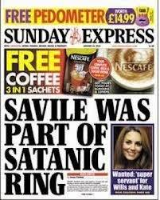
6. Marc Dutroux was part of a mafia-style operation which kidnapped and killed children and which organised orgies for top people including politicians and police.
In 1989, Dutroux was sentenced to 13 years in jail for kidnapping and raping young girls. He was out within 3 years.
Dutroux claimed that two police officers had helped Lelievre and himself to kidnap Marchal, and Lambreks who were later raped and murdered.
The common knowledge that police officers and high ranking officals also attended Nihouls orgies at the chateau must give further fuel to the fire that the accused was not acting alone. -aangirfan: Marc Dutroux
http://aangirfan.blogspot.com.au/2006/02/marc-dutroux.html
SATANIC RITUAL ABUSE IN DUNDEE
http://aangirfan.blogspot.com.au/2013/06/satanic-ritual-abuse-in-dundee....
SATANIC RITUAL ABUSE ALLEGATIONS ...
http://aangirfan.blogspot.com.au/2014/02/abuse-allegations.html
USA'S JENNY HILL; RITUAL ABUSE; SAVILE
http://aangirfan.blogspot.com.au/2013/05/usas-jenny-hill-ritual-abuse-sa...
SATANIC RITUAL ABUSE AND PROJECT MONARCH...
http://aangirfan.blogspot.com.au/2013/07/satanic-ritual-abuse-and-projec...
CHILD ABUSE LIST; RITUAL ABUSE.
http://aangirfan.blogspot.com.au/2012/10/child-abuse-list-ritual-abuse.h...
HOW THE COPS COVER-UP CHILD ABUSE?.
http://aanirfan.blogspot.com.au/2014/07/how-cops-cover-up-child-abuse.ht...
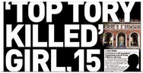
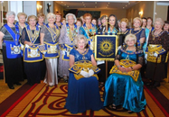
Hampstead is home to a lot of the top people in the UK.
The Honourable Fraternity of Ancient Freemasons (HFAF) in Hampstead.
UK SS Stealing Children To Make Money (Russia Today Interview)
Russia Today - the Voice of Freedom.
Brilliant interview on how UK SS are selling children.
6th July 2010 - 4 Minutes 30 Seconds
https://www.youtube.com/watch?v=vOx2CCphPg0
DISCLAIMER: THE POSTING OF STORIES, COMMENTARIES, REPORTS, DOCUMENTS AND LINKS (EMBEDDED OR OTHERWISE) ON THIS SITE DOES NOT IN ANY WAY, SHAPE OR FORM, IMPLIED OR OTHERWISE, NECESSARILY EXPRESS OR SUGGEST ENDORSEMENT OR SUPPORT OF ANY OF SUCH POSTED MATERIAL OR PARTS THEREIN.
Link: http://aanirfan.blogspot.co.uk/2015/02/satanic-child-abuse-in-hampstead....
Darkness Visible Part One
Part One A: http://loveforlife.com.au/node/8557
Part One B: http://loveforlife.com.au/node/8567
Part One C: http://loveforlife.com.au/node/8568
Part One D: http://loveforlife.com.au/node/8569

Sequential Order
We ask you to NOT believe anything we say/share and instead use scrutiny like an intense blow torch and go where the logic of truth/sense takes you. This is very, very important. Put everything you believe up to the test of scrutiny to see how it stacks up. If you are true to your heart/senses and go where the logic of truth/sense takes you will find that NO belief, etc, will stand up to the test of scrutiny. They just do not stack up because they are lies/fraud.
After you have watched and read all the material and any questions are left unanswered, send us your landline number and we will use the internet phone as a free unlimited call. We are on Sydney NSW Australia time. Best times for us to chat are between 11.00am and 6.00pm.
It is critical that you fully comprehend Image Power, "Name", Contract To "Name", "The System" Of "Names", "Spelling", Trauma, Reaction To Trauma, Curses, Processing Curses, Full-Responsibility/Liability, Limited Liability/Responsibility (passing-the-back), Slavery, Senses/Sense vs Non-Sense/Senses, 1st Party vs 3rd Party, Re-Presenting Intellectual Property such as but not limited to "Name", Storytelling/Storytellers, Duality, Black-Magic, Belief, Lies, "i", All Seeing "i" (eye), etc..... These themes and others are covered over and over and over again.
If you do not comprehend these insights and are unable to use your senses to sense your way through all the non-sense/non-sensory-images that enslave MAN under their image power (darkness = "The System" = Hell), men and women will remain deeply trapped under a terrible state of trauma. Our intention is to inspire you to remedy by showing you how to move away from reacting to trauma in all its nefarious and devious forms.
His-Story/Her-Story (History)
Arthur Cristian - Love For Life
2005-2007 - Re-posted July 2014
http://loveforlife.com.au/node/8529
The Dream Of Life Part 6
Under The Spell Of Intellectual Property
Arthur Cristian - Love For Life
19th April 2012 - 51 Minutes 52 Seconds
http://www.youtube.com/watch?v=IMK7CkU1ih8
The "Name" Is The Mark Of The Beast
The Strawman Identifying
Your Slave Status In "The System"
By Arthur Cristian - Love For Life
5th February 2012 - 56 Minutes 25 Seconds
http://www.youtube.com/watch?v=DdOag66v7uo
IMAGE POWER
The Nefarious Tactics Used
To Disguise Truth And Distract Us
From Remedy
Arthur & Fiona Cristian
Love For Life
24th January 2014
This post contains many recent Facebook comments
and email replies which collectively provides a big picture
into exposing the deception behind IMAGE POWER.
http://loveforlife.com.au/node/8496
The Pull Of E-Motion
Arthur & Fiona Cristian
Love For Life
8th February 2014
http://loveforlife.com.au/node/8499
IMAGE POWER
Superb Diamond Range Interviewing
Arthur & Fiona Cristian 4th February 2014
http://youtu.be/qFnuuw3kLog
http://loveforlife.com.au/node/8501
Trauma Induced Fantasy
July 2013 Interview With
Jeanice Barcelo And Arthur & Fiona Cristian
http://youtu.be/CZVj-ddUoZw
http://loveforlife.com.au/node/8500
Processing Curses
A Lie Is A Curse
Liars Process Curses
Arthur & Fiona Cristian
Love For Life
26th February 2014
http://loveforlife.com.au/node/8503
How The System Is Really Constructed
Bouncing Back Curses Upon Curse Makers
To Stop Harm Forevermore
Arthur & Fiona Cristian
Love For Life
27th February 2014
http://loveforlife.com.au/node/8504
Slave To A Name
Parts One, Two, Three, Four,
Arthur & Fiona Cristian
Love For Life
3rd to 6th March 2014
http://loveforlife.com.au/node/8505
Educated Slaves
Arthur & Fiona Cristian
Love For Life
20th March 2014
http://loveforlife.com.au/node/8506
The Only Path To Freedom
Beware The False Steps
Arthur & Fiona Cristian
Love For Life - 2nd April 2014
http://loveforlife.com.au/node/8508
Free-Dumb For All
Arthur & Fiona Cristian
Love For Life - 5th April 2014
http://loveforlife.com.au/node/8510
Revoking The Ego
Arthur & Fiona Cristian
Love For Life - 8th April 2014
http://loveforlife.com.au/node/8511
How MAN Commits Spiritual Suicide
Arthur Cristian
Love For Life - 3rd April 2014
http://loveforlife.com.au/node/8509
How To Detect Intel Operatives Working
For The New World Order Agenda
Arthur & Fiona Cristian
Love For Life - 10th April 2014
http://loveforlife.com.au/node/8512
How The Psyop Program & Intel Networks
Are Messing With Your Head +
His-Story/Her-Story
Arthur & Fiona Cristian - April 2014
http://loveforlife.com.au/node/8513
Godzilla Through The Looking Glass
Destroyed By Name"
Arthur & Fiona Cristian
Love For Life - 20th April 2014
http://loveforlife.com.au/node/8514
What It's Going To Take
To Co-Create Freedom Forevermore
Arthur & Fiona Cristian
Love For Life - 22nd April 2014
http://loveforlife.com.au/node/8514
Falling For Fairy Stories
Arthur & Fiona Cristian
Love For Life - 24th April 2014
http://loveforlife.com.au/node/8514
A Disassociation From The Work
Of Kate of Gaia
Arthur & Fiona Cristian
Love For Life - 17th May 2014
http://loveforlife.com.au/node/8517
Separating The Wheat From The Chaff
Arthur & Fiona Cristian
Love For Life - 22nd May 2014
http://loveforlife.com.au/node/8516
The True Satanic/Freemasonic Symbolism
Of John The Baptist
Arthur Cristian - Love For Life
24th May 2014
http://loveforlife.com.au/node/8518
Denial And Apathy
How Deep Does Duplicity And
Complicity To Harm Doing Go?
Arthur & Fiona Cristian
Love For Life - 24th May 2014
http://loveforlife.com.au/node/8519
Revolution Or Revolution
Arthur & Fiona Cristian
Love For Life - 25th May 2014
http://loveforlife.com.au/node/8520
Routing Out Psyop Programs
Routs Out Intel Operatives
Exposing Max Igan's Psyop Program
Arthur & Fiona Cristian
Love For Life - 31st May 2014
http://loveforlife.com.au/node/8524
The Psyop Program Scam
Behind Religion Belief Faith
& Associated Opinion
Arthur Cristian
Love For Life
11th June 2014
http://loveforlife.com.au/node/8525
Another Delusion
Arthur Cristian
Love For Life
11th June 2014
http://loveforlife.com.au/node/8526
A World Of Words Is A World Of Lies
Arthur Cristian
Love For Life
13th June 2014
http://loveforlife.com.au/node/8527
E-MAN
The Name Of The Beast Is MAN
Arthur & Fiona Cristian
Love For Life - 9th May 2014
Includes Mountain MAN Arrested
Facebook Discussion About "Name"
Uploaded 25th June 2014
http://loveforlife.com.au/node/8528
E-Motion
Arthur & Fiona Cristian
Love For Life - 13th August 2014
http://loveforlife.com.au/node/8537
Discussion With Brother Gregory
Clearly Demonstrating Christianity
Is Part Of The Problem
And Not The Solution
Arthur & Fiona Cristian
Love For Life
Between the 12th May 2014 and 30th August 2014
http://loveforlife.com.au/node/8542
The Psyop Program Behind Free Food
And Permaculture
Arthur & Fiona Cristian
Love For Life
29th October 2014
Facebook discussion with Unconditional Love Moon
http://loveforlife.com.au/node/8544
Head So Strong
Music and Vocals Arthur Cristian
Backing Vocals and Vocal Effects Arthur Cristian & Hannah Wood
Lyrics Fiona and Arthur Cristian
Written during our spare time between Aug & Oct 2014
https://www.youtube.com/watch?v=OG4UQCTsqwU
The Time Of Trauma That Destroys Us
Arthur Cristian - Love For Life
9th November 2014
http://loveforlife.com.au/node/8547
The Most Powerful Video On Spirituality
And Happiness FOR SLAVES
Or
How To Accept Slavery And Be Happy About It
Arthur Cristian - Love For Life
6th August 2014
Facebook Discussion About The Work Of Eckhart Tolle
http://loveforlife.com.au/node/8548
What Can We Do What Can We See
Arthur Cristian - Love For Life
A series of Arthur Cristian Facebook
posts and discussions
between 17th and 21st November 2014
http://loveforlife.com.au/node/8552
The Misuse Of Love By Intel Networks
To Create Doubt And Uncertainty
With The Intention To Destroy Love
And Therefore Destroy MAN
(True Freedom, Peace, Joy, Abundance And Truth
For Everyone)
By Arthur Cristian - Love For Life
26th November 2014
http://loveforlife.com.au/node/8554
The Void Of E-GO That Is Spiritual Suicide
The Justification Of Laziness
That Perpetuates System Creature Comforts
Ensuring Our Fall
Arthur & Fiona Cristian
Love For Life
13th December 2014
http://loveforlife.com.au/node/8556
Darkness Visible Part One A, B, C, D
The Freemasonic World In Plain Sight
Decoding George Washington Lithographs
Arthur & Fiona Cristian
Love For Life
14th December 2014
Part One A http://loveforlife.com.au/node/8557
Part One B http://loveforlife.com.au/node/8567
Part One C http://loveforlife.com.au/node/8568
Part One D http://loveforlife.com.au/node/8569
Darkness Visible Part Two
Yin And Yang, Duality, Spiritual Suicide
And Frank O'Collins UCADIA / One Heaven
Arthur & Fiona Cristian
Love For Life
14th December 2014
http://loveforlife.com.au/node/8558
Darkness Visible Part Three
How The Word Sausage
Re-Presents The New World Order
Boiling Point & Out To Get Us
Arthur & Fiona Cristian
Love For Life
27th December 2014
http://loveforlife.com.au/node/8560
Darkness Visible Part Four
Aleister Crowley - Thelema - OTO
And The Black Magic Psychedelia Of The Intellect
Facebook Discussion
4th to 10th January 2015
http://loveforlife.com.au/node/8561
Darkness Visible Part Five
Living MAN Fiona Cristian's Standing
+ Decoding Judeo/Judaism
Fiona Cristian & Arthur Cristian
Love For Life
24th January 2015
http://loveforlife.com.au/node/8562
Darkness Visible Part Six
The Many Fingers Of The Hidden Hand Appearing
YouTube Community Flagged A Video
Posted To The ArthurLoveForLife YouTube Channel
As Being "Hate Speech"
Fiona Cristian & Arthur Cristian
Love For Life
4th February 2015
http://loveforlife.com.au/node/8563
Darkness Visible Part Seven
The Full Responsibility For Setting
True Freedom For All Into Motion
In Present-Sense Forevermore
Fiona Cristian & Arthur Cristian
Love For Life
10th February 2015
http://loveforlife.com.au/node/8564
Who We Really Are Does Not End
At The Surface Of Our Skin
Arthur Cristian & Fiona Cristian
Love For Life - 22nd February 2015
http://loveforlife.com.au/node/8565
The Rot Parts One, Two, Three
Arthur Cristian
Love For Life
5th June 2015
http://loveforlife.com.au/node/8571
New Love For Life Kindom Facebook Group
Started March 2015
https://www.facebook.com/groups/1434747556816918
Includes 63 Minute
Introduction To Kindom Video
https://youtu.be/7SspPm9wRgo
By Arthur & Fiona Cristian
and
Facebook Kindom Group Guidelines
http://loveforlife.com.au/node/8566
The Love For Life website home-page provides
the bigger-picture background to the themes
touched on in this video: http://loveforlife.com.au
Crop Circles Are A Massive Hoax
Facebook Discussion On Simon Kawai's Wall
Involving Arthur & Fiona Cristian
31st August 2013
http://loveforlife.com.au/node/8470
OPPT & Slavery Through Intellectual Conscription By Deceit
Arthur & Fiona Cristian - Love For Life
27th February 2013 onwards...
Part One: http://youtu.be/Qjp_9nlrBao
Part Two: http://youtu.be/tbybeOWZ-Bc
Part Three: http://youtu.be/yOWoxH-HbVw
Water Is The Life Of MANS Consciousness (Breath)
Arthur & Fiona Cristian - Love For Life - 8th February 2013
http://loveforlife.com.au/node/8350
Part One: http://youtu.be/4ze66_33wxM - 70 Minutes 5 Seconds
Part Two: http://youtu.be/43gIi-sjxJc - 81 Minutes 13 Seconds
Part Three: http://youtu.be/oooY6W63K-M - 70 Minutes 18 Seconds
What Do You Believe On Origins?
Who Said There Was A Beginning?
Who's Truth Do You Accept?
Belief Is A Strange Idea.
Discussion Lyndell, Scott and Arthur & Fiona Cristian
Between March and April 2013
Posted 29th October 2013
http://loveforlife.com.au/node/8487
So You Want The Good Bits Of "The System"
But Not The Bad Bits?
By Arthur & Fiona Cristian
Love For Life - 12th August 2013
http://loveforlife.com.au/node/8468
Turning Away From The Reflection
Of MANS Looking Glass
Arthur & Fiona Cristian
Love For Life
30th April 2013
http://loveforlife.com.au/node/8404

REMEDY
From Bare Dirt To Abundance
A Year In The Life Of The
Love For Life Food Forest
Arthur & Fiona Cristian
8th February 2013
51 Minutes 46 Seconds
http://www.youtube.com/watch?v=1sJCcCvZ97A
From Bare Dirt To Abundance Part Two A
5th November 2014
http://youtu.be/TPTPn8tgcPI
From Bare Dirt To Abundance Part Two B
Coming Shortly
Control The Land
And You Control MAN On The Land
Displace MAN From Land
And You Turn MAN Into Slaves
Arthur & Fiona Cristian - Love For Life
April 2011 (Updated 14th September 2011)
http://loveforlife.com.au/node/8237
The Divine Spark
Facebook Discussion With Raymond Karczewski
Arthur & Fiona Cristian & Others
2nd October 2013
http://loveforlife.com.au/node/8483
Capturing Another MANS Uniqueness
A Facebook Debate With
Arthur & Fiona Cristian - Love For Life
And Raymond Karczewski
Starting 13th May 2013
http://loveforlife.com.au/node/8414
The Spell Is Broken
Taking The Land To Create Kindom
Arthur & Fiona Cristian
Love For Life
3rd March 2013
http://loveforlife.com.au/node/8365
The Steps Of Kindom
Arthur & Fiona Cristian
Love For Life 2006/2007
http://loveforlife.com.au/node/8304
To explore these themes in greater detail go here where you can find links to all our Love For Life comments, articles, debates, discussions, videos, podcasts, etc: http://loveforlife.com.au/node/3385
All the best
Arthur & Fiona Cristian
Love For Life
Website: http://loveforlife.com.au
Email : action@loveforlife.com.au
Mobile : 0011 61 418 203204 - (0418 203204)
Snail Mail: PO Box 1320 Bowral 2576 NSW Australia
Facebook Arthur Cristian : http://www.facebook.com/arthurcristian
YouTube Arthur Cristian : http://www.youtube.com/ArthurLoveForLife
Register To The Love For Life Mailing List: http://loveforlife.com.au/content/09/05/14/mailing-list
Facebook Group Why Aren't We Free Discussion : http://www.facebook.com/164918753537287
Facebook Group Kindom/Do No Harm Community Discussion : http://www.facebook.com/151811728195925
Links below will kick in when the professionally recorded Love For Life music is released.
SoundCloud : http://soundcloud.com/loveforlife
Nimbit Music : http://www.nimbitmusic.com/loveforlife
Twitter : https://twitter.com/loveforlifemusi
Facebook Music : http://www.facebook.com/loveforlifemusic
YouTube Love For Life Music : http://www.myspace.com/loveforlifemusic
MySpace : http://www.myspace.com/loveforlifemusic
Google + Fiona Cristian : https://plus.google.com/1004901751608716100903.2
‹ Darkness Visible Part One A - The Freemasonic World In Plain Sight - Decoding George Washington Lithographs - Arthur CristianupDarkness Visible Part One D The Hampstead Satanic Ritual Abuse Children Gabriel Draper & Alisa Draper & Mum Ella Draper ›
- Articles/Emails Arthur Cristian

- Australian Stories

- Banks

- Corporations

- Freedom Fighter Updates

- Law articles & documents
- Love for Life Campaign

- Psychic Reign

- Videos and DVD's
- Add new comment

Support The Love For Life Campaign, Kindom & The Cristian Family
Supporting The Love For Life Website, The Cristian Family and The Living Dream Of Kindom (Creation Of Do No Harm Communities) - The Love for Life website is produced for free without a fee (no contract or conditions attached) as a gift of love for the benefit of others. If you feel you have gained something from visiting it, feel inspired, and would like to reciprocate as an equal exchange in substance and support (value), you are most welcome to make a gift of love to keep it and the dream of Kindom going. As always, we thank you for your gifts of love.
 | Bank:  Account name:  BSB:  Account number:  SWIFT BIC Code: | Australia New Zealand Banking Group (ANZ)  Fiona Caroline Cristian  012 547  5576 81376  ANZBAU3M

PAY PAL
Go To Your Pay Pal Account To Send Gifts To action @ loveforlife.com.au

We Stand For NO SYSTEM
Kindom (Do No Harm Communities) is the dream for freedom, but it is the dream for the freedom of those around us who also live the dream of freedom, because it is in living for the freedom of others that we get our freedom. When we live for the dreams of Kindom of those around us, we live life as a gift because we live for (dedicate our lives to) their dream of freedom, truth, peace, joy, abundance, etc, just as they live for our Kindom dreams too. This is true co-creation (cooperation) with no attack on the uniqueness of each of us. When we live this way, we have no need for any man-made system - everything/everyone has already been taken care of by our love for life.
Just as we do not have to jump 10 feet across the room to grab our next breath, neither do we have to worry about food, water and shelter because it has all been taken care of as we each co-create Kindoms/Kin-Domains for everyone. Now everybody and everything of the dream of life that is Kindom/Paradise is free (has been set free once again). The issue is greed and selfishness, power and control trips, arrogance, ignorance, being fed many many lies and being traumatised. The issue is not overpopulation - there is more than enough land available for every family to have a hectare (2.5 acres Kin-Domain) to care for. The land of Australia can provide a Kin-Domain for every family across Earth, each with a food forest, clean fresh drinking water and plenty of space for building natural do no harm habitats and with plenty of land left over.
Everyone must have the freedom to take full-responsibility for their lives, for the water they drink, the food they eat and for their shelter. Currently, "The System" forces everyone to give up taking full-responsibility so that we become grown up children accustomed to sucking on the nipples of "The System" corporations for everything, having to use money to get by and to follow the rules of money because we are not co-creating freedom, peace, truth, joy and abundance for each other. Money only leads to haves and have nots and all the abuse, manipulation and distractions that we are subjected to as slaves to money.
When we give up living for other's Kindom dreams, we start creating hell ("The System") all around us because we become self-centred - now it's all about "my freedom","my money", "my land", "my belief", "my saviour", "mine", "mine","mine", "i","i", "i", "own", "own", "own", etc. To protect what we claim we own requires a man-made system with FORCE to protect those self-centred claims. This is ALL trauma based and all story-telling (brainwashing/braindirtying).
NO SYSTEM = KINDOM/DO NO HARM COMMUNITIES
Our true freedom comes when we set our thoughts of freedom into motion so that we live freedom rather than just talking and thinking about it while we still slave for "The System". Kindom will not happen while we meditate for hours in the bush or do yoga retreats or wait for Jesus or follow the processes of the OPPT (One People's Public Trust now called One People). This is not freedom because we are not living freedom because we are living the story-telling of Jesus or Zeitgeist or The Secret or Thrive or One Earth/Consciousness/People.
Living Kindom is very, very hard work as we set about repairing the damage to MAN/Earth/Nature that we are ALL responsible for but the burden becomes lighter the more of us put our life-energy into the dream of returning Earth to Paradise. Day-after-day, we all have to work our arses off until Kindom is all around us (MAN) once again. This is the price we pay to set each other free on a piece of land (Kin-Domain), so that no one is under the image-power (education/brainwashing/story-telling) of another MAN anymore and so that everyone can have their space of love to create and live their unique, do no harm dreams. This only happens once we have the Kindoms set up so that everyone is provided for.
Once we re-create the food forests, whether on land or in the suburbs, we can re-claim our freedom, breaking the strangle-hold of "The System" because we are no longer reliant on its services and benefits and no longer turning each other into slaves of "The System", cogs in the wheels of "The System" machine. If we don't put the effort in to set everyone and everything free all around us then we still live in HELL ("The System"). The key is to live for everyone else's freedom so that we can have it too.
From Bare Dirt To Abundance
A Year In The Life Of The
Love For Life Food Forest
Arthur & Fiona Cristian
8th February 2013
51 Minutes 46 Seconds
http://www.youtube.com/watch?v=1sJCcCvZ97A
From Bare Dirt To Abundance Part Two A
5th November 2014
http://youtu.be/TPTPn8tgcPI
http://loveforlife.com.au/node/8545
From Bare Dirt To Abundance Part Two B
Coming Shortly
We live for NO SYSTEM. We do not lose anything by not having a man-made system and, in fact, we gain. We gain our freedom and we gain abundance. Let go of the fear.

A Collection Of Various Love For Life Posts
Providing The Big Picture We See

Sequential Order
We ask you to NOT believe anything we say/share and instead use scrutiny like an intense blow torch and go where the logic of truth/sense takes you. This is very, very important. Put everything you believe up to the test of scrutiny to see how it stacks up. If you are true to your heart/senses and go where the logic of truth/sense takes you will find that NO belief, etc, will stand up to the test of scrutiny. They just do not stack up because they are lies/fraud.
After you have watched and read all the material and any questions are left unanswered, send us your landline number and we will use the internet phone as a free unlimited call. We are on Sydney NSW Australia time. Best times for us to chat are between 11.00am and 6.00pm.
It is critical that you fully comprehend Image Power, "Spelling", Trauma, Reaction To Trauma, Curses, Processing Curses, Full-Responsibility/Liability, Limited Liability/Responsibility (passing-the-back), Slavery, Senses/Sense vs Non-Sense/Senses, Re-Presenting Intellectual Property such as but not limited to "Name", Storytelling/Storytellers, Duality, Black-Magic, Belief, Lies, "i", All Seeing "i" (eye), etc..... These themes and others are covered over and over and over again.
If you do not comprehend these insights and are unable to use your senses to sense your way through all the non-sense/non-sensory-images that enslave MAN under their image power (darkness = "The System" = Hell), men and women will remain deeply trapped under a terrible state of trauma. Our intention is to inspire you to remedy by showing you how to move away from reacting to trauma in all its nefarious and devious forms.
IMAGE POWER
Superb Diamond Range Interviewing
Arthur & Fiona Cristian 4th February 2014
http://youtu.be/qFnuuw3kLog
http://loveforlife.com.au/node/8501
His-Story/Her-Story (History)
Arthur Cristian - Love For Life
2005-2007 - Re-posted July 2014
http://loveforlife.com.au/node/8529
The Dream Of Life Part 6
Under The Spell Of Intellectual Property
Arthur Cristian - 51 Minutes 52 Seconds
http://www.youtube.com/watch?v=IMK7CkU1ih8
Trauma Induced Fantasy
July 2013 Interview With
Jeanice Barcelo And Arthur & Fiona Cristian
http://youtu.be/CZVj-ddUoZw
http://loveforlife.com.au/node/8500
The Dark Side Of The Moon
The Background To "The System"
Arthur & Fiona Cristian Interviewed By
Jahnick Leaunier, The Tru-Mon Show
24th August 2016
Love For Life - 142 Minutes
https://youtu.be/C5TViw1NLr4
Eric Dubay's Flat Earth Is A Cult
The Background To The System Part Two
Arthur & Fiona Cristian Chatting With
Jahnick Leaunier On The Tru-Mon Show
Love For Life - 31st August 2016
http://loveforlife.com.au/node/8585
154 Minutes
https://youtu.be/rCPWgEQg-2M
Eclipse Of The Sun - Video (Arthur swears in this video)
The Background To The System Part Three
Arthur & Fiona Cristian Chatting With
Jahnick Leaunier On The Tru-Mon Show
Love For Life - 25th October 2016
https://youtu.be/FMOsOi1kNRc
The "Name" Is The Mark Of The Beast
The Strawman Identifying
Your Slave Status In "The System"
By Arthur Cristian - Love For Life
5th February 2012 - 56 Minutes 25 Seconds
http://www.youtube.com/watch?v=DdOag66v7uo
The Satanic Craft Of Inculcation In Practice
Fiona's ACT Supreme Court Affidavit Explaining Inculcation & Illumination
Arthur & Fiona Cristian
Love For Life
4th March 2016
http://loveforlife.com.au/node/8578
The Spinning Top
Full Bloom Inculcation
Arthur And Fiona Cristian
Love For Life
Facebook Discussions Between The
8th December 2016
And
26th January 2017
Link: http://loveforlife.com.au/content/16/03/04/satanic-craft-inculcation-pra...
The Shit Of Death
Arthur & Fiona Cristian
Love For Life
28th January 2017
Link: http://loveforlife.com.au/content/16/03/04/satanic-craft-inculcation-pra...
The Selfie Of Freakenstein
Arthur & Fiona Cristian
Love For Life
17th March 2017
http://loveforlife.com.au/node/8588
Three Sets Of Fiona Cristian Documents Filed With ACAT
Merged Into One Document For Downloading
https://www.scribd.com/document/327370355/Fiona-Cristian-Affidavit-ACT-S...
Fiona Cristian Affidavit
ACT Supreme Court / Court Of Appeal
https://www.scribd.com/doc/316218306/Three-Sets-of-Fiona-Cristian-Docume...
Dancing With Magic (Lies)
Arthur & Fiona Cristian
Videos, Articles, Comments
And Pending E-Book
Love Fort Life
September 2015
http://loveforlife.com.au/node/8575
Dancing With Magic Part One
Arthur & Fiona Cristian - Love For Life
5th September 2015
https://youtu.be/hx7qJ7r2OS4
Dancing With Magic Part Two
Arthur Cristian - Love For Life
12th September 2015
https://youtu.be/b_KuEFdKmnA
Dancing With Magic Part Three
Arthur & Fiona Cristian - Love For Life
13th September 2015
https://youtu.be/9pJc1NfnAcI
Dancing With Magic (Lies) Part Four:
Arthur & Fiona Cristian - Love For Life
16th September 2015
https://youtu.be/kSVURGwm1Go
Introduction To Kindom Video
By Arthur & Fiona Cristian - Love For Life
6th March 2015
https://youtu.be/7SspPm9wRgo
To Be Educated Is To Have No Soul
The System Is Soul Destroying
Frederick Malouf & Michael Tellinger's
Contrived Gifting
Arthur & Fiona Cristian
Love For Life
1st September 2016
http://loveforlife.com.au/node/8586
Illumination IS Definition
Arthur & Fiona Cristian
Love For Life
26th to 29th January 2016
http://loveforlife.com.au/node/8577
IMAGE POWER
The Nefarious Tactics Used
To Disguise Truth And Distract Us
From Remedy
Arthur & Fiona Cristian
Love For Life
24th January 2014
This post contains many recent Facebook comments
and email replies which collectively provides a big picture
into exposing the deception behind IMAGE POWER.
http://loveforlife.com.au/node/8496
The Pull Of E-Motion
Arthur & Fiona Cristian
Love For Life
8th February 2014
http://loveforlife.com.au/node/8499
Processing Curses
A Lie Is A Curse
Liars Process Curses
Arthur & Fiona Cristian
Love For Life
26th February 2014
http://loveforlife.com.au/node/8503
How The System Is Really Constructed
Bouncing Back Curses Upon Curse Makers
To Stop Harm Forevermore
Arthur & Fiona Cristian
Love For Life
27th February 2014
http://loveforlife.com.au/node/8504
Slave To A Name
Parts One, Two, Three, Four,
Arthur & Fiona Cristian
Love For Life
3rd to 6th March 2014
http://loveforlife.com.au/node/8505
Educated Slaves
Arthur & Fiona Cristian
Love For Life
20th March 2014
http://loveforlife.com.au/node/8506
The Only Path To Freedom
Beware The False Steps
Arthur & Fiona Cristian
Love For Life - 2nd April 2014
http://loveforlife.com.au/node/8508
Free-Dumb For All
Arthur & Fiona Cristian
Love For Life - 5th April 2014
http://loveforlife.com.au/node/8510
Revoking The Ego
Arthur & Fiona Cristian
Love For Life - 8th April 2014
http://loveforlife.com.au/node/8511
How MAN Commits Spiritual Suicide
Arthur Cristian
Love For Life - 3rd April 2014
http://loveforlife.com.au/node/8509
How To Detect Intel Operatives Working
For The New World Order Agenda
Arthur & Fiona Cristian
Love For Life - 10th April 2014
http://loveforlife.com.au/node/8512
How The Psyop Program & Intel Networks
Are Messing With Your Head +
His-Story/Her-Story
Arthur & Fiona Cristian - April 2014
http://loveforlife.com.au/node/8513
Godzilla Through The Looking Glass
Destroyed By Name"
Arthur & Fiona Cristian
Love For Life - 20th April 2014
http://loveforlife.com.au/node/8514
What It's Going To Take
To Co-Create Freedom Forevermore
Arthur & Fiona Cristian
Love For Life - 22nd April 2014
http://loveforlife.com.au/node/8514
Falling For Fairy Stories
Arthur & Fiona Cristian
Love For Life - 24th April 2014
http://loveforlife.com.au/node/8514
A Disassociation From The Work
Of Kate of Gaia
Arthur & Fiona Cristian
Love For Life - 17th May 2014
http://loveforlife.com.au/node/8517
Separating The Wheat From The Chaff
Arthur & Fiona Cristian
Love For Life - 22nd May 2014
http://loveforlife.com.au/node/8516
Revolution Or Revolution
Arthur & Fiona Cristian
Love For Life - 25th May 2014
http://loveforlife.com.au/node/8520
Routing Out Psyop Programs
Routs Out Intel Operatives
Exposing Max Igan's Psyop Program
Arthur & Fiona Cristian
Love For Life - 31st May 2014
http://loveforlife.com.au/node/8524
The Psyop Program Scam
Behind Religion Belief Faith
& Associated Opinion
Arthur Cristian
Love For Life
11th June 2014
http://loveforlife.com.au/node/8525
Another Delusion
Arthur Cristian
Love For Life
11th June 2014
http://loveforlife.com.au/node/8526
A World Of Words Is A World Of Lies
Arthur Cristian
Love For Life
13th June 2014
http://loveforlife.com.au/node/8527
E-MAN
The Name Of The Beast Is MAN
Arthur & Fiona Cristian
Love For Life - 9th May 2014
Includes Mountain MAN Arrested
Facebook Discussion About "Name"
Uploaded 25th June 2014
http://loveforlife.com.au/node/8528
E-Motion
Arthur & Fiona Cristian
Love For Life - 13th August 2014
http://loveforlife.com.au/node/8537
Discussion With Brother Gregory
Clearly Demonstrating Christianity
Is Part Of The Problem
And Not The Solution
Arthur & Fiona Cristian
Love For Life
Between the 12th May 2014 and 30th August 2014
http://loveforlife.com.au/node/8542
The Psyop Program Behind Free Food
And Permaculture
Arthur & Fiona Cristian
Love For Life
29th October 2014
Facebook Discussion With Unconditional Love Moon
http://loveforlife.com.au/node/8544
Head So Strong
Music and Vocals Arthur Cristian
Backing Vocals and Vocal Effects Arthur Cristian & Hannah Wood
Lyrics Fiona and Arthur Cristian
Written during our spare time between Aug & Oct 2014
https://www.youtube.com/watch?v=OG4UQCTsqwU
The Time Of Trauma That Destroys Us
Arthur Cristian - Love For Life
9th November 2014
http://loveforlife.com.au/node/8547
The Most Powerful Video On Spirituality
And Happiness FOR SLAVES
Or
How To Accept Slavery And Be Happy About It
Arthur Cristian - Love For Life
6th August 2014
Facebook Discussion About The Work Of Eckhart Tolle
http://loveforlife.com.au/node/8548
What Can We Do What Can We See
Arthur Cristian - Love For Life
A series of Arthur Cristian Facebook
posts and discussions
between 17th and 21st November 2014
http://loveforlife.com.au/node/8552
The Misuse Of Love By Intel Networks
To Create Doubt And Uncertainty
With The Intention To Destroy Love
And Therefore Destroy MAN
(True Freedom, Peace, Joy, Abundance And Truth
For Everyone)
By Arthur Cristian - Love For Life
26th November 2014
http://loveforlife.com.au/node/8554
The Void Of E-GO That Is Spiritual Suicide
The Justification Of Laziness
That Perpetuates System Creature Comforts
Ensuring Our Fall
Arthur & Fiona Cristian
Love For Life
13th December 2014
Massive Update Occurred 14th Dec 2014 3.10pm Sydney Aust time
http://loveforlife.com.au/node/8556
Darkness Visible Part One A, B, C, D
The Freemasonic World In Plain Sight
Decoding George Washington Lithographs
Arthur & Fiona Cristian
Love For Life
14th December 2014
Part One A http://loveforlife.com.au/node/8557
Part One B http://loveforlife.com.au/node/8567
Part One C http://loveforlife.com.au/node/8568
Part One D http://loveforlife.com.au/node/8569
Darkness Visible Part Two
Yin And Yang, Duality, Spiritual Suicide
And Frank O'Collins UCADIA / One Heaven
Arthur & Fiona Cristian
Love For Life
14th December 2014
http://loveforlife.com.au/node/8558
Darkness Visible Part Three
How The Word Sausage
Re-Presents The New World Order
Boiling Point & Out To Get Us
Arthur & Fiona Cristian
Love For Life
27th December 2014
http://loveforlife.com.au/node/8560
Darkness Visible Part Four
Aleister Crowley - Thelema - OTO
And The Black Magic Psychedelia Of The Intellect
Facebook Discussion
4th to 10th January 2015
http://loveforlife.com.au/node/8561
Darkness Visible Part Five
Living MAN Fiona Cristian's Standing
+ Decoding Judeo/Judaism
Fiona Cristian & Arthur Cristian
Love For Life
24th January 2015
http://loveforlife.com.au/node/8562
Darkness Visible Part Six
The Many Fingers Of The Hidden Hand Appearing
YouTube Community Flagged A Video
Posted To The ArthurLoveForLife YouTube Channel
As Being "Hate Speech"
Fiona Cristian & Arthur Cristian
Love For Life
4th February 2015
http://loveforlife.com.au/node/8563
Darkness Visible Part Seven
The Full Responsibility For Setting
True Freedom For All Into Motion
In Present-Sense Forevermore
Fiona Cristian & Arthur Cristian
Love For Life
10th February 2015
http://loveforlife.com.au/node/8564
Who We Really Are Does Not End
At The Surface Of Our Skin
Arthur Cristian & Fiona Cristian
Love For Life - 22nd February 2015
http://loveforlife.com.au/node/8565
Introduction To Kindom Video
By Arthur & Fiona Cristian - Love For Life
6th March 2015
https://youtu.be/7SspPm9wRgo
The Rot Parts One, Two, Three
Arthur Cristian
Love For Life
5th June 2015
http://loveforlife.com.au/node/8571
"The Good Guys" And The "Bad Guys"
Working Together To Bring In
The New World Order
Arthur Cristian - 18th July 2015
http://loveforlife.com.au/node/8572
Can You Spot The Ego?
Where's Wally? Part One
Compilation of Facebook & Youtube
Insight Posts During Aug/Sept 2015
By Arthur Cristian
http://loveforlife.com.au/node/8573
Can You Spot The Ego?
Where's Wally? Part Two
Compilation of Facebook & Youtube
Insight Posts During Aug/Sept 2015
By Arthur Cristian
http://loveforlife.com.au/node/8576
Dancing With Magic (Lies)
Arthur & Fiona Cristian
Videos, Articles, Comments
And Pending E-Book
Love Fort Life
September 2015
http://loveforlife.com.au/node/8575
Dancing With Magic Part One
Arthur & Fiona Cristian - Love For Life
5th September 2015
https://youtu.be/hx7qJ7r2OS4
Dancing With Magic Part Two
Arthur Cristian - Love For Life
12th September 2015
https://youtu.be/b_KuEFdKmnA
Dancing With Magic Part Three
Arthur & Fiona Cristian - Love For Life
13th September 2015
https://youtu.be/9pJc1NfnAcI
Dancing With Magic (Lies) Part Four:
Arthur & Fiona Cristian - Love For Life
16th September 2015
https://youtu.be/kSVURGwm1Go
Illumination IS Definition
Arthur & Fiona Cristian
Love For Life
26th to 29th January 2016
http://loveforlife.com.au/node/8577
The Satanic Craft Of Inculcation In Practice
Fiona's ACT Supreme Court Affidavit Explaining Inculcation & Illumination
Arthur & Fiona Cristian
Love For Life
4th March 2016
http://loveforlife.com.au/node/8578
The Dark Side Of The Moon
The Background To "The System" Part One
Arthur & Fiona Cristian Chatting With
Jahnick Leaunier On The Tru-Mon Show
Love For Life - 24th August 2016
http://loveforlife.com.au/node/8583
Eric Dubay's Flat Earth Is A Cult
The Background To The System Part Two
Arthur & Fiona Cristian Chatting With
Jahnick Leaunier On The Tru-Mon Show
Love For Life - 31st August 2016
http://loveforlife.com.au/node/8585
To Be Educated Is To Have No Soul
The System Is Soul Destroying
Frederick Malouf & Michael Tellinger's
Contrived Gifting
Arthur & Fiona Cristian
Love For Life
1st September 2016
http://loveforlife.com.au/node/8586
New Love For Life Kindom Facebook Group
Started March 2015
https://www.facebook.com/groups/1434747556816918
Includes 63 Minute
Introduction To Kindom Video
https://youtu.be/7SspPm9wRgo
By Arthur & Fiona Cristian
and
Facebook Kindom Group Guidelines
http://loveforlife.com.au/node/8566
The Love For Life website home-page provides
the bigger-picture background to the themes
touched on in this video: http://loveforlife.com.au
Crop Circles Are A Massive Hoax
Facebook Discussion On Simon Kawai's Wall
Involving Arthur & Fiona Cristian
31st August 2013
http://loveforlife.com.au/node/8470
OPPT & Slavery Through Intellectual Conscription By Deceit
Arthur & Fiona Cristian - Love For Life
27th February 2013 onwards...
Part One: http://youtu.be/Qjp_9nlrBao
Part Two: http://youtu.be/tbybeOWZ-Bc
Part Three: http://youtu.be/yOWoxH-HbVw
Water Is The Life Of MANS Consciousness (Breath)
Arthur & Fiona Cristian - Love For Life - 8th February 2013
http://loveforlife.com.au/node/8350
Part One: http://youtu.be/4ze66_33wxM - 70 Minutes 5 Seconds
Part Two: http://youtu.be/43gIi-sjxJc - 81 Minutes 13 Seconds
Part Three: http://youtu.be/oooY6W63K-M - 70 Minutes 18 Seconds
What Do You Believe On Origins?
Who Said There Was A Beginning?
Who's Truth Do You Accept?
Belief Is A Strange Idea.
Discussion Lyndell, Scott and Arthur & Fiona Cristian
Between March and April 2013
Posted 29th October 2013
http://loveforlife.com.au/node/8487
So You Want The Good Bits Of "The System"
But Not The Bad Bits?
By Arthur & Fiona Cristian
Love For Life - 12th August 2013
http://loveforlife.com.au/node/8468
Turning Away From The Reflection
Of MANS Looking Glass
Arthur & Fiona Cristian
Love For Life
30th April 2013
http://loveforlife.com.au/node/8404

REMEDY
From Bare Dirt To Abundance
A Year In The Life Of The
Love For Life Food Forest
Arthur & Fiona Cristian
8th February 2013
51 Minutes 46 Seconds
http://www.youtube.com/watch?v=1sJCcCvZ97A
From Bare Dirt To Abundance Part Two
5th November 2014
http://youtu.be/TPTPn8tgcPI
http://loveforlife.com.au/node/8545
From Bare Dirt To Abundance Part Three
7th March 2016
60 Minutes
https://youtu.be/SH9i8ZStzWI
Love For Life Food Forest & Native Garden March 2016
Extension Of The Love For Life Food Forest And Establishment
Of A New Native Garden At The Front Of The Rental Property
In East Bowral - 24th October 2015 to Mid February 2016.
15 Minutes
https://youtu.be/y-Uz8HmnSIM
Control The Land
And You Control MAN On The Land
Displace MAN From Land
And You Turn MAN Into Slaves
Arthur & Fiona Cristian - Love For Life
April 2011 (Updated 14th September 2011)
http://loveforlife.com.au/node/8237
The Divine Spark
Facebook Discussion With Raymond Karczewski
Arthur & Fiona Cristian & Others
2nd October 2013
http://loveforlife.com.au/node/8483
Capturing Another MANS Uniqueness
A Facebook Debate With
Arthur & Fiona Cristian - Love For Life
And Raymond Karczewski
Starting 13th May 2013
http://loveforlife.com.au/node/8414
The Spell Is Broken
Taking The Land To Create Kindom
Arthur & Fiona Cristian
Love For Life
3rd March 2013
http://loveforlife.com.au/node/8365
The Steps Of Kindom
Arthur & Fiona Cristian
Love For Life 2006/2007
http://loveforlife.com.au/node/8304
To explore these themes in greater detail go here where you can find links to all our Love For Life comments, articles, debates, discussions, videos, podcasts, etc: http://loveforlife.com.au/node/3385
All the best
Arthur & Fiona Cristian
Love For Life
Website: http://loveforlife.com.au
Email : action@loveforlife.com.au
Mobile : 0011 61 418 203204 - (0418 203204)
Snail Mail: PO Box 1320 Bowral 2576 NSW Australia
Facebook Arthur Cristian : http://www.facebook.com/arthurcristian
YouTube Arthur Cristian : http://www.youtube.com/ArthurLoveForLife
Register To The Love For Life Mailing List: http://loveforlife.com.au/content/09/05/14/mailing-list
Facebook Group Why Aren't We Free Discussion : http://www.facebook.com/164918753537287
Facebook Group Kindom/Do No Harm Community Discussion : http://www.facebook.com/151811728195925
Links below will kick in when the professionally recorded Love For Life music is released.
SoundCloud : http://soundcloud.com/loveforlife
Nimbit Music : http://www.nimbitmusic.com/loveforlife
Twitter : https://twitter.com/loveforlifemusi
Facebook Music : http://www.facebook.com/loveforlifemusic
YouTube Love For Life Music : http://www.myspace.com/loveforlifemusic
MySpace : http://www.myspace.com/loveforlifemusic
Google + Fiona Cristian : https://plus.google.com/100490175160871610090

Peaceful Transition Through Sacrifice And Service
We feel there is an essential peaceful do no harm transition required to get all of MAN back to standing on MANS feet without reliance upon another MAN for water, food, shelter. As it stands everyone in "The System" are highly dependent and reliant on the "group mind-set" that forms "The System" of slaves providing services and benefits for the emotionally addicted slaves to "The System" (and you can put us in the same basket too). The transition is to get MAN back to relying ONLY on nature without 3rd party interlopers, intermeddlers, interceders getting in the way. The transition is a team effort with the foresight for setting all of MAN free down-the-line so that MAN is no longer dependent on slaves and masters providing services, benefits, privileges and exclusivity while being bound to contracts, rituals, procedures, conditions, rules & regulations which compromises MAN severely.
This transition is all about shifting from limited liability/responsibility to full liability/responsibility. This full responsibility is all about caring for our health, nature all around us, clean uncorrupted (pure) water and food, partner/co-creator, children, shelter, animal-friends in partnership, etc. In "The System", we are already together destroying each other - we have to come together to create peace together so that we can all have peace. We cannot live peacefully when we are islands, not taking full responsibility for the lives of those around us until EVERYONE can take full responsibility for their life, which means that EVERYONE is healed of system trauma. In "The System", we all come together to make slaves of each other - now is the moment to come together to set each other free, to live for each other's freedom, peace, joy and abundance. Once we have set each other free, we are free.
Control The Land
And You Control MAN On The Land
Displace MAN From Land
And You Turn MAN Into Slaves
Arthur & Fiona Cristian - Love For Life
April 2011 (Updated 14th September 2011)
http://loveforlife.com.au/node/8237
The Spell Is Broken
Taking The Land To Create Kindom
Arthur & Fiona Cristian
Love For Life
3rd March 2013
http://loveforlife.com.au/node/8365
"The Steps Of Kindom"
http://loveforlife.com.au/node/8304
---------
Once we fix these issues, we or our children or our descendants to come, can start focusing on the even bigger picture of getting back to where our ancestors were, as breatharyan's, before they fell into non-sense images to be enslaved by them.
All the best to you and your family
Arthur & Fiona Cristian
Love For Life

The Cristian Family Declaration
The Cristian family and The Love for Life Campaign are apolitical, non-religious, non-violent, anti weapons, anti drugs (both pharmaceutical and recreational) and anti any ideology that denies the existence of Do No Harm Communities (Kindoms) and suppresses the uniqueness and freedom of all men, women and children.
The Cristian family and our Love For Life work is unaligned to any big business corporation, intelligence agency, government body, "system" law, "system" think tanks, "system" green or environmental movements, religion, cult, sect, society (fraternity, brotherhood, sisterhood, order, club, etc,) secret or not, hidden agenda, law or sovereignty group, occult, esoteric, New Age or Old Age.
The Cristian family supports and promotes the remedy that brings an everlasting peace, freedom, truth, joy, abundance and do no harm for all of life without causing loss of uniqueness or the need for having slaves and rulers. We are not into following the one in front or being shepherds for sheeple. Most importantly, we take full-responsibility for everything we think, feel and do.
The Cristian family are not Christians.
Arthur & Fiona Cristian
Love For Life
December 2006

THE CRISTIAN FAMILY PLEDGE
Being of clear brain, heart and intention, we each declare the following to be true:
• We have no intention of ending our own lives.
• We will not tolerate suppression of truth, ideas, freedom, or our work. We stand for freedom of speech.
• We stand together to support others in the expression of truths and freedom to speak out no matter how radical those ideas may seem.
• Standing for freedom takes courage; together we shall be strong in the face of all odds.
• If it is ever claimed that we have committed suicide, encountered an unfortunate accident, died of sickness/disease, disappeared, been institutionalized, or sold out financially or in any other way to self-interested factions, we declare those claims false and fabricated.
• We testify, assert and affirm without reservation, on behalf of all those who have dedicated their lives to the ending of secrecy and the promotion of freedom of thought, ideas and expression that we shall prevail.
• We Do Not Have Multiple Personality Disorders
Arthur Cristian
Fiona Cristian
Jasmin Lily Cristian
Emma Rose Cristian
Frances Hannah Cristian
Xanthe Jane Cristian
15th December 2006 (Edited/Updated 18th September 2011)

Update Regarding The Love For Life
Home Page And Quick User Guide
We are turning the Love for Life Quick User Guide http://loveforlife.com.au/node/6608 into a blog of all the main insights of our work since March 2005, whether through articles, videos, podcasts or discussions/debates.
As we do not have the time to compile everything we have written into a book, as many have suggested we do, compiling all our most important work into one area of the website is a way of providing easy access to this work so those interested are able to fully comprehend the big picture.
Instead of having to find our different articles, videos, etc, in various parts of the website, it will all be accessible here: http://loveforlife.com.au/node/6608 and here: http://loveforlife.com.au/node/3385.

Love For Life Videos
As amateurs and posted in the Quick User Guide below the Facebook links, we're currently creating and posting a series of videos called "The Dream Of Life" which covers the ground of all the Love For Life insights. We plan to have the videos completed by December 31st 2012. Once this is behind us, our intention is to create a 2 hour or so video covering the body of this work. All videos are embedded in the quick user guide http://loveforlife.com.au/node/6608 and uploaded in Arthur's YouTube channel: http://www.youtube.com/user/ArthurLoveForLife.

Love For Life Music
We have started recording songs, with others, that express the themes of Love For Life. They are now being posted on Arthur's YouTube channel: http://www.youtube.com/user/ArthurLoveForLife and are embedded in the quick user guide http://loveforlife.com.au/node/6608. We have over 100 songs to record. A few rough demos have already been used as the soundtrack on the first "Dream of Life" video.

About Us - Love For Life & The Cristian Family
Also, everything we, the Cristian family, have gone through, from bank fraud and the theft of the family home to death threats and attempts on Arthur's life, is documented in the Quick User Guide too. If you, the reader, are prepared to put the effort in, you will comprehend the extent to which we have all been tricked into becoming slaves, giving up our uniqueness and our full-responsibility for life and destroying everything of life to the point where life is in danger of dying out completely. You will also comprehend the remedy to all this chaos; a remedy that requires only love for life and the determination to do what needs to be done. Though our focus is very strongly on the remedy that creates a world of freedom, truth, peace, joy, abundance and Do No Harm for all of life without loss of uniqueness or the need for slaves and rulers, we realise that it is vital to comprehend how to get there and what stops us from getting there. This is why there is so much information on the hows and whys of everything going wrong in the world today. We are not into peddling conspiracy theories, we are into routing out all forms of organised crime.
Saturday 26th November 2011
Arthur and Fiona Cristian
Love For Life
Website: http://loveforlife.com.au
Email: action@loveforlife.com.au
Mobile: 0011 61 418 203204 - (0418 203204)
Facebook Arthur Cristian: http://www.facebook.com/arthurcristian
YouTube Arthur Cristian: http://www.youtube.com/ArthurLoveForLife
SoundCloud: http://soundcloud.com/loveforlife
Nimbit Music: http://www.nimbitmusic.com/loveforlife
Twitter: https://twitter.com/loveforlifemusi
Facebook Music: http://www.facebook.com/loveforlifemusic
Facebook Why Aren't We Free Discussion: http://www.facebook.com/164918753537287
Facebook Do No Harm Community: http://www.facebook.com/151811728195925
YouTube Love For Life Music: http://www.myspace.com/loveforlifemusic
MySpace: http://www.myspace.com/loveforlifemusic
Google + Fiona Cristian: https://plus.google.com/100490175160871610090
Register To The Love For Life Mailing List: http://loveforlife.com.au/content/09/05/14/mailing-list

1. For The Body Of The Love For Life Work by Arthur and Fiona Cristian
Which Unravels The Reasons For The Chaos, Mayhem and Confusion Being Experienced In The World Today, Explains The Need For"Community Immunity" and Responsibility, and Focuses On The Creation Of Kindoms - Do No Harm, Life-Sustainable Communities (As The Remedy That Heals All Mans Woes) - And How We Can Co-Create Them. For Comments, Articles And Discussions, Go Here: http://loveforlife.com.au/node/3385 - Also Go Here To See Podcasts And Videos Posted by Arthur & Fiona Cristian: http://loveforlife.com.au/node/7309 - The Information Shared Comes From Inspiration, Intuition, Heartfelt-Logic And Information Gathered From Nature And Many Amazing Men And Women Along The Way. It Is Not Found In Any Books Or Channellings, Or Talked About By "Experts". Go Here To Read A Brief Synopsis Of Why We Started Love For Life: http://loveforlife.com.au/node/8182

2. For Information About The Ringing Cedars of Russia Series
go here: http://loveforlife.com.au/node/1125 and for more on Eco Homes, Villages, Organic and Permaculture Gardening and Life-Sustainability, etc, go here: http://loveforlife.com.au/node/3641 and here: http://loveforlife.com.au/node/1985 and Mikhail Petrovich Shchetinin - Kin's School - Lycee School at Tekos: http://loveforlife.com.au/node/5173

3. For How To Eat A Raw, Living Food Diet,
go here: http://loveforlife.com.au/node/5068 - LIFE is information. When we distort LIFE and then eat, drink, absorb, think, feel, hear, see, touch, taste, smell and perform these distortions, the information of LIFE, your LIFE, our LIFE, our children's lives, everyone's LIFE, is distorted.

4. To Find A Menu For The Extensive Research Library (over 8,000 items posted embodying over 11,000 documents, pdf's, videos, podcasts, etc)
Which Covers Topics From Health to Chemtrails/Haarp to Brain Control to Archaeology to Astronomy Geocentricity Heliocentricity to Pandemics Bird Flu Swine Flu to Fluoride to Cancer to Free Energy to Global Warming, 9/11, Bali Bombings, Aspartame, MSG, Vaccinations, Aids/HIV, Mercury, New World Order, Satanism, Religions, Cults, Sects, Symbolism, etc, etc, go here: http://loveforlife.com.au/node/82

5. If You Would Like To Read About The Cristian Family NSW Supreme Court Case
(Macquarie Bank/Perpetual Limited Bank Fraud Condoned By Judges, Registrars, Barristers, Lawyers, Politicians, Public Servants, Bureaucrats, Big Business and Media Representatives - A Crime Syndicate/Terrorist Organisation) Which Prompted The Creation Of This Love For Life Website December 2006, And The Shooting And Torture Of Supporters Who Assisted Us In Reclaiming The Family Home, Joe Bryant And His Wife, Both In Their Late 70's, go here: http://loveforlife.com.au/node/5 And Read Some Of Our Email Correspondence With Lawyer Paul Kean - Macedone Christie Willis Solari Partners - Miranda Sydney May 17th-June 27th 2006: http://loveforlife.com.au/node/7300

6. For The Stories Of Other Victims Of The System,
go here: http://loveforlife.com.au/australian_stories (If you have a story you would like us to put up, we would love to here from you:
action @ loveforlife.com.au)

7. For Documentation Of Harm Done By The Powers-That-Be And Their Representatives,
Evidence Revealing How Victims Did Not Break The Peace, Caused No Crime or Harm, There Were No Injured Parties. Documenting Incontrovertible Evidence Demonstrating How The Powers That Be (PTB) And Their Lackeys Will Break All The Laws They Are Supposed To Uphold. They Will Kidnap, Intimidate, Terrorise, Rape, Pillage, Plunder And Lie And Take Responsibility For None Of It. All Part Of Their Tactics Of Using Fear And Trauma To Keep Us In Our Place. Relatives Of Those Under Their Radar Are Also Not Safe From Attack And Intimidation. All Starting From A $25 Fine For Not Voting And A $65 Fine For Not Changing A Dog Registration. We Do Not Have Freedom And Can Only Appear To Have Freedom If We Comply. Regardless How Small The Matter The PTB Throw Hundreds Of Thousands Of Dollars Away To Enforce Their Will.... Go Here:
Fiona Cristian Reply To State Debt Recovery Office - Part One to Part Ten - From 17th October 2008 And Still Continuing:
http://loveforlife.com.au/node/6319 or
Fiona Cristian Reply To State Debt Recovery Office
Part One: http://loveforlife.com.au/node/5742 - From 17th October 2008
Part Two: http://loveforlife.com.au/node/6135 - From 18th December 2008
Part Three: http://loveforlife.com.au/node/6295 - From 9th January 2009
Part Four: http://loveforlife.com.au/node/6296 - From 14th January 2009
Part Five: http://loveforlife.com.au/node/6375 - The Sick Puppy - From 20th February 2009
Part Six: http://loveforlife.com.au/node/6390 - Police Officers, Sheriff’s Officers, Tow Truck Driver and State Debt Recovery Office Blatantly Ignore the Law To Rape, Pillage and Plunder The Private Property Of Fiona Cristian - From 11th March 2009
Part Seven: http://loveforlife.com.au/node/6445 - Affidavit Of Truth - Letter To The Queen + Australia: Fascism is Corporatism - From 30th March 2009
Part Eight: http://loveforlife.com.au/node/6652 - The Pirates Auction And The Ghost Of VSL386 - From 4th April 2009
Part Nine: http://loveforlife.com.au/node/7073 - Arthur Cristian's Letter To Pru Goward MP - From 15th December 2009
Part Ten: http://loveforlife.com.au/node/7500 - Should We Be In Fear Of Those Who Claim To Protect Us? "Roman Cult" Canon Law - Ecclesiastical Deed Poll - The Work Of Frank O'Collins - From 13th October 2010

8. If You Are Interested In Information On Freedom From Statutes, Rule-Of-Law, Free Man/Free Woman, Strawman, "Person" and Admiralty Law (The Law Of Commerce),
go here: http://loveforlife.com.au/node/895 - For Common Law, Democracy, Constitution, Trial By Jury, Fee Simple, etc, go here: http://loveforlife.com.au/category/main/law-articles-documents

9. If You Are Interested In Banking and Money Created (Fiat/Credit/Debt/Mortgage/Loan/Overdraft etc) Out-Of-Thin-Air, How Banks Counterfeit Money,
go here: http://loveforlife.com.au/banks

10. For A List Of All The Latest Posts In The Love For Life Website,
go here: http://loveforlife.com.au/tracker

11. For Links To Many Hundreds Of Videos, DVDs And Podcasts
go here: http://loveforlife.com.au/video_dvd

12. To See The Cristian Family Pledge, Legal and other Disclaimers
go here: http://loveforlife.com.au/content/06/12/05/love-life-legal-disclaimer

13. To Read About How A Representative Of The NSW Jewish Board Of Deputies Had Threatened To Shut Down The Love For Life Website
go here: Part One: http://loveforlife.com.au/node/6616 Part Two: THE STEVE JOHNSON REPORT AND VIDEO: http://loveforlife.com.au/node/6665 and Part Three: Latest Update On James Von Brunn: http://loveforlife.com.au/node/6673
Conscious Love Always
Arthur & Fiona Cristian
Love For Life
action @ loveforlife.com.au
www.loveforlife.com.au
0418 203204 (int: 0011 61 418 203204)
PO Box 1320 Bowral 2576 NSW Australia
Arthur Cristian
Create Your Badge
Love For Life Discussions - Why Aren't We Free? How Can We Be Free?
Promote your Page too

Love For Life Legal Disclaimer
The information contained on this world wide web site (the web site and all information herein shall be collectively referred to as "Web Site Information"), under the registered url name, loveforlife.com.au, resides on a host server environment in Pittsburgh, Pennsylvania 15203, United States of America.
The Web Site Information has been prepared to provide general information only and is not intended to constitute or be construed as providing substantive professional advice or opinion on any facts or circumstances. Transmission of the information is not intended to create, nor does its receipt give rise to, a professional-client relationship between 'Love for Life' and the receiver.
While every care has been taken to ensure the accuracy and timeliness of the information prepared and/or reported on this site, 'Love for Life' is not responsible for any errors or omissions or for the Web Site Information not being up to date. The Web Site Information may not reflect the most current developments.
The impact of the law, policy and/or procedure for any particular situation depends on a variety of factors; therefore, readers should not act upon any Web Site Information without seeking professional advice. 'Love for Life' is not responsible for any action taken in reliance on any Web Site Information herein.
'Love for Life' is not responsible for any action you or others take which relies on information in this website and/or responses thereto. 'Love for Life' disclaim all responsibility and liability for loss or damage suffered by any person relying, directly or indirectly, on the Web Site Information, including in relation to negligence or any other default.
'Love for Life' does not warrant, represent or hold out that any Web Site Information will not cause damage, or is free from any computer virus, defect(s) or error(s). 'Love for Life' is not liable to users for any loss or damage however caused resulting from the use of material found on its web site.
'Love for Life' does not necessarily endorse or approve of any Web Site Information linked to and contained on other web sites linked herein and makes no warranties or representations regarding the merchantability or fitness for purpose, accuracy and quality, of any such information.
The sending of information by you, and the receipt of it by 'Love for Life', is not intended to, and does not, create a professional-client relationship.
All Web Site Information is considered correct at the time of the web site's most recent revision.

ADDITIONAL DISCLAIMER

THE CRISTIAN FAMILY SUPPORTS
FREEDOM OF SPEECH - FREEDOM OF THOUGHT

Posted Wednesday 17th June 2009
Updated September 2011

NSW Jewish Board Of Deputies
Has Threatened To Shut Down
The Love For Life Website

No Freedom Of Speech - No Freedom Of Thought
Love For Life does not support harm doing in any shape or form. However, we are supporters of free speech and post articles, documentaries, etc, that represent a wide cross section of ideas. See the Love For Life extensive research library where over 6000 documents, articles and videos are posted: http://loveforlife.com.au/node/82. We clearly see the evidence of the destruction to MAN and the earth that has been caused by ALL religions over the centuries and are therefore not supporters of religions, cults, sects or any group that demands conformity of thought, speech or action, or has rules, regulations or rituals that must be followed. Religions, nationalities and cultural "identities" are formed as a result of the brainwashing we receive from childhood. They are part of the tactics the Establishment uses to keep us all divided from one another and fighting one another.
All religions promote discrimination and division, leading to hatred and even violence and murder. None of them have yet to produce a remedy to all the suffering, poverty, unhappiness and discrimination in the world. If any religion truly had the remedy to all the suffering on earth, there would no longer be any suffering. What have Christianity, Islam, Buddhism, Hinduism, Judaism, atheism and the New Age done to end the suffering in the world?
Since December 2006, there have been many attempts to take down the Love For Life website. Any attempts have been thwarted by Love For Life supporters inundating the harm-doers with emails, etc, objecting to them taking down the website for a variety of reasons. The trouble makers usually back off when they realise that they can post all their views, arguments, beliefs, etc, in the Love For Life website without censorship or restriction imposed. They get to see that even the Queen, Pope, Prime Minister, President of America, etc, can post all their views without hindrance or sabotage and that we support freedom of speech/thought which means we support the right of all sides to express their views.
Of note, there is a vast amount of information posted in the Love For Life website which we do not agree with but we leave it all up because we refuse to be biased, opinionated or self-centered/self-serving. Of the many thousands of comments posted over the years we have only removed posts containing secret links to commercial advertisements, terrible foul language, threats of violence and death, etc, and attacks on other people's characters that avoid the subject/debate at hand. Besides links to advertisements, we have taken down less than six comments due to the above. We usually leave everything up, all warts and all, even those posts threatening to do terrible things to Fiona, our children, our dogs, our friends, family & supporters, etc.
The Love For Life website has information from all sides on many subjects, whether about Islam, Judaism, Christianity, Law, health, psychology, mind control, vaccination, aspartame, MSG, Chemtrails etc. There are over 11,000 articles, documentaries etc on the website and they are so diverse that we are sure that everyone would be able to find something they loved and something they hated, if they took the time to search. If we removed all the articles hated by everyone, there would probably be nothing left! We are not anti anyone but freedom of speech is freedom of speech and no one should condemn the work of another without taking the time to research the subject themselves. Yes, there are articles by those who have a less-than-rosy-viewpoint of Judaism, but there are also articles on the dark side of Tibetan Buddhism (and it is very dark) for those who are interested in the truth: Tibet - Buddhism - Dalai Lama: http://loveforlife.com.au/node/6271 Should the authors of these articles be abused and imprisoned for daring to challenge the widely conceived reputation of Buddhism as being the religion of peace and love and that of the Dalai Lama as a saint, or should those interested be allowed to study the work and come to their own conclusions? The same applies to all the articles, documentaries, etc, about Christianity, Islam, Freemasonry, New World Order, etc.
The Love for Life website also shows how the Rule of Law, the Bar, the Government, the Monarchy, the system of commerce, the local, national and multi/trans-national private corporations, all the courses and careers on offer from our universities, all the educators, scientists, academics and experts, the aristocrats and the Establishment bloodlines have also done NOTHING to end the suffering in the world. The website maps the insanity of a world where there is no help for those in need, just as there was no help available for us when we were victims of terrible bank fraud: "NSW Supreme Court Case - Macquarie Bank/Perpetual Limited vs Fiona Cristian - Victims Of Bank Fraud Condoned By Judges" http://loveforlife.com.au/node/5 (orchestrated, condoned and protected by an international crime syndicate/terrorist organisation of judges, barristers, registrars, lawyers, politicians, banksters, big business representatives, media moguls and other lackeys who, all together, put up a wall of silence despite our trying many, many avenues. After the family home was stolen and business destroyed we were left close to poverty and destitution caring for 4 young daughters. Three years later not much has changed regardless of all our efforts. Where were all the followers of all the religions to help us? Or do we have to be members of those religions to receive help from others involved in them?
The New South Wales Jewish Board of Deputies accused us of being anti - Jewish, see: http://loveforlife.com.au/node/6616 and http://loveforlife.com.au/node/6665 because we had posted an excerpt from James von Brun's book: Kill the Best Gentiles: http://loveforlife.com.au/node/6054 in which he blames Jews for the problems of the world. Obviously this is not our view because of what we have stated above. We do not hate anyone, whatever religion they follow. We are always open to talk to any religious leader or politician and meet with any judge, member of the Bar, experts, academics, educators etc to share the remedy we offer that heals all the divisions between MAN and MAN, and MAN and the EARTH.
Today, a representative of the New South Wales Jewish Board of Deputies is threatening to close the website down, because they have decided it is anti - Jewish and that we promote racism. What has the New South Wales Jewish Board of Deputies done to end the suffering in the world? Can they show that they are concerned with the suffering of ALL men, women and children AND ARE SEEN TO BE DOING SOMETHING ABOUT IT or are they only concerned with Jewish affairs? If so, they, along with all the other religions that only care for their own, are part of the problem, not part of the solution. The man who rang Arthur today was only concerned with Jewish affairs; he was not interested in our intentions or in anybody else, just as most Christians, Muslims, Sikhs, Catholics, etc, are only interested in their own. While we separate ourselves into groups, dividing ourselves from others with rules, regulations, rituals, procedures and conditions, we will never solve our problems.
No matter what we in the Western World Civilisation of Commerce have been promised by our politicians, religious leaders, scientists, educators, philosophers, etc, for the past two hundred years, all we have seen is ever-increasing destruction of men, women and children and the earth. None of the so-called experts and leaders we have been taught to rely on are coming up with a solution and none of them are taking full-responsibility for the fact that they can't handle the problem. All religious books talk about end times full of destruction and suffering but why do we have to follow this program when there is an alternative to hatred, mayhem and death? Why are our leaders following the program of destruction and death rather than exploring the alternatives? It seems that any mainstream politician, priest or academic are only interested in supporting the RULES OF THE DIVIDE, that maintain the haves and the have nots. For 200+ years, 99% of the world population have been so trained to pass on their responsibility for themselves, others and the earth, that the 1% of the population that make up the leaders of the rest of us are making all the decisions leading to the destruction of all of us and the earth. Let's not forget the education system that brainwashes the 99% of the population that we are free and have equal rights while, in fact, we are feathering the nests of those at the top.
At the root of all our problems is self-centredness, an unwillingness nurtured by the Establishment that keeps us concerned only with our own needs rather than the needs of others around us and the Earth. Instead of creating and releasing acts of love for those around us as gifts to benefit them and the earth, we take, take and take, until there is nothing left. The whole point of the Love for Life website is to show people the root of all our problems and to share the remedy. The extensive research library is there to attract browsers and to provide access to information not available through mainstream channels. If the New South Wales Jewish Board of Deputies can, after careful examination of our work, prove that anything we are saying is wrong, we will be happy to accept their proof. If they cannot, and they are still insistent on closing the website down, they will be showing themselves to be traitors to MAN because they are not interested in pursuing any avenue that can end the suffering in the world.
All religions, corporations and organisations that support and maintain the Western World Civilisation of Commerce are part of the problem because our civilisation is a world of haves and have nots, racism, violence, hatred, poverty, sickness, discrimination, abuse, starvation, homelessness, corruption, collusion, vindictiveness, social unrest, arrogance, ignorance, fear, war and chaos. While we support civilisation, we support death and destruction because ALL civilisations that have ever existed are apocalyptic by design.
If we truly want peace on earth and freedom for all, we have to let go of all that which keeps us divided, and come together as MAN, conscious living co-creators of creation. The Love For Life website offers a remedy to the problems we all face in the form of DO NO HARM COMMUNITIES: http://loveforlife.com.au/node/3641 For more details see here: http://loveforlife.com.au/node/6511 and here: http://loveforlife.com.au/node/3385 - We also highly recommend that everyone read the brilliant Russian books called The Ringing Cedars: http://loveforlife.com.au/node/1125 - The Love For Life Website Homepage also provides lots of inspiring remedy based information: http://loveforlife.com.au - If you want to be kept up to date with our work please register to the Love For Life Mailing Listhere: http://loveforlife.com.au/content/09/05/14/mailing-list. We usually send two postings per month. Presently (September 2011) there are over 7000 registrations reaching over 500,000 readers across Earth. The website now (September 2011) receives up to 12 million hits per month. Since December 2006, over 100 million people have visited the Love For Life website.
Conscious Love Always
Arthur and Fiona Cristian
Love For Life
17th June 2009

Clarification Regarding Our Intentions
Behind The Use Of Donations
The Love For Life website is offered for free without a fee and without any conditions attached. If people are inspired to donate money, then we accept their gift and have provided an avenue for them to support the work we do through Fiona's Paypal or ANZ bank account http://loveforlife.com.au/node/8515. There is no obligation whatsoever to donate and all are equally welcome to our work and to our "time", whether they donate or not. Over the last 9 years, all the Love For Life work has been put out for free and it has often been donations from supporters that have enabled us to renew the domain name, etc, to keep the website going. While some complain that we have an avenue for donations, others complained when we didn't! Either use it or don't - the choice is yours.
Since Love For Life started March 2005 and website December 2006, Arthur has worked 16 hours a day, 7 days a week unpaid for much of this period, putting together the website and sharing insights to wake people up to what has been done to them, whether through the 11,500+ individual articles, videos, podcasts, debates, discussions, pdf's, research documents, etc, found amongst the 8,500+ posts, as well as helping many, many men and women over the phone, and through email, website correspondence, Facebook and YouTube, and creating the Love For Life food forest vege garden and Love For Life music recording studio. This is our life is a gift commitment to serve MAN/Nature/Earth but we are still severely compromised by "The System" and still have to give to Caesar what is claimed to belong to Caesar, which is where the donations help us.
Fiona & Arthur Cristian
Love For Life
21st July 2014
Best viewed at 1024x768
This work is licensed by Fiona Cristian under a
Creative Commons Attribution-Noncommercial-No Derivative Works 2.5 Australia License.

